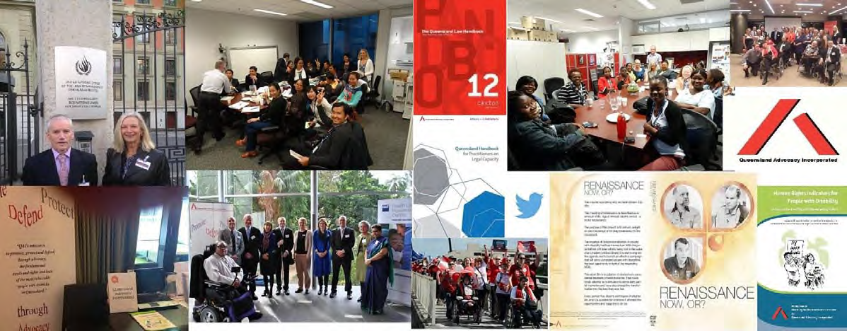

Queensland Advocacy Incorporated 2014-15 Annual Report

Visitors from Kenya, Ghana and Tanzania
d David and Michelle at the United

Nations in Geneva
Dis-Abled Justice II

Capacity Handbook
Michelle and David with our visitors from Hong Kong

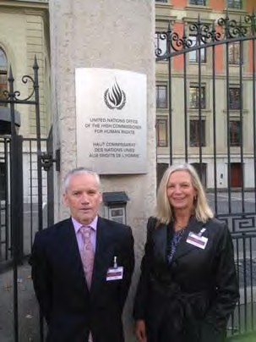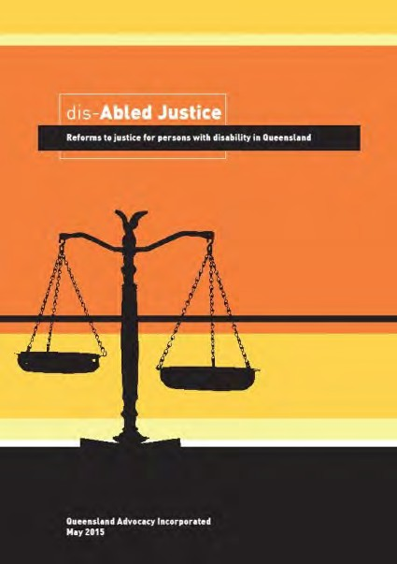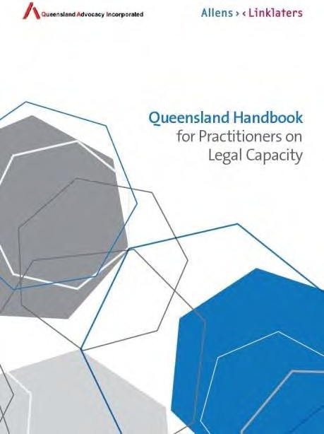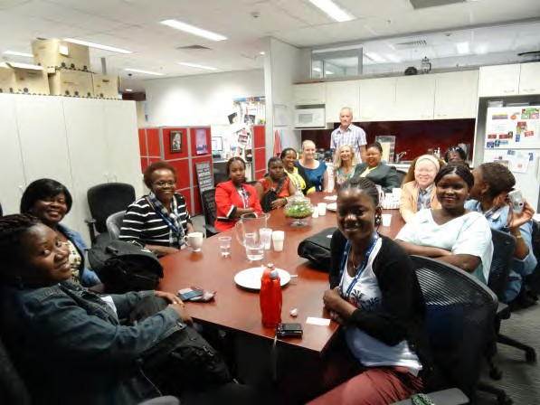

Queensland Advocacy Incorporated
2nd Floor, South Central
43 Peel Street (Cnr Merivale Street) BRISBANE QLD 4101

Phone 07 3844 4200
1300 130 582
Fax 07 3844 4220
Email qai@qai.org.au Internet www.qai.org.au

Contents, Management Committee & Staff

Contents Page No.
Introduction 4
President’s Report Byron Albury 6
Treasurer’s Report Meriel Stanger 7
Director’s Report Michelle O’Flynn 9
Systems Advocacy Emma Phillips 15
Systems Advocacy Nick Collyer 20
Principal Solicitor Rebekah Leong 25
Mental Health Legal Service Julie Hearnden, Roba Rayan 27
Kylie McGrath, Tony McCarthy
Human Rights Legal Service David Manwaring 30
Justice Support Program Elizabeth Francis, Tony
35

McCarthy
Attachment: Audited Financial Reports for 2014-15

Management Committee

President Byron Albury
Vice President Fiona Kennedy
Treasurer Meriel Stanger
Secretary Julie Johnson
Committee Member Trevor Boone
Committee Member Michael Duggan
Committee Member Jade Chee
Committee Member Nicole Nolan

Staff

Director Michelle O’Flynn
Systems Advocate Nick Collyer
Systems Advocate Emma Phillips
Individual Advocate Elizabeth Francis
Principal Solicitor Rebekah Leong
QAI hours of operation Monday to Friday
9am -5pm
Mental Health Lawyer Julie Hearnden
Advocate/Paralegal Tony McCarthy
Mental Health Paralegal Roba Rayan
Human Rights Lawyer David Manwaring
Office/Finance Manager Deborah Bryzak
Administration Assistant Karlie Harris
Administration Assistant Krischelle Mangalindan
Administration Assistant Shelly Samios

Introduction

Queensland Advocacy Incorporated (QAI) is an independent community based systems and individual advocacy organisation for people with disability in Queensland. QAI advocates for the fundamental needs, rights and lives and protection of the most vulnerable people with disability in Queensland. QAI does this by engaging in systems advocacy work - through campaigns directed to attitudinal, law and policy change. QAI also provides limited individual legal and non-legal advocacy for vulnerable people with disability through three discrete projects. These are:

The Justice Support Program (JSP)
The JSP advocates for individuals with a disability in the Justice and related systems. The Advocate’s role is to marshal legal and community support services to provide the person with the best possible opportunity to remain in the community and to prevent them from re- offending.

The Mental Health Legal Service (MHLS)
The MHLS is a specialist legal service dedicated to providing legal advice and representation to individuals receiving involuntary treatment for mental illness in Queensland.

The Human Rights Legal Service (HRLS)
The HRLS provides specialist legal advice and conducts strategic casework aimed at protecting and promoting the fundamental human rights of vulnerable people with disability in Queensland. Once a week, the HRLS operates a specialist, telephone-based Legal Advice Service (LAS). The aim of the LAS is to increase the access of people with disability to the law.

The Department of Social Services funds QAI systemic advocacy. The Community Legal Services Program funds the Human Rights Legal Service (HRLS). The Department of Justice and Attorney General through the Legal Practitioners’ Interest on Trust Accounts Fund (LPITAF) funds the Mental Health Legal Service (MHLS) and the Justice Support Program (JSP). QAI has also received donations over the past year and continues to seek funding from philanthropic organisations and trusts for projects.

This Annual Report covers the period from 01 July 2014 to 30 June 2015. It describes in detail the efforts of QAI to be a strong and effective systems and individual advocacy organisation, committed to its mission of promoting, protecting and defending through advocacy, the fundamental needs and rights and lives of the most vulnerable people with disability in Queensland.

Mission
QAI’s mission is:
“To promote, protect and defend, through advocacy, the fundamental needs and rights and lives of the most vulnerable people with disability in Queensland.”

Objectives

QAI’s objectives are:

- To affirm and put first people with disability in Queensland;
- To undertake systems advocacy that strives to promote, protect and defend the fundamental needs and rights and lives of the most vulnerable people with disability in Queensland;
- To undertake legal advocacy that strives to promote, protect and defend the fundamental needs and rights and lives of the most vulnerable people with disability in Queensland;
- To take an active leadership role in advocating for the fundamental needs and rights and lives of the most vulnerable people with disability in Queensland;
- To support, promote and protect the development of advocacy initiatives for the most vulnerable people with disability in Queensland;
- To be accountable to the most vulnerable people with disability in Queensland;
- To conduct an efficient and accountable organisation; and
- To adhere to and constantly reaffirm the following beliefs and principles:
- All human life has intrinsic dignity and worth;
- People with disability must positively and actively be accorded worth, dignity, meaning and purpose through being included in and with their community;
- Social Advocacy is functioning (speaking, acting, writing) with minimum conflict of
interest on behalf of the sincerely perceived interests of a person or group, in order to promote, protect and
- Defend the welfare of, and justice for, either individuals or groups, in a fashion which strives to be emphatic and vigorous and is likely to be ‘costly’ to the actor in terms of: o time or other resources;
o emotional stress;
o bodily demands;
o social opprobrium, rejection, ridicule;
o self-esteem, self-certainty;
o socio-economic security, livelihood; and
o physical safety, life

The essential elements of Social Advocacy are:
- strict partiality;
- minimal conflict of interest;
- emphasis on fundamental needs and issues;
- vigorous action;
- cost to the advocate;
- fidelity; and
- being mindful of the most vulnerable person.

Systems advocacy is a particular form of advocacy that focuses on influencing and changing ‘the system’, that is, the whole of society and the various systems operating within, in ways that will benefit people with disability as a group within society. Systems advocacy includes, but is not limited to, policy and law reform activities.

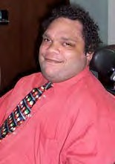
President’s Report
I'd like to take this opportunity to welcome everybody to the 28th Annual Report of Queensland Advocacy Incorporated. It has been my honour and privilege to serve as president of QAI for the past 4 years. Over that time, QAI has been involved in a number of activities which have had a profound impact on the people we continue to serve.

Committee Changes
On behalf of the Queensland Advocacy Incorporated the management committee, I would like to express our thanks to two fellow committee members who have chosen to retire; Julie Johnson and Jade Chee. Both ladies have served on the management committee of QAI with passion, dignity and class it's been an honour
having served with you on behalf of the management committee and staff and the membership of QAI we thank you very much and wish you well for the future.

A few key events from the past financial year include:

- Representation at the United Nations: In 2014, Director Michelle O’Flynn and Human Rights Lawyer David Manwaring were fortunate enough to receive a grant of funding from the Australian Human Rights Commission to appear before the Committee at the United Nations Convention Against Torture in Geneva Switzerland.
- International Visitors: QAI hosted guests from Cambodia, Hong Kong, Tanzania, Ghana and Kenya over the year. We thank QUT for the invitation to be involved, but we extend our thanks and gratitude to the Fellows. It was a great pleasure to meet with our international compatriots, to share our knowledge and experiences, and to learn more about the wonderful opportunities that await people with disability in these countries.
QAI also released two publications earlier in the year:

- Queensland Handbook for Practitioners on Legal Capacity – This publication was launched by The Honourable Justice Ann Lyons on 19 May 2015. It is hoped that Queensland lawyers will find the Handbook useful in supporting their vulnerable clients and increase access to justice for people with disability. QAI gratefully acknowledges the significant pro bono support of Allens and Scott Lang without whom this project would not have been possible.

- ‘dis-Abled Justice II: Reforms to justice for people with disability in Queensland’ – Dan O’Gorman SC launched our publication in May at our forum. QAI is very grateful to Hebert Smith Freehills who donated $5,000 donation which enabled the printing of this fine resource.
I'd like to take this opportunity to thank the entire board Fiona Kennedy, Mike Duggan, Meriel Stanger, Trevor Boone, Jade Chee, Julie Johnson and Nicole Nolan for their ongoing support of QAI and their ongoing commitment to supporting Queensland's most vulnerable people. I would also like to thank our members for joining us at the Annual General Meeting and for their continued support.

Byron Albury

Treasurer’s Report

I am very happy to present QAI’s Financial Report for the year ending 30 June 2015.

I would like to thank Hayward’s Chartered Accountants for the preparation of the Audited Financial Reports and for their support throughout the year.

QAI has continuation of funding for various projects.

Department of Social Services | $440,395.00
Department of Social Services – Quality Assurance | $5,000.00
Legal Aid Queensland – Human Rights Legal Service | $123,202.00
Legal Aid Queensland – Mental Health Legal Service | $170,065.00
Legal Aid Queensland – Justice Support Program | $143,506.00
University of Queensland - Human Rights Legal Service | $6,000.00
Mental Health Review Tribunal | $5,670.00

Other Income

Disabled Justice Project | $3141.00
Interest Received | $7,160.00
Memberships | $899.00
Donations (Acknowledged below) | $2,999.00
Community Education | $818.00
Copyright | $675.00
Herbert Smith Freehills – Disabled Justice Publication | $5,000.00
Investment Interest | $1,351.00
Human Rights Commission – Representation at UN in Geneva | $7,500.00
Human Rights Commission – Sydney | $2,000.00

*Audited financial reports can be found at the end of the Annual Report.

Donations

I would like to acknowledge our Donations:

Senator Suzanne Boyce | Ed Colwell
Grill’d Burgers | Carol Holt
Hudpac Corporation | Minter Ellison – Workplace Giving
Queensland Law Society | Thea Summerville
Margaret Ward | Nigel Webb

QAI has continued to review and update their financial policies and procedures and I am satisfied that QAI is in a good place for the changes which are on the horizon with the introduction of NDIS.

Deborah Bryzak is doing a fabulous job of administrating the day to day running of QAI and I would like to take this opportunity to thank Deborah for all her assistance and guidance in enabling me the perform the role of Treasurer.

I have thoroughly enjoyed working with the Management Committee and the very capable, dedicated staff of QAI.

Kind regards Meriel Stanger
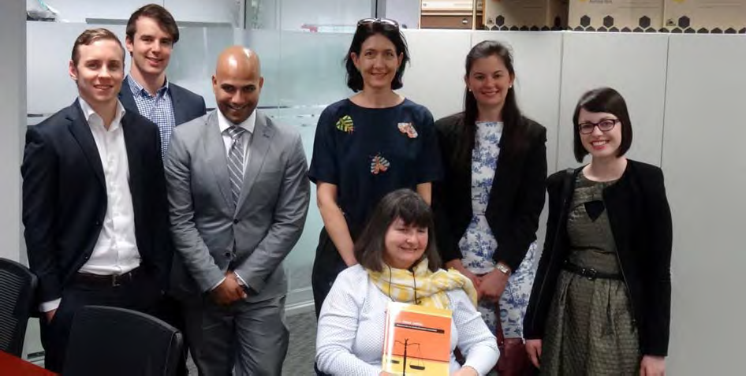
Meriel with the staff of Herbert Smith Freehills who contributed to the printing of “Disabled Justice II: Reforms to justice for people with disability in Queensland.”

Director’s Report

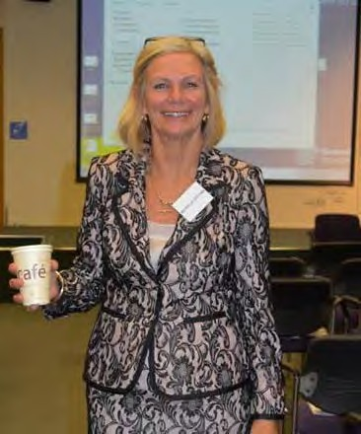
The year has been an interesting and as ever challenging on all fronts. With a change in government early in 2015, most of the sector was poised with hopeful anticipation and in some respects that has been realised with the repeal of the most unpopular and unworkable laws introduced by the previous Attorney General.

However, for the most part, that relief has not been felt in the communities/disability services sphere with the state government delaying signing the bi-lateral agreement with the NDIA until negotiations about the Medicare levy funding were satisfactory. Unfortunately, but not surprisingly, this has translated into no funding being made available to the many vulnerable people with disabilities who continue to live without support or with very little, who endure appalling living conditions, and who continue to be shunted into congregate and inappropriate care arrangements.

Human Resources
Over the past year QAI staff participated in two team building exercises that were enjoyed by all and enabled us to better appreciate our differences and commonalities.
QAI is often admirably supported by highly skilled and dedicated part-time staff members who fulfil time limited contract work when available funding can be sourced. During the course of the contract period relationships are formed creating a highly efficient and expert team. Once the contract ends these staff members are sorely missed.

Roba Rayan had worked as a paralegal across MHLS and JSP, and also to backfill the MHLS role in place of Julie Hearnden (on secondment to the Office of the Public Advocate). At the end of her term she sought and found full time employment elsewhere and Tony McCarthy was the successful applicant for the position of the Paralegal working across the MHLS and JSP and is a very appreciated member of the team.

Julie Hearnden accepted an extended secondment to the Office of the Public Advocate and has been working only two days per week for MHLS as she manages the two positions. Kylie McGrath had been standing-in admirably for Julie in her reduced capacity and they too have been a very successful partnership. Kylie has since moved on and we will soon be finding a replacement.

Krischelle Mangalindan found permanent employment elsewhere and with a new shared position to fill as part-time receptionist/administration officer, we welcomed Shelly Samios to our fold. Shelly and Karlie Harris are working as a most efficient and effective team that is a credit to them both.

Our office Manager Deborah Bryzak continues to support all staff and Management Committee with her scrupulous attention to our finances and Human Resource obligations. I am grateful to her for our close working relationship.

Volunteers/Student Placement

Debbie Stafford completed her PLT (professional legal training) placement as a valued and welcomed member of the Mental Health Legal Service.

Hannah Baldry completed her PLT with David Manwaring in HRLS and the service and clients have benefited greatly with her assistance.

Our systems team was complimented by the addition of our social worker student volunteer Ari Pavlou who performed 500 hours with us. We are most grateful to him for all his assistance in research, editing, organisational assistance with forums and his energy and enthusiasm. This placement involved shared supervision across our systems team but was supported also by an assigned external supervisor. Tian Jin (Larita) will commence her social work placement with us in July.

QAI is very appreciative of all our volunteers and Nick Lauer has continued to give freely of his time and knowledge to the streamlining of our database and systems.

Funding and Quality Assurance
Our responsibilities to our funding body Department of Social Services were met by the submission of the Audited Financial Acquittal Report for the 2013-14 NDAP funding prior to 31st October, 2014.

The Office Manager and the Director met with our State and Commonwealth delegates from DSS to discuss issues with compliance with new National Standards for Disability Services (NSDS) as well as continued funding for systems advocacy under the NDIS. Concerns were also raised about the review of advocacy framework. We move towards compliance to the National Standards for Disability Services by 31st July 2015.

Our individual advocacy services perform across a range of activities funded by Department of Justice and the Attorney General Legal Assistance Strategy and Funding via the Legal Practitioner Interest on Trust Accounts Fund. This is administered by Legal Aid Queensland and the current service agreement continues until 2017.

QAI has made significant contributions to affect change in the disability landscape and the partnerships and collaborations with other organisations and individuals are gaining ever increasing momentum and effect.

A summary of my activities for the past year are outlined below. Some of the work of staff members is performed on an individual basis, but a great proportion of work is through collaboration and cooperation and at times partnerships.

Other Funding Applications to engage in systems advocacy

Submission to the Australian Human Rights Commission for Funding to Attend the 53rd Session of the UN Committee Against Torture.
Application for LPITAF Funding for the Development of Rights Indicators to Prevent the Use of Restrictive Practices on Vulnerable People
An application was submitted to the Department of Communities Child Safety and Disability Services for the funding grant to hold advocacy presentations with and for people with disability.
Following on from enquiries from the Legal Assistance Strategy Funding Grants –QAI submitted a further application for the development of a set of Human Rights Indicators for the Use of Restrictive Practices.

SUBMISSIONS Policy
The following submissions have been tendered in a bid to change policy and practice:-
  - Public Advocate in response to the Issues Paper on Decision-making support in Queensland’s guardianship system.

  - Various letters and reports regarding deinstitutionalisation – executive summary from the Renaissance – Now Or? forum and dvd.
  - Engagement with Disability Services Qld and advocacy and service groups regarding the unblocking of funding.
QAI submitted a response to the Public Advocate’s scoping paper about complaints handling: Strengthening voice: A Summary of the Scoping Paper about complaints management systems for adults with impaired capacity

The HRLS consulted with the Director in order to submit a further paper in regard to the review of the QCAT Act with particular emphasis on offer of legal representation to all people with disability appearing before the tribunal and training for QCAT members.

Submission to the Office of the Public Advocate was made with the assistance of Emma Phillips regarding Complaints – this was in conjunction with the NDIS Quality and Safeguards meetings I attended and in readiness for the submission on Q & S for the NDIS.

SUBMISSIONS Legal/Law Reform

Submission tendered to the Legal Affairs and Community Safety Committee on the Justice and Other Legislation Amendment Bill 2014 regarding proposal to prevent Community Legal Centres from undertaking law reform activities

Submission tendered to the Draft Guardianship and Administration and Other Legislation Amendment Bill 2014 written by David Manwaring.

Senate Committee - Community Affairs References Committee - “The adequacy of existing residential care arrangements available for young people with severe physical, mental or intellectual disabilities in Australia.”

NDIS - Information Linkages Capacity Building Framework or what was referred to as “Tier 2”.

Parliamentary Joint Standing Committee on the National Disability Insurance Scheme Queensland NDIS Readiness 2016
Senate Community Affairs References Committee - Impact on service quality, efficiency and sustainability of recent Commonwealth community service tendering processes by the Department of Social Services
BSWAT Bill (employment wage assessment tool) pertaining to employees with disability

Research and Papers

Position Statement and Paper - Conclusions on the use of Restrictive Practices Position Statement and Research Paper on Supported Decision-Making
Staff have engaged in research in areas such as supporting people to exercise legal capacity, support for decision making, welfare reform and employment, electronic monitoring of people with disability in residential accommodation, and most recently, forensic disability services and has produced a paper on this subject. Other areas of focus have included the beginnings of analysis of the intersection of international conventions and the CRPD and how this applies to people with disability in Queensland with a view to activism for a Bill of Rights locally and nationally.

Meetings and Networking Opportunities

QAI has regularly participated in the following engagements on a regular and ongoing basis:- Convening Combined Advocacy Groups of Queensland Teleconferences every 6 weeks.
  - Prof. Karen Nankervis and Dept. Communities regarding the Joint Action Plan for People with Disabilities in Long Stay Health Facilities

Restrictive Practices Implementation Working Group

Ongoing collaborations with the Office of the Public Advocate on several fronts including support for decision making, safeguards for people with disability under the NDIS, complaints mechanisms,

Disability Services Partnership Forum
  - In November I joined the Board of Disability Advocacy Network of Australia.

Other initiatives for networking and engagement included:-
  - NDIS – Discussions with representatives from the NDIA.
  - QADA to discuss potential joint responses to Department of Justice and Attorney General regarding collaborative efforts.
  - Legal Aid Qld and the project managers for the LAQ operational plan 2014–17 action: Better understand how people with disabilities are accessing legal aid services
  - Mental Health Review Team regarding the Mental Health Bill.
  - Engagements when required with the Office of the Adult Guardian and the Public Trustee to discuss the proposed cessation of DSP to people in forensic detention.
  - Department of Housing and Public Works to discuss housing shortfalls for the Joint Action Plan and the NDIS rollout.
  - Disability Services Qld. Minister Coralee O’Rourke – establishing a relationship and bringing issues to the table.
  - Engagement with people with disability from QDN’s Hot Topics Groups upon invitation.

QAI gains international exposure

QAI has recently forged alliances with QUT and thanks to Dr. Niki Edwards, were delighted to meet fifteen delegates from Cambodia who met to discuss the importance of advocacy and the grassroots representation of people with disabilities in policy, service development and service evaluation within the context of the Convention on the Rights of Persons with Disabilities (CRPD).

Later in the year QAI hosted a group of women with disabilities AusAID/DFAT fellows - from Ghana, Tanzania and Kenya - One of the focuses of this group is advocacy and community care.

We have appreciated and enjoyed this cultural exchange of ideas and the opportunity to share our experiences so that advocates from different countries can learn from one another. We hope that our guests from Cambodia, Ghana, Tanzania and Kenya are able to keep their responses in community and not in bricks and mortar.

David Manwaring and I travelled to Geneva Switzerland as part of the NGO Delegation to the United Nations Convention Against Torture. Our focus was the imposition of Restrictive Practices and Involuntary Treatment of people with disability and or mental illness and the involuntary detention of people within forensic disability systems.

David Manwaring, Rebekah Leong and I attended an event arranged by Emma Phillips at the Australian Human Rights Commission to advance the work undertaken for the UN Committee Against Torture. This event was a collaboration of the four disabilities NGO in Geneva and a group of allied researchers and academics with commitment to the cessation of cruel inhuman and degrading treatment of people with disability.

Human Rights Alliances
QAI’s David Manwaring, Rebekah Leong and I attended an event arranged by Emma Phillips at the Australian Human Rights Commission to advance the work undertaken for the UN Committee Against Torture. This event was a collaboration of the four disabilities NGO in Geneva and a group of allied researchers and academics with commitment to the cessation of cruel inhuman and degrading treatment of people with disability

The work QAI has performed to advance the human rights of people with disability has been acknowledged and with the recent appearance at the UN CAT, raised the profile of our organisation. Our promotion and media on this event helped to motivate the establishment of a collective of like-minded groups and individuals have joined in alliance to advance a call for a Human Rights Act for Queensland. This alliance includes groups such as Caxton Legal Centre, Mamre, Qld. Council for Civil Liberties, QAILS, ATSILS, Together Union, United Voice Union, QCOSS, academics, human rights lawyers, and more.

Campaigns and Media

  - BSWAT Bill (employment wage assessment tool) pertaining to employees with disability
  - Letter writing and visits to key election candidates to safeguard advocacy funding

Appearances on ABC tv and radio regarding the following issues:-
    - Electronic monitoring of people with disability in residential settings (using closed circuit television and or baby monitoring devices)
    - Police target the illegal use of accessible car parking
    - Excessive use of force by police (amputee arrest at Sunnybank following G20)
    - News Limited article 25th March on Forensic Detention and welfare cuts
  - Courier Mail joint article with QDN - People with disability locked out of work
  - Federal Government’s plan to cut the Disability Support Pension to people who have been confined in forensic detention in relation to alleged criminal offences.
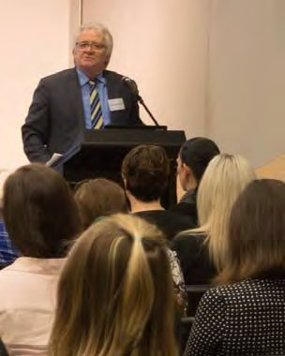
  - Letter campaign to call for Royal Commission into abuse of people with disability who reside in institutional settings..
  - Letters sent to the Minister for Transport and the Minister for Main Roads to discuss our ideas regarding the fixture of restraints for the safety of people who use mobility devices. Thanks to Andrew Evans and Ben Lawson for their collaboration and first-hand experiences of this issue.

Publications/Promotions
The launch of “dis-Abled Justice: reforms to justice for persons with disability in Queensland coincided with the launch at 80 George Street on the 28th May, 2015. We thank Herbert Smith Freehills for the kind donation of $5,000 toward the printing of this book. Presenters at this forum included personal stories of people with disability and their experiences with the criminal justice system.

Dan O’Gorman SC

We acknowledge and are deeply grateful to Leona Berrie from WWILD for introducing us to Kobie for sharing her experiences as a witness and complainant in the courts. Dan O’Gorman (our VIP guest speaker who launched the publication), by speaking of supports for communication for all people to participate in jury services, and Kobie's experiences as a witness and complainant in the courts allude to the need for an expansion of supports for people with disability to exercise their legal capacity.

Benita Bierzynski from SUFY presented David’s story with permission and contribution by David’s Mother Carmel. David’s story, illustrated the historical ill-treatment of people with disability in the mental health system. The archaic approaches to ‘secure and contain’ a person by a series of experts who did not know him well enough to understand, signify the gross failure of several government systems yet offers a classic lesson on the changes that must be made as indicated in this report “dis-Abled Justice”. QAI is indebted to the authentic lived experiences of people with disability every day, but we are especially grateful to these contributors for sharing personal accounts that are evidence and drivers for the work we do to promote protect and defend the human rights of people we serve.

QAI also launched with Allens-Linklater the Queensland Handbook for Practitioners on Legal Capacity. QAI gratefully acknowledges the significant pro bono support of Allens and Scott Lang without whom this project would not have been possible and The Honourable Justice Ann Lyons, for launching the publication. We also thank the Queensland Law Society and Stafford Shepherd for their input and endorsement of the handbook for use by Queensland solicitors.

Presentations/Events
B E Lifestyles Forum regarding how to enable people with disability choice and control under the NDIS with particular emphasis on self-direction.
David Manwaring and I delivered a presentation to visiting nurses from Hong Kong regarding advocacy. The nurses were undergoing an exchange program with Department of Communities and were invited to QAI at the request of Simon Wardale from Forensic Disability Services.

At the request of Kathy Ellem from QUT School of Public Health and Social Work I presented a lecture on the topic of advocacy for the Human Service and Social Work students.

David Manwaring and I presented at the QAILS Conference “Engaging with the UNCAT review’ to provide other CLC workers and supporters with insight into UN and convention body processes, practical steps to engaging with these processes, and reflections on taking casework experience into broader advocacy.

CLIENT/STAKEHOLDER SATISFACTION
We received positive feedback from two clients of the Human Rights Legal Service.

An email from two of the nurses who visited QAI from Hong Kong wrote to us expressing their appreciation of our time, and the information package we provided to them. A subsequent letter from Karen Nankervis, Chair Centre of Excellence expressing thanks and appreciation for the learning experience we provided to the nurses.
We received positive feedback and appreciation for our efforts from two people regarding our media release on employment of people with disability.

QAI received thanks and appreciation from an occupational therapist on final placement for information and advice regarding Advance Health Directives, support for decision making QAI received positive feedback from a number of sources in relation to our forums, presentations we delivered, as well as the resources we published.

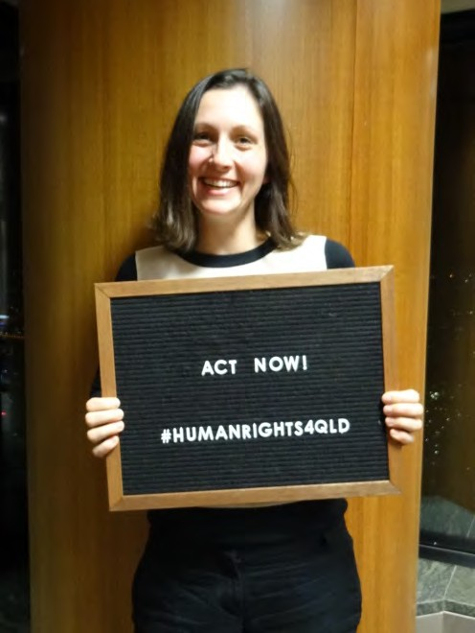
Systems Advocacy – Emma Phillips
I have been working for QAI since June 2014, in the role of Systems Advocate (Research & Writing). I commenced in this role two days per week and I am presently working five days per fortnight.

I am thoroughly enjoying this work, as the scope and content of the matters that I work on are important and interesting and strongly resonate with my personal values. I am fortunate to enjoy positive, supportive and productive working relationships with the other members of the systems team (Michelle O’Flynn, also QAI Director, and Nick Collyer), as well as other staff of QAI.

Submissions
- I researched and drafted QAI’s submission on the Interim Report of the Reference Group on Welfare Reform to the Minister for Social Services: A New
System for Better Employment and Social Outcomes (August 2014).

- I drafted Submission to Public Advocate in response to Issues Paper on Decision-making support in Queensland’s guardianship system (December 2014).
- I worked with Michelle O’Flynn to research and draft feedback on the draft Framework for Information, Linkages and Capacity Building, initially in the form of dot points for the DSQ Disability Service Partnership and then in the form of a submission to National Disability Insurance Agency (March 2015).
- We prepared a response to the Office of the Public Advocate considering key components of a complaints handling system for adults with impaired capacity, with a view to identifying and articulating what may constitute best practice in complaints management for the systems that adults with impaired capacity may interact with.
- I assisted Michelle O’Flynn with QAI’s submission to the Senate Community Affairs References Committee, examining the impact on service quality, efficiency and sustainability of recent Commonwealth community service tendering processes by the Department of Social Services.
- I assisted Michelle O’Flynn with some research and transcription of audio recordings of an NDIS consultation held in Brisbane, as part of the preparatory work for the NDIS Quality and Safeguards Submission.
- I helped Michelle O’Flynn to research and draft a submission to the Senate Community Affairs References Committee examining violence, abuse and neglect against people with disability in institutional and residential settings, including the gender and age related dimensions, and the particular situation of Aboriginal and Torres Strait Islander people with disability, and culturally and linguistically diverse people with disability (14 May 2015).

Funding Applications
- I drafted a funding application to enable QAI to send two advocates, Michelle O’Flynn and David Manwaring, to the United Nations Committee Against Torture, 53rd Sessions, in Geneva in November 2014. This application was successful, as was the participation by QAI in the Australian NGO delegation to Geneva.
- At the invitation of the Australian Human Rights Commission, I drafted and submitted a further funding application to assist QAI, in collaboration with other organisations who collectively formed the Australian NGO delegation before the UN CAT, to convene a disability sector roundtable at the Australian Human Rights Commission in Sydney, convened in February 2015. This was a successful event that furthered the dialogue on human rights and torture in the Australian disabilities context.
- I drafted an application for $50,000 LPITAF funding for a project entitled: Addressing rights abuses in Queensland - the development of Rights Indicators to prevent the use of Restrictive Practices on vulnerable people. While we have been given indications that this application is being favourably considered, we are yet to be notified of the outcome.
- I worked with Elizabeth Frances and Rebekah Leong to develop an application for
$20,000 funding from the Legal Aid Queensland CLE Collaboration Fund for a project to produce, publish and distribute a pictorial booklet for people with intellectual disability as an educational resource in the event that they are being questioned by police or are charged with an offence and required to go to court. This funding application was successful and the booklet is presently being developed.

Research
- I researched and wrote a research paper and position statement on the use of Restrictive Practices on people with an intellectual or cognitive impairment, which has been widely disseminated.
- I researched and wrote a position statement and research paper on supported decision- making.
- I researched and wrote a research paper and position statement on the Forensic Disability Service in Queensland, that has recently been finalised.
- I assisted Nick Collyer to write and edit dis-Abled Justice II: Reforms to Justice for Persons with Disability in Queensland.

Meetings (external) and events
- Meetings and correspondence with staff of the Australian Human Rights Commission (principally Helen Potts and Penny Gerstle), as well as relevant staff of other peak disability organisations, principally Ngila Bevan from PWDA to facilitate participation in the Australian NGO delegation before the UN CAT.
- I helped to organise the disability sector roundtable convened with other organisations who formed the Australian NGO delegation to the UN CAT in Geneva at the Australian Human Rights Commission in February 2015: ‘Implementing the UN Convention Against Torture and Other Cruel Inhuman or Degrading Treatment or Punishment (CAT) in Australia: A workshop from a Disability Rights Perspective’.

- I have attended meetings with members of Parliament, including the Hon Yvette D’Ath (present Attorney-General), the Hon Peter Wellington (Speaker) and Craig Crawford MP (member for Barron River) as part of the campaign for the introduction of a Human Rights Act in Queensland.
- I helped to organise the forum to launch dis-Abled Justice: Reforms to Justice for Persons with Disability in Queensland (May 2015).
- I attended the QAI and Caxton Legal Service forum in the Banco Court on the excessive use force by police in the context of persons with a mental health condition (May 2015).
- I attended the QAI Forum “Renaissance – Now or?” held at the Anti-Discrimination Commission of Queensland. This Forum explored the continuation of the deinstitutionalisation of people with disabilities (August 2014).

Campaigns and Media
- I have worked intensively on the campaign for the introduction of a Human Rights Act in Queensland, in collaboration with the other member organisations of the Rights for Queenslanders Alliance. My work on this campaign has included:
  - Attending sub-committee meetings and committee meetings
  - Researching, drafting and settling legal, informative and media documents.
  - Helping to organise the event: The Right Way: A Dialogue about a Human Rights Act for Queensland, which was held at Parliament House on 14 September 2015.
  - Reviewing and critiquing relevant documents, including the terms of reference for the group and the campaign strategy
  - Applying for pro bono assistance relating to the structure of the organisation.

- Presenting on this issue to the Advocacy Champions at Endeavour Foundation on 19 August 2015.
- I contributed to the media release on QAI’s submission on the Interim Report of the Reference Group on Welfare Reform to the Minister for Social Services: A New System for Better Employment and Social Outcomes.
- I wrote a media release on QAI’s involvement in the Australian NGO delegation before the UNCAT in Geneva (November 2014).
- I wrote a media release on the need for a Human Rights Act in Queensland.

- I drafted a media release: ‘An important new resource offers hope for improvement for people with disability in the criminal justice system’, discussing QAI’s new publication, dis-Abled Justice: Reforms to justice for persons with disability in Queensland (May 2015).

Publications/Promotions/Networking
- I undertook the background research, and helped to prepare a powerpoint presentation, for the Positive Practices Symposium convened by the Department of Communities, Child Safety and Disability Services in June 2014. This paper was presented by Michelle O’Flynn, David Manwaring and Nick Collyer. QAI received positive feedback on this presentation, both at the conference and by later email correspondence.

- I have joined the newly formed Disability Rights Sub-Committee of Australian Lawyers for Human Rights and participate in their bi-monthly committee meetings and research and law reform activities.
- I have participated in each of the team building days for QAI staff and in the QAI strategic planning day.
- On 18 May 2015, my first staff appraisal was conducted by Michelle O’Flynn and Deborah Bryzak.

PROGRESS: AGAINST STRATEGIC PLAN KEY PERFORMANCE INDICATORS

Progress: Against Strategic Plan Key Performance Indicators

Clarity of the rightful place of people with disability as citizens with all that citizenship involves

In my research and writing, I have emphasised perspectives including Social Role Valorization and Williams’ model of citizenhood.

In all of the submissions I draft for QAI, I link the themes back to the importance of choice, autonomy and full engagement for all people, including people with disability, in all aspects of life and in the community.

Consistent use of positive imagery of and with people with disability

As part of my work on the Human Rights Act campaign, I have consistently helped to develop positive imagery of and with people with disability, including in discussions with key parliamentary figures and in written materials developed and disseminated on behalf of the campaign.

In my work writing submissions, research papers and position papers for QAI, I consistently use positive imagery with respect to people with disability. I frequently discuss the need to be mindful of our language and discourse when writing about and for people with disability.

Conceptual analysis in well-argued papers, reports and articles

In my work for QAI, I have engaged in a significant amount of legal and sociological research and analysis and have drafted a number of submissions, papers and correspondence.

I have developed, either independently or collaboratively, QAI’s position on topics including the use of Restrictive Practices on vulnerable people with an intellectual or cognitive disability, the Forensic Disability Service, supported decision-making, the ILC tier of the NDIS, the interface between disability and the criminal justice system, and in light of the proposed introduction of a Human Rights Act in Queensland.

Clear planning and implementation strategies, keeping to time lines and any budget for campaign work

To date, I have met all time-lines, both internal (time-frames agreed with other QAI staff members) and external (for example, deadlines for submissions or funding applications).

Strategic thinking, argument and skill in lobbying in written material

In my work on submissions that I have drafted for QAI, I have demonstrated my ability to think strategically and logically and develop strong arguments designed to protect and advance the rights of people with disability.

As part of my work for Rights for Queenslanders, I have used strategic thinking and analytical skills to identify and highlight persuasive angles that best benefit people with disability.

Supportive team relationships

I consider that I have developed good working relationships with other QAI staff, in particular those engaged in systems work – Michelle O’Flynn (to whom I report) and Nick Collyer (fellow systems worker). In my opinion, we work well together and have positive and supportive working relationships.

I have also worked closely with Ari Pavlou and Larita Jin, our social work students, and have adopted a successful mentoring and supervisory role.

I also work well with other staff members of QAI when the opportunity arises for collaboration (this is usually in the context of funding applications), including Deborah Bryzak, Elizabeth Francis, Rebekah Leong and David Manwaring.



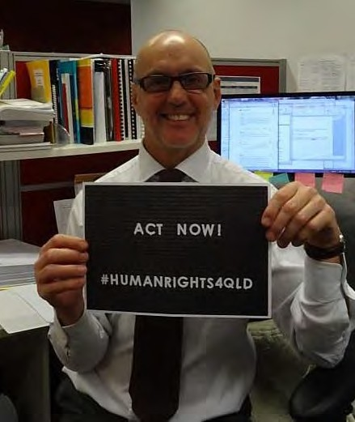
Systems Advocacy – Nick Collyer

Campaigns

QAI and Aboriginal Disability Justice Campaign (QAI is an ADJC member):
Campaign to oppose the Social Services Amendment Bill 2015 (plan to cease payment of Disability Support Pension to people in psychiatric confinement)

Systemic actions as below:-

- ADJC submission - see ‘Submissions on Policy Issues’ below
- Letter Scott Morrison (Minister)
- Canberra meetings) with MPs and Senators - Rachel Siewert, Claire Moore, Ken Wyatt AM, Jenny Macklin and with the Department of Social Services Director General
- QAI letter to all Senators
- Letter to Queensland Public Advocate and Queensland Public Guardian
- Meeting with Public Guardian Kevin Martin with Michelle
- Canberra meetings for Social Services Amendment Bill 2015 - 23 Feb 2015
- Letters to Kath Halbert, Rachel Siewert, Alistair Webb, Ken Wyatt, Claire Moore

Submissions on Policy Issues

Inquiry into the Social Services Amendment Bill 2015 (plan to cease payment of Disability Support Pension to people in psychiatric confinement)

If enacted, the Bill would —

- Fail to achieve the stated aim of parity across the criminal justice systems. The people targeted are not criminally responsible for their actions.

- Reintroduce a punitive dimension that for good reason has been long been absent from the intent of forensic detention.

- Save taxpayers no money in the short term, shifting costs from Commonwealth to states and territories, and

- Increase costs by prolonging institutionalisation and dependency.

- Introduce arbitrary inequity by denying income support to people in relation to (alleged) offences far less serious than those specified in the amendment. The ‘serious offence’ provision is broad in scope. In our view, the offences specified in section 9E are misleading and only the ‘tip of the iceberg’. In Queensland ‘serious offence’ will likely capture many offences set out in the Criminal Code 1899 (Qld) (the Code), including:

- s 61 Riot,

- s 72 Affray,
- s 408A Unlawful use or possession of a motor vehicle and
- s 225 The like by women with child (Any woman who [attempts to] procure her own miscarriage.

Submission by the Aboriginal Disability Justice Campaign to Senate Community Affairs References Committee re on Violence, abuse and neglect against people with disability in institutional and residential settings, including the gender and age related dimensions, and the particular situation of Aboriginal and Torres Strait Islander people with disability, and culturally and linguistically diverse people with disability

- QAI contributed a case study for the ADJC submission

Submission to the Legal Affairs and Community Safety Committee on the Justice and Other Legislation Amendment Bill 2014 - “Gag Clause for Community Legal Centres”

Summary of Recommendations:
  - Clause 80 should be redrafted to allow the Minister to allocate funds to law reform activities.
  - Law reform continues to be a critical need for people with disability
  - Law reform is optimal utilisation of resources
  - Law reform is integral to frontline service delivery
  - Legal professionals and paralegals in CLCs are in a prime positon to observe patterns of disadvantage, bottlenecks, inequities and injustices that can only be addressed by legislative and policy reform.
  - By alerting government that a particular problem is widespread, a service can assist to remedy a problem faced by many individuals throughout the same jurisdiction, delivering or obviating the need for that same frontline service to thousands, or more.
  - Failing to utilise and capitalise on that information is not only inefficient, and ineffective, it is failure to be accountable to government and to the public.
  - Targeted law reform reduces the need for frontline services and makes economic and social logic.

Other Work

dis-Abled Justice
Researched and wrote a new edition of Phillip French’s original, with the assistance of a host of student volunteers. Emma Phillips, Michelle O’Flynn and Rebekah Leong contributed to the writing.

ADJC Remote Access Project
This is a pilot for a larger project to investigate access to criminal justice for people with intellectual impairments and mental illness in Remote Aboriginal and Torres Strait Islander Communities. Until now, ADJC has largely relied on other research and powerful but largely case-study/anecdotal evidence of human rights abuses and other injustices with respect to Aboriginal and Torres Strait Islander people with cognitive impairments or mental illness. The plan here is to go a layer deeper than ADJC has so far, and to establish a stronger knowledge base from which ADJC can seek to influence policy and legislative processes.

- Establish relationships with people with disabilities in a Queensland remote Aboriginal community.
- Seek out potential allies in that community.

- Gather first-hand knowledge of the experiences of people with intellectual impairments from rural or remote community who have been held in forensic detention.
- Establish a firm knowledge-base for legislative and policy change.

Back ground research in relation to Accessible Public Transport/securing wheelchairs on city buses.
- Consulted with Dr John McPherson BCC, Nigel Webb QDN, David Swift QDN, Lloyd Walker, Consultant, Craig Whiteman- BCC, Meriel Stanger Queensland Advocacy Incorporated.
- Conversation with Craig Whiteman- BCC and Lloyd Walker

NDAP Performance Report-
Contributed information on systems activities I have been involved in.

Project Plan for ADJC - Remote Access Project
This is a pilot for a larger project to investigate access to criminal justice for people with intellectual impairments and mental illness in Remote Aboriginal and Torres Strait Islander Communities. Until now, ADJC has largely relied on other research and powerful but largely case-study/anecdotal evidence of human rights abuses and other injustices with respect to Aboriginal and Torres Strait Islander people with cognitive impairments or mental illness. The plan here is to go a layer deeper than ADJC has so far, and to establish a stronger knowledge base from which ADJC can seek to influence policy and legislative processes.

Objectives

- Establish relationships with people with disabilities in a Queensland remote Aboriginal community.
- Seek out potential allies in that community.

- Gather first-hand knowledge of the experiences of people with intellectual impairments from rural or remote community who have been held in forensic detention.
- Establish a firm knowledge-base for legislative and policy change.

Plan

- ADJC will engage and partner with one Aboriginal and Torres Strait Islander organisation and one Disability org in Queensland
- With permission, one ADJC representative, one disability organisation representative, a film-maker and one Aboriginal (and Torres Strait Islander) representative will engage with and visit a remote community in Queensland, particularly Palm Island
- Network, observe and report on access to criminal justice issues for people with intellectual impairment and mental illness
- Answer key questions including:

- What are the pathways that draw people into the criminal justice system?
- How do people stay enmeshed in the criminal justice system?
- How would communities like to deal with these issues themselves?

Parliamentary Joint Standing Committee on the National Disability Insurance Scheme Gave evidence at a public hearing before the Committee on Friday 13 March 2015 at 9.00am in Brisbane. The purpose of the hearing was to take evidence regarding the Queensland disability sector's readiness to participate in the NDIS when it commences on 1 July 2016. Full details of the inquiry are available at the committee's webpage.

Media Releases

25 November 2014: ‘Let’s make an end to institutional living’
Call for a national inquiry into institutional abuse (post Yooralla scandal)

10 March 2015: Joint media release (with QDN) ‘People with disability locked out of work’ “The Courier Mail printed two articles today that grossly misrepresent people with disabilities”, said the Directors of Queensland Advocacy Incorporated (QAI) and Queenslanders with Disabilities Network (QDN) in a joint statement.
“The articles ‘Jobless welfare figures reveal we’re living in the slacker state’ (CM 10 March 2015, p 1) and ‘Pole position for dole is right here’ (CM 10 March 2015, p 2) suggest that DSP recipients could be out working but that they choose not to do so.”

31 March 2015: Media release “Shame on the Federal Government for punishing people with disabilities, and shame on News Limited for playing up to prejudice around mental illness” said Queensland Advocacy Incorporated Director Michelle O’Flynn. News Limited’s 25 March 2015 article ‘Welfare Cuts for criminally insane’ reported the Federal Government’s plan to cut the Disability Support Pension to people who have been confined in relation to alleged criminal offences.

Events Organised

Combined Advocacy Groups of Queensland (CAGQ) Annual Meeting
Date: 27 October 2014
Venue: ADCQ Training Rooms, Floor 17- 53 Albert St Brisbane Speakers:
Tony Hayes Deputy Director General Disability Services Queensland Kevin Martin, Public Guardian Queensland
Madonna Nicoll President, SUFY (Speaking Up for You)
Mary Mallett CEO DANA (Disability Advocacy Network Australia) Carol Holt- Community Safeguards Coalition

QAI Forum (with Caxton Legal Service) ‘Excessive Use of Force: Death and serious injury in the course of arrest of people with mental health conditions’
Date: 7 May 2015
Venue: Banco Court, Queen Elizabeth II Courts of Law, 415 George St Brisbane
Speakers: Mental Health Commissioner Lesley Van Shoienbroek, Police Commissioner Ian Stewart, Charandev Singh, Dr Tony Goldsworthy

The Ferguson shooting and riot in the US is just one in a series of incidents that has put excessive use of force by police in the news. The American shootings appear to have a race dimension. Here in Australia, people with mental illness and disabilities are overrepresented in these incidents.

In 2013, the Australian Institute of Criminology released a report detailing fatal police shootings between 1989 and 2011. In that period, police fatally shot 105 people- 42% were mentally ill and 59% of those had schizophrenia.
In 2014, Queensland police shot 6 people, four fatally, and these are under investigation by the Coroner. At least two of the victims had a known mental illness. In November 2014

footage of Queensland police pinning and punching a man whose prosthetic legs were missing went viral.

Launch of dis-Abled Justice
Date: 28 May 2015
Venue: 80 George Street, Brisbane Disabled Justice Launch Media Release

Events, Seminars, Forums, Meetings Attended

Aboriginal Disability Justice Campaign (ADJC) Working Group
Campaign against the Commonwealth’s proposal to cease payments of the Disability Support Pension to people in psychiatric detention in relation to serious offences.\

- Letters to Scott Morrison, Sen Mitch Fifield and all other senators.

- Contributed ADJC letter to Scott Morrison, Fifield and others.

- Met with Senators Rachel Siewert and Clair Moore in Canberra to discuss the proposed changes and strategy to prevent them.
- 29 October 2014 - University of Queensland Policy Research breakfast Presenter
- Universal Periodic Review - Meeting at ADCQ to discuss disability sector contribution to NGO report.
- 6 December 2014 - Social Media 101 for CLC
- QAILS Webinar- Navigating the Canberra Zoo
- February 2015 - National ADJC teleconference
- 18 February 2015 - Review of Operational Plan
- 9 March 2015 - Met with Amparo, QADA, sunshine coast citizen advocacy re parliamentary hearing
- 13 March 2015 - Presented to Parliamentary Joint Standing Committee on the NDIS
- 12 March 2015- The idea of an Asia-Pacific CRPD Tribunal @ University of Queensland- Seminar
- 27 March 2015- Meeting with Clinton Myles of the Public Trustee
- Ongoing - Community Safeguards Coalition Monthly Meetings (alt with Michelle O’Flynn)
- Ongoing - CAGQ Monthly meeting

Correspondence

- Yvette D’Ath Follow-up re dis-Abled Justice
- Hon Jo-Ann Miller – Minister Corrective Services, Police - Follow-up re dis-Abled Justice

Premier Palaszczuk - Follow-up re dis-Abled Justice
- Letter to Senator Fifield - Call for Royal Commission into abuse of people with disability living in state-funded institutions
- Letter to Minister Kevin Andrews re call for Royal Commission into abuse of people with disability living in state-funded institutions
- Letter to various Ministers and members of Government and Opposition re: importance of systemic advocacy
- Letters to Tony Abbott PM and other government Ministers re: call for Royal Commission into abuse of people with disability living in state-funded institutions
- Letter to Scott Morrison (Federal Minister) and all Senators and Queensland’s Public Advocate and Public Guardian re cuts to DSP

Principal Solicitor

QAI has provided individual advocacy services since 2008, when the Human Rights Legal Service was established to promote and protect the fundamental human rights of people with disability in Queensland. The Justice Support Program followed in 2009, providing non-legal advocacy for vulnerable people navigating the criminal justice system. In 2010, the Mental Health Legal Service commenced to provide legal advice and assistance for people subject to involuntary mental health treatment and detention. Over this time, we have assisted 1757 clients, opened 1289 cases and provided 1947 advices.

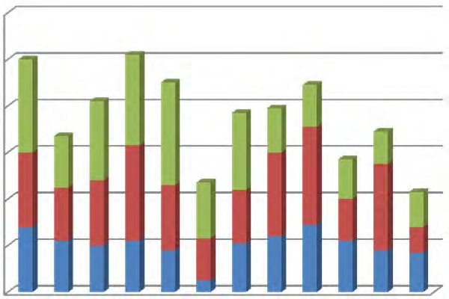In 2014-15, we received on average 75 requests for assistance per month. 65% are provided with advice or representation. Of the 35% turned away, 12% could not be assisted due to capacity issues. This does not take into account the clients whom we book in for an advice only, as we do not presently have the resources to provide them with representation.
20

0
Informations
Advices Cases
120

100

80

60

40



Table: Requests for assistance per month

Funding
From 1 July 2014, all individual advocacy services have been funded for 3 years with funds invested by the Queensland Government from the State Budget and Legal Practitioner Interest on Trust Accounts Fund. We thank the Department of Justice and Attorney-General for their ongoing support.
The Mental Health Legal Service receives some additional funding for services from the Mental Health Review Tribunal.

The Human Rights Legal Service receives support from the University of Queensland for its contribution to their clinical legal education program.

2014-15 Activities
- Launch of the Queensland Handbook for Practitioners on Legal Capacity, drafted with the pro bono assistance of Allens, and endorsed by the Queensland Law Society. (19/05/15)

- Working collaboratively with the Queensland Aged and Disability Advocacy Inc to deliver training on guardianship and administration to people with mental illness and their families, with funding from the Legal Aid Queensland Community Legal Education Fund.
- Active participant in the Guardianship and Administration Network, an initiative of QAILS for community legal centres and affiliates to discuss common issues.
- Undertaking a “costs assessment” of QAI files to better understand the true cost of providing the legal services that QAI provides.
- Presentations given:
- Disability law - Presentation to Court Network volunteers (15/09/14)
- G20 implications for people with disability – Presentation to QCOSS Futures Forum (17/09/14)
- Clients with challenging behaviours – Joint presentation to volunteer lawyers of the Homeless Persons’ Legal Clinic (QPILCH) (28/11/14 )
- Effective collaboration, including working with the private profession and universities
– Presentation on a panel to CLC lawyers organised by QPILCH (19/02/15)
- Panel participant about the Capacity Handbook at the Seniors’ Legal and Support Service State Conference (09/06/15)

Pro bono and volunteers
QAI could not achieve the quantity or quality or services without the generous support of volunteers and pro bono assistance. In 2014-15, we thank the following for their ongoing assistance and support:

Firms | Barristers and solicitors | Other
- Allens  - Sparke Helmore | - Janice Crawford  - David Cormack | - Office of Advocate | the | Public
 | - Nanette Noble | - Office of Advocate | the | Public
 | - Nicholas Tucker | - Office of Advocate | the | Public
 | - Karen Williams | - Office of Advocate | the | Public
 | - Karen Barnard | - Office of Advocate | the | Public

We also thank the senior law students who volunteer their time, one day per week over a 12 week period, to assist both individual advocates and systems advocates
at QAI.

Semester 2, 2014 | Semester 1, 2015
Jessica Bojarovski | Sophie Clarke
Carmen Trevino | Kerrie Hales
Thomas Serafin | Jelena Rakic
Matthew Wilkinson | Bo McGrath
Adam Rod | Anna Fanelli.
Myles Lawrence

Thanks to Shalini Ramjee and Julian Ladd, organised through the UQ Pro Bono Centre, for their assistance in the costs assessment project. We also had two PLT students in 2014-15 to whom we are also grateful: Deborah Stafford and Hannah Baldry.

Mental Health Legal Service

Background

Mental health laws in Queensland enable the forcible detention and treatment of people with mental illness, impacting on basic human rights. The Mental Health Review Tribunal provides an important safeguard against the unlawful or arbitrary use of these powers. In 2013-14, only 2.4% (285 matters) of the 12,078 matters before the Tribunal were attended by a lawyer representing the patient, the lowest rate in Australia. In contrast, of the 1,637 matters relating to forensic order reviews 56% (910 matters) were attended by the Attorney-General’s representative, an increase of 6% from last year.¹

Since 2010, QAI’s Mental Health Legal Service (MHLS) has been providing quality legal advice and representation to people receiving involuntary treatment for mental illness under the Mental Health Act 2000 (Qld). The MHLS aims to empower their clients to meaningfully participate in treatment decisions made about them. While we attend many Tribunal hearings each year, much success achieved occurs outside the hearing room.
Since 2013, the MHLS has focused its attention on representing forensic patients, dual diagnosis patients and complex cases, given the vulnerability of this client group and the lack of other legal services providing representation in this area. During its operation, the MHLS has given 974 one off advices and opened 912 cases.
2015
2014
2013
2012
2011
2010
100

50

0
ADVICES
CASES
300

250

200

150

Table: MHLS advices and cases by calendar year
*Statistics for 2015 only up to 6/10/15

Legal Advice and Casework
In 2014-15, the MHLS provided 227 advices and opened 189 cases, which included:
- Representation by QAI workers at 127 Mental Health Review Tribunal hearings, and 1 Mental Health Court appeal;
- Instructing counsel in 33 matters referred to us from the Mental Health Review Tribunal;
- Referral of 27 matters to a private law firm for pro bono legal assistance.

¹ See Mental Health Review Tribunal, Annual Report 2013‐14

Client demographics
15% of our casework clients identified as being Aboriginal, Torres Strait Islander or both.
Top 5 areas of law:  - Forensic orders (46%)  - Involuntary treatment orders (32%)  - Confidentiality orders (16%)  - Electroconvulsive therapy (3%)  - Other Mental Health Act matter (such as moving out of Queensland, or progression of limited community treatment) (2%) | Top 5 Authorised Mental Health Services:  - The Park (15%) – same position as last year  - Townsville (12%) – same position as last year  - The Prince Charles Hospital (12%) – up from 7th place  - Gold Coast (11%) – down from 3rd place  - Royal Brisbane and  Women’s Hospital (11%) – same position as last year | Top referral sources:  - Repeat clients (49%)  - Mental Health Review Tribunal (17%)  - Health services (9%)  - Flyer / brochure (3%)  - Internet search (2%)  - Legal Aid Queensland (2%)  - Government department (2%)

Table: MHLS casework statistics for 2014‐15

Representation highlights and systemic issues
- We represented forensic patients in 2 separate matters in which we were successful in obtaining interim approvals for their move interstate to be closer to family supports. This is a significant step in recognising the importance of supportive relationships and a patient’s right to family life. It also highlighted the difficulties posed by current legislation to secure a move out of Queensland for forensic patients.
- We were successful in obtaining revocation of an ITO from the Tribunal for a client who had been subject to the order for over 7 years. Despite a second opinion report recommending that the ITO continue, the client had strong supporting evidence from his private GP, psychiatrist and family members that he could be provided with treatment on a voluntary basis.
- We represented an indigenous client who had been prohibited by the terms of his forensic order from returning to his community of origin for more than 10 years. With the support of MHLS, the Tribunal amended the forensic order conditions to allow the client to attend a cultural celebration in which dancers from his community of origin would perform. The travel was undertaken successfully.
- We represented a client on an appeal to the Mental Health Court by the Attorney- General, against a decision of the Tribunal to revoke the forensic order. The Mental Health Court accepted evidence that the client had demonstrated a commitment to medication and complying with the recommendations of the treating team. The Court therefore upheld the Tribunal’s decision.

Pro bono work
We would like to thank barrister Janice Crawford for providing representation before the Mental Health Court on a pro bono basis.

We also thank barristers David Cormack, Nanette Noble, Nicholas Tucker and Karen Williams who provide their services at below commercial rates in order to provide representation to clients referred from the Mental Health Review Tribunal in important matters. These fees are paid for by the Tribunal.

We thank law firm Allens who provide volunteer lawyers to represent clients in ITO review hearings and some forensic order review hearings, enabling the MHLS to maximise its capacity to support as many clients as possible.

We also thank solicitor Karen Barnard who volunteered 1 day a week with us during the early part of 2015 to support the advice work of the MHLS.

Other activities
The MHLS has made submissions on the review of the Mental Health Act 2000 (Qld) in September 2013, July 2014, and most recently on the consultation draft on 26/06/15. All submissions are available on QAI’s website. The Mental Health Bill 2015 was introduced to Parliament on 17/09/15. Further submissions on the Bill have been invited by 16/10/15.

The MHLS continues to provide community legal education in relation to mental health law. During 2014-15, this included:
- Presentation on Mental Health Law to student volunteers of QPILCH’s Mental Health Law Practice (7/10/14);
- Presentation on Mental Health Issues in the Courts at the Judicial Conference of Australia Colloquium (11/10/14)
- Presentation on Patient Rights under the Mental Health Act, hosted by the Mental Illness Fellowship Queensland (01/11/14)
- Presentation to consumers at the Browns Plains Adult Mental Health Service (21/05/15)
- Training for volunteer lawyers and students who provide representation at the Mental Health Review Tribunal, hosted by Allens. (3/06/15)

Staffing
The MHLS is funded for 1 solicitor and 0.6 paralegal, under the supervision of a part time principal solicitor and supported by administrative staff. During 2014-15, positions within the MHLS have been held by:
Solicitor: Julie Hearnden, Kylie McGrath Paralegal: Roba Rayan, Tony McCarthy PLT students: Deborah Stafford

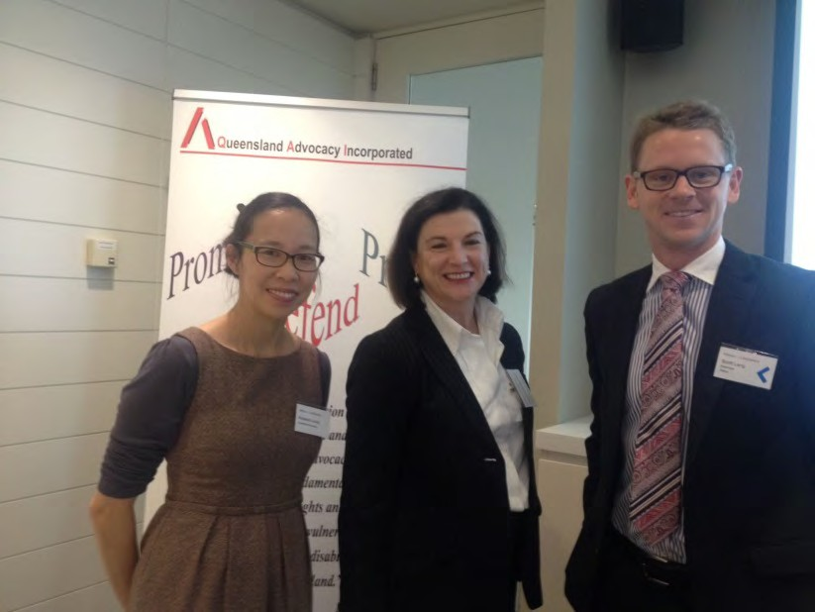

Rebekah with Justice Ann Lyons and Scott Lang from Allens at the launch of the Capacity Handbook

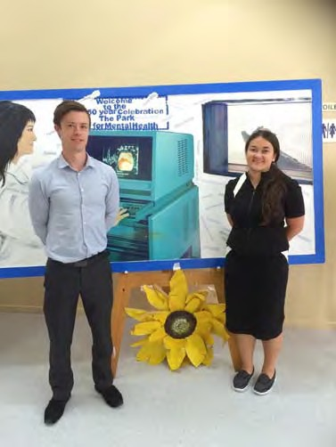
Tony and Julie at The Park Centre for Mental Health event for Mental Health Week 2015

Human Rights Legal Service

Background
The Human Rights Legal Service (HRLS) was established in 2008 and implements a framework promoting the four key principles of human rights, namely freedom, respect, equality and dignity. The service also endorses the rights as set out in the Convention on the Rights of Persons with Disabilities (CRPD).

The function of the HRLS is to promote and protect the fundamental human rights of people with disability in Queensland, in particular;
- The right to life, liberty and security
- Freedom from torture or cruel, inhuman treatment or punishment; and
- The right to equality before the law and equal protection of the law

The HRLS lawyer achieves this by providing specialist legal advice, representation or referral when these rights are threatened or disregarded.

The work of the HRLS encompasses the following areas;
- Restrictive practices including the use of seclusion, containment and chemical, mechanical and/or physical restraint;
- Guardianship and Administration;
- Forensic Orders and Forensic Orders – Disability;
- Health care and life sustaining measures;
- Funding and/or support issues; and
- Abuse/neglect and serious injury of people with disabilities.

Staffing
The HRLS is funded for 1 full time solicitor who is supervised by a part time principal solicitor and also supported by administrative staff.

Funding
From 1 July 2014 the funding process for HRLS has changed. Prior to this date funding was recurrent through the Community Legal Service Program (CLSP). Under the new Legal Practioner Interest on Trust Accounts Fund (LPITAF) funding arrangements funding has been secured until June 2017.

We also received pecuniary support from the University of Queensland for operating the Disability Law Clinic (DLC).

HRLS Operation in 2014-2015
The HRLS continues to use the same operational strategy as in previous years, this being to provide legal advice and casework on a range of matters as well as to provide representation in guardianship, restrictive practices, Forensic Orders and Forensic Order – Disability matters.

Casework
Casework is where the HRLS lawyer provides ongoing assistance and/or acts on behalf of a client in respect of a matter. A matter consists of a single problem or a group of related problems, or a group of problems which may be unrelated, but are dealt with together. Casework can extend out over several months with hours of legal and non-legal work invested into the matter. Representation at a QCAT hearing is an example of a matter.

Throughout 2014-2015 the HRLS opened 21 cases.

Representation
HRLS provided representation at 7 Mental Health Review Tribunal (MHRT) hearings re forensic orders and forensic orders - disability. HRLS also provided legal representation at 10 Queensland Civil and Administrative Tribunal (QCAT) hearings in relation to guardianship, administration and restrictive practice matters. QCAT appointed David Manwaring as separate representative in 3 matters.

HRLS casework examples
Example 1

Capacity, serious life decisions, understanding substituted decision making.
QAI was approached by QCAT to be appointed as separate representative (SR) for an adult who was refusing to eat. The adult had multiple differential diagnosis including personality disorder, psychotic delusion, depression and eating disorder. The issue was the determination of the adult’s capacity to refuse to eat and hence what treatment would be provided. The treating team believed the adult had capacity to make this decision; however the adult’s family did not and attributed the decision not to eat to being mentally unwell. The adult continue to starve themselves, becoming more cognitively impaired, very weak and at risk of becoming comatosed. Family sought urgent invention resulting in QCAT appointing a SDM. However hospital refused to acknowledge SDM authority and continued to refuse admission until further intervention by QCAT. The adult was later placed on an ITO as hospital recognised she lacked capacity to consent to treatment or to make a decision to refuse to eat.
Example 2

Support for a Forensic Order – Disability Client.
Late 2014 the client transferred from one Hospital and Health Service (HHS) to another, so that he could be closer to his family supports. The new HHS was reluctant to take responsibility for the client. Disability Services, who had been significantly involved in the client’s care, had not taken up this role in his new area. As a result, much of the burden of looking after the client had fallen to his primary family support and he was at risk of losing his support workers and accommodation due to a variety of issues.

QAI supported the client at stakeholder meetings with Disability Services and Mental Health. We also advocated to the Director of Mental Health for the client to be formally transferred to the new HHS.

The client was eventually transferred to the new HHS. The new treating team took responsibility for the client and worked hard with Disability Services to ensure that he was quickly discharged from hospital acute care to appropriate accommodation with 24 hour support. Disability Services have also increased their role by providing accommodation, support workers, therapy and a risk assessment in the context of intellectual disability. As a result, the client is now properly cared for and his family carer is no longer at risk of burnout.

Example 3

Capacity, power of attorney, end of life decisions
QAI was approached by QCAT to be appointed as separate representative (SR) for an adult who was residing with her mother. The adult had diagnosis of borderline personality disorder and eating disorder. After a capacity assessment I determined that the adult had the capacity to instruct me – on further exploration and discussion a decision was made that I continue on as separate representative, as this provided a greater scope in which to present the issues and her case.

The adult had over the years caused self-inflicted injuries to herself to the extent that she required a feeding tube as food taken orally was not being absorbed properly, she would also remove the feeding tube regularly. She was reluctant to continue with the feeding tube, however at this time did not express a direct wish to die, but realised that that could/would be the likely outcome. Apparently further surgical intervention was not possible. The hospital had told this lady (23 years old) that there were only two options 1) she accept tube feeding or 2) she receive palliation. Although the hospital stated they were willing to continue with 1) they believed 2) was the better option.

The adult accepted the tube feeding – however the hospital felt she did not have capacity to consent to this and sought the appointment of a guardian for all health matters and a declaration that the adult did not have capacity. This application was made despite there being a valid ‘enduring power of attorney’ which nominated her mother as attorney for health decisions. The treating team did not understand this and held the belief that mum could not make decisions for her daughter in an attorney role or be appointed as her guardian. Throughout the primary concern for the adult was that her ‘decision making’ was being ignored and she feared the appointment of the OPG believing the guardian would request palliation which would eventually result in her death.

Outcome of the hearing: Application for appointment of guardian dismissed, declaration made that adult had capacity, the adults enduring power of attorney was held to be valid and therefore at those times where her capacity is impaired her mother is the decision maker.

Example 4

Individualised funding v’s block funding
HRLS provided assistance/support in securing an individual funding package for an adult where previously they received only block funding. Through strong advocacy funding was secured above normal benchmark criteria. The adult’s appointed guardian (parent) will now self-manage those funds under a ‘your life your choice’ style arrangement and is currently interviewing for support workers. Such an arrangement will provide comfort to the parents & the adult as there had been many issues with previous support services, including alleged abuse/neglect.

Telephone advices (non- casework)
Supervised by the HRLS lawyer the Telephone Legal Advice Service (TLAS) is operated by a volunteer lawyer from the Office of Public Advocate every second Thursday. Additionally law students from the Disability Law Clinic provide advices on Tuesday, again under the supervision of the HRLS lawyer. It is planned to extend TLAS to every Thursday once additional pro-bono assistance has been secured. The HRLS lawyer provides advices outside of these times depending on urgency of matter.

Telephone advice is not simply a dialogue delivering generic advice on the law, all advice provided by the HRLS/TLAS is specific to the person’s unique situation. Advice is defined as when the lawyer explains the law in relation to the client’s circumstances and helps them to select between options about their problem. Advice extends to assisting with the drafting of simple letters or documents, making phone calls on the client’s behalf and referral to other agencies.

During 2014-2015 the HRLS/TLAS provided legal advices to 56 clients. Areas of law covered were predominantly guardianship and administration, complaints about government processes/procedures (funding & accommodation), disability discrimination, restrictive practices and forensic orders. Other areas included tenancy, wills and power of attorneys. It is anticipated that the number of advices will increase in the next financial year when TLAS is at full operation.

Extra curricula activities
In addition to casework, the HRLS advocated more broadly for clients’ rights particularly those espoused in the CRPD. This included liaising with delegates of the Adult Guardian, QCAT & Department of Communities and non-government organisations. The HRLS lawyer also
- Provided CLE session to Health and Legal Clinic at St Vincent’s Hospital.
- Met with fellows from Cambodia (funded by DFAT)
- Met with Fiona Anderson & Ray Jeffery NDIA Brisbane
- Met with Terry Butler – Federal Minister
- Presentation to Law & Social Work Students – QPILCH Health Advocacy Legal Clinic
- Facilitated Public Guardian presentation to DLC students
- Facilitated FD Director presentation to DLC students
- Met with fellows from Tanzania, Ghana & Kenya
- Attended 53rd Session Convention Against Torture(CAT) Geneva
- Submission on Guardianship & Administration Amendment Bill
- Attendance at Restrictive Practices Implementation Working Group meetings Monthly meetings with Karen Nankervis Centre of Excellence
- Met with Geoff Rowe & Karen Williams (QADA) to discuss collaboration between QAI
and QADA
- Teleconference with PWDA re post UN CAT event
- Civil Law Training
- Met with Darryl Barrett – AHRC
- Presented two sessions at QAILS Annual Conference
- Met with Ian Wilson Director and Administrator, Forensic Disability Service.
- Meet with Liza Windle & Shannon Lowie (DJAG) to discuss QAI’s application to develop a set of Human Rights Indicators for Restrictive Practices.
- Attended a CRU NDIS briefing session.
- Met with Will Cocks - Investigation / Conciliation Officer at the AHRC.

Disability Law Clinic (University of Queensland)
The Disability Law Clinic (DLC) commenced operation on 30 July 2013 and is run during each university semester (13 weeks) . DLC is in partnership with University of Queensland Pro Bono Centre as part of their Clinical Legal Education Program. Students are supervised by the HRLS lawyer.

Eleven (11) students have completed this clinic to date. Feedback from UQ Coordinator (Monica Taylor) and students has been positive.

QAI & HRLS would like to thank the following students for their contribution to DLC.

Semester 2 - 2014 | Semester 1- 2015
Hannah Baldry Alexander Meritt Whan Hee Cho | Alexander Goodwin Taylor Mobbs

Committee Membership
QAILS Human Rights Social Justice sub-committee
The HRLS Lawyer continues to be an active member of this sub-committee. The work of QAI is also promoted through this forum.

Queensland Law Society Health and Disability Committee
The HRLS Lawyer has been a member of this committee since its inauguration on 28.05.2014. The committee provides a forum for legal, medical and health professionals and the government to raise, identify, debate and resolve issues in disability and health law.

Pro bono assistance
HRLS would like to thank the involvement of the following Counsel:

Karen Williams - Ms Williams provides significant and ongoing support and advice to HRLS in the carriage of matters.

QAI thanks the Office Public Advocate in providing volunteer lawyers for TLAS.

We also thank Victoria Taylor-Philip who volunteered with HRLS for a period of 13 weeks from Feb-Jun, attending 1 day per week.

David Manwaring
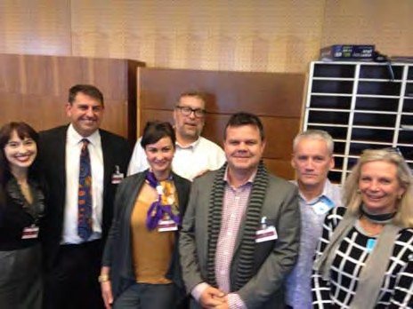
08 October 2015

Michelle and David with the Geneva delegation

Justice Support Program

About Us
The Justice Support Program (JSP) was established in response to QAI’s report “Disabled Justice: The barriers to justice for persons with disability in Queensland” (2007), which highlighted the overrepresentation of people with disability in the criminal justice system and made recommendations for reform.

Today, the Justice Support Program provides non-legal advocacy for vulnerable people with impaired capacity who have been charged with a criminal offence, by identifying their legal and social issues, linking them with appropriate legal and support services, helping them to achieve a fair outcome from the Court and prevent any further entrenchment into the criminal justice system.

Advice and casework
JSP provided 54 non-legal advices and minor assistance and opened 35 cases in the 2014-15 financial year. Charges range from minor wilful damage and public nuisance to serious sexual and physical assault. Since commencement in September 2009, JSP has assisted 365 people and to our knowledge only 3 clients have re-offended.

JSP clients are people with psychiatric illness, intellectual disability or acquired brain injury. We always encourage our clients to participate in any discussions or planning however we frequently have to work with our clients’ family, friends, guardians, carers or support workers because of our clients’ limited capacity to understand the complex issues that need to be resolved, and their dependence on the other person to provide day to day support and information, e.g. budgeting, transport, personal history, etc..

Many clients find out about the service through the brochures which are available throughout court registries and police stations in the greater Brisbane area. Other clients are referred through internet searches, community organisations and Legal Aid Queensland.

Scope of work and case studies
Emma Phillips and I successfully applied for a $20,000 grant from the Legal Aid Queensland (LAQ) Community Legal Education Collaboration Fund to create, publish and distribute an illustrated booklet which describes in simple terms what to do if the police want to question or arrest you in relation to an offence. The message will apply to all suspects or defendants in Queensland but the booklet will be designed specifically to help a person with intellectual impairment understand their and the police’ rights and obligations in relation to the criminal investigation, arrest and prosecution process.

Ideally the booklet would be part of the library of every place where a person with intellectual disability (ID) resides, works, learns or otherwise accesses.

My experience is that often the parent/sibling/support person (carer) of people with ID have had little or no contact with the police and the criminal justice system. Sadly I find that the suspect with ID has actually been encouraged by his/her carer to “own up to the offence” or “help the policeman and answer the question”.

Rebekah Leong and I had previously met with Linda Richards and Katherine Gorter from LAQ Community Legal Education Unit and they were very enthusiastic and supportive of the project when they received our application.

JSP advocates prefer to advise or assist the client directly or jointly in the company of their parent, support worker or friend. Invariably the first contact with JSP is because the client has been charged, has to go to court and has no idea as to what to expect at court or how to get legal help. We explain in very broad terms the court process and provide detailed advice and instructions on how to access legal advice or representation and the importance of accessing the duty lawyer service at the court. We refer clients to community services and supports that will help to change the client’s behaviour that brought him or her to the attention of the police.

If the client lives outside the greater Brisbane area or has someone who is willing and able to support them through the process then we manage by providing advice over the phone. This is where the booklet will be invaluable, even though it will be designed to look more like a storybook and will use very simple language, the crucial legal information will be available to help the support person navigate their way through the criminal justice process and achieve a fair outcome for the person they care for.

If the client or his/her carer is not an effective advocate then we open a case and prepare to provide active support at court, making appointments and arranging ongoing community supports. Even if we are not able to meet our client face to face we can be very effective via phone and email.

All advices and cases vary when it comes to assessing the nature of the client’s impairment, the type of support he or she needs and how or where to access that support.

In one case, the JSP advocate noted an elderly and flustered woman who pleaded not guilty to charges of shoplifting. After being told by a court worker that she had refused to see the Duty Lawyer (DL), the JSP advocate approached the client who agreed to see the DL once she realised it was a free service. It was revealed that the client had been diagnosed with depression and anxiety and had been frightened of what would happen if she confessed to the charges. The JSP advocate supported the client at the next mention by ensuring she accessed the DL and provided full instructions regarding the nature and extent of her disabilities. The DL assisted her to plead guilty, the Court sentenced her to 6 months GBO and no conviction was recorded.

Promotion of the service and networking
Attended:
- G20 Community Services Forum
- B E Lifestyles Forum
- WWILD Paperbag Lunch Seminar: Is it just behavioural? - People with Intellectual Disability and Effective Mental Health Management (Luke Hatzieptrou spoke about the complexities of identification, assessment and treatment of mental illness in people with intellectual disability, and the need for broader dissemination of specialist knowledge and training in this area).

Liaison to exchange information and strengthen referral pathways:
- Court Network Program Manager
- Court Diversion Program Manager (Drug Diversion and Queensland Courts Referral)
- The Magistrates Court Liaison Service for Queensland Mental Health (Mental Health Court Liaison Service)
- FOCAL (an Ipswich community support service which originated as the Friends of Challinor Aid League)
- Share Bayside
- FSG Australia
- House With No Steps

- Life Without Barriers
- Disability Services Queensland Specialist Services
- Office of the Director of Mental Health
- Legal Aid Queensland
- Director of Public Prosecutions Mental Health Chambers
- Auscript
- MHC Registry
- Queensland Police Service

Staffing
The JSP budget is enough to employ an advocate for the equivalent of 6 working days per week. Since it is not practical to try to recruit an adequately experienced and capable Advocate for 1 day a week, JSP and QAI’s Mental Health Legal Service combine resources and share a Paralegal/Advocate position.

In 2014-15 JSP was staffed by: Senior Advocate: Liz Francis
Paralegal Advocate: Tony McCarthy

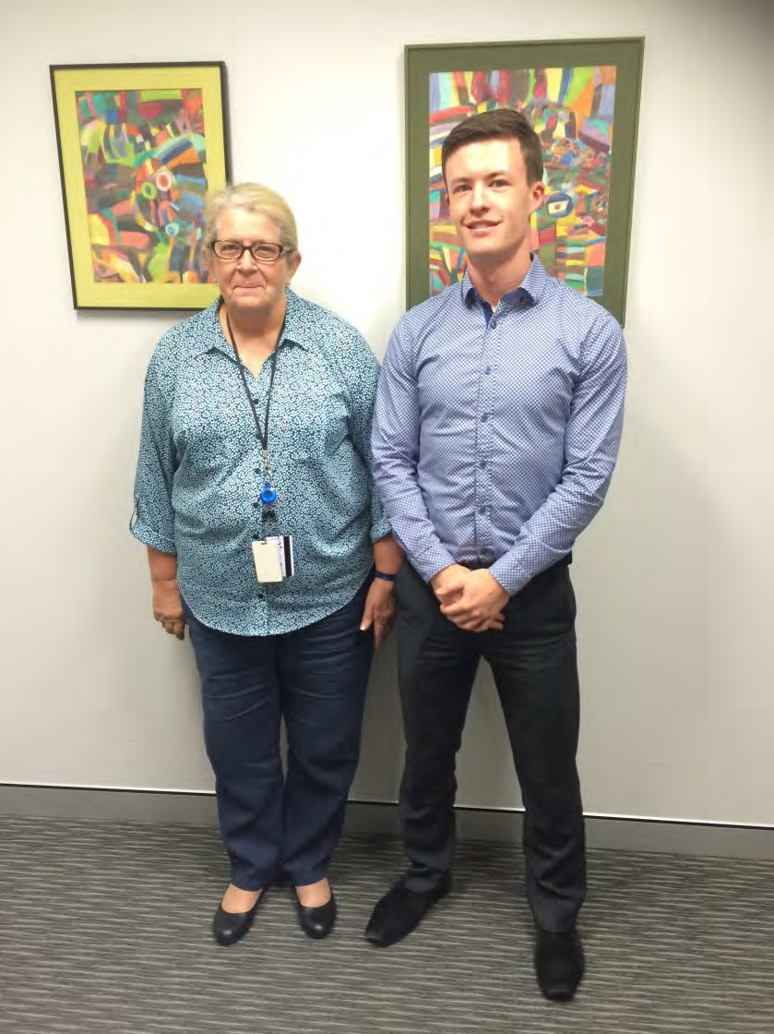

Liz Francis and Tony McCarthy

QUEENSLAND ADVOCACY INCORPORATED

FINANCIAL REPORT FOR THE YEAR ENDED 30 JUNE 2015

1.

QUEENSLAND ADVOCACY INCORPORATED INCOME AND EXPENDITURE STATEMENT FOR THE YEAR ENDED 30 JUNE 2015

INCOME |  | 2015 |  |  | 2014
Grant - Department of Social Services |  | 445,395.86 |  |  | 429,963.86
Grant - Dept of Justice & Altorney-General | 436,773.00 |  |  |  | 422,901.00
Unexpended Grant from Previous Year | 40,445.33 |  |  |  | 38,936.63
Less Unexpended Grant | (16,788.50) |  |  |  | (40,445.33)
 |  | 460,429.83 |  |  | 421,392.30
Legal Aid Queensland - CLEC | 20,000.00
Less Unexpended Grant | (20,000.00)
Grant - Dept of Justice & Attorney-General -SSAP |  |  |  |  | 50,000.00
University of Queensland - Disability Law Clinic |  | 6,000.00 |  |  | 6,000.00
Mental Health Review Tribunal |  | 28,155.80 |  |  | 33,320.30
Membership |  | 899.91 |  |  | 1,327.15
Donations |  | 2,999.00 |  |  | 17,206.93
Workshops, Functions and Events |  | 23,608.97 |  |  | 17,892.11
Paid Parental Leave |  | 3,887.99 |  |  | 7,465.20
Sundry Income |  | 7,177.78 |  |  | 1,739.73
Interest Received |  | 7,160.86 |  |  | 6,790.49
Investment Income |  | 1,366.21 |  |  | 2,814.99
 |  |  | 987,082.21 |  |  | 995,913.06
LESS EXPENDITURE
Total Expenditure (Schedule Attached) |  |  | 981,040.87 |  |  | 950,829.03
NET OPERATING SURPLUS/(DEFICIT) FOR THE YEAR |  |  | $6,041.34 |  |  | $45,084.03
Market Value Adjustment to Investment |  |  | (14.89) |  |  | 4807.96
NET SURPLUS[(DEFICIT) FOR THE YEAR |  |  | $6,026.45 |  |  | $49,891.99

2.
QUEENSLAND ADVOCACY INCORPORATED
INCOME AND EXPENDITURE STATEMENT
FOR THE YEAR ENDED 30 JUNE 2015
2015 |  | 2014
EXPENDITURE
Administration Expenses |  | 21,891.00
Audit & Accountancy 5,200.00 |  | 6,400.00
Bank Charges 715.60 |  | 610.44
Bookkeeping 94,588.31 |  | 80,477.80
Cleaning 2,400.00 |  | 2,400.00
Computer Supplies & Support 11,363.64 |  | 17,366.56
Consultancy 30,190.28 |  | 30,272.70
Depreciation 8,993.00 |  | 11,517.00
Donations 442.62 |  | 500.00
Electricity 5,577.04 |  | 6,166.08
Insurance 6,840.46 |  | 7,161.50
Interpreting Services 1,580.64 |  | 682.68
Management Committee Expenses 4,512.40 |  | 8,723.80
Minor Equipment 601.19 |  | 2,354.09
Occupancy Costs 86,743.53 |  | 83,398.91
Postage, Printing & Stationery 15,887.07 |  | 7,065.17
Repairs & Maintenance 514.00 |  | 1,776.78
Staff Amenities 1,037.06 |  | 2,386.40
Staff Training & Supervision 4,545.89 |  | 7,260.51
Subscriptions/Memberships 5,783.83 |  | 3,848.02
Sundry Expenses 996.48 |  | 3,234.54
Superannuation 52,926.42 |  | 49,106.28
Telephone 8,130.96 |  | 7,898.85
Travel Expenses 5,159.12 |  | 9,208.17
Wages & Salaries 599,978.39 |  | 546,834.85
Website Maintenance 664.36 |  | 408.72
Workers' Compensation 3,386.88 |  | 3,416.69
Workshops and Meetings 22,281.70 |  | 28,461.49
TOTAL EXPENDITURE $981,040.87 |  | $950,829.03

3.
QUEENSLAND ADVOCACY INCORPORATED
ASSETS AND LIABILITIES STATEMENT
AS AT 30 JUNE 2015
 |  | 2014
CURRENT ASSETS
Cash on Hand 300.00 |  | 300.00
Cash at Bank (Note 2) 354,864.54 |  | 327,823.92
Debtors & Prepayments 3,411.16 |  | 2,441.00
Deposits 19,805.00 |  | 19,805.00
378,380.70 |  | 350,369.92
FIXED ASSETS (Note 3) 27,258.00 |  | 36,251.00
INVESTMENT 55,473.06 |  | 54,121.74
461,111.76 |  | 440,742.66
CURRENT LIABILITIES
Creditors & Accruals 26,925.92 |  | 39,962.80
Provisions for Employee Entitlements 90,007.84 |  | 58,971.48
Grants Received & Unexpended 36,788.50 |  | 40,445.33
153,722.26 |  | 139,379.61
NET ASSETS $307,389.50 |  | $301,363.05
MEMBERS FUNDS
Balance 1 July 2014 301,363.05 |  | 251,471.06
Net Surplus/(deficit) for Year 6,026.45 |  | 49,891.99
TOTAL MEMBERS FUNDS $307,389.50 |  | $301,363.05

4.

QUEENSLAND ADVOCACY INCORPORATED SCHEDULE OF CASH FLOWS
FOR THE YEAR ENDED 30 JUNE 2015

CASH FLOWS FROM OPERATING ACTIVITIES | 2015 |  | 2014
Receipts
Investment Income | 7,735.18 |  | 13,562.08
Other Income | 72,536.29 |  | 48,272.64
Cash fiows from Government Grants | 902,168.86 |  | 942,185.16
Payments to Employees and Administation | (954,048.39) |  | (928,324.62)
Net cash provided by (used in) operating activities | $28,391.94 |  | $75,695.26
CASH FLOWS FROM INVESTING ACTIVITIES
Investment Units Purchased | (1,351.32) |  | (6,148.95)
Payment for purchase of plant & equip |  |  | (14,312.00)
Net cash provided by (used in) investing activities | $(1,351.32) |  | $(20,460.95)
CASH FLOWS FROM FINANCIAL ACTIVITIES
Net increase ( decrease) in cash held | 27,040.62 |  | 55,234.31
Cash at beginning of the reporting period | 328,123.92 |  | 272,889.61
Cash at end of the reporting period | $355,164.54 |  | $328,123.92
Reconciliation of Net Surplus/Deficit to Net Cash
Provided by (Used in) Operating Activities
Operating Result | 6,026.45 |  | 49,891.99
Plus Depreciation | 8,993.00 |  | 11,517.00
- (Increase)/Decrease in Receivables | (970.16) |  | 1,790.16
- Increase/(Decrease) in Payables | (13,036.88) |  | 19,116.23
- Increase/(Decrease) in Provisions | 31,036.36 |  | (8,128.82)
- Increase/(Decrease) in Grants Unexpended | (3,656.83) |  | 1,508.70
Net cash provided by (used in) operating activities | $28,391.94 |  | $75,695.26

The accompanying notes form part of these financial statements.

5.

QUEENSLAND ADVOCACY INCORPORATED
NOTES TO AND FORMING PART OF THE FINANCIAL STATEMENTS FOR THE YEAR ENDED 30 JUNE 2015

- STATEMENT OF SIGNIFICANT ACCOUNTING POLICIES

This financial report is a special purpose financial report prepared in order to satisfy the financial reporting requirement of the Corporations Act 2001. The committee has determined that the association is not a reporting entity.

The report is also prepared on an accruals basis and is based on historical costs and does not take into account changing money values or, except where specifically stated, current valuations of non-current assets.

The following significant accounting policies, which are consistent with the previous period unless otherwise stated, have been adopted in the preparation of this financial report.

  - Fixed Assets - Depreciation

Depreciation is charged on all Fixed Assets on the prime cost method and is brought to account over the estimated economic lives of all Assets.

  - Employee Entitlements

Liabilities for Wages & Salaries and Annual Leave are recognised and are measured as the amount unpaid at the reporting date at current pay rates in respect of employees' services up to that date. Other employee entitlements payable later than one year have been measured at the present value of the estimated future cash outflows to be made for those entitlements.

Contributions are made by the association to an employee superannuation fund and are charges as expenses when incurred.

  - ) Comparative Figures

Comparative figures, where necessary, have been reclassified in order to comply with the presentation adopted in the figures reported for the current financial year.

  - Economic Dependence

Queensland Advocacy Incorporated is dependant on government funding to operate. As at the date of the report the committee has no reason to believe the government will not continue
to support the organisation.

6.

QUEENSLAND ADVOCACY INCORPORATED
NOTES TO AND FORMING PART OF THE FINANCIAL STATEMENTS FOR THE YEAR ENDED 30 JUNE 2015

2015 2014

- CASH AT BANK

QAI Cheque Account | 286,575.66 | 262,839.44
QAI Gi Fund | 68,288.88 | 64,984.48
 | $354,864.54 | $327,823.92
3. FIXED ASSETS
Furniture & Equipment - Cost | 105,031.00 | 105,031.00
Less Accumulated Depreciation | 77,773.00 | 68,780.00
 | $27,258.00 | $36,251.00
4. AUDITOR'S REMUNERATION

Apart from the remuneration disclosed the auditors received no other benefits.

7.

QUEENSLAND ADVOCACY INCORPORATED STATEMENT BY MEMBERS OF THE COMMITTEE

The committee has determined that the association is not a reporting entity and that this special purpose financial report should be prepared in accordance with the accounting policies outlined in Note 1 to the financial statements.

In the opinion of the committee the financial report as set out on pages 1 to 11:

- Presents a true and fair view of the financial position of Queensland Advocacy Incorporated as at 30 June 2015 and its performance for the year ended of that date.

- At the date of this statement, there are reasonable grounds to believe that Queensland Advocacy Incorporated will be able to pay its debts as and when they fall due.

This statement is made in accordance with a resolution of the Committee and is signed for and on behalf of the Committee by:



Treasurer _ _,Cf\ ,_->..:;c:;..;-., =-=:t;:1-c'.':::::'."'.=---------

Dated this 14th day of October 2015

TtLt:PllON[: (07J 3357 832:2

!-!ARTERED CCOUNTANTS

8.

INDEPENDENT AUDITOR'S REPORT TO THE MEMBERS OF

QUEENSLAND ADVOCACY INCORPORATED

Report on the Financial Report

We have audited the accompanying financial report, being a special purpose financial report, of Queensland Advocacy Incorporated which comprises the assets and liabilities statement as at 30 June 2015, and the income and expenditure statement, a summary of significant accounting policies, other explanatory notes and the statement by members of the committee.

Committee's Responsibility for the Financial Report
The committee of the association is responsible for the preparation and fair presentation of the financial report and has determined that the accounting policies described in Note 1 to the financial statements, which form part of the financial report, are consistent with the financial reporting requirements of the Associations Incorporation Act (Qld) and are appropriate to meet the needs of the members. The committee's responsibilities also include such internal control as the committee determines is necessary to enable the preparation and fair presentation of the financial report that is free from material misstatement, whether due to fraud or error.

Auditor's Responsibility

Our responsibility is to express an opinion on the financial report based on our audit. No opinion is expressed as to whether the accounting policies used, as described in Note 1, are appropriate to meet the needs of the members. We conducted our audit in accordance with Australian Auditing Standards. These Auditing Standards require that we comply with relevant ethical requirements relating to audit engagements and plan and perform the audit to obtain reasonable assurance whether the financial report is free from material misstatement.

An audit involves performing procedures to obtain audit evidence about the amounts and disclosures in the financial report. The procedures selected depend on the auditor's judgment, including the assessment of the risks of material misstatement of the financial report, whether due to fraud or error. In making those risk assessments, the auditor considers internal control relevant to the entity's preparation and fair presentation of the financial report in order to design audit procedures that are appropriate in the circumstances, but not for the purpose of expressing an opinion on the effectiveness of the entity's internal control. An audit also includes evaluating the appropriateness of accounting policies used and the reasonableness of accounting estimates made by the committee, as well as evaluating the overall presentation of the financial report.

9.

We believe that the audit evidence we have obtained is sufficient and appropriate to provide a basis for our audit opinion.

Opinion

In our opinion, the financial report of Queensland Advocacy Incorporated presents fairly, in all material respects the financial position of Queensland Advocacy Incorporated as of 30 June 2015 and of its financial performance for the year then ended in accordance with the accounting policies described in Note 1 to the financial statements, and the requirements of the Associations Incorporation ACT (QLD).

Basis of Accounting and Restriction on Distribution

Without modifying our opinion, we draw attention to Note 1 to the Financial Statements, which describe the basis of Accounting. The Financial Report has been prepared to assist Queensland Advocacy Incorporated to meet the requirements of the Associations Incorporation Act (Qld). As a result, the Financial Report may not be suitable for another purpose.


HAYWARDS ACCOUNTANTS


14 OCTOBER 2015 BRISBANE

10.

QUEENSLAND ADVOCACY INCORPORATED SUPPLEMENTARY INCOME AND EXPENDITURE STATEMENT FOR THE YEAR ENDED 30 JUNE 2015

DEPARTMENT OF SOCIAL SERVICES

INCOME | 2015 |  | 2014
Grant - Department of Social Services | 440,395.86 |  | 429,963.86
Sundry Income |  |  | 1,373.64
 | 440,395.86 |  | 431,337.50
LESS EXPENDITURE
Total Expenditure (Schedule Attached) | 448,955.12 |  | 417,025.50
NET SURPLUS/(DEFICIT} FOR THE YEAR | $(8,559.26) |  | $14,312.00

11.

QUEENSLAND ADVOCACY INCORPORATED SUPPLEMENTARY INCOME AND EXPENDITURE STATEMENT FOR THE YEAR ENDED 30 JUNE 2015

DEPARTMENT OF SOCIAL SERVICES
2015 2014

EXPENDITURE
Audit & Accountancy | 2,594.80 |  | 3,406.00
Bank Charges | 571.94 |  | 610.44
Bookkeeping | 57,580.86 |  | 45,871.80
Cleaning | 1,197.60 |  | 1,202.40
Computer Supplies & Support | 5,670.45 |  | 11,589.41
Consultancy | 7,704.50 |  | 909.09
Depreciation | 8,993.00 |  | 11,517.00
Electricity | 2,813.04 |  | 3,311.03
Insurance | 3,465.05 |  | 4,501.82
Management Committee Expenses | 4,512.40 |  | 8,723.80
Minor Equipment | 541.19 |  | 1,509.09
Occupancy Costs | 49,297.76 |  | 48,850.58
Postage, Printing & Stationery | 8,182.88 |  | 3,726.39
Repairs & Maintenance | 256.48 |  | 890.17
Staff Amenities | 550.82 |  | 1,142.28
Staff Training & Supervision | 3,541.68 |  | 2,545.27
Subscriptions/Memberships | 1,628.03 |  | 1,417.46
Sundry Expenses | 585.94 |  | 3,234.54
Superannuation | 22,474.16 |  | 20,683.12
Telephone | 3,863.62 |  | 4,032.79
Travel Expenses | 2,390.44 |  | 2,576.59
Wages & Salaries | 258,319.67 |  | 218,660.67
Website Maintenance | 356.02 |  | 294.60
Workers' Compensation | 1,690.06 |  | 1,711.77
Workshops and Meetings | 172.73 |  | 14,107.39
TOTAL EXPENDITURE | $448,955.12 |  | $417,025.50

12.
QUEENSLAND ADVOCACY INCORPORATED
SUPPLEMENTARY INCOME AND EXPENDITURE STATEMENT
FOR THE YEAR ENDED 30 JUNE 2015
LEGAL AID FUNDING
 | 2014
INCOME
Grant Received - Department of Justice and Attorney-General 436,773.00 | 422,901.00
Unexpended Grant from Previous Year 40,445.33 | 38,936.63
Less Unexpended (16,788.50) | (40,445.33)
Disability Law Clinic 6,000.00 | 6,000.00
Mental Health Review Tribunal 28,155.80 | 33,320.30
494,585.63 | 460,712.60
EXPENDITURE
Audit & Accountancy 2,605.20 | 2,994.00
Bookkeeping 32,007.45 | 34,606.00
Bank Charges 135.33
Computer Supplies & Support 5,693.19 | 5,777.15
Consultants 22,485.78 | 28,7SS.61
Electricity 2,764.00 | 2,855.05
Insurance 3,375.41 | 2,6S9.68
Interpreting Service 626.09 | 682.68
Meeting Expenses 415.54 | 211.22
Minor Equipment 60.00 | 845.00
Occupancy Costs 37,445.77 | 34,548.33
Office Cleaning 1,202.40 | 1,197.60
Office Overheads 3,058.51 | 3,127.56
Repairs & Maintenance 257.52 | 886.61
Staff Amenities 486.24 | 1,244.12
Staff Training & Supervision 1,004.21 | 4,715.24
Subscriptions/Memberships 4,117.62 | 2,430.56
Superannuation 30,452.26 | 26,447.89
Telephone 4,267.34 | 3,866.06
Travel Expenses 1,842.33 | 1,176.89
Wages & Salaries 337,770.73 | 299,561.78
Website Maintenance 308.34 | 114.12
Work Cover 1,696.82 | 1,704.92
Workshops and Meetings 507.55 | 304.53
TOTAL EXPENDITURE 494,585.63 | 460,712.60
NET SURPLUSl(DEFICIT) FOR THE YEAR $ NIL | $ NIL

13.

QUEENSLAND ADVOCACY INCORPORATED SUPPLEMENTARY INCOME AND EXPENDITURE STATEMENT FOR THE YEAR ENDED 30 JUNE 2015

LEGAL AID FUNDING

INCOME | 2015 |  | 2014
Grant Received - Legal Aid Queensland - CLEC | 20,000.00
Less Unexpended | (20,000.00)
EXPENDITURE
NET SURPLUS/(DEFICIT) FOR THE YEAR | $ NIL |  | $ NIL

Queensland Advocacy Incorporated
2nd Floor, South Central
43 Peel Street (Cnr Merivale Street) BRISBANE QLD 4101

Phone 07 3844 4200
1300 130 582
Fax 07 3844 4220
Email qai@qai.org.au Internet www.qai.org.au

