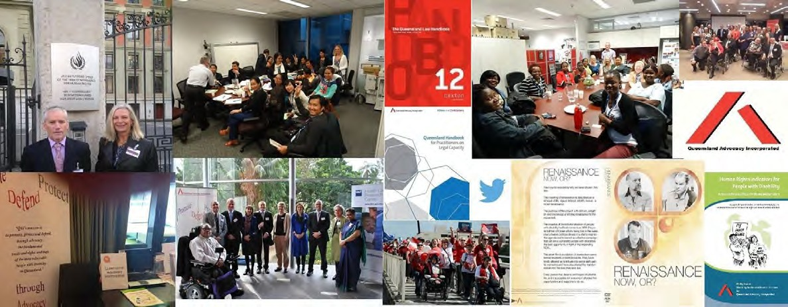

Queensland Advocacy Incorporated 2015-16 Annual Report

Julie and Tony at a Mental Health Week event

Staff at a team building event at Cork and Chroma

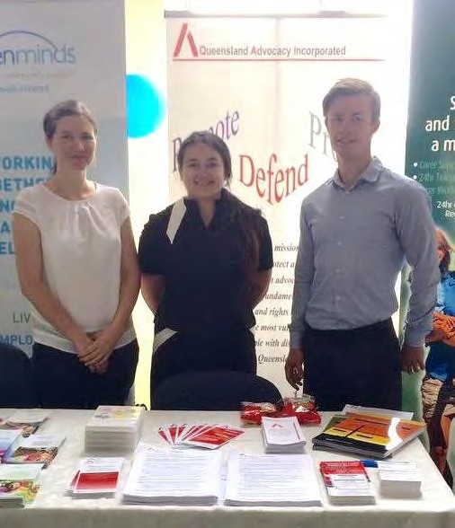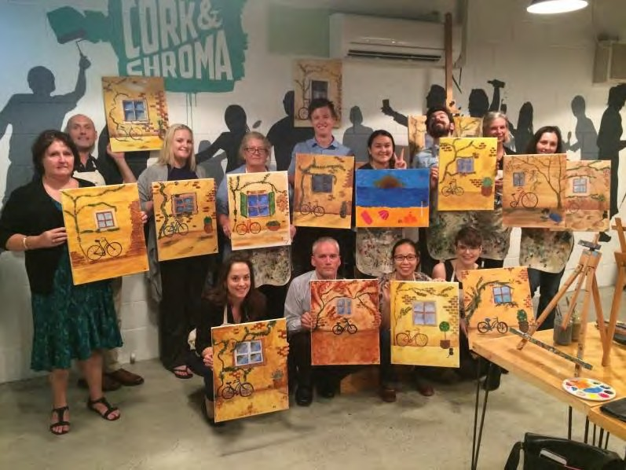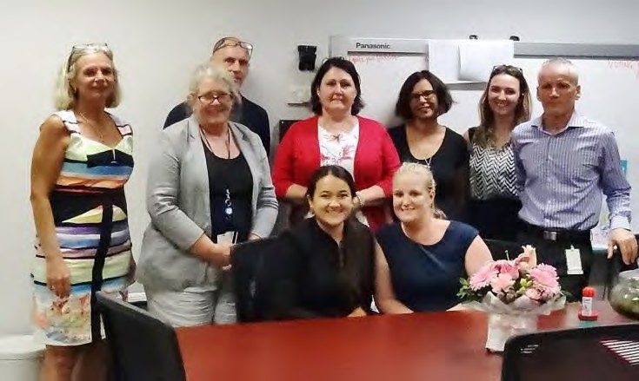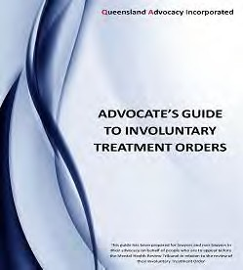

Staff members of QAI QAI’s publication: Advocate’s Guide to
Involuntary Treatment Orders

Queensland Advocacy Incorporated
2nd Floor, South Central
43 Peel Street (Cnr Merivale Street) BRISBANE QLD 4101

Phone 07 3844 4200
1300 130 582
Fax 07 3844 4220
qai@qai.org.au www.qai.org.au

Contents, Management Committee & Staff
Introduction 1
President’s Report 4
Treasurer’s Report 6
Director’s Report 7
Systems Advocacy – Emma Phillips 14
Systems Advocacy – Nick Collyer 21
Principal Solicitor 24
Mental Health Legal Service 26
Human Rights Legal Service 30
Justice Support Program 34
Audited Financial Reports 35

Management Committee

President Byron Albury
QAI hours of Operation:

Monday to Friday 9am -5pm
Vice President Fiona Kennedy
Treasurer Meriel Stanger
Secretary Nicole Nolan (until March 2016)
Secretary Donna Best
Committee Member Trevor Boone
Committee Member Michael Duggan
Committee Member Niki Edwards

Staff

Director Michelle O’Flynn
Systems Advocate Emma Phillips
Systems Advocate Nick Collyer
Advocate Elizabeth Francis
Principal Solicitor Rebekah Leong (until October 2015)
Principal Solicitor David Manwaring
Mental Health Lawyer Tony McCarthy
Mental Health Lawyer Neha Vaidyanathan
Human Rights Lawyer David Manwaring
Office/Finance Manager Deborah Bryzak
Administration Assistant Karlie Harris (until July 2016)
Administration Assistant Shelly Samios
Administration Assistant Rebecca Howes

QAI Annual Report 2015-16 Contents

Introduction

Queensland Advocacy Incorporated (QAI) is an independent community based systems and individual advocacy organisation for people with disability in Queensland. QAI advocates for the fundamental needs, rights and lives and protection of the most vulnerable people with disability in Queensland. QAI does this by engaging in systems advocacy work - through campaigns directed to attitudinal, law and policy change. QAI also provides limited individual legal and non-legal advocacy for vulnerable people with disability through three discrete projects. These are:

The Justice Support Program (JSP)
The JSP advocates for individuals with a disability in the Justice and related systems. The Advocate’s role is to marshal legal and community support services to provide the person with the best possible opportunity to remain in the community and to prevent them from re- offending.

The Mental Health Legal Service (MHLS)
The MHLS is a specialist legal service dedicated to providing legal advice and representation to individuals receiving involuntary treatment for mental illness in Queensland.

The Human Rights Legal Service (HRLS)
The HRLS provides specialist legal advice and conducts strategic casework aimed at protecting and promoting the fundamental human rights of vulnerable people with disability in Queensland. Once a week, the HRLS operates a specialist, telephone-based Legal Advice Service (LAS). The aim of the LAS is to increase the access of people with disability to the law.

The Department of Social Services funds QAI systemic advocacy. The Department of Justice and Attorney General through the Legal Practitioners’ Interest on Trust Accounts Fund (LPITAF) funds the Human Rights Legal Service (HRLS), the Mental Health Legal Service (MHLS) and the Justice Support Program (JSP). QAI has also received donations over the past year and continues to seek funding from philanthropic organisations and trusts for projects.

This Annual Report covers the period from 01 July 2015 to 30 June 2016. It describes in detail the efforts of QAI to be a strong and effective systems and individual advocacy organisation, committed to its mission of promoting, protecting and defending through advocacy, the fundamental needs and rights and lives of the most vulnerable people with disability in Queensland.

Mission
QAI’s mission is: “To promote, protect and defend, through advocacy, the fundamental needs and rights and lives of the most vulnerable people with disability in Queensland.”

Objectives
QAI’s objectives are:

- To affirm and put first people with disability in Queensland;
- To undertake systems advocacy that strives to promote, protect and defend the fundamental needs and rights and lives of the most vulnerable people with disability in Queensland;
- To undertake legal advocacy that strives to promote, protect and defend the fundamental needs and rights and lives of the most vulnerable people with disability in Queensland;
- To take an active leadership role in advocating for the fundamental needs and rights and lives of the most vulnerable people with disability in Queensland;
- To support, promote and protect the development of advocacy initiatives for the most vulnerable people with disability in Queensland;
- To be accountable to the most vulnerable people with disability in Queensland;
- To conduct an efficient and accountable organisation; and
- To adhere to and constantly reaffirm the following beliefs and principles:
  - All human life has intrinsic dignity and worth;
  - People with disability must positively and actively be accorded worth, dignity, meaning and purpose through being included in and with their community;
  - Social Advocacy is functioning (speaking, acting, writing) with minimum conflict of interest on behalf of the sincerely perceived interests of a person or group, in order to promote, protect and defend the welfare of, and justice for, either individuals or groups, in a fashion which strives to be emphatic and vigorous and is likely to be ‘costly’ to the actor in terms of:
    - Time or other resources;
    - Emotional stress;
    - Bodily demands;
    - Social opprobrium, rejection, ridicule;
    - Self-esteem, self-certainty;
    - Socio-economic security, livelihood; and
    - Physical safety, life
The essential elements of Social Advocacy are:
  - Strict partiality;
  - Minimal conflict of interest;
  - Emphasis on fundamental needs and issues;
  - Vigorous action;
  - Cost to the advocate;
  - Fidelity; and
  - Being mindful of the most vulnerable person.
Systems advocacy is a particular form of advocacy that focuses on influencing and changing ‘the system’, that is, the whole of society and the various systems operating within, in ways that will benefit people with disability as a group within society. Systems advocacy includes, but is not limited to, policy and law reform activities.

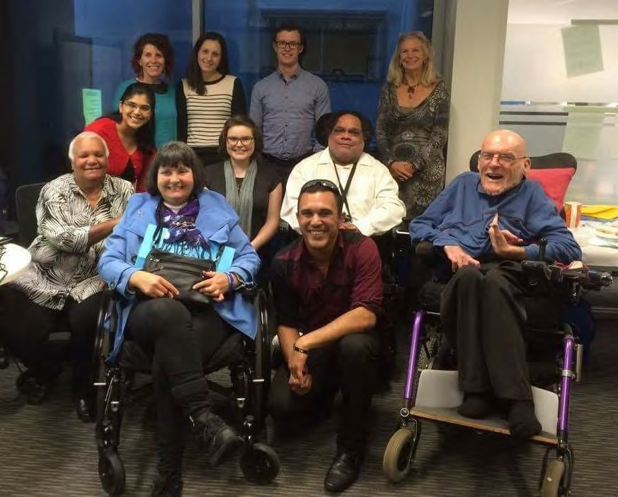

Byron, Mike, Meriel, and QAI staff members with Aunty Betty McGrady and Jade Carroll at Aboriginal and Torres Strait Islander Cultural Awareness Training.

President’s Report

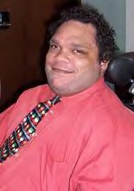
I would like to take this opportunity to welcome everybody to the 29th Annual Report of Queensland Advocacy Incorporated. It has been a delight to
serve as President of QAI for another year with my esteemed colleagues on the Management Committee. QAI has been immersed in a wide array of activities which both strategically and individually have promoted, protected and defended the needs, rights and lives of vulnerable people with disability.
I’d like to acknowledge the support and contribution of my colleagues, including Nicole Nolan who served as Secretary for a time before having to resign her position which has been commendably filled by Donna Best. For the next twelve months all of us have committed to serve again as the Management Committee as an effective team working with staff and the Director.
A quick overview of the big systemic issues that QAI has responded to or raised to the attention of the sector, have included all manner of NDIS related activities including the Act and the Queensland transition to NDIS.
Review of the National Disability Advocacy Framework and the National Disability Advocacy Program has had a major impact across the advocacy sector and QAI tendered a comprehensive submission and encouraged many of our partners to tender their own.
Senate Inquiries included violence, abuse and neglect against people with disability in institutional and residential settings, as well as the Indefinite Detention of people with disability.
Key areas of focus in the area of criminal justice include the forensic disability service, the Aboriginal Disability Justice Campaign and the revocation of the bill that would have withdrawn the Disability Support Pension from people incarcerated in forensic detention. The Coroner’s Inquest into the shooting death of a man with mental illness has spanned the past 12 months and continues as we speak. QAI’s involvement has been pivotal in potentially securing significant changes to police procedures.
The Campaign for a Human Rights Act Campaign has been a key activity for QAI with future projects being linked to this work. A conference on Human Rights is being planned with Griffith University in March in 2017. These are but a few of the systemic issues QAI has targeted this past year and include Employment, Child Protection, Crime and Corruption.
QAI also was fortunate to gain funding from the Australian Human Rights Commission to send David Manwaring to New York.as a delegate to the Conference of State Parties to the CRPD
Staff members are represented on boards of other organisations – David Manwaring is a board member of Community Legal Services Queensland and Michelle is a board member of Disability Advocacy Network Australia.
I’d like to commend and thank our hardworking staff members who are dedicated to enabling people with disability to live a good but ordinary life.

Byron Albury

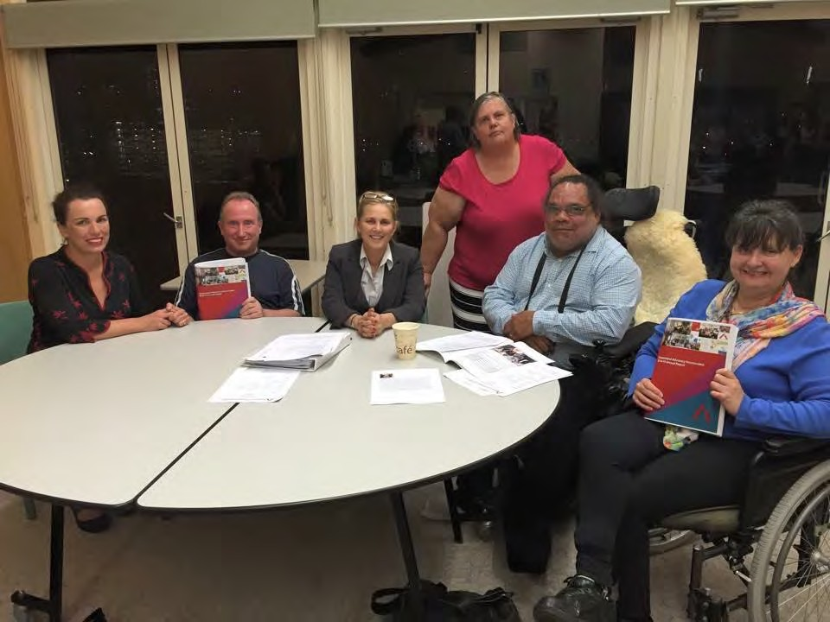

Meriel with fellow Management Committee members

Treasurer’s Report

It is with great pleasure to present QAI’s Financial Report for the year ending 30th June 2016. I would like to thank Hayward’s Chartered Accountants for the preparation of the Audited Financials and for their support throughout the year.
QAI’s work continues to rely heavily on its Annual Funding Agreement with the Department of Social Services (DSS) and Legal Aid. QAI has continued to review and update their financial policies and procedures and I am satisfied that QAI is well placed for the challenges ahead. It has been an interesting time adjusting to the changes within the disability sector and finding our place in the NDIS.
Deborah Bryzak is doing an excellent job of administrating the day to day financial obligations of QAI and I would like to take this opportunity to thank Deborah for all her assistance and guidance in enabling me to perform the role of Treasurer.
QAI has continuation of funding for various projects.

Department of Social Services | $451 314.16
Legal Aid Queensland | $449 330.00

Other Income

Disability Law Clinic | $4 000.00
DSS Conference of State Parties | $4 050.00
Mental Health Review Tribunal | $4 334.00
Memberships | $1 063.53
Donations (Acknowledged below) | $29 086.00
- Hudpac Pty Ltd | $7 500.00
- Minter Ellison | $1 632.00
- Human Rights Act for Queensland
FSG Australia | $5 000.00
The Aboriginal and Torres Strait Islander Legal Service (Qld) Ltd | $10 000.00
Micah Projects | $5 000.00

*Audited financial reports can be found at the end of the Annual Report. Kind regards,

Meriel Stanger

Director’s Report

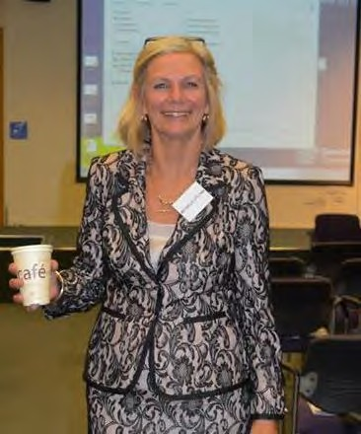
This year Queensland Advocacy’s Management Committee, members and staff collaborated to develop a new Strategic Plan to carry us forward over
the next three years.
While our key goals are somewhat perennial with systems changes often slower to come into effect, in reflecting on the previous plan, we reconsidered its breadth and the rapid changes occurring on a regular basis, it was agreed that a 3 year plan would allow QAI to be more responsive to opportunities as well as any potential new threats to vulnerable people with disability.
The review of the National Disability Advocacy Framework and the Independent Review of the NDIS Act were indicative of the rapidity and intensity of areas of focus for the organisation.

Human Resources
In this past year several staff changes occurred. Neha Vaidyanathan joined the ranks of the Mental Health Legal Service (MHLS) as part-time solicitor. Paulette Dupuy was employed part- time to support the work of the Human Rights Legal Service (HRLS) and MHLS by providing legal advice and limited assistance within the scope of those two services.
David Manwaring stepped into the role of Principal Solicitor while Rebekah Leong took maternity leave.
Julie Hearnden departed QAI for a new position in North Queensland.
In 2016 Paulette Dupuy’s employment contract finalised. We will miss her input and friendly conversations, and the support she provided to people with disability.
Karlie Harris tendered her resignation in June to move to another position to broaden her horizons and to work closer to home. All staff, Board and members and the people with whom we work will miss her, but wish her every success. Rebecca Howes has joined the admin team to fill some big shoes and her enthusiastic assistance is appreciated by all staff and especially her team member Shelly Samios. Both Shelly and Rebecca are supported and supervised by Office Manager Deborah Bryzak.
All QAI staff take opportunities for continuous professional development with training identified at annual reviews.

Volunteers/Student Placement
QAI is well supported by a team of volunteers and students in our legal services (The Principal Solicitor report will acknowledge all those who have participated this last year). However, we are fortunate and appreciative of Nick Lauer who has continued to give freely of his time and knowledge to the streamlining of our database and systems. Elise Nolan too has continued in her voluntary capacity with QAI and we all appreciate her contributions and collaboration on mutual interests.
Tian Jin (Larita King) our social worker student volunteer from QUT completed her 500 hour placement with QAI. We are grateful for her contribution and wish her every success for her future.
We were fortunate to have Leigh Jardine and Victoria Taylor-Philip as PLT students on placement with us for approximately 20 weeks.

Funding and Quality Assurance
Once again QAI maintains an exemplary standard of quality practice across the entire organisation. Our accreditation for the Department of Social Services and for the National Association of Community Legal Services is preeminent and we are proud of our endeavours for and with people with disability.
QAI has made significant contributions to affect change in the disability landscape and the partnerships and collaborations with other organisations and individuals are gaining ever increasing momentum and effect.
A summary of activities for the past year are outlined below. Some of the work of staff members is performed on an individual basis, but a great proportion of work is through collaboration and cooperation and at times partnerships.

Submissions

Policy and Inquiries
QAI appeared before the Senate Inquiry into violence, abuse and neglect against people with disability in institutional and residential settings (with Emma). We provided the Senate Committee with related submissions and papers in support of our verbal submission. From our summary “Abusive practices can become embedded if they are not immediately addressed. When subtle forms of abuse are viewed as harmless, more overt and serious issues are more likely to occur and be ignored. People who are systematically abused can normalise this behaviour and unwittingly perpetuate the abuse upon others. Other people who normalise abusive behaviour can become perpetual victims.”
Position Paper and Submission - As a follow up to the Griffith University Symposium and the Specialist Disability Accommodation consultation QAI’s paper “A Home Of One’s Own” was submitted to the Joint Standing Committee on the National Disability Insurance Scheme.

Legal/Law Reform
National Disability Advocacy Framework The main thrust of this submission was to protest the funding of advocacy from the same source that provides funding for “reasonable and necessary” supports to people with disability – the NDIS.
QAI’s tendered a submission to the Independent Review of the Operation of the National Disability Insurance Scheme Act 2013 (Commonwealth) to Earnst and Young for the Department of Social Services.
QAI’s submission to the Disability Services and Other Legislation Amendment Bill 2015 - The measures of Queensland’s interpretation of Transition to the National Disability Insurance Scheme raised concerns that were discussed at a Parliamentary Committee level although we were disappointed that action was not taken to address those concerns particularly as they related to deaths in care.
I tendered QAI’s comprehensive submission to the Department of Social Services review of the National Disability Advocacy Program.
This work was the culmination of consultation meetings with Board members, staff, people with disability, DANA executive, allies in advocacy and community legal sector, from March this year and is indicative of the cooperation and collaborative efforts made by QAI to promote, protect and defend the rights for people with disability to have a good but ordinary life.

Meetings, Consultations and Networking Opportunities

Office of the Information Commissioner
Office of the Minister for Transport – safety for passengers travelling on buses. Ben Lawson and Andrew Evans are two young men with physical impairment and who’s first

hand experiences of injuries sustained while travelling on buses in unsecured wheelchairs has been helpful to ensure accessible and safe public transport.
NACLC teleconference - to discuss the impact of the new NPA and funding issues on specialist disability CLCs. With the changes to funding arrangements NACLC wanted our feedback as to how this is affected our services.
Regular consultations with Department of Housing and Public Works for Housing Strategy External Reference Group meetings
Community Resource Unit and National Disability Services to discuss perceptions regarding the NDIS for people with disability and their families.
QAI continues to host regular CAGQ (Combined Advocacy Groups of Queensland)
teleconferences.
I participated in the forum hosted by ADCQ, Griffith University and QDN “Marginalised Queenslanders influencing public policy”
QAI staff met with the Advisor to the Office of the Hon. Jo-Ann Miller Police Minister to discuss a Disability Justice Plan, Police interaction and criminal justice system (corrections).
Staff members of QAI travelled to Arthur Gorrie and Wolston Correctional facilities for tour and information regarding supports and rehabilitation/opportunities for people with disabilities, mental health issues.
Following a series of letters written to authorities we met with the following: -
- Barry Thomas - from Mental Health Review Tribunal - regarding the recording of MHRT proceedings.
- Julia Duffy and Lindsay Irons - from the Public Guardian - unnecessary guardianship applications.
- John Allen Chief Psychiatrist following our letter to Dr Bill Kingswell in relation to Clinical Reports and their accuracy.
QAI meets with allied advocacy organisations on a regular basis to discuss issues relevant to the people they support, including Amparo Advocacy and how referral pathways can be most effective, and with SUFY to discuss updates from the DANA Advocacy Summit, concerns around people living in boarding houses and hostels, and also ways to progress a campaign against abuse of people with disability, and the apparent lack of concern from government.
QAI was an active participant and interested party to the Consultation on NDIA Specialist Disability Accommodation.
March 8th and 9th I attended the DANA Disability Advocacy Summit where presentations from the NDIA about the ILC Commissioning (Implementation) and DSS in regards to the Review of the National Disability Advocacy Program (NDAP) has serious implications for continued funding of advocacy and what was termed ‘advocacy-like’ activities.
I submitted two online surveys to the Department of Communities, Child Safety and Disability Services – Strategic Investment and Stakeholder Satisfaction.
As a Board member of DANA I provided feedback to the discussion paper on “Independence of Advocacy” to ensure that there was some separation of functions that were clearly not advocacy and to offer suggestions that better manage conflict of interest.
QAI was represented in the review of Queenslanders with Disability Network at the Mercy Centre at Wooloowin.
Commissioner for Mental Health Dr Lesley van Schoubroeck, consulted QAI regarding women who had been detained as children at Wolston Park and the statute of limitations of their complaints of abuse. This has developed into a campaign to redress the statute of limitations and is currently progressing.

Several staff members of QAI participated in a forum convened by Tamara Walsh, Associate Professor in Law, The University of Queensland, and speakers included
Magistrate David Fanning and Kerry Walker, Neighbourhood Justice Centre, Victoria; Inspector Corey Allen, Queensland Police Service Academy; Karyn Walsh, Micah Projects; Shane Duffy, Aboriginal and Torres Strait Islander Legal Service; Magistrate Anne Thacker, Queensland Magistrates Court; Debbie Kilroy, Sisters Inside; Scott McDougall, Caxton Legal Centre; Janet Wight, Youth Advocacy Centre. The discussion centred on Criminal justice partnerships: Setting an agenda for research and reform. QAI will be collaborating in the progression on a model or pilot project in future.
QAI staff met with Caroline Savage from GROW – a mental health peer support group to discuss advocacy training modules for peer supporters, the NDIS and ways of networking with the Mental Health and disability sector.
At the request of Basic Rights CLC, QAI staff and I met with Jenny Newton to discuss the External Merits Review process for appeals to the Administrative Appeals Tribunal about NDIA decisions, and how the landscape in the Townsville and North Queensland NDIS rollout was unfolding. QAI holds keen interest in provision of support for Internal Merits Review and representation for External Merits Review for people with complex support needs.
To ensure sector collaboration I met with Director of Community Legal Centres Queensland James Farrell, and Amanda Alford and Kirsty Mackie in person and teleconference meeting with several others from Victoria and New South Wales, in regard to a combined NACLC submission for the review of the National Disability Advocacy Program. The writer for the NACLC submission was subsequently linked with member organisations of CAGQ to gather case examples of how individual advocacy organisations and community legal centres collaborate to ensure access to justice for people with disability.

Partnerships and Collaborations
Disability Services Partnership Forum meets every 6 weeks and I attend them on a regular basis when possible.
As Director and Board member I continued to participate in DANA Management Committee
teleconference and face to face meetings.
QAI maintained our working relationship with the Office of the Public Advocate as participants in the Decision-making Support Advisory Group.
As part of a delegation of Community Legal Centres, QAI met (along with QPilch and CLCQ) with the Minister for Health Mr. Cameron Dick to discuss state and commonwealth funding to community legal centres.
QAI staff introduced Patrick McGee from the Aboriginal Disability Justice Campaign (QAI is a member organisation) in a meeting to Ian Wilson at the Forensic Disability Service Wacol.
This organisation is a member of a national collective of proponents for ratification of the Optional Protocol Convention Against Torture, informing the group of the work of QAI around the Human Rights Act for Queensland and our submission to the Senate Inquiry regarding the indefinite detention of people with disability.
Emma and I have participated in regular skype meetings with Miriam Taylor from Queensland Centre for Intellectual and Developmental Disability (QCIDD) in regard to the project - Challenging the Criminal Code (Section 216). This has developed into a collaborative effort for an event “Rights Denied” to be held later this year. From this we have enlisted support from Australian Lawyers for Human Rights President Benedict Coyne and planned to include this topic for a future event next year around the intersection of international human rights treaties and their impact upon people with disabilities.

QAI and Aged and Disability Advocacy Australia (ADA Australia) continue to partner in delivering training and information for people with disability, carers and health professionals about Guardianship and related directives.
As a supporter of worthy organisations QAI has offered letters of support and agreement to various initiatives or concerns including ANUHD’s Proposal for Change to the National Construction Code to provide accessibility in housing, written support to an open letter of recommendation for continued funding to Women’s Legal Service, and a letter of support to the Attorney General for the continuation of funding for WWIld to work with victims with disability who have a need for support to progress their complaints or matters through the court system.

Campaigns and Media
QAI is represented at the core subcommittee of the group driving the campaign for a Human Rights Act for Queensland. We have continued to collaborate with the Human Rights Act for Queensland alliance in promotion of this initiative via social media.
In January I spoke at length with Asena Basak from the SBS “Insight” program about the issues with the Section 2016 of the Criminal Code in Queensland regarding intimate relationships for people with disability. We discussed how people with related issues such as access to justice, support for decision making to exercise legal capacity and to exert authority and autonomy while ensuring that there are safeguards against breaches of human rights, abuse, neglect and victimisation. This program went to air in April 2016.

Publications/Promotions
At the request of Jocelyn Bosse, editor of the blog “Pandora’s Blog” for the UQ Justice & the Law society, I wrote the article “Citizenship, Rights and the Need for Legislative Reform in Australia’s Landscape for People with Disability”.
http://www.jatl.org/blog/2015/11/12/citizenship-rights-and-the-need-for-legislative-reform-in- australias-landscape-for-people-with-disability
QAI’s team in the Legal Service published the Advocates’ Guide to Involuntary Treatment

Orders Presentations/Events
In September 2015 QAI hosted the “Rights and Advocacy for ALL People with Disability Forum and Workshop” to begin Disability Action Week. Speakers included people with disability, advocates from around Queensland, and our special guest – Minister Coralee O’Rourke who spoke of the importance of advocacy and launched Disability Action Week.
This event was a free prelude to a series that we will conduct over the next twelve months, aimed at people with disability and their family members to raise awareness of the types of advocacy, what advocacy can achieve for them in the face of adversity, and to demonstrate

how individual and systems advocacy meld to change policies, laws, and practices that would otherwise adversely affect the lives of vulnerable people with disability.
Facilitators were appointed to each group to ensure that everyone was supported to be meaningfully engaged in the day's activities. QAI invited people with disability and or family members from across Queensland proactively including rural and remote regions and used a portion of the funding to ensure that people who might not otherwise be afforded opportunities to attend due to their location or heightened vulnerabilities were included.
Committee members and staff from QAI attended the event - The Right Way – A Dialogue about a Human Rights Act for Queensland, hosted by Caxton Legal Centre, chaired by Aimee McVeigh. The event was pertinent to people with disability and their supporters and allies, by the powerful and compelling video presentation by people with disability – George, Michelle, Chris and Wanita whose personal accounts brought home the message to every person in Parliament House that evening. This video presentation was facilitated and narrated in inimitable style by Benita Bierzynski from SUFY and QAI is very grateful to her, to SUFY and most of all to Wanita, Chris, George and Michelle.
QAI is a regular participant and presenter to QDN’s self-advocacy group Hot Topics with three events this year.
Not only do our individual advocates engage with the Community Legal Centre of Queensland but our systems team are regular contributors and collaborators on mutual interests with at least two events this year.
Department of Social Services contacted QAI to participate in and deliver a presentation for International Day of People with Disability. I delivered a power point presentation at their Brisbane office of Department of Social Services. This power point is the resource developed from the Rights and Advocacy for ALL People with Disability forum and workshop held during Disability Action week in September. This resource includes sound recordings of the voices of participants and is the first of two such developments.
At the Civil Society Conference in Melbourne “Reforming NDIS: Fulfilling the Promise to Revolutionise Disability Services” I delivered a power-point presentation “Choice and Control for Marginalised People – Supported Decision Making with People Living with Restrictive Practices”.
Event on 30th May - the QAI Part Two “Rights and Advocacy for All People with Disability” workshop was held at Trinity Place.
Beginning with a presentation of the Power-Point developed from the material that was created by participants at Part 1 Forum and Workshop, I presented the latest news from the NDIA about ILC, the role of the LAC, and the future of Advocacy. Later we pondered questions around the issues for advocacy and the information from the tables was included in the QAI submission for the Review of NDAP.
Part 2 Power-Point shall be combined with the first part and created as a dvd resource for people with disabilities, families and supporters and will also be presented to the NDIA and the Department of Social Services to demonstrate people with disabilities working with systems advocacy to inform policy reform.
Kelvin Grove QUT’s lecturers seek QAI’s expertise about advocacy on a regular basis and this year I delivered a presentation about QAI and advocacy to social worker students.
Further to this a 2 hour lecture to masters of social work was considerably more detailed than previous presentations, utilising the Action for Advocacy Development Network folder materials to delve into advocacy roles and conflicts of interest.

Client/Stakeholder Satisfaction
QAI receives thanks and positive feedback from clients of our individual advocacy services on a regular basis.
Positive feedback was received for presentations made at the QAILS conference, the Cairns forum on the Mental Health Act Review and our “Rights and Advocacy for ALL People with Disability” forum.
QAI also received commendation from people with disability for the resource developed at the Advocacy Forum and Workshop last September, with a request to share on a website which we were very pleased to agree to do.
We received thanks and positive feedback from a person with mental illness for our media release and letter to the Courier Mail about the stigmatisation by media of people with mental illness and disability.
QAI received a letter of commendation from the Treasurer regarding our input to the National Injury Insurance Scheme.
Attorney-General’s release of the “Willing to Work: National Inquiry into Employment Discrimination Against Older Australians and Australians with Disability Report” quoted QAI’s submission (by Emma Phillips).
‘Good student feedback’ via Niki Edwards for the Advocacy Lecture for Masters Students at QUT.
Positive feedback regarding the submission for a Human Rights Act for Queensland was received from allies and others.
Twelve individuals provided participant feedback for the Advocacy Workshop held in May with a high level of satisfaction, enjoyment, appreciation and support of the event.
Australian Lawyers for Human Rights not only have offered considerable positive feedback but also wrote a letter of support to DSS and Carolyn Wilkes about our collaborations: - “ALHR’s Disability Rights Subcommittee and QAI have been working together in this space over the past year on projects which aim to raise awareness and protect the human rights of people with disabilities in Australia…. ALHR understands that QAI’s current funding from the Department for Social Services is under review to determine whether it will continue beyond June 2017. Without such funding, QAI may not be able to continue to provide an important voice for people with disabilities through its advocacy services. This would be a great loss for many individuals and communities across Queensland and Australia that rely on the fruits of QAI’s excellent systems advocacy and advocacy services.”

Systems Advocacy – Emma Phillips

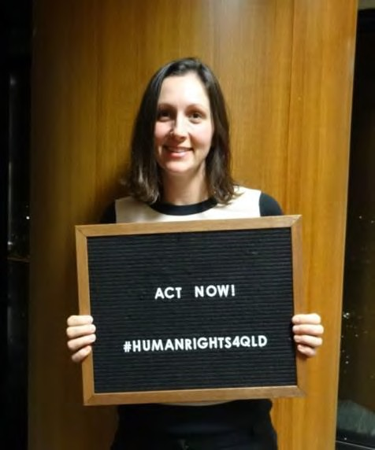
I have been working for QAI since June 2014, in the role of Systems Advocate (Research & Writing). I am presently working three days per week
(0.6% FT equivalent).
I feel very fortunate to be working in such a dynamic, important and interesting area and one where perspective I am advocating on for the issues I am involved in resonate strongly with my personal values. I am also fortunate to enjoy positive, supportive and productive working relationships with the other members of the systems team (Michelle O’Flynn, also QAI Director, and Nick Collyer), as well as other staff of QAI.

Submissions

Submission to Parliamentary Inquiry on indefinite detention
In April 2016, QAI made a submission to the inquiry on the
indefinite detention of people with cognitive and psychiatric impairment in Australia. This inquiry was conducted by the Senate Community Affairs References Committee. This was a very indepth submission that drew upon the work QAI has done in the areas of forensic disability, the interface between disability and the criminal justice system, indefinite detention of vulnerable people with disability and the use of Restrictive Practices on persons with disability. Following on from this submission, we were invited to appear before the Senate Committee (please see details, below).

National Disability Employment Framework Review
QAI made an extensive submission on the Review of the National Disability Employment Framework, conducted by the Department of Social Services. This submission covered issues including the workforce participation of people with disability in Australia; international obligations regarding work and employment, focusing on Article 27 of the Convention on the Rights of Persons with Disabilities and Article 23 of the Universal Declaration of Human Rights; the relevance of Australian disability discrimination law framework in the context of our international obligations; ways to improve employment outcomes for people with disability; ways to help reduce barriers to employment for people with disability and barriers for employers hiring people with disability; ways to promote the benefits of employing people with disability; principles for changes to Disability Employment Services; the efficacy of current employment services and programs for people with disability; Australian Disability Enterprises and improving the interface between ADEs and open employment opportunities for people with disability; support for employers of people with disability; the employment framework in the context of the introduction of the NDIS; the role of Personal Helpers and Mentors; and the life course and diversity and the relevance of a holistic approach. In November 2015, I participated in the second round of the national public consultation in Brisbane, conducted by DSS as part of the national review of the Disability Employment Framework.

Australian Human Rights Commission – Willing to Work Submission
The Willing to Work inquiry conducted by the Australian Human Rights Commission was an important inquiry and QAI made two submissions – one on behalf of QAI and one in collaboration with the Disability Rights Sub-Committee of Australian Lawyers for Human Rights. Our submissions focused on the relevance of the Convention on the Rights of Persons with Disabilities in understanding and complying with our obligations as regards employment and work for people with disabilities. Key issues included in the submission were the impact of employment discrimination on people with disability; the barriers people with disability face in accessing and maintaining employment; the practices, attitudes and

laws which discourage or prevent equal participation in employment of Australians with disability; the reasons why employers should increase their employment of persons with disability; the action that should be taken to address employment discrimination against Australians with disability; and proposed measures to enhance workforce participation by persons with disability.

Submission to the Parliamentary Crime and Corruption Commission
In November 2015, QAI made a submission to the review of the Crime and Corruption Commission conducted by the Parliamentary Crime and Corruption Committee (PCCC). This submission detailed QAI’s core concerns about the handling of allegations of misconduct and corruption in Queensland and proposed a series of reforms.

Human Rights Act Inquiry submission
In April 2016, QAI made a submission to the Legal Affairs and Community Safety Committee’s inquiry of whether it is appropriate and desirable to legislate for a Human Rights Act (HR Act) in Queensland. This submission received positive feedback from individuals and organisations, including being cross-referenced by Community Legal Centres Queensland, favourably commended by Caxton Legal Centre and cited in the Committee’s Report. The submission addressed the following issues: whether it is appropriate and desirable to legislate for a Human Rights Act (HR Act) in Queensland, other than through a constitutionally entrenched model; the effectiveness of current laws and mechanisms for protecting human rights in Queensland and possible improvements to these mechanisms; the operation and effectiveness of human rights legislation in Victoria, the Australian Capital Territory and by ordinary statute internationally; the costs and benefits of adopting a HR Act (including financial, legal, social and otherwise); previous and current reviews and inquiries (in Australia and internationally) on the issue of human rights legislation; the proposed objectives of the legislation and rights to be protected; how the legislation would apply to: the making of laws, courts and tribunals, public authorities and other entities; the implications of laws and decisions not being consistent with the legislation; the implications of the legislation for existing statutory complaints processes; and the functions and responsibilities under the legislation.

Review of the Child Protection Act
QAI made a submission to the review of the Child Protection Act 1999 (Qld) in February 2016. The core focus of this submission is on the way in which families which include a parent with a disability experience the court system. An issue of particular concern that has been raised by our services is the removal of children from parents with a mental illness or disability, which is an issue that is not addressed by the Act in its present form.

The Feasibility of, and Options for, Creating a National Long Service Standard, and the Portability of Long Service and Other Entitlements
In December 2015, QAI made a submission to the Senate Education and Employment Standing Committee inquiry into the feasibility of, and options for, creating a national long service standard and the portability of long service and other entitlements.

Reforming Employment Services and Developing Supports that Work for Jobseekers – Civil Society of Australia
I developed a series of proposals for reforming employment services and developing supports that work for people with disability. These proposals were circulated amongst the individuals and organisations registered to participate in this dialogue and resulted in an invitation to present at the Civil Society conference in Melbourne in April 2016 about these proposals.

Disability Employment Framework Review (DSS) – Round Two
Following on from our work preparing a submission and attending stakeholder consultations into the first round of the review of the Disability Employment Framework currently being conducted by DSS, we participated in a further national public consultation in November 2015. We also completed an in-depth survey that built on the results of the submissions

received as part of the first round of consultations, providing feedback on the proposed model developed by DSS.

Independent Review of the Operation of the National Disability Insurance Scheme Act 2013 (Commonwealth)
QAI made a submission to the Independent Review of the Operation of the National Disability Insurance Scheme Act 2014 (Commonwealth).

Submission to the ILC Consultation
On 22 April 2016, QAI made a submission to the ILC Consultation.

Drafting Issues for inclusion in the National Action Plan on Business & Human Rights (Disability and Employment)
In February 2016, QAI collaborated with Australian Lawyers for Human Rights in developing the framework of issues for inclusion in the National Action Plan on Business & Human Rights (Disability and Employment). This was an excellent collaborative opportunity for QAI and ALHR to further our productive working relationship. Issues identified included the concentration of people with disability in Australian Disability Enterprises (sheltered workshops); increasing employment of people with disability in the open labour market while ceasing to pay wage subsidies to businesses employing workers with disability; the lack of adequate real workplace experience for people with disability; barriers to access to the workplace faced by people with disability; and bureaucracy and red tape as barriers to entry to the labour market by people with disability.

Draft guidelines on the establishment of Independent Monitoring Frameworks and their participation in the work of the UN Committee on the Rights of Persons with Disabilities
On receipt of an invitation from the UN Committee on the Rights of Persons with Disabilities to be involved in this consultation, I prepared and submitted a draft comment on the Draft guidelines on the establishment of Independent Monitoring Frameworks and their participation in the work of the UN Committee on the Rights of Persons with Disabilities on 22 June 2016.

Senate Inquiries

Senate Community Affairs References Committee – Inquiry into violence, abuse and neglect of people with disability in residential and institutional settings
With Michelle O’Flynn, I appeared before the Senate Community Affairs References Committee on 16 October 2015. This was on invitation, following the detailed submission we had made on this issue. This was an excellent opportunity to inform the Senate of our concerns about the treatment of people with disability in these circumstances, including the application of Restrictive Practices as a form of government-sanctioned torture and the need for ratification of the OPCAT.

Senate Inquiry into indefinite detention
On 23 March 2016, I appeared before the Senate Community Affairs References committee’s public hearing on its inquiry into indefinite detention. This was an excellent opportunity to put forward QAI’s position regarding issues including forensic disability, the interface of disability and the criminal justice system, indefinite detention of vulnerable people with disability and the application of Restrictive Practices on people with disability. The Chair of the Committee, Rachel Siewert MP, noted that this inquiry was prompted, in significant part, by QAI’s submissions on the inquiry into violence, abuse and neglect of persons in institutional and residential settings.

Funding Applications

National Disability Conference Initiative 2016-17
QAI submitted a DSS Grants funding opportunity for the National Disability Conference Initiative 2016-17, submitted 27 April 2016. We have recently been advised that our

application was successful and we have been provided with $10,000 funding towards holding a forum on the intersection of international human rights treaties in March 2017.

Australian Human Rights Commission Funding to attend Conference of State Parties to the CRPD
QAI drafted an application for funding to send a delegate to participate in the Conference of State Parties to the Convention on the Rights of Persons with Disabilities, held in New York in June 2016. On 27 May 2016, we were notified that our application was successful and David Manwaring subsequently participated in the COSP in New York.

Funding Application – Human Rights Innovation Fund (Amnesty International Australia)
I prepared a submission for funding for the Human Rights Act for Queensland Campaign to the Human Rights Innovation Fund of Amnesty International Australia, submitted in November 2015. This funding is directed towards the development of resources and awareness-raising to ensure the community is properly consulted and informed of the benefits of a Human Rights Act for Queensland during the Parliamentary Inquiry into the introduction of a Human Rights Act for Queensland.

Expression of Interest for Australian Human Rights Commission funding to attend the Universal Period Review in Geneva
In collaboration with Australian Lawyers for Human Rights and the Aboriginal Disability Justice Campaign, we drafted an Expression of Interest for funding from the Australian Human Rights Commission to send a disability-specific NGO delegation to participate in the Universal Period Review of Australia’s human rights record in Geneva. This funding application was unfortunately unsuccessful. However, it was an excellent opportunity to strengthen connections with these organisations and with the Australian Human Rights Commission.

Research

Forensic Disability Service
I wrote a research paper and position statement on the Forensic Disability Service in Queensland. This paper discusses how the indefinite incarceration of persons with an intellectual or cognitive disability within the Forensic Disability Service Unit is a fundamental human rights concern. This is an issue that directly touches upon three core issues of vital importance from a human rights perspective: the inequitable and less favourable treatment of a person from a vulnerable, marginalised group; disregard for the presumption of innocence; and the deprivation of liberty for an indefinite period.

Research on the intersection of international human rights treaties
I have researched and written a research paper examining the intersection of international human rights treaties and conventions aimed at ensuring respect for the fundamental rights of all people with disability to participate in a full, inclusive life. Our focus in undertaking this research is driven, in part, by the desire to progress towards a federal Human Rights Act.
This paper addresses the following core themes: the scope and content of the key conventions; key areas of intersection and relevance for specific human rights concerns in Australia in the disabilities context, including torture (Restrictive Practices), indefinite detention, health and work; human rights that have been adopted in Australian law; key weaknesses in the human rights framework, including the limitation of rights, limited jurisprudence and difficulties translating rights into practice; areas where the CRPD stands alone; measuring impact; and recommendations, which include comprehensive legislative protection of human rights, the development of human rights indicators, implementation of all international conventions in Australian legislation and ensuring successful follow-up of UN recommendations.

Meetings (external) and events
- On 2 July 2015, I participated in a discussion evening organised by the Values in Action Association Inc at the Community Resource Unit. The discussion was led by Lorna Sullivan, who spoke of the need to consciously create space for Right Relationships to emerge, outlining six key aspects or factors needed to shift a service to ethical partnering.
- On 23 August 2015, I participated in an evening Disability Research Masterclass with Adjunct Professor Michael Kendrick: Activists as intellectuals—intellectuals as activists: Can researchers and activists work together to make a positive difference?
- On 12 September 2015, I participated in the QAI Strategic Planning day.
- I helped to organise and attended the QAI Advocacy Forum and Workshop on 14 September 2015. I also presented at this forum on the different strategies systems advocates can use to bring about change in an area, focusing on Restrictive Practices as an example.
- On 24 and 25 September 2015, I completed the two-day Social Roles Valorisation training course: Towards a better life: An exploration of the Social Role Valorisation framework with regard to people who are marginalised.
- On 23 October 2015, I presented a paper entitled ‘”Therapeutic rehabilitation” or indefinite warehousing? Shining light on a closed system through an examination of the forensic detention of persons with an intellectual or cognitive disability’ for the 8th International ACSO Conference: ‘Do Prisons Change Lives?’ in Melbourne. This paper considered the establishment and operation of the Forensic Disability Service and the disjuncture between the stated vision in establishing the FDS and the reality of its operation. This included consideration of the significant human rights breaches perpetrated on the residents of the FDS, who are all people with an intellectual or cognitive impairment who are alleged to have engaged in offending behaviour, and proposed reforms to address the grave human rights breaches currently perpetrated.
- I have attended meetings with members of Parliament, including Don Brown MP and Nikki Boyd MP as part of the campaign for the introduction of a Human Rights Act in Queensland.
- I attended tele-meetings and engaged in correspondence with staff of the Australian Human Rights Commission, as well as relevant staff of other peak disability organisations to facilitate QAI’s funding for and participation in the Australian NGO delegation before the 9th session of the COSP to the CRPD in New York.

Campaigns and Media

Human Rights Act for Queensland
I have worked intensively on the campaign for the introduction of a Human Rights Act in Queensland, in collaboration with the other member organisations of the Rights for Queenslanders Alliance. My work on this campaign has included:
- Attending sub-committee meetings and committee meetings
- Researching, drafting and settling legal, informative and media documents.
- Helping to organise the event: The Right Way: A Dialogue about a Human Rights Act for Queensland, which was held at Parliament House on 14 September 2015.
- Reviewing and critiquing relevant documents, including the terms of reference for the group and the campaign strategy
- Applying for pro bono assistance relating to the structure of the organisation.
- Presenting on this issue to the Advocacy Champions at Endeavour Foundation on 19 August 2015;

- Assisting the Anti-Discrimination Commission of Queensland at the public information sessions on a Human Rights Act for Queensland. This included appearing at sessions in Logan, the Gold Coast and Toowoomba in February 2016;
- Participating in briefings with broader groups, including an alliance of disability organisations who met to prepare a disability-specific agenda to present to Minister O’Rourke.
- Having a number of tele-meetings with DLA Piper, from whom we have successfully secured pro bono legal assistance. These meetings have predominantly been directed towards determining an appropriate structure for the campaign and making arrangements to implement this structure. We have worked to arrange for the drafting and execution of a Memorandum of Understanding to formalise arrangements for the auspicing of the Rights for Queenslanders Alliance within QAI.

Media releases
I have written media releases, including:
- In March 2016, I drafted a media release and accompanying letter to the Editor of the Courier Mail regarding the sensationalist media reporting of a teen with intellectual disability/mental illness who came into contact with the criminal justice system.
- We also released a media release ‘Queensland Advocacy Incorporated highlights the urgent need for human rights safeguards to stop the abuse of our most vulnerable’ following the incident at Don Dale.

Publications/Promotions/Networking
- I prepared and presented a paper at QAI’s Advocacy Forum and Workshop on 14 September 2015.
- I have been actively involved in the steering committee of the Rights for Queenslanders Alliance, including attending committee meetings and meetings with politicians.
- In collaboration with Dan Rogers I co-authored an article for the online journal ‘Right Now’ about the need for a Human Rights Act in Queensland, which incorporated specific examples of the way a Human Rights Act would help to protect vulnerable people with disability in Queensland.
- I organised the launch of the Human Rights Act for Queensland campaign, including the powerpoint presentation shown at the launch, held at Parliament House on 14 September 2015.
- I have continued to be actively involved as a member of the Disability Rights Sub- Committee of Australian Lawyers for Human Rights and participate in their committee meetings and research and law reform activities.
- I have participated in each of the team building days for QAI staff and in the QAI strategic planning day.
- I have also engaged in some preliminary discussions with the Disability Rights Subcommittee of ALHR regarding future collaborative work in the areas of housing and advocacy for people with disability.
- On 12 April 2016, I attended the event: ‘The Right Stuff? Do we need Human Rights Protections? at the Banco Court. It was organised as part of our campaign for a Human Rights Act for Queensland.
- On 22 April 2016, I attended a meeting with Michelle O’Flynn and Dr Lesley van Schoubroeck, Commissioner, Queensland Mental Health Commission, at the Queensland Mental Health Commission. The purpose of this meeting was to discuss claims made by women who had been incarcerated in Wolston Park regarding violent and abusive treatment. This was a productive meeting that is relevant to the ongoing work QAI is

involved in regarding the statute of limitation for abuse claims for victims of childhood sexual abuse.
- On 10 May 2016, I attended the ‘Seeking Justice Forum for adults who experienced sexual abuse as children in an institutional setting’, at Undumbi room, Parliament house, on removing the statute of limitations to make a claim where victim of child sexual abuse. I attended this event with Michelle O’Flynn and Tony McCarthy.
- On 18 April 2016, I attended the ILC face-to-face consultation at Brisbane City Hall. This was held as part of the consultation, which culminated in the tendering of written submissions.
- On 1 June 2016, I attended the CLC Queensland and NCLAC research partnerships roundtable. This was a very interesting and informative session and also an excellent networking opportunity.
- On 23 June 2016, I participated in the Community Legal Centres Queensland webinar: ‘Making an impact with social media and digital video’.
- On 27 June 2016, I attended a one-day workshop organised by Brain Injury Australia and the NHMRC Australian Centre of Research Excellence in Offender Health at the Kirby Institute, UNSW Australia in Randwick, Sydney. This was an excellent forum and I valued the opportunity to attend and actively contribute to this event. It was directly relevant to work QAI has done in the area.

Systems Advocacy – Nick Collyer

Key Performance Indicators
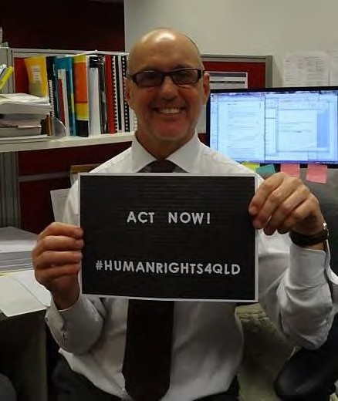
- Clarity of the rightful place of people with disability as citizens with all that citizenship involves
- Consistent use of positive imagery of and with people with disability
- Conceptual analysis in well-argued papers, reports and articles
- Clear planning and implementation strategies, keeping to time lines and any budget for campaign work
- Strategic thinking, argument and skill in lobbying in written material
- Supportive team relationships.

Campaigns
- Campaign to oppose the Social Services Amendment Bill 2015 (plan to cease payment of Disability Support Pension to people in psychiatric confinement)
- QAI + Aboriginal Disability Justice Campaign (QAI is an ADJC member) Campaign to get the NDIS Standing Committee to host a Roundtable on forensic disability. Ongoing. ADJC has approached Rachel Siewert and the Committee, which has agreed to host a Roundtable. I contributed to the briefing paper for the Committee, and the strategizing with Patrick (McGee). ADJC’s systemic plans at the Commonwealth level are for the moment on hold while we wait for the outcome of the Federal election. The return of Rachel Siewert (Greens WA) will be key to pressing this agenda: she is our best ally at the Federal level.
- ADJC Remote Access Project
- Campaign to defeat the Social Services Amendment Bill 2015 (plan to cease payment of Disability Support Pension to people in psychiatric confinement) began when MYFEO statement came out in early 2015. Ongoing – Commonwealth Government reintroduced this measure in the Omnibus Savings Bill 2016.
- National Advocacy Plan for Forensic Disability
- Aboriginal Disability Justice Campaign (ADJC) Working Group
- Accessible Public Transport/securing wheelchairs on city buses.

Media Releases
- 16 June 2016 - ‘People with Disability Call for Party-Political Commitment Beyond NDIS' (Federal election release)
- Immigration and people with disability (draft)
- 16 June 2016 - ‘Bouquets for State Budget but (show us the money) for Mental Health Act’

Project Work

Coronial Inquiry into Deaths by Police Shooting
Objectives:
- Systemic reform of policies and procedures governing police interactions with persons with disabilities, and police training.

- Implementation of QAI’s Disabled Justice recommendations+ ‘Policing and Mental Illness’ Forum follow-up.
Progress:
- Fact finding phase ended in April 2016. Recommendations Phase hearings commence 17 October 2016. Steven Jones has agreed to act as counsel.

Events, Seminars, Forums, Meetings
- CAGQ Monthly meetings
- Mental Health Commissioner Strategic Conversations
  - In May 2015 Queensland Advocacy Incorporated + Caxton Legal Service invited the Mental Health Commissioner to take part as a panel member in our Forum on Policing and Mental Illness. Since then, the Queensland Mental Health Commission has hosted strategic conversations to consider opportunities to improve outcomes for people experiencing a mental illness, or people who may be experiencing a mental health related crisis who come in contact with police.
- 7 Dec 2015 – Meeting with Leona Berrie from WWILD at QAI
- 26 April 2016 and 26 August 2016 – Criminal Justice Partnerships Forum at YFS
- Follow up of Criminal Justice Partnership Forum – Tamara Walsh at QAI to discuss Criminal Justice Partnerships and proposal to Attorney General’s for trial at Beenleigh
- 11 February 2016: 1.00–3.00pm – Disability Services Partnership Forum
  - I attend these 6-weekly forums when needed. Wide ranging discussion of many Queensland and Commonwealth disability sector matters.
- 5 Jan 2016 – National Advocacy Strategy with Patrick McGee & Simon Wardale
- 28 Jan 2016 – Clinton Myles from Office of the Public Trustee
- 16 Feb 2016 – NDIA Specialist Disability Accommodation Pricing and Payments Framework consultation at the Pullman
- 11 Mar 2016 – Meeting with Australian Lawyers Alliance Rodney Hodgson re the Queensland Education, Tourism etc Committee’s Inquiry into a Suitable Model for the NIIS in Queensland.
- 14 Sep 2016 – Advocacy Workshop (with Michelle, Karlie, Shelly, Deb and other staff)
- Crime, Justice and Social Democracy Conference at QUT
- 13 Oct 2015 – Mental Health Commissioner Strategic Planning Group Meeting
- 11-13 Nov 2015 – Panel Member ASSID Conference Melbourne
- 21-23 Oct 2015 – Presentations at Conference Abstracts Do prisons change lives? 8th ACSO International Criminal Justice Conference Melbourne
- Aboriginal Disability Justice Campaign (ADJC) Working Group

Correspondence
- Letter to Mary Burgess – Office of the Public Advocate
- Letter to Dr Bill Kingswell and to Hon Cameron Dick regarding Accuracy of Clinical Reports
- Letter to Health Minister regarding locked wards
- Letter to Scott Morrison (Federal Minister), all Senators and Queensland’s Public Advocate and Public Guardian regarding planned cuts to DSP

- Letters to Attorney General, and Minster for Police and Corrective Services proposing they develop Disability Justice Plans, and requesting meetings
- Letter to Health Minister regarding locked wards
- Letter to Jo-Ann Miller (Police Minister) regarding proceeding with minor charges against suspects with disabilities receiving support and already in care
- Letter to Barry Thomas and to Minister for Health regarding Tribunal Recordings

Submissions
- 5 May 2016 – Youth Justice Bill Submission
- Disability Services Act Amendment Bill 2015
- 4 April 2016 – Sentencing Advisory Council Submission
- April 2016 – NDAP Submission
- NDAP Performance Report
- QAI Position Paper on Housing
- Disability Services Amendment Act 2016
- Inquiry into a suitable model for the implementation of the National Injury Insurance Scheme
- 22 April 2016 – ILC Submission
- Feedback to the Public Advocate on their report re Decision-Making support
- 20 April 2016 – Submission in response to Department Housing Discussion Paper ‘Working Together for Better Housing and Sustainable Communities’
- 23 May 2016 – Constitutional Amendment Submission

Other Work

QAI Position Paper on Housing
The paper sets out QAI’s Values and Beliefs, relevant international conventions and their practical implications, and a number of housing Principles, for example: Inquiry into a suitable model for the implementation of the National Injury Insurance Scheme.

Principal Solicitor

QAI has provided individual advocacy services since 2008, when the Human Rights Legal Service was established to promote and protect the fundamental human rights of people with disability in Queensland. The Justice Support Program followed in 2009, providing non-legal advocacy for vulnerable people navigating the criminal justice system. In 2010, the Mental Health Legal Service commenced to provide legal advice and assistance for people subject to involuntary mental health treatment and detention. Over this time, we have opened 1410 cases and provided 2332 advices.

Funding
From 1 July 2014, all individual advocacy services have been funded for 3 years with funds invested by the Queensland Government from the State Budget and Legal Practitioner Interest on Trust Accounts Fund. We thank the Department of Justice and Attorney-General for their ongoing support.
The Mental Health Legal Service receives some additional funding for services from the Mental Health Review Tribunal.
The Human Rights Legal Service receives pecuniary support from the University of Queensland for its contribution to their clinical legal education program.

Primary responsibilities
Rebekah Leong commenced 12 months parental leave on 30.10.2015 and David Manwaring has taken up the role 2 days per week.
The focus of the Principal solicitor’s role is to act as responsible person for QAI in compliance with the NACLC Risk Management and CLC Practice guide. To that end, the principal solicitor has:
- Reviewed and closed 269 cases;
- Reviewed 242 advices;
- Provided ongoing supervision, management and support to individual advocacy workers, volunteers and students;
- Monitored intake, individual caseloads, and continued with regular individual review sessions with legal staff;
- Undertook 3 staff appraisals;
- Maintained precedents and research folder;
- Continued with regular file/casework review meetings;
- Conducted partial review of procedures, implementing new/amended processes as required or appropriate;
- Liaised with PII Representative in regards to risk management around publications, submissions, media releases and social media, also with regard to client authorities and retainers, nominated persons and supervision;
- Participated in NACLC Accreditation Process.

Additional work
In addition to the primary responsibilities of Principal solicitor, I have during the reporting period:
- Provided supervision to 2 students undertaking Practical Legal Training placement
- Continued with involvement in the Coroner’s inquest re police shootings;

- Delivered QAI/QADA Workshops
- Managed a personal caseload as per HRLS report.
- Attend CLE-LAF workshop at LAQ
- Active member of QLS Health & Disability Committee.
- Active board member with Community Legal Centres Queensland (CLCQ);
- Corresponded with MHRT President re representation and funding under the Mental Health Act 2016;
- Attended the 9th Conference of State Parties on CRPD in New York.
- Commenced preliminary work on 2017-2020 funding application, as well as reported on funding targets under 2016-2017 agreement.

Pro bono and volunteers
QAI could not achieve the quantity or quality of services without the generous support of volunteers and pro bono assistance. In 2015-16, we thank the following for their ongoing assistance and support:

Firms | Barristers and solicitors | Other
- Allens  - Clyde & Co | - Janice Crawford  - David Cormack  - Nanette Noble  - Nicholas Tucker  - Karen Williams  - Karen Barnard | - Office of the Public Advocate
We also thank the following law students who either volunteered their time or undertook a placement in one of our clinics and provided assistance to individual and system advocates.

Semester 2, 2015 | Semester 1, 2016
Laura Wauchope Jasmine Lam Bryant Bourna Leigh Jardine Kylie Elliot Brenton Switzer | Ben Hockin Harriet Crouch Matthew Staley Lauren Ash Sian Retchless Jordan Daniels
QAI had two PLT students to whom we are also grateful: Leigh Jardine and Victoria Taylor- Philip.

Mental Health Legal Service

Background
Mental health laws in Queensland enable the forcible detention and treatment of people with mental illness, impacting on basic human rights. The Mental Health Review Tribunal provides an important safeguard against the unlawful or arbitrary use of these powers. In 2014-15, only 2.4% (292 matters) of the 12,143 matters before the Tribunal were attended by a lawyer representing the patient, the lowest rate in Australia. In contrast, of the 1,636 matters relating to forensic order reviews, 56% (910 matters) were attended by the Attorney-General’s representative.¹
Since 2010, QAI’s Mental Health Legal Service (MHLS) has been providing legal advice and representation to people receiving involuntary treatment for mental illness under the Mental Health Act 2000 (Qld). The MHLS aims to empower individuals to meaningfully participate in treatment decisions made about them. This is achieved through representation at MHRT hearings, and outside the hearing room by providing clients with information and encouraging the development of skills to effectively self-advocate.
Since 2013, the MHLS has focused its attention on representing forensic patients, dual diagnosis patients and complex cases, given the vulnerability of this client group and the lack of other legal services providing representation in this area. During its operation, the MHLS has given 1186 one off advices and opened 994 cases.

300

250

200

150

100

50

0
2010
2011
2012
2013
2014
2015
2016*
Cases Advices

Table: MHLS advices and cases by calendar year
*Statistics for 2016 only up to 30/06/2016

Legal Advice and Casework
In 2015-16, the MHLS provided 263 advices and opened 126 cases, which included:
- Representation by QAI workers at 92 Mental Health Review Tribunal hearings;
- Instructing counsel in 25 matters referred to us from the Mental Health Review Tribunal;
- Referral of 9 matters to a private law firm for pro bono legal assistance.

1 See Mental Health Review Tribunal, Annual Report 2014-15

MHLS casework statistics for 2015-16
Authorised Mental Health Service
27%
22%
10%
20%
10%
The Park
Townsville TPCH
PAH
Gold Coast Other
11%
Referral Source
22%
2%
47%
10%
Repeat Client
MHRT
Health Service QPILCH
Other
19%
Problem Type
3% 1%
14%
19%
63%
FO
CO ITO ECT
Other MHA

Representation highlights and systemic issues
- We represented a forensic patient and were successful in obtaining approval from the MHRT for the client to transfer interstate to be closer to family supports. This is a significant step in recognising the importance of supportive relationships and a patient’s right to family life. It also highlighted the difficulties posed by current legislation to secure a move out of Queensland for forensic patients.
- We were successful in assisting two clients to obtain revocation of their FO from the MHRT despite opposition from the Attorney-General. The clients had strong networks of professional and personal supports, and sought to manage their mental wellbeing as a voluntary patient.

Pro bono work
We also thank barristers David Cormack, Nanette Noble, Nicholas Tucker and Karen Williams who provide their services at below commercial rates in order to provide representation to clients referred from the Mental Health Review Tribunal in important matters. These fees are paid for by the Tribunal.
We thank law firm Allens who provide volunteer lawyers to represent clients in ITO review hearings and some forensic order review hearings, enabling the MHLS to maximise its capacity to support as many clients as possible.

Other activities
The new Mental Health Act 2016 (Qld) was passed on 18 February 2016 and is expected to commence in early 2017. The MHLS has begun reviewing its information and education materials in preparation for the new Act. The MHLS also presented to the Community Legal Centres Queensland (CLCQ) Annual Conference on changes to the Mental Health Act. MHLS also made submissions on the first round of draft Chief Psychiatrist Policies that will be implemented under the new Mental Health Act 2016 (Qld).
The MHLS developed a number of new education and information resources for individuals and advocates relating to mental health and involuntary detention. This included:
- New factsheets about electro-convulsive therapy (ECT) and how to make a complaint about mental health treatment.
- Advocate’s Guide to Involuntary Treatment Orders. This guide is intended to support lawyers and non-lawyers in their advocacy on behalf of people who are to appear before the MHRT in relation to the review of their ITO.
The MHLS continues to provide community legal education in relation to mental health law. During 2015-16, this included:
- Providing a series of workshops to volunteer lawyers, advocates and other interested stakeholders on supporting clients at their ITO review hearings in Cairns.
- Presenting on Mental Health Law to student volunteers of QPILCH’s Mental Health Law Practice.
- Presenting on assisting people with disabilities at the Queensland Bar Association Course.
- Presenting to health professionals at the Valley Integrated Adult Mental Health Service.
- Training for volunteer lawyers who provide representation at the Mental Health Review Tribunal, hosted by Allens.

The MHLS also continues to engage with other stakeholders within the community to promote QAI and raise awareness about mental health and involuntary detention. During 2015-16, this included:
- Showcasing QAI’s services at The Park – Centre for Mental Health during Mental Health Week, providing information about QAI’s services to advocates and patients.
- Engaging in a panel discussion regarding feedback and complaint mechanisms for mental health and drug services in Queensland, convened by the Queensland Mental Health Commission.
- Engaging in a panel discussion regarding forensic mental health diversion programs in Queensland at Griffith University’s annual Forensic Mental Health Forum.

Staffing
The MHLS is funded for 1.6 solicitor, under the supervision of a part time principal solicitor and supported by administrative staff. During 2015-16, positions within the MHLS have been held by:
- Solicitor: Julie Hearnden, Kylie McGrath, Tony McCarthy (pictured below), Neha Vaidyanathan (pictured below)
- Paralegal: Tony McCarthy
- PLT students: Leigh Jardine, Victoria Taylor-Philip

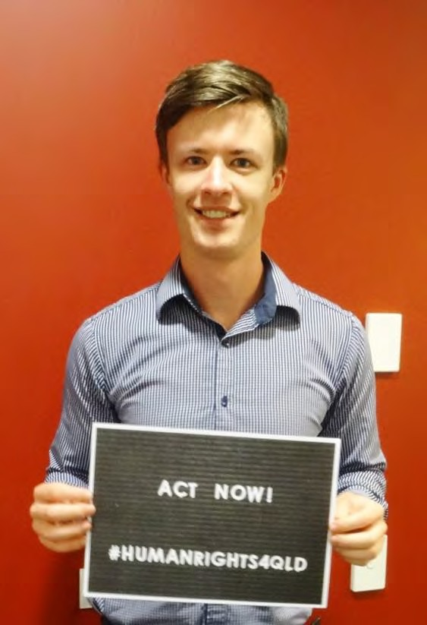


Human Rights Legal Service

Background
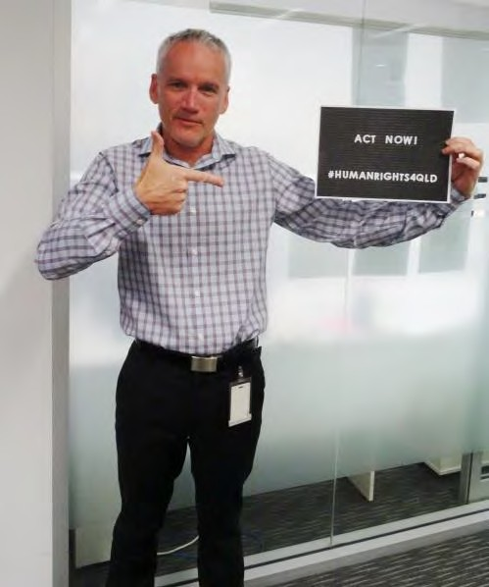
The Human Rights Legal Service (HRLS) was established in 2008 and implements a framework promoting the four key principles of human rights, namely freedom, respect, equality and dignity.
The service also endorses the rights as set out in the Convention on the Rights of Persons with Disabilities (CRPD).
The function of the HRLS is to promote and protect the fundamental human rights of people with disability in Queensland, in particular;
- The right to life, liberty and security;
- Freedom from torture or cruel, inhuman treatment or punishment; and
- The right to equality before the law and equal protection of the law
The HRLS lawyer achieves this by providing specialist legal advice, representation or referral when these rights are threatened or disregarded. The work of the HRLS encompasses the following areas;
- Restrictive practices including the use of seclusion, containment and chemical, mechanical and/or physical restraint;
- Guardianship and Administration;
- Forensic Orders and Forensic Orders – Disability;
- Health care and life sustaining measures;
- Funding and/or support issues; and
- Abuse/neglect and serious injury of people with disabilities.

Staffing
The HRLS is funded for 1 full time solicitor who is supervised by a part time principal solicitor and also supported by administrative staff.

HRLS Operation in 2015-2016
The HRLS continues to use the same operational strategy as in previous years, this being to provide legal advice and casework on a range of matters as well as to provide representation in guardianship, restrictive practices, Forensic Orders and Forensic Order – Disability matters.

Casework
Casework is where the HRLS lawyer provides ongoing assistance and/or acts on behalf of a client in respect of a matter. A matter consists of a single problem or a group of related problems, or a group of problems which may be unrelated, but are dealt with together. Casework can extend out over several months with hours of legal and non-legal work invested into the matter. Representation at a QCAT hearing is an example of a matter. Throughout 2015-2016 the HRLS opened 19 cases.

Representation
HRLS provided representation at 5 Mental Health Review Tribunal (MHRT) hearings re forensic orders and forensic orders - disability. HRLS also provided legal representation at 8 Queensland Civil and Administrative Tribunal (QCAT) hearings in relation to guardianship, administration and restrictive practice matters. QCAT appointed David Manwaring as separate representative in 2 matters.

HRLS casework examples
Appointment as Separate Representative
QAI was appointed by QCAT as separate representative (SR) for an adult to ensure their human rights were being protected and promoted. The adult had jointly appointed guardians and administrators (parents), there was conflict between one of those guardians/administrators (G/A’s) with the service provider (SP). The SP sought to have both G/A’s removed. The SP argued that the G/A’s were too restricting in personal and finances decisions to the point that the adult’s rights were being violated. QCAT held some concerns in that regard but were also concerned about the SP motivation. QCAT felt that the best option was to appoint a SR to ensure the adult’s rights were protected. The outcome was that one of the joint guardians was removed, however that person remained as an administrator.
Forensic Order – Disability
HRLS represented client X at his Forensic Order (Disability) (FOD) hearing before the Mental Health Review Tribunal (MHRT). The FOD was ordered in September 2012 by the Mental Health Court in respect of 4 counts of indecent dealing with children for which X was charged in December 2009. Following the making of the order, X was compliant with all conditions imposed and attended counselling with a psychiatrist and psychologist, which included sessions in respect of the alleged offences. QAI had provided representation on numerous occasions previously.
X had no history of excessive drinking or illicit drug use. X lived on a rural property and spent most of his time managing and labouring on the family farm. The psychiatric and psychological reports reflected that X was happiest working on the farm and had good family support. X did not have a drivers licence and was dependent upon his mother to drive him to appointments (his father being immobilised by a back injury). Attendance at appointments with the Mental Health Service and psychiatrist imposed significant inconvenience to himself and his family taking him away from his farm duties. His treating team and a second opinion psychiatric report were unanimous in their view that the FOD should be revoked.
The legal representative for the Attorney General supported revocation of the order. Ultimately, the MHRT revoked the FOD in line with the recommendations of the treating team and as outlined in written submissions from QAI.

Telephone Advices (Non-Casework)
Supervised by the HRLS lawyer the Telephone Legal Advice Service (TLAS) is operated by volunteer lawyers from Clyde & Co and the Office of Public Advocate. Additionally law students from the Disability Law Clinic and Legal Clinic provide simple advice on Tuesdays and Thursdays respectively, again under the supervision of the HRLS lawyer. The HRLS lawyer provides advices outside of these times depending on urgency of matter.
Telephone advice is not simply a dialogue delivering generic advice on the law, all advice provided by the HRLS/TLAS is specific to the person’s unique situation. Advice is defined as

when the lawyer explains the law in relation to the client’s circumstances and helps them to select between options about their problem. Advice extends to assisting with drafting of simple letters or documents, making phone calls on client’s behalf and referral to other agencies.
During 2015-2016 the HRLS/TLAS provided legal advices to 135 clients. Areas of law covered were predominantly guardianship and administration, complaints about government processes/procedures (funding & accommodation), disability discrimination, restrictive practices, orders and ancillary issues airing under the Mental Health Act such as Involuntary Treatment, forensic orders both psychiatric and disability. Other areas included tenancy, wills and power of attorneys.

Extra curricula activities
In addition to casework, the HRLS advocated more broadly for clients’ rights particularly those espoused in the CRPD. This included liasing with delegates of the Adult Guardian, QCAT & Department of Communities and non-government organisations. A selection of other activities by the HRLS lawyer includes:
- Attended 13 Professional Development sessions;
- Presented 7 Training Sessions on Guardianship (QAI/QADA Project);
- Trained new student volunteers;
- Attended Health & Disability Committee Meetings;
- Met with Public Guardian re Guardianship applications;
- Met with Public Trustee (Clinton Myles) re various issues;
- Contributed to submissions by systems team;
- Attended & presented at Community Legal Centres Queensland (CLCQ) Conference;
- Presented 2 sessions at the QPILCH’s Health and Legal Advocacy Clinic (HALC);
- Attended NACLC conference – Melbourne;
- Updated Ch19 of Queensland Law Handbook to the online version;
- Met with Clyde & Co re pro bono assistance;
- Attended QADA event re Legal Topics for Older Persons;
- Attended Decision Making Support Advisory Group Meeting
- Arranged for Public Advocate & Public Guardian to present to Disability Law Clinic;
- Training of new legal staff and volunteer lawyers at QAI;
- Attended Arthur Gorrie & Wolston Correction Centre; and
- Attended the 9th Conference of State Parties (COSP) to the Convention on the Rights of Persons with a Disability held in New York.

Disability Law Clinic (University of Queensland)
The Disability Law Clinic (DLC) commenced operation on 30 July 2013 and is run during each university semester (13 weeks) . DLC is in partnership with University of Queensland Pro Bono Centre as part of their Clinical Legal Education Program. Students are supervised by the HRLS lawyer. Eleven (11) students have completed this clinic to date. QAI & HRLS would like to thank the following students for their contribution to DLC.

Semester 2 - 2015 | Semester 1- 2016
Jasmine Lam Laura Wauchope | Harriet Crouch Benjamin Hockin

Legal Clinic (Queensland University of Technology
This is a new clinic for QAI in partnership with QUT Faculty of Law, delivered as work integrated leaning experiences. This allows students to maintain academic support and undertake assessment whilst engaging in a legal placement with a community legal centre. Students have the opportunity to see law in action whilst being involved in the delivery of legal services. The inaugural clinic commenced 03.03.2016 and is across all services. QAI would like to thank the following students for their contribution.

Semester 1 - 2016
Jordan Daniels Sian Retchless

Committee Membership
Community Legal Centres Queensland Management Committee
The HRLS Lawyer has since October 2015 been a member of this committee. Queensland Law Society Health and Disability Committee
The HRLS Lawyer has been a member of this committee since its inauguration on 28.05.2014. The committee provides a forum for legal, medical and health professionals and the government to raise, identify, debate and resolve issues in disability and health law.

Pro bono assistance
HRLS would like to thank Karen Williams Barrister for her ongoing support and advice in HRLS matters. QAI also thanks the Office of the Public Advocate and Clyde & Co in providing volunteer lawyers for TLAS.

Staff Changes
David Manwaring commenced in the role of Principal Solicitor on 01.11.2015, while Rebekah Leong took family leave. He undertakes this role 2 days per week and continues in his substantive role as HRLS for 3 days per week. Paulette Dupuy commenced with the HRLS on 13.10.2015 and finished on 24.06.2016, Paulette undertook her duties whist David completed the Principal Solicitor role. Since Paulette’s departure Neha Vaidyanathan, solicitor works across both the MHLS and HRLS.

David Manwaring

Justice Support Program

About Us
The Justice Support Program (JSP) provides non-legal advocacy for vulnerable people with impaired capacity who have been charged with a criminal offence. We identify their legal and social issues and link them with appropriate legal and support services. By doing this we help them achieve a fair outcome from the Court and by helping them resolve the personal or social problems which have contributed to their offending behaviour we prevent any further entrenchment into the criminal justice system.

Advice and casework
This year JSP provided advice, information and minor assistance to 26 people and extensive advocacy and case management to 28 people. A couple of the cases were finalised within 2 months, the rest take several months or even more than a year to complete. This is because most clients have difficulty communicating with their lawyer and need help to complete the tasks their lawyer gives them e.g. providing a copy of their medical records or attending appointments. Invariably they end up needing help because of the ongoing court case rather than with the extra support they have accessed. Most Criminal charges range from public nuisance to assault occasioning bodily harm, the social problems are usually insufficient support or supervision or inappropriate accommodation. Since commencement in September 2009, JSP has assisted 413 people. To our knowledge only 4 clients have re- offended, 2 of whom have chronic, treatment resistant mental illness and will probably be charged several more times in their lifetime.
JSP clients are encouraged to participate in any discussions or planning about the resolution of their problems, however we also work with their family, friends, guardians, carers or support workers. Most clients have limited capacity to understand the complex issues that are the cause or reason for their problem behaviour and depend on their support network to help them resolve these issues, as well as provide day to day support and information,
e.g. budgeting, transport, personal history, etc..
Many clients find out about the service through the brochures which are available throughout court registries and police stations in the greater Brisbane area. Other clients are referred through internet searches, community organisations and Legal Aid Queensland.

Scope of Service
We prefer to advise or assist the client directly or jointly in the company of their parent, support worker or friend. Invariably the first contact with JSP is because the client has been charged, has to go to court and has no idea as to what to expect at court or how to get legal help. We explain in very broad terms the court process and provide detailed advice and instructions on how to access legal advice or representation and the importance of accessing the duty lawyer service at the court. We refer clients to community services and supports that will help to change the client’s behaviour that brought him or her to the attention of the police.

Regional Restrictions
We actively assist clients located in the area covered by Caboolture to Gatton to Beenleigh to Cleveland. We can only help in a more limited way if the client lives outside the south east Queensland area, however so long as the client has someone who is willing and able to support them through each step in the process we frequently manage by providing one off or repeated advice over the phone or by email.
If you know of a person who needs JSP advocacy, then phone contact the JSP Advocate Liz Francis direct at jsp@qai.org.au or on 0422 039 258

Audited Financial Reports

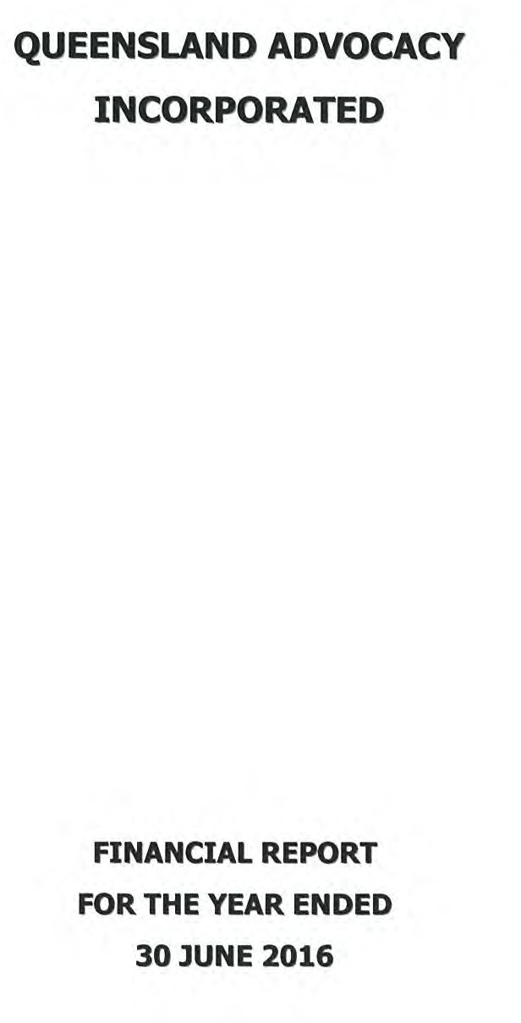

1.

QUEENSLAND ADVOCACY INCORPORATED INCOME AND EXPENDITURE STATEMENT FOR THE YEAR ENDED 30 JUNE 2016

INCOME |  | 2016 | 2015
Grant - Department of Social Services |  | 451,314 .16 | 445,395.86
Grant - Dept of Justice & Attorney -General | 449,330.00 |  | 436,773.00
Unexpended Grant from Previous Year | 16,788 .50 |  | 40,445.33
Less Unexpended Grant |  |  | (16,788.50)
 |  | 466,118.50 | 460,429.83
Legal Aid Queensland - CLEC |  |  | 20,000.00
Unexpended Grant from Previous Year | 20,000.00
Less Unexpended Grant | (20,000.00) |  | (20,000.00)
University of Queensland - Disability Law Clinic |  | 4,000.00 | 6,000.00
Mental Health Review Tribunal |  | 21,548.25 | 28,155.80
Membership |  | 1,063.53 | 899.91
Donations |  | 29,086.00 | 2,999.00
Workshops, Functions and Events |  | 9,063.14 | 23,608.97
Paid Parental Leave |  | 11,826.00 | 3,887.99
QADA Training Project |  | 4,615.47
Sundry Income |  | 2,461.24 | 7,177.78
Interest Received |  | 8,178.32 | 7,160.86
Investment Income |  | 1,081.19 | 1,366.21
 |  | 1,010,355.80 | 987,082.21
LESS EXPENDITURE
Total Expenditure (Schedule Attached) |  | 982,826.19 | 981,040.87
NET OPERATING SURPLUSl(DEFICIT) FOR THE YEAR |  | $27,529 .61 | $6,041.34
Market Value Adjustment to Investment |  | (3,352.21) | (14.89)
NET SURPLUSl(DEFICIT} FOR THE YEAR |  | $24,177.40 | $6,026.45

2.

QUEENSLAND ADVOCACY INCORPORATED INCOME AND EXPENDITURE STATEMENT FOR THE YEAR ENDED 30 JUNE 2016

EXPENDITURE
Audit & Accountancy | 4,200.00 | 5,200.00
Bank Charges | 690.79 | 715.60
Cleaning | 2,400.00 | 2,400.00
Computer Supplies & Support | 9,796.80 | 11,363.64
Consultancy | 38,729.48 | 30,190.28
Depreciation | 10,303 .00 | 8,993.00
Donations |  | 442.62
Electricity | 6,170.14 | 5,577.04
Insurance | 6,067.51 | 6,840.46
Interpreting Services | 685.10 | 1,580.64
Management Committee Expenses | 11,434.71 | 4,512.40
Minor Equipment | 1,421.04 | 601.19
Occupancy Costs | 90,212.30 | 86,743.53
Postage, Printing & Stationery | 6,659 .14 | 15,887.07
Repairs & Maintenance | 100 .01 | 514.00
Staff Amenities | 2,084.84 | 1,037.06
Staff Training & Supervision |  | 4,545.89
Subscriptions/Memberships | 6,738.19 | 5,783.83
Sundry Expenses | 1,764.29 | 996.48
Superannuation | 61,056.83 | 52,926.42
Telephone | 8,053.99 | 8,130.96
Travel Expenses | 6,475.69 | 5,159.12
Wages & Salaries | 679,615.56 | 694,566.70
Website Maintenance | 648.00 | 664.36
Workers' Compensation | 3,646.83 | 3,386.88
Workshops and Meetings | 23,871.95 | 22,281.70
TOTAL EXPENDITURE | $982,826 .19 | $981,040.87

3.
QUEENSLAND ADVOCACY INCORPORATED
ASSETS AND LIABILITIES STATEMENT
AS AT 30 JUNE 2016
 |  | 2015
CURRENT ASSETS
Cash on Hand 300.00 |  | 300.00
cash at Bank (Note 2) 369,976.44 |  | 352,284.05
Debtors & Prepayments 16,751.37 |  | 3,411.16
Deposits 22,977.46 |  | 22,385.49
410,005.27 |  | 378,380.70
FIXED ASSETS (Note 3) 29,453.00 |  | 27,258.00
INVESTMENT 53,202.04 |  | 55,473.06
492,660.31 |  | 461,111.76
CURRENT LIABILITIES
Creditors & Accruals 46,309.94 |  | 26,925.92
Provisions for Employee Entitlements 94,783.47 |  | 90,007.84
Grants Received & Unexpended 20,000.00 |  | 36,788.50
161,093.41 |  | 153,722.26
NET ASSETS $331,566.90 |  | $307,389.50
MEMBERS FUNDS
Balance 1 July 2014 307,389.50 |  | 301,363.05
Net Surplus/(deficit) for Year 24,177.40 |  | 6,026.45
TOTAL MEMBERS FUNDS $331,566.90 |  | $307,389.50

4.

QUEENSLAND ADVOCACY INCORPORATED SCHEDULE OF CASH FLOWS
FOR THE YEAR ENDED 30 JUNE 2016

2016 2015

CASH FLOWS FROM OPERATING ACTIVITIES
Receipts
Investment Income | 9,259.51 |  | 7,750.07
Other Income | 78,100.66 |  | 69,955.80
Cash flows from Government Grants | 900,644.16 |  | 902,168.86
Payments to Employees and Administation | (956,732.75) |  | (954,048.39)
Net cash provided by (used in) operating activities | $31,271.58 |  | $25,826.34
CASH FLOWS FROM INVESTING ACTIVITIES
Investment Units Purchased | (1081.19) |  | (1,366.21)
Payment for purchase of plant & equip | (12,498.00)
Net cash provided by (used in) investing activities | $(13,579.19) |  | $(1,366.21)
CASH FLOWS FROM FINANCIAL ACTIVITIES
Net increase (decrease) in cash held | 17,692.39 |  | 24,460.13
Cash at beginning of the reporting period | 352,584.05 |  | 328,123.92
Cash at end of the reporting period | $370,276.44 |  | $352,584.05
Reconciliation of Net Surplus/Deficit to Net Cash
Provided by (Used in) Operating Activities
Operating Result | 27,529.61 |  | 6,041.34
Plus Depreciation | 10,303.00 |  | 8,993.00
- (Increase)/Decrease in Receivables | (13,932.18) |  | (3,550.65)
- I ncrease/(Decrease) in Payables | 19,384.02 |  | (13,036.88)
- I ncrease/ (Decrease) in Provisions | 4,775.63 |  | 31,036.36
- I ncrease/ (Decrease) in Grants Unexpended | (16,788.50) |  | (3,656.83)
Net cash provided by (used in) operating activities | $31,271.58 |  | $25,826.34

s.
QUEENSLAND ADVOCACY INCORPORATED
NOTES TO AND FORMING PART OF THE FINANCIAL STATEMENTS FOR THE YEAR ENDED 30 JUNE 2016

  - STATEMENT OF SIGNIFICANT ACCOUNTING POLICIES

This financial report is a special purpose financial report prepared in order to satisfy the financial reporting requirement of the Corporations Act 2001. The committee has determined that the association is not a reporting entity.

The report is also prepared on an accruals basis and is based on historical costs and does not take into account changing money values or, except where specifically stated, current valuations of non-current assets.

The following significant accounting policies, which are consistent with the previous period unless otherwise stated, have been adopted in the preparation of this financial report.

    - Fixed Assets - Depreciation

Depreciation is charged on all Fixed Assets on the prime cost method and is brought to account over the estimated economic lives of all Assets.

    - Employee Entitrements

Liabilities for Wages & Salaries and Annual Leave are recognised and are measured as the amount unpaid at the reporting date at current pay rates in respect of employees' services up to that date. Other employee entitlements payable later than one year have been measured at the present value of the estimated future cash outflows to be made for those entitlements.

Contributions are made by the association to an employee superannuation fund and are charges as expenses when incurred.

( c) Comparative Figures

Comparative figures, where necessary, have been reclassified in order to comply with the presentation adopted in the figures reported for the current financial year.

( d) Economic Dependence

Queensland Advocacy Incorporated is dependant on government funding to operate. As at the date of the report the committee has no reason to believe the government will not continue to support the organisation.

6.

QUEENSLAND ADVOCACY INCORPORATED
NOTES TO AND FORMING PART OF THE FINANCIAL STATEMENTS FOR THE YEAR ENDED 30 JUNE 2016

2016 2015

  - CASH AT BANK

QAI Cheque Account | 291,914.39 | 283,995.17
QAI Gift Fund | 78,062.05 | 68,288.88
 | $369,976.44 | $352,284.05
3. FIXED ASSETS
Furniture & Equipment - Cost | 117,529.00 | 105,031.00
Less Accumulated Depreciation | 88,076.00 | 77,773.00
 | $29,453.00 | $27,258.00
4. AUDITOR'S REMUNERATION

Apart from the remuneration disclosed the auditors received no other benefits.

7.

QUEENSLAND ADVOCACY INCORPORATED STATEMENT BY MEMBERS OF THE COMMITTEE

The committee has determined that the association is not a reporting entity and that this special purpose financial report should be prepared in accordance with the accounting policies outlined in Note 1 to the financial statements.

In the opinion of the committee the financial report as set out on pages 1 to 11:

- Presents a true and fair view of the financial position of Queensland Advocacy Incorporated as at 30 June 2016 and its performance for the year ended of that date.

- At the date of this statement, there are reasonable grounds to believe that Queensland Advocacy Incorporated will be able to pay its debts as and when they fall due.

This statement is made in accordance with a resolution of the Committee and is signed for and on behalf of the Committee by:

President (?_.c.._._AL_D_u rJ_ _ _ _ _

Treasurer

Dated this 19th day of September 2016

d
i/ -

G<, ---
CHARTERED ACCOUNTANTS

LEVEL 1 488 LUTWYCHE ROAD
LUTWYCHE OLD 4030

POBox198
LUTWYCHE OLD 4030

TELEPHONE: (07) 3357 8322
FACS IMILE. (07) 3357 9909
EMAIL: admin@haywards.net.au

PARTNERS. GREG DORGE
PETER GESCH PHIL ROB INSON

8.

INDEPENDENT AUDITOR'S REPORT TO THE MEMBERS OF

QUEENSLAND ADVOCACY INCORPORATED

Report on the Financial Report

We have audited the accompanying financial report, being a special purpose financial report, of Queensland Advocacy Incorporated which comprises the assets and liabilities statement as at 30 June 2016, and the income and expenditure statement, a summary of significant accounting policies, other explanatory notes and the statement by members of the committee.

Committee's Responsibility for the Finanaal Report
The committee of the association is responsible for the preparation and fair presentation of the financial report and has determined that the accounting policies described in Note 1 to the financial statements, which form part of the financial report, are consistent with the financial reporting requirements of the Associations Incorporation Act (Qld) and are appropriate to meet the needs of the members. The committee's responsibilities also include such internal control as the committee determines is necessary to enable the preparation and fair presentation of the financial report that is free from material misstatement, whether due to fraud or error.

Auditor's Responsibility

Our responsibility is to express an opinion on the financial report based on our audit. No opinion is expressed as to whether the accounting policies used, as described in Note 1, are appropriate to meet the needs of the members. We conducted our audit in accordance with Australian Auditing Standards . These Auditing Standards require that we comply with relevant ethical requirements relating to audit engagements and plan and perform the audit to obtain reasonable assurance whether the financial report is free from material misstatement.

An audit involves performing procedures to obtain audit evidence about the amounts and disclosures in the financial report. The procedures selected depend on the auditor's judgment, including the assessment of the risks of material misstatement of the financial report, whether due to fraud or error. In making those risk assessments, the auditor considers internal control relevant to the entity's preparation and fair presentation of the financial report in order to design audit procedures that are appropriate in the circumstances, but not for the purpose of expressing an opinion on the effectiveness of the entity's internal control. An audit also includes evaluating the appropriateness of accounting policies used and the reasonableness of accounting estimates made by the committee, as well as evaluating the overall presentation of the financial report.

LIABILITY LIMITED BY A SCHEME APPROVED UNDER PROFESSIONAL STANDARDS LEGISLATION

9.

We believe that the audit evidence we have obtained is sufficient and appropriate to provide a basis for our audit opinion.

Opinion

In our opinion, the financial report of Queensland Advocacy Incorporated presents fairly, in all material respects the financial position of Queensland Advocacy Incorporated as of 30 June 2016 and of its financial performance for the year then ended in accordance with the accounting policies described in Note 1 to the financial statements, and the requirements of the Associations Incorporation ACT (QLD) .

Basis of Accounting and Restriction on Distribution

Without modifying our opinion, we draw attention to Note 1 to the Financial Statements, which describe the basis of Accounting. The Financial Report has been prepared to assist Queensland Advocacy Incorporated to meet the requirements of the Associations Incorporation Act (Qld). As a result, the Financial Report may not be suitable for another purpose.

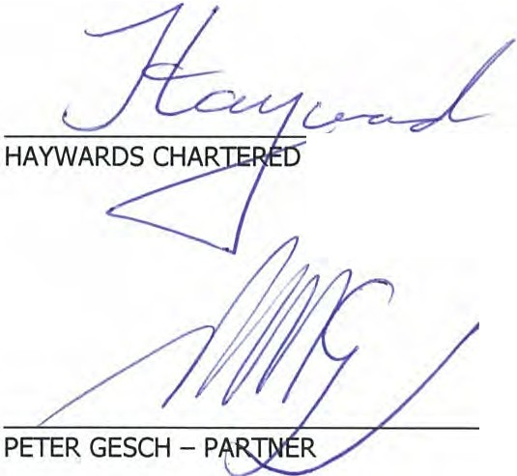19 SEPTEMBER 2016 BRISBANE
ACCOUNTANTS

10.

QUEENSLAND ADVOCACY INCORPORATED SUPPLEMENTARY INCOME AND EXPENDITURE STATEMENT FOR THE YEAR ENDE0.30 JUNE 2016

DEPARTMENT OF SOCIAL SERVICES

INCOME | 2016 | 2015
Grant - Department of Social Services | 451,314.16 | 440,395 .86
 | 451,314 .16 | 440,395.86
LESS EXPENDITURE  Total Expenditure (Schedule Attached) | 451,314.16 | 448,955.12
NET SURPLUSl{DEFIOT} FOR THE YEAR | $ NIL | $(8 , 559.26)

11.

QUEENSLAND ADVOCACY INCORPORATED SUPPLEMENTARY INCOME AND EXPENDITURE STATEMENT FOR THE YEAR ENDED 30 JUNE 2016

DEPARTMENT OF SOCIAL SERVICES
EXPENDITURE |  | 2015
Audit & Accountancy | 2,100.00 | 2,594.80
Bank Charges | 372.83 | 571.94
Cleaning | 1,200.00 | 1,197.60
Computer Supplies & Support | 4,898.40 | 5,670.45
Consultancy | 3,728.65 | 7,704.50
Depreciation | 10,303.00 | 8,993.00
Electricity | 3,564.47 | 2,813.04
Insurance | 3,033.75 | 3,465.05
Management Committee Expenses | 12,125.90 | 4,512.40
Minor Equipment | 710.54 | 541.19
Occupancy Costs | 45,106.26 | 49,297.76
Postage, Printing & Stationery | 3,547.25 | 8,182.88
Repairs & Maintenance | 50.00 | 256.48
Staff Amenities | 965.49 | 550.82
Staff Training & Supervision | 6,554.74 | 3,541.68
Subscriptions/Memberships | 2,321.75 | 1,628.03
Sundry Expenses | 115.14 | 585.94
Superannuation | 28,337.71 | 22,474.16
Telephone | 3,674.72 | 3,863.62
Travel Expenses | 3,314.78 | 2,390.44
Wages & Salaries | 310,527.94 | 315,900.53
Website Maintenance | 324.00 | 356.02
Workers' Compensation | 1,891.59 | 1,690.06
Workshops and Meetings | 2,545.25 | 172.73
TOTAL EXPENDITURE | $451,314.16 | $448,955.12

12.

QUEENSLAND ADVOCACY INCORPORATED SUPPLEMENTARY INCOME AND EXPENDITURE STATEMENT FOR THE YEAR ENDED 30 JUNE 2016

LEGAL AID FUNDING

INCOME | 2016 | 2015
Grant Received - Department of Justice and Attorney-General | 449,330.00 | 436,773.00
Unexpended Grant from Previous Year | 16,788.50 | 40,445.33
Less Unexpended |  | (16,788.50)
Disability Law Clinic | 4,000.00 | 6,000.00
Mental Health Review Tribunal | 21,548.25 | 28,155.80
 | 491,666.75 | 494,585.63
EXPENDITURE
Audit & Accountancy | 2,100.00 | 2,605.20
Bank Charges | 317.96 | 135.33
Computer Supplies & Support | 4,898.40 | 5,693.19
Consultants | 17,213.40 | 22,485.78
Electricity | 2,605.67 | 2,764.00
Insurance | 3,033.76 | 3,375.41
Interpreting Service | 685.10 | 626.09
Meeting Expenses | 374.15 | 415.54
Minor Equipment | 710.50 | 60.00
Occupancy Costs | 45,106 .04 | 37,445.77
Office Cleaning | 1,200.00 | 1,202.40
Office Overheads | 3,276.89 | 3,058.51
Repairs & Maintenance | 50.01 | 257.52
Staff Amenities | 1,051.17 | 486.24
Staff Training & Supervision | 5,842.64 | 1,004.21
Subscriptions/Memberships | 4,416.44 | 4,117.62
Superannuation | 32,719.12 | 30,452.26
Telephone | 4,379 .27 | 4,267 .34
Travel Expenses | 1,863.89 | 1,842.33
Wages & Salaries | 357,261.62 | 369,778.18
Website Maintenance | 324.00 | 308.34
Work Cover | 1,823.42 | 1,696.82
Workshops and Meetings | 413.30 | 507.55
TOTAL EXPENDITURE | 491,666 .75 | 494,585.63
NET SURPLUSl(DEFICIT} FOR THE YEAR | $ NIL | $ NIL

13.

QUEENSLAND ADVOCACY INCORPORATED SUPPLEMENTARY INCOME AND EXPENDITURE STATEMENT FOR THE YEAR ENDED 30 JUNE 2016

LEGAL AID FUNDING

2016 2015

INCOME

Legal Aid Queensland - CLEC Unexpended Grant from Previous Year Less Unexpended

20,000 .00
(20,000.00)
20,000.00

(20,000.00)

EXPENDITURE

NET SURPLUS[(DEFICIT} FOR THE YEAR
$ NIL $ NIL

Queensland Advocacy Incorporated
2nd Floor, South Central
43 Peel Street (Cnr Merivale Street) BRISBANE QLD 4101

Phone 07 3844 4200
1300 130 582
Fax 07 3844 4220
Email qai@qai.org.au Internet www.qai.org.au

