Queensland Advocacy Incorporated
2012-13 Annual Report

Queensland Advocacy Incorporated
2nd Floor, South Central
43 Peel Street (Cnr Merivale Street) SOUTH BRISBANE QLD 4101
Phone 07 3844 4200
1300 130 582
Fax 07 3844 4220
Email qai@qai.org.au Internet www.qai.org.au

Contents Pg No

Introduction |  | 2-4
President’s Report | Byron Albury | 5
Treasurer’s Report | Meriel Stanger | 6
Acting Director’s Report | Michelle O’Flynn | 7-12
25 Year Celebrations |  | 13-15
Systems Advocacy | Michelle O’Flynn | 16-25
Systems Advocacy | Nick Collyer | 26-30
Human Rights Legal Service | David Manwaring | 31-35
Mental Health Legal Service | Julie Hearnden | 36-40
Justice Support Program | Elizabeth Francis | 41-43

Attachment: Financial Statement for the year ended 30 June 2013

Management Committee

President Byron Albury
Vice President Fiona Kennedy
Treasurer Meriel Stanger
Secretary Trevor Boone
Committee Member Michael Duggan
Committee Member Jade Chee

Staff

Director Ken W ade
Acting Director/ Systems Advocate Michelle O’Flynn Systems Advocate Nick Collyer
QAI hours of operation Monday to Friday 9am - 5pm
Individual Advocate Elizabeth Francis
Individual Advocate/Paralegal Natalia Nash
Human Rights Lawyer David Manwaring
Mental Health Lawyer Julie Hearnden
Mental Health Lawyer Rebekah Leong
Office/Finance Manager Deborah Bryzak
Administration Assistant Karlie Harris

Queensland Advocacy Incorporated (QAI) is an independent community based systems and individual advocacy organisation for people with disability in Queensland. QAI advocates for the fundamental needs, rights and lives and protection of the most vulnerable people with disability in Queensland. QAI does this by engaging in systems advocacy work - through campaigns directed to attitudinal, law and policy change. QAI also provides limited individual legal and non- legal advocacy for vulnerable people with disability through three discrete projects. These are:

The Justice Support Program (JSP)
The JSP advocates for individuals with a disability in the Justice and related systems. The Advocate’s role is to marshal legal and community support services to provide the person with the best possible opportunity to remain in the community and to prevent them from re-offending.

The Mental Health Legal Service (MHLS)
The MHLS is a specialist legal service dedicated to providing legal advice and representation to individuals receiving involuntary treatment for mental illness in Queensland.

The Human Rights Legal Service (HRLS)
The HRLS provides specialist legal advice and conducts strategic casework aimed at protecting and promoting the fundamental human rights of vulnerable people with disability in Queensland. Once a week, the HRLS operates a specialist, telephone-based Legal Advice Service (LAS). The aim of the LAS is to increase the access of people with disability to the law.
The Department of Families, Housing, Community Services and Indigenous Affairs (FaHCSIA) under the Commonwealth Disability Services Act funds QAI systemic advocacy. The Community Legal Services Program funds the Human Rights Legal Service (HRLS). The Department of Justice and Attorney General through the Legal Practitioners’ Interest on Trust Accounts Fund (LPITAF) funds the Mental Health Legal Service (MHLS) and the Justice Support Program(JSP). QAI has also received donations over the past year and continues to seek funding from philanthropic organisations and trusts for projects.
This Annual Report covers the period from 01 July 2012 to 30 June 2013. It describes in detail the efforts of QAI to be a strong and effective systems and individual advocacy organisation, committed to its mission of promoting, protecting and defending through advocacy, the fundamental needs and rights and lives of the most vulnerable people with disability in Queensland.

Mission
QAI’s mission is:
“To promote, protect and defend, through systems advocacy, the fundamental needs and rights and lives of the most vulnerable people with disability in Queensland”

Objectives
QAI’s objectives are:
- To affirm and put first people with disability in Queensland;
- To undertake systems advocacy that strives to promote, protect and defend the fundamental needs and rights and lives of the most vulnerable people with disability in Queensland;
- To undertake legal advocacy that strives to promote, protect and defend the fundamental needs and rights and lives of the most vulnerable people with disability in Queensland;
- To take an active leadership role in advocating for the fundamental needs and rights and lives of the most vulnerable people with disability in Queensland;
- To support, promote and protect the development of advocacy initiatives for the most vulnerable people with disability in Queensland;
- To be accountable to the most vulnerable people with disability in Queensland;
- To conduct an efficient and accountable organisation; and
- To adhere to and constantly reaffirm the following beliefs and principles:
  - All human life has intrinsic dignity and worth;
  - People with disability must positively and actively be accorded worth, dignity, meaning and purpose through being included in and with their community;
  - Social Advocacy is functioning (speaking, acting, writing) with minimum conflict of interest on behalf of the sincerely perceived interests of a person or group, in order to promote, protect and
  - Defend the welfare of, and justice for, either individuals or groups, in a fashion which strives to be emphatic and vigorous and is likely to be ‘costly’ to the actor in terms of:
    - time or other resources;
    - emotional stress;
    - bodily demands;
    - social opprobrium, rejection, ridicule;
    - self-esteem, self certainty;
    - socio-economic security, livelihood; and
    - physical safety, life

The essential elements of Social Advocacy are:
- strict partiality;
- minimal conflict of interest;
- emphasis on fundamental needs and issues;
- vigorous action;
- cost to the advocate;
- fidelity; and
- being mindful of the most vulnerable person.
Systems advocacy is a particular form of advocacy that focuses on influencing and changing ‘the system’, that is, the whole of society and the various systems operating within, in ways that will benefit people with disability as a group within society. Systems advocacy includes, but is not limited to, policy and law reform activities.

President’s Report

Byron Albury
President
I'd like to take this opportunity to welcome everybody to the 26th Annual Report of Queensland Advocacy Incorporated. It has been my honour and privilege to serve as president of QAI for the past 2 1/2 years. Over that time QAI has been involved in a number of activities which have had a profound impact on the people we continue to serve. I will attempt to outline a few but you will read more from the staff of QAI in the report.
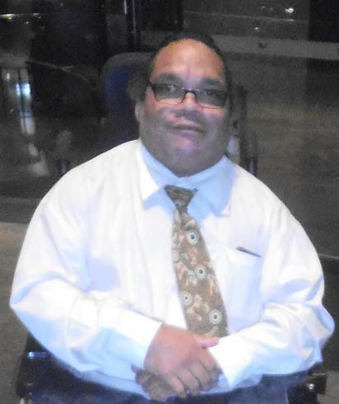
One of the key things that we have worked on as an organisation was the taxi subsidy scheme petition which as we all know had the desired outcome of 5162 people signing a petition in as little six weeks. It's pretty amazing what people can do when we put our minds to it.

QAI also worked on the Supported Decision-Making Forum cohosted by QUT in June and in addition, hosted a forum on Restrictive Practices in August.
I'd like to take this opportunity to thank the entire board Fiona Kennedy, Mike Duggan, Meriel Stanger, Trevor Boone and Jade Chee for your ongoing support of QAI and the ongoing commitment to supporting Queensland's most vulnerable people.
But most of all I'd like to thank you the members for joining us at the Annual General Meeting and taking the time to help shape the future of QAI.
Once again thank you all for your support.

Treasurer’s Report

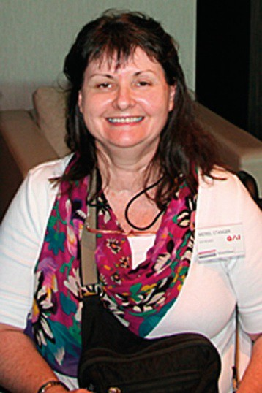
Meriel Stanger
Treasurer

I am pleased to present QAI’s Financial Report for the year ending June 2013.
I would like to thank Hayward’s Chartered Accountants for the preparation of the
Audited Financial Reports and for their support throughout the year. QAI has continuation of funding for various projects.
DFHCSIA |  | $414,226.00
Community Legal Services Program – Human Rights Legal Service |  | $117,002.00
LPITAF-Justice Support Program |  | $135,957.00
LPITAF-Mental Health Legal Service |  | $161,119.00
MHRT |  | $5,700.00
Donations |  | $2,992.46

See attached Financial Audit for the year ending 30 June 2013.

I would like to acknowledge our Donations:
Minter Ellison, Mamre Association, Grill’d Burgers, Alainna Simpson, Barbara Dundas, Madonna Nicoll and Judith Finch.

QAI has continued to review and update their financial policies and procedures and I am satisfied the procedures now in place will enable QAI to continue to function smoothly in the future. QAI’s day to day financial matters are administered by Deborah Bryzak. Deborah provides me with an enormous amount of assistance and I would like to thank her for guiding me through the maze of figures and reports.
I have thoroughly enjoyed working with the Management Committee and the dedicated staff of QAI and I would like to thank them for their support and continued vision. My time as Treasurer has been positive, harmonious and rewarding and I look forward to being passionate about my future as Treasurer of QAI.

Acting Director’s Report

Ken Wade
Director
With much trepidation I attempt to construct a report (a broad overview of the work of the organisation) for and on behalf of our Director Ken Wade who has taken extended leave. Ken’s request for leave was granted and I was honoured to be asked to step in to warm his seat for the next three months. Some members may know that I enjoy sailing and diving so please forgive the maritime metaphors. I sincerely hope that I can keep a steady hand on the tiller and keep us on an even keel as we enter somewhat turbulent waters with political changes that are emerging almost daily.
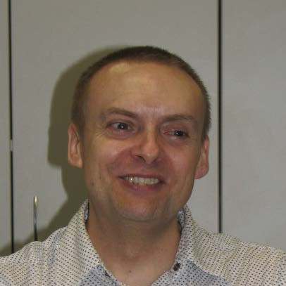
QAI staff members are talented, versatile and committed to working with and for people with disability. We work best as a team, yet each individual

performs high calibre work deserving its own showcase. I am very proud to be a member of such a self-disciplined and highly tuned crew.
In the past twelve months there have been some changes in the staff with the departure of former board member and principal solicitor Robert McRae. Rebekah Leong who took maternity leave has returned to that position after some time with her most adorable child Leo. While Robert has had a long term relationship with QAI and some of that history has gone with him, we welcome the return of Bek whose work ethic and output is legendary. She certainly gives us a high watermark.
Karlie Harris moved from full time reception duties for a time to work part time in Justice Support Program (JSP), and Connor Reidy came to QAI to job share reception duties with Karlie. Connor sadly left us, but Karlie was welcomed back to the warm embrace of the reception desk (some might say the engine room of this vessel) where she so ably works with every crew member.
Natalia Nash completed an ‘internship’ as a volunteer with the Mental Health Legal Service (MHLS) and also volunteered with our systems advocate Nick Collyer in the rewrite of Disabled Justice and was then offered a three month contract as a paralegal with MHLS. Natalia left our shores to venture overseas to be married and has since returned once again in August 2013, to be initiated into the QAI ranks working both in the MHLS and JSP services as an individual advocate.
Our organisation is supported by a team of wonderfully energetic and eager volunteers. Individual volunteers working with our services and with Nick Collyer are mentioned in their own reports, but we must make special mention of Nick Lauer who enthusiastically works for us to renew and restructure our database and document register into a more efficient and times- saving system.
Quality assurance and accreditation processes have changed in the past two years and in February 2013 QAI was successfully accredited under National Association of Community Legal Centres (NACLC). This was due to diligent work on developing new policies and procedures,

and adherence to planning and reporting requirements and was labour intensive for a considerable time.
Similarly DFhacsia had imposed new regimes for quality assurance and with compliances already in place, QAI made excellent progress. An audit against the Australian Government’s Disability Advocacy Standards was conducted by the Institute for Healthy Communities in July, and QAI was certified in August of 2013 for the next three years. We will undergo a first surveillance audit on or before July 2014. QAI staff, management committee and members are proud to have achieved two accreditations within this past year.
Legal Practitioner Interest on Trust Accounts Fund (LPITAF) which provides the funds to our individual advocacy services has undergone review this year to which QAI made submissions and representations. The outcome of the review can be summed up by this quote from the Department of Justice and Attorney General website:
“Allocation of the majority of LPITAF funds will move from a recurrent or ‘rolling’ basis to strategic triennial allocations. When applying for funding, organisations will have to demonstrate that their services align with the strategic objectives for frontline service delivery.”
QAI services are funded for another year and QAI welcomes the implementation of triennial allocations which we hope will anchor our individual services for vulnerable people with disability.
For QAI to perform with incisive responses against potential risks to people with disability and their families, we must be vigilant. To do this we sometimes rely on information provided to us by people with disability, their families, supporters and allies. We are most grateful to them, for sharing with us experiences that are at times dark and painful moments in their lives. Clients of our services inform the systemic arm of QAI as we learn of recurring threats. Our allies in other advocacy agencies such as members of the Combined Advocacy Groups of Queensland report regional issues that provide evidential information that support our systemic work. Collaboration with Community Safeguards Coalition strengthens the advocacy message to bureaucrats and ministers and we thank the tireless Carol Holt for her endeavours.
Successful advocacy must not merely respond. ‘Advocacy’ in itself conjures images of proactive measures in speaking and writing to drive change. To do this QAI is a forerunner of the disability advocacy sector with written material, community workshops and presentations and hosting forums on topics that challenge the status quo.
I would like to extend thanks to the Management Committee for their stewardship of QAI, and continued support of staff and the work we perform.

Reporting Period:
This report will provide a snapshot of the work undertaken during the 2012-2013 financial year, but will also include an update of our most recent work of particular interest.
Reports contained within include advocacy efforts across Human Rights Legal Service (HRLS), Justice Support Program (JSP), Mental Health Legal Service (MHLS) and our Systemic Advocacy Program including Law Reform and Community Living.
As Director Ken has undertaken representation for QAI in numerous arenas such as the following:-
- Met with representative from the Centre of Excellence for Behaviour Support regarding their internal review.
- Engaged with further developments and progression of the Shadow Report to the Convention on the Rights of Persons with Disabilities (CRPD) entitled “Disability Rights Now”. Attended the national launch in Sydney in August and innovated a State launch in Brisbane with our
co-hosts and partners DLA Piper.
- Participated in teleconferences with Queensland Action for Universal Housing Design.
- Met with politicians such as Jarrod Bleijie (Attorney General), Tracy Davis (Minister for Communities, Child Safety and Disability), Chris Davis (Assistant Minister for Mental Health), and Desley Scott (opposition MP)
- Attended NDIS consultations including the NDIS Bill Senate Hearing in Qld. Parliament House
- Attended State Budget briefing
- Collaborated on the LPITAF review submission with MHLS
- Attended DFhacsia symposium on Advocacy in Sydney
- Travelled to Toowoomba with Michelle O’Flynn to meet with residents and staff of Baillie Henderson Hospital and members of Toowoomba Community Connections
- Met with Michael Tunney from Dept. of Housing with Michelle O’Flynn to raise the housing issue for people living in institutional care settings
- Presentation to the 80th Anniversary of Montrose at Government House
- Met with Public Advocate (Jodie Cook) about people with disabilities living in long stay health facilities and Adult Guardian (Kevin Martin) on related topics such as Restrictive Practices
- Participated in the PIAC Accessible Public Transport Standards Forum
- Collaborated with colleagues on the review of the Restrictive Practices legislation and promoted our position to Department of Communities

- Worked with Michelle O’Flynn to investigate the relinquishment of administration of federal funding for Brisbane South Home Modifications services.
- Attended Prop Bono Partnerships Forum and the new Banco Court
- During Law Week manned the QAILS staff to promote QAI’s legal services and JSP
- Coronial Reforms Forum - QAI has agreed to partner QAILS, Prisoners’ Legal Service, Sisters’ Inside and other like-minded groups to promote a review of the coronial system for investigating reportable deaths in Queensland.
- Worked with Michelle O’Flynn by attending Your Life Your Choice co-production meeting in providing feedback to the direct payments handbooks.
- Developed relationship with Kelly Schubring from QUT Real World Placements to explore potential student placements at QAI.
- Attended Australian Human Rights Commission Consultation on access to Justice for People with Disabilities who encounter the criminal justice system
- Attended with David Manwaring the Restrictive Practices Review Forum staged by Disability Services
- Continued development of relationships with law firm partnerships such as DLA Piper, Minter Ellison, Ashurst, Allens Arthur Roberson, and Herbert Smith Freehills.
- Attended Peter Holbrook workshop on social enterprises at NDS Hub
- Attended the Disability Care Australia conference in Melbourne
- Attended the Melbourne DANA Forum on Advocacy in the Disability Care Launch sites
- Participated in the Fhacsia quality assurance second stage audit
- Along with Rebekah Leong, Julie Hearnden, attended meeting with Paul Sheehy the Director of the Mental Health Act Review.
- Participated in teleconference with Griffith University’s Lesley Chenoweth, Kathy Ellem and Margaret Rodgers from Community Resource Unit regarding partnership around the dvd project for deinstitutionalisation of people with disability residents of Baillie Henderson Hospital. and other such institutions.
- Met with new Mental Health Commissioner to discuss the Commissioner’s response to the consultation request for submissions about the review of the Mental Health Act.
- Met with Celia de Winter with Julie Hearnden and Nick Collyer regarding gaps in legal service provision for people with disability in Tasmania
- Met with Mathew Keely, QAI’s former solicitor and attended at his invitation the launch of Caps, Apps, and other Mobile Traps – Young People Mobile Phones and consumer rights.
- Interviews with Courier Mail Brisbane Times, 4BC radio, ABC radio and ABCTV and Channels 9 and 10

QAI is part of the Queensland Disability Services Partnership Forum. This is a body that meets every 2-3 months with the aim of exchanging information and views about issues facing people with disability in Queensland. The Forum contains a mixture of stakeholders including government, advocacy groups and service providers. It provides government with an opportunity to inform stakeholders about developments and to accept feedback and criticism of its programs and performance.
This is an extremely useful venue for information interchange, and government has proved itself receptive to concerns raised about policy, programs and legislation. Issues raised for consideration have included restrictive practices, the NDIS, direct funding and self-management of supports, assessment tools, funding, housing, congregate and shared accommodation, supported decision making, long-stay residence of people with disability in health and aged-care facilities, responses to aging parent carers.
These conversations have helped to shape government practice including the revocation of an odious carer assessment tool, and the shape of the review of restrictive practices legislation in Queensland.
QAI attended a roundtable on a review of the operations of the Department of Child Safety and its supporting legislation. The review is wide ranging and seeks to address problems with the response of the Department to issues of child protection, which currently see an emphasis on intrusive interventions resulting in removal of children from their family rather than the provision of support to families to ensure the family unit remains functional, caring and intact. This operational emphasis reflects the division of the Department’s operational budget, which sees 800 million dollars divided disproportionately in favour of intrusive interventions. Only 50 million dollars from this budget is directed towards family support aimed at preserving the integrity of the family.
QAI raised the twin issues of forced removal of children from people with disability who almost by assumption are considered to be incapable parents and the forced relinquishment of children with disability by parents who are unable to cope on their own. QAI emphasised the impropriety of assuming that people are incapable or inappropriate parents because they have a disability, particularly intellectual or cognitive disability or mental illness. QAI contrasted this with the position under the Guardianship and Administration Act with regard to capacity.
With political climates in state and federal governments set to charter potential torpedoes, QAI is ready and armed for any skirmishes. Our intrepid teamwork is often held together by the one person who holds recent history of QAI, our Office Manager Deborah Bryzak keeps watch over our financial and human resources with the diligence of a Howard Hughes. Her keen eye on funding grants and opportunities ensures that our vessel stays afloat with scrubbed decks and a well-slipped hull.
Our administrative anchor Karlie ensures a seamless flow from calls received to intake and referral, and together with Deb they are a dynamic force behind every event that QAI stages.

Like any ship, QAI is well maintained, and has not only an excellent crew but sails at times close to the wind, as all advocates must. We do not have anyone staying below.
We do not merely choose the calms seas, and run from the wind or stormy weather…all hands are on deck grinding those winches to keep the good ship QAI on course, fearless and heading straight into the eye of the storm.
Michelle O’Flynn, Acting Director

25 Year Celebration

In February this year, QAI celebrated our 25th anniversary with our very generous hosts Minter Ellison and invited guests. Her Excellency Ms Penelope Wensley AC Governor of Queensland and patron of QAI launched the celebrations and her speech was warmly received by a rapt audience.
Speech by Her Excellency Ms Penelope Wensley AC Governor of Queensland Patron of Queensland Advocacy Inc.
15th February, 2013

Ladies and Gentlemen, Good evening,
I join Byron Albury in acknowledging Australia's indigenous peoples and in particular the Jagera and Turrbul people, who lived in the Brisbane region before European settlement and whose descendants retain a close connection with its lands and waters.
Thank you, Nick, for the warm welcome, and thank you, Ken, for inviting me to be part of - in fact, to launch - this celebration of the twenty-fifth anniversary of Queensland Advocacy Inc, and for providing an opportunity for me, as QAI's Patron, to acknowledge the achievements of the organisation over that quarter of a century, in promoting and safeguarding the rights and dignity of the most vulnerable people with disabilities in this State. I am pleased to be here.
A twenty-fifth anniversary is, of course, a silver anniversary and that reference to ‘silver' will not go unremarked today, because it is singularly apt for today's celebration. First of all, silver is valuable - as are the several streams of QAI's advocacy services on behalf of individuals and, more broadly, those programs that seek to change, for the better, community attitudes to those most vulnerable of Queenslanders living with a disability.
At the same time, as we all know, even though silver is valuable, it will corrode and lose its sheen without constant attention - and the cause of advocacy, in particular "systems advocacy" to use QAI's own term - seeking community-wide change in laws, attitudes and behaviours - also requires constant attention to keep advocacy targeted and current.
Silver also has the unusual qualities of being simultaneously strong, malleable and capable of withstanding extremes of temperature. The parallel here is that, in addition to being valued for its achievements, QAI also needs strength, resilience and toughness to continue with its mission through inevitable challenges and disappointments along the way. And, bringing the metaphor almost to a conclusion, QAI, like silver, needs flexibility along with strength so that it can retain the capacity to respond to rapidly changing environments, to events and developments that may affect the lives and interests of its client group.
Today's celebration acknowledges twenty-five years over which those ‘sterling' characteristics have been consistently developed and displayed by QAI and, of course, it recognises the

contribution of every individual who has given time and effort, shed sweat and tears, in the pursuit of QAI's goals and principles. In that respect, I am pleased that all three directors over the lifespan of QAI to date are here this evening. Though they might not care to be called historical monuments, they will accept, I hope, the idea that they represent an unbroken living history of this organisation over a quarter of a century, and that they are, in a sense, representing this evening all those who have worked in and with QAI over two and a half decades.
I mentioned systems advocacy earlier, but I will also make specific mention of perhaps QAI's best-known and most resource-intensive activity, which is its advocacy and advisory services for individuals with disabilities who find themselves caught up in the legal system. I use this term broadly to include not only the justice system, but also quasi-legal and administrative processes in which decisions are made that affect the lives of these individuals and their families.
There are few situations where any of us would feel more anxious than in formal proceedings where such decisions are made. And we can only try to imagine what the experience would be like if, without the support of organisations like QAI, we lacked reasonable knowledge and understanding of the process itself and of the implications and potential outcomes of various courses of action. It is precisely this situation in which the most vulnerable Queenslanders with disabilities sometimes find themselves.
The work QAI has always done and continues to do in this field has righted wrongs, given the vulnerable a voice they might otherwise lack, and sought to bring about better understanding in our institutions and in our community about the lives, needs and wants of the most vulnerable in the community. The number of people in need who have been given support, has now passed the thousand mark, as the December 2012 Newsletter proclaimed - "1,000 clients and counting"
- and that is certainly a record worth celebrating.
So much for looking back: today is also an opportunity to look ahead - to the still-crowded agenda for improving the lives and protecting the rights and the dignity of the most vulnerable among us. One major issue is the proposal for a National Disability Insurance Scheme, and I am pleased to see the breadth, if not always the depth, of this national conversation. While I, as Governor, must remain above politics, I can suggest that we need to welcome warmly the potential benefits of the proposed scheme, and the paradigm shift it represents, but also to avoid simplistic notions that an NDIS can, at one fell swoop, eliminate the many challenges faced by Australians with a disability OR, for that matter, the need for advocacy on their behalf and in their interests. In this regard, I was interested in the thoughts and the questions about the NDIS, specifically linked to the issue of advocacy, that Jeremy Ward raised, in his interview in that same edition of the newsletter, which suggested to me that (politics aside) there is a good deal more planning and community discussion yet before us on this matter.
I know that QAI is deeply engaged in, and strongly committed to advance, this community debate - this national discussion - and I can presume to speak for all of us in expressing the hope that the process comes to a successful and practical conclusion that brings the largest

possible benefit to the lives of the largest number of people living with disabilities.
As Governor and as Patron of Queensland Advocacy Inc, I congratulate QAI on its twenty-fifth birthday and on its dedicated and often highly challenging work in our community over that time span. QAI, I believe, has helped make our State a fairer, more just, more inclusive and more compassionate place, and I thank sincerely all those whose commitment, passion, dedication and determination have enabled QAI to pursue its goals and stick to its values with such robustness over a quarter of a century - Management Committee members, directors, staff, volunteers, supporters, carers and, of course, those on whose behalf QAI advocates. As Governor and Patron, I wish QAI continued success in the future and it is with great pleasure that I declare this silver celebration well and truly under way. Thank you.

Systems Advocacy – Michelle O’Flynn


Michelle O’Flynn Systems Advocate/ Acting Director
I have now been working as part of the systems advocacy team for over a year and believe I have found my niche within QAI. I love systems
work and relish any opportunity to contribute to the social advocacy arena. The following is a brief summary of my work in the past year.

Submissions Policy
I provided feedback to Ken regarding DSQ Self-Directed Framework and in September I supported the advocacy effort into the Taxi Subsidy Scheme cuts and the issues regarding the Family Support Program, and the NDIS and advocacy and the NDIS.

In December QAI made a submission for the Elderly Parent Carer Trial Initiative in order to influence and guide the process and to pose alternative options to congregate care.
“Introductory Statements:
The question posed is how to provide sustainable living arrangements for adult sons and daughters. It is not about sustainable living arrangements for elderly parent carers. Whatever proposals or options are delivered should comply with the United Nations Convention on the Rights of Persons with Disabilities.
Therefore QAI rejects any notion of people with disability living in retirement or nursing homes with their elderly parent carers. This model is inappropriate both on the basis of age and cultural needs of the individual person with disability. It is also incongruent with the intent of the impending NDIS and indeed the objectives of the Your Life Your Choice Framework. Any proposals should consider the best interests of the persons with disability including the presumption of capacity and the right to autonomy and control over their own lives.”
As part of our ongoing work in the Community Living Project, QAI offered our submission to Jodie Cook, Public Advocate. This submission “People with Disability in Long-Stay Health Care Facilities” was in response to her Position Statement on Continuing the Deinstitutionalisation of People with Disability in Queensland.
“The archaic conception that institutional care is ‘best’ for people with disability is no longer the prevailing mindset of our society. What is becoming the exemplar is the notion and practice of social inclusiveness. In making this submission an opportunity arises in which to reflect on the progress made in the movement to community living options for people with disability living in Queensland, and how and why this has happened. There have been numerous advocacy efforts around people who have been left behind, and it is hoped that this support will provoke actions towards achieving for these people a life supported to live in a home of their own in the community…”

Employment
In response to the Discussion Paper “Improving Employment Opportunities for People with Disability in Australia” QAI produced a submission that had a sharp focus on the barriers to equity in workplace conditions.
QAI made submission to Issues Paper “Employment services – Building on Success”. This paper had as a focal point the Disability Employment Services and particularly those that are also Australian Disability Enterprises (ADEs - sheltered workshops). Our paper made criticisms of the current system and key recommendations for the future employment of people with disability.
After attending the DFhacisa workshop regarding the wage assessment tool BSWAT QAI made a submission to the notes made on the discussion guide to reinforce our position:
It would be far better to invest in the people with disability as a priority over maintaining or sustaining unviable ADE’s. - Those workers who have been providing good outcomes for ADE’s should be transitioned to open employment. Funding should be provided to work with the new open employers and co-workers to ensure a welcoming and accepting workplace environment.
Success stories are those ones where ADE’s are training grounds that progress their workers into open employment…
This premise (for any discounted productivity wage) is unfair and unrealistic - People without disabilities are not subjected to such processes and there are many people who work with varying levels of productivity and quality of work but are not unfairly discriminated against by having their wages garnished.
Submission to Senate Inquiry - The involuntary or coerced sterilisation of people with disabilities in Australia
The work performed by QAI in the past was kindly submitted by Miriam Taylor from QCIDD in a joint offer along with work from QDN. The 56 page document was included in total onto the website. In order to support this QAI submitted a seven point summary in our covering letter to the QAI six page policy statement.

Submissions Legal
QAI wrote to QAILS and researched interstate counterparts for collaboration on efforts on embedding the CRPD into legislation and practice. We also provided feedback to Queensland Association of Independent Legal Services Human Rights Social Justice policy development.
In September I supported Ken‘s submission to the NDIS Eligibility and Reasonable and Necessary Supports.
Our efforts of influence to the Queensland roll out of the NDIS the Your Life Your Choice Amendment to the DSA began to gain momentum with our attendance at the Public Hearing.

This was followed by a number of submissions to the Health and Communities Committee–
These were pursued by further submissions and representations to Department of Communities Child Safety and Disability Services in relation to the implementation of the Amended Bill.

YLYC handbooks
QAI has advocated strongly for more choice and control for people with disability and their families within YLYC as a prelude to the NDIS. It had been apparent that some of the progressive intent was in jeopardy of reverting to the status quo situation with some misunderstanding or reluctance of government and service providers to move to the new shift of mindset required. We made submissions after workshops on two occasions by letter. When the Department of Communities released the handbooks that were distributed for comment, we had grave concerns that once again there appeared to be some regression and our submissions were provided in two stages by directly offering track changes to the handbooks designed for the Department of Communities website.
I supplied notes for Ken for our final submission regarding the Direct Payment Handbook for the Your Life Your Choice at a workshop held in early June.

NDIS Draft Rules:
QAI submitted our responses to the draft rules for the NDIS on two occasions, the first being made by notes directly attached to the draft consultation paper on 1st March 2013. More detailed submission was made for seven individual rules on the 22nd March, 2013.
One of our key messages is as follows:-
“Currently in Queensland many people with disability reside in inappropriate settings such as hospitals, nursing homes, boarding homes, hostels, and other congregate care living arrangements. Where people with disability reside in hospitals, support and care is funded by the Health Department and not Disability Services. Advocacy for these residents to individually funded and appropriate housing of their choice in the community has been stymied by the abdication of responsibility of both Health and Disability Services Departments.
QAI would expect that the NDIS would prioritise funding for the development of careful planning for exit strategies for these people. This would necessitate taking into consideration optimal support and living arrangements especially for those residents who have been in care for long periods, often most of their lives.”

Meetings- External
02.07.12 Met with Matthew Bowden and Tracey Moffatt from PWD as part of Systems Team and kept minutes and reported.
04.07.12 met with Janet White from Youth Advocacy Centre to discuss youth and the criminal justice system. Took notes and reported

04.07.12 Met with Di Toohey and Benita Bierzynski from SUFY to discuss issues of shared care and hostels, took notes and reported
Began to collect some material regarding the names and locations of this type of hostel.
27.07.12 Met with Bill Carter, Lisa Fraser and Kelly Weekely from the Centre of Excellence
03.08.12 Met with Marg Rodgers to be briefed on work performed around Baillie Henderson
17.08.12 Attended Paper Bag Lunch hosted by WWild regarding Mental Health responses.
20.08.12 Met with Greg Murphy from DSQ Wacol Campus to meet and greet and forge relationship within DSQ.
In September QAI attended a Community Safeguards Coalition meeting with Clare O’Connor of DSQ to discuss the follow-on from Growing Stronger discussing issues such as unblocking funding, Accommodation Support &Respite Services (AS &RS) among others.
In October I accompanied David Manwaring to the Forensic Disability Unit at Wacol to meet with Donna Lockyer in regard to their implementation of the CRPD.
The Public Hearing of the amendment to the Disability Service Act (Your Life Your Choice) was attended by QAI and to which we followed up with letters to the Health and Community Services Committee.
David Manwaring and I attended a meeting with Jodie Cook the Public Advocate to discuss issues of mutual interest and possible partnerships.
Late in October I joined the Hot Topics group at QDN in a discussion about what makes a good service and this included some preliminary discussion about self-direction.
Ken and I travelled to Toowoomba in October to meet with the residents and staff of Browne House, Baillie Henderson Hospital, and later met with other members of Toowoomba Community Connections to plan for our next phase of advocacy planning.
In November, Ken and I met with Nathaniel Tunney from Minister Mander’s office in response to letters about the residents of Baillie Henderson Hospital and also in light of the “Under Occupancy” initiative. We learned a little about the Logan Renewal scheme as part of this discussion.
QAI attended the Your Life Your Choice workshops held by DSQ, the first in late November and the second early in 2013 and also the roundtable for the Elderly Parent Carer Trial initiative.
David Swift met with me in regard to audits and assessments for people with disability in employment situations.
In March QAI was represented at the NDIS Forum at Mt. Gravatt hosted by Labour candidate Laura Fraser Hardy and Senator Claire Moore. After raising concerns I followed this up with

letter writing to both the candidate and the Senator regarding the prioritization of long stay residents in congregate care for eligibility for the NDIS.
To celebrate the 20 year anniversary of The Disability Discrimination Act staff from QAI attended a gathering with Kevin Cocks at the Antidiscrimination Commission to view video stories of experiences of people with disability and discrimination.
On 13th May Ken and I met with Public Advocate Jodie Cook at her invitation. This came in response to the concerns we had raised about people with disability residing permanently in institutional care and the apparent dearth of urgent and intentional processes to ensure that they are eligible and prioritised for NDIS funding or community living options. Ms. Cook informed us of her plans for a report to be tabled in Parliament and a future group to be formed including QAI about this cohort of people in 8 health facilities across Queensland.
June – attended Roundtable meeting regarding Issues for People with Intellectual Disabilities, such as Self Advocacy, People with disability in the criminal justice system, and an Intellectual Disability Council - what it could mean for Queensland.
In late June I attended a workshop with DFHACSIA regarding the wage assessment tool BSWAT and changes required after the Federal Court rulings. QAI made submission to DFHACSIA after this workshop to reinforce our position.
August Met with Jodie Cook Public Advocate regarding Supported Decision Making

Research
Began early investigation in to hostels in Queensland with levels of care 1-3 as foundation material for future work
Collated research regarding cost benefit analysis of institutional/group living with shared care vs support for ordinary life in the community. This will be the basis of a paper to underpin the efforts around Baillie Henderson and Jacana reforms.
I have undertaken collation of feedback and research material in order to further my submissions for employment, self-direction of funds, issues with the Public Trustee.
I have begun a collation of research material of other deinstitutionalisation processes from interstate and personal stories of former residents of those facilities in preparation for our larger campaign.
As a result of some enquiries and a particular situation for an individual who bears the imposition of Guardianship and Administration orders, we have been collating stories and issues of the Public Trustee and will arrange to meet with that office to discuss these concerns. At this stage there appears to be issues ranging from overly excessive fees and charges, not releasing individuals’ own money to them and not providing enough money to live, freezing funds, and generally not including the wishes of individuals and or their supporters. There also appears to be some concerns regarding relationships between the office of the Public Trustee,

The Office of the Adult Guardian, the Mental Health Services including the Review Tribunal and service providers. QAI are determined to ensure that these officious bodies do not oppress and undermine the rights or wishes of people with disability and their families in these processes.
Investigation and Action: QAI investigated and wrote to Mr Lawrence Springborg in relation to the Department of Health relinquishing responsibility for the administration of Federal funding for the South Brisbane Home Modification Services.

Campaigns and Media
Engaged and liaised with parents and allies regarding the funding cuts to Family Support Program.
Engaged and collaborated with Nick (QAI) as part of the FSP, under-occupancy and NDIS campaigns.
Acted as spokesperson to the media generated by media release:- The Australian, The Courier Mail, and Gold Coast ABC FM Nicole Dyer Program.
Followed up with Denise Pambid from DSQ in relation to this issue and as a result QAI and others have meeting with DSQ representatives about this issue.
Collaborated with Ken, DLA Piper (Sydney) and QPPD members for the Sydney Launch of UN CRPD
Collaborated with Ken and staff on the Qld. Launch of the Shadow Report of the UN CRPD
As part of the larger project of deinstitutionalisation of residents of Baillie Henderson Hospital, (and indeed all congregate facilities), QAI wrote letters to many Ministers, Directors General, and leading bureaucrats within Housing, Disability Services and Communities, and Health Departments to raise the profile of our interest and energies directed at this objective. This is a small part of an overall campaign that will grow in size and impetus.
An overall project of deinstitutionalisation with a focus on Baillie Henderson Hospital is being undertaken by QAI. A component of this project had been to engage with family members to learn of how people can live with support in the community and that this is not restricted by misconceptions of type of severity of disability. A strategy to reach out to family members has developed into a larger project in partnership with Kathy Ellem and Sheena Cranwell from Griffith University (and by generous hospitality of Prof. Lesley Chenoweth). This project will capture and contrast the stories of individuals who once lived in congregate care and how their lives are transformed with support to have a good life in the community.
The intent was to produce a dvd that can be used to sow seeds of encouragement and inspiration to family members, be an effective lobbying tool with politicians and bureaucrats, and as a collage of stories for the 1000 voice website will promote positive images of people with disability and provide awareness and enlist support from the general population.

To date this has constituted liaison with a local service provider in Toowoomba via email, phone and two visits as well as two visits to Griffith University to meet with Kathy Ellem, Sheena Cranwell and Lesley Chenoweth. We travelled to Toowoomba to meet with three people who are generously sharing their life experiences for this project.
I have also had phone conversations with family members of people with institutional life experiences who will also contribute to this project. This has developed into encouraging them towards assisting their family members to self-direction.
We have maintained our letter writing effort to ensure that the residents of Baillie Henderson Hospital are not forgotten with letters to the Minister Tracy Davis.
Despite high hopes of a partnership with Griffith University in the development of a dvd resource, this partnership has now been ended. However, I have travelled to Toowoomba and met with people who were former residents of institutions and the project is continuing, albeit on our own.
I developed questions and précis, and facilitated the Speaker Panel at the Supported Decision Making Forum
Along with other staff members of QAI I participated in the Restrictive Practices Forum held at the rooms of the ADCQ.

Publications/Promotions/Networking
18th and 19th July Attended Centre of Excellence Positive Practices Symposium, took notes and reported
Chaired CAGQ teleconference 30th July.
Took minutes and liaised with members of CAGQ
Collaborated with QPPD on FSP, and appointments to the Adult Guardian and The Public Advocate.
Set up meeting for Ken and Nick to attend with key bureaucrats within DSQ regarding Family Support Program.
Set up meeting with Greg Murphy from DSQ Wacol Campus.
In liaising with CAGQ members and Community Safeguards Coalition allies I provided information regarding upcoming policy and legislation issues such as the Your Life Your Choice Amendment bill and the Elderly Parent Carer Trial.
I have consulted with Margaret Rogers from CRU in connection with advocacy efforts for residents of Baillie Henderson Hospital and their families.
I have been engaged with a discussion with the Shut-In Campaign group and discussed issues

of the people residing in institutions and their access to the NDIS, and independent advocacy within the NDIS.
I have met with Marg Rodgers on a few occasions to discuss matters surrounding the previous work performed around Baillie Henderson Hospital, as well as YLYC Peer Support Tender.
I have consulted with Leanne Burke from Staffing Options regarding the Department of Communities YLYC Tender process for resource development and a possible collaboration.
Delivered advocacy presentation to family members at Mercy Disability Services Wooloowin

Developed easy English advocacy PowerPoint and presented to young women with disabilities at Miraa House
Despite attempts to join in the Shut-in campaign these meetings are held on days that I do not normally work. However, I did manage to raise the issue of prioritising people who live in institutions getting access to and self-directing their supports and services within Disability Care Australia. Other members of Shut-in have taken up this issue in their states and we hope to make this a national concern.
Liaise with Community Safeguards Coalition on various key issues of funding, Your Life Your Choice, housing, and concerns with the service sector.
I have now taken on the task of updating notes for DLA Piper for the re-write of Include Me In.
Whenever possible I have maintained a high level of contact with departmental personnel on any issue that come to my attention to seek out accurate details and to inform the department/s of issues, concerns or possibilities.

Support/Information/Advice
After discussions with Andrea Simmons I contacted Kim Chandler from Department of Communities, about safeguarding advocacy within the NDIS. This contact was to ensure the Qld. Departmental representative had good understanding of the DANA recommendations about this topic.
With our collaborative work in Combined Advocacy Groups of Queensland (CAGQ) there are times when we at QAI are called upon to support our allies with information and this may include some investigative work. I have made contact with key personnel in Department of Communities and Disability Services on several occasions in regard to funding matters particularly clarification about changes to Family Support Program.

PROGRESS: AGAINST STRATEGIC PLAN KEY PERFORMANCE INDICATORS
Developed and completed Annual Operational Plan and a personal workplan.
Met with Julie Hearnden to be briefed on work performed around Baillie Henderson

Met with Systems team weekly.
Met with Systems team to discuss the Sydney launch of the Shadow Report on the CRPD. Met with key staff to discuss the Brisbane Launch of the Shadow Report of the CRPD.
Followed up with Peter Wellington’s office regarding alleged new locked facility planned for Sunshine Coast
Some aspects of the work have been slow to show results due to the complex nature of the work, and also due to external pressures ie: Difficulty in getting responses from Ministers in regard to our goals, and also in regard to coordinating the schedules of partnerships.
Otherwise activity has been high and changes to policy and implementation has been visible.

CLIENT/STAKEHOLDER FEEDBACK/SATISFACTION
Positive feedback from participants at Mercy Disability Services.

QUALITY ASSURANCE-

During the months of September, October, and November, QAI worked towards the finalisation of our policy document in consultation with relevant staff members and uploaded all documents to the NACLC website in preparation of our accreditation audit. This was then followed up by the development of staff work plans in accordance with NACLC requirements. Relevant staff names and project titles were attributed to associated goals within the Operational Plan.
In January, QAI completed draft changes to the QAI Governance Charter the Rules of Association and the Constitution, to be in accord and consistent with new Policy and Procedure manual and to comply with requirements for NACLC. The policy and procedure work for NACLC was followed by compliance with the requirements for Fhacsia accreditation.

Staff Changes/Volunteers/Student Placements
I moved to working four days per week from 1st July, 2013

Staff Development and Training
I attended the CRU workshop “Conversation about Agency Transformation” with Mary Kealy – former CEO of the Brothers of Charity Ireland, who led the agency as it moved from providing support in congregated group settings to providing individual supports so each person could live a ‘real life in a real place”. This training opportunity provided me with keen insight to use in my advocacy efforts in the area of deinstitutionalisation.
I attended the CRU 25th Anniversary Forum on 13th September in order to learn about family governed and managed supports

Supporting People with Disability and their Families
In the course of my work there occasionally presents opportunities to provide information and advice to people with disability, their family members or supporters, service providers and allies. This can occur either during a phone conversation or via email and at times, does require some investigation and follow up and is entered by Karlie either as “information” or “advice”. There have been several such entries in this reporting period in the area of education, funding, facilitated communication, self-direction, the NDIS, YLYC and the Public Trustee.

New Projects:
Unblocking Block Funding: I have completed a paper to be submitted to government departments and the Premier in regard to this issue. It is incongruent that some people with disability should be excluded from the opportunity to change service providers or to be denied the opportunity to self-direct their supports and services.
Public Trustee: QAI will partner with a law firm to investigate potential for a review of this statutory body. I have continued to support individuals in this matter and collation of research material is completed.

Systems Advocacy – Nick Collyer

Nick Collyer
Systems Advocate

Introduction
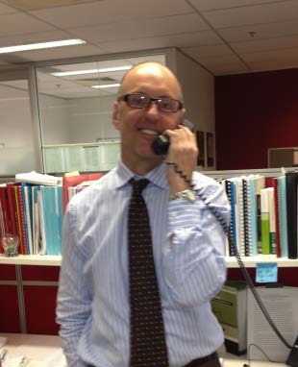Here is a summary of my work this year 2012-2013
We have tried to raise QAI’s media profile by releasing a number of statements to the media about disability-related state government actions and policies, by creating QAI’s first Twitter account for brief real- time responses to current events, and by keeping our website up to date with the latest news and QAI publications. We are fortunate to have received a good number of follow up approaches from National, State and Brisbane-based print and electronic media. Ken has been our spokesperson, with Michelle’s assistance. There has also been a flurry of consultations on disability-related legislative reforms, and we have written a number of submissions about those.

Submissions, Discussion Papers, Reports

- Submission to the National Aboriginal Disability Justice Campaign - July 2012

- Advocacy and a National Disability Insurance Scheme (NDIS) - Discussion Paper September 2012
- Consolidation of Commonwealth Anti-Discrimination Legislation- Submission 21 December 2012
- Public Trust- What do they do? How are their fees set? Submission preparation, January - 2013
- Submission on the NDIS Bill 2013 - 25 January 2013

- NDIS Bill 2012 Senate Committee Hearings- Appeared (with Ken Wade) before the Senate Health and Community Affairs Committee and presented QAI views on the Bill; answered Senators’ questions.
- Mental Health Commission - Submission on the draft legislation- Feb 2013 (assisted Rebekah and the MHLS with some comparisons with legislation and MH Commissions in other jurisdictions including Canada, WA, NSW and the UK)
- Consolidation of Commonwealth Anti-Discrimination Legislation- Submission 21 December 2012
- Elimination of Restrictive Practices in Queensland State Government funded Disability Services- Review- Submission

We have interviewed advocates and legal practitioners in the sector, compiling case studies to illustrate inappropriate use of these practices, and to show how support can be provided without them.
- Human Rights Commission- Consultation on Access to Justice June 2013

- Disability Parking Permits Inquiry from Dept. Communities (how to challenge)

- National Consultation on Public Transport Standards - May 2013

- Transport Accessibility Standards Consultation 2012

- How has your accessibility to conveyances (e.g. trains, buses and coaches, trams, ferries, wheelchair accessible taxis and aircraft) changed? Can you provide examples?
- QAI Submission on the Review of the Queensland Civil and Administrative Tribunal Act 2009

Campaigns and Media
The Under-Occupancy Campaign - June-July 2012
In June, Housing Minister Bruce Flegg wrote to all Queensland Housing tenants and enclosed a survey on ‘under-occupancy’ together with a covering letter. The covering letter began with the sentence ‘Queensland Housing is in crisis’, triggering widespread panic amongst Queensland Housing tenants, many of whom believed they would be forced to move or accept strangers into their homes. The Department alone received more than 4000 calls or complaints about the letter in the week following. QAI and QDN received dozens of distressed calls from members and other people living in Queensland Housing premises. The Tenants’ Union and TAAS services were swamped with enquiries and complaints. I met with the Minister and explained our concerns; the Minister acknowledged that the letter could have been better drafted.
The FSP Campaign - July-August 2012
The Newman Government reviewed hundreds of DSQ Family Support Packages. The packages provide a pool of money available for families and carers in need of particular services and goods not available under other programs, ranging from incontinence pads for people with disabilities to counselling and recreational services for family members. Most packages have been renewed in full; some have been cut. Information has been difficult to obtain, and there has been a perplexing disparity between what DSQ says and what families say. QAI used a combination of media releases, radio and print media interviews and meetings with government to get our point across. In the end no-one lost their funding.
The Cuts to TAAS - August 2012
QAI opposes the proposed axing of the Tenancy Advice and Advocacy Services across the state. I prepared and distributed a statement to the media about the TAAS program.

LNP Must Sharpen Teeth of Advocacy Watchdog
I wrote and distributed a media release commending the LNP on the disability-related policies it announced on Saturday 18 March 2012 and proposing that they increase the powers of the Public Advocate.
The NDIS positives: jobs growth for people with disabilities and supporters
When the increase of the Medicare Levy was announced Queensland Advocacy Incorporated decided to put a positive spin on the ‘expensive’ NDIS.
Alison Bailey Campaign
Alison Bailey is a 38 year old woman with multiple disabilities including dementia who lives in an aged care hostel at Woodridge. QAI was approached by Alison’s sister Jackie about raising awareness of this issue. I drafted a media release which was approved and sent out as follows:
“25 years ago a devout 13 year old girl from Logan made a pilgrimage with her family to the holy city of Lourdes. Allison Bailey had a brain tumour, and with the help of the Make-a- Wish Foundation she went to pray there – not for herself, but for world peace….”
Alison still lives in aged care, highlighting the plight of the approx. 7500 young people living in aged care around Australia.
Taxi (TSS) Review Campaign
We conducted a late 2012 campaign against the state government’s plan to introduce a $400 annual cap on the taxi subsidy cap.
- Issued a number of media releases
- Began a petition, garnering 5000 signatures
- Conducted a number of interviews with the media
- Wrote to the Premier, the Transport Minister, and to local members, and encouraged thousands of other people to do so.
- Prepared the petition for Byron and Ken to present in front of the media at Parliament House to the Opposition Leader and Shadow Minister for Transport Jackie Trad.
- Contributed to the QDN submission to the Minister’s Panel on the TSS (due 4 January 2013
Arranged meetings with other people and organisations opposed to the proposed cap. Arguments against the cap were:
  - The cost-saving premise on which this review is based is mistaken. There has been no blowout in membership or in costs.

    - The Panel document shows that the growth in subscribers from 2007 – 2012 was 12.9%, the same as Queensland’s population growth over the same period.
    - Getting from A to B can be a major trial for many people with disabilities. The government reversed its decision to introduce the cap.

Major Correspondence
- To Commonwealth Attorney-General Nicola Roxon Re: Need for More Effective State and Territory Enforcement of Human Rights Conventions July 2012
- QAI proposed to the Commonwealth that it take the initiative with the states and territories and urge them to adopt human rights scrutiny of all legislation.
- To Premier Campbell Newman re: Support for an NDIS Trial Site in Qld.
- QAI urged the Premier to propose Toowoomba as a trial site for the NDIS.
- Letter To Minister for Housing Dr Bruce Flegg - July 2012
- NB see above under ‘Submissions’
- To the Premier and the Attorney-General re: Office of the Public Advocate - April 2012
- Re: The Office of the Public Advocate as a Statutory Authority
- Letter to Dr Bruce Flegg about Proposed Cuts to TAAS - August 2012
- Queensland Advocacy Incorporated has been at the forefront of the campaign against the proposed axing of the Tenancy Advice and Advocacy service Program.
- People with disabilities will be adversely affected by the axing of the program.

Meetings, Workshops, Symposiums
Supported Decision-making Seminar- 28 June 2013
All big events like this one are a group achievement- Karlie Harris and Deb Bryzak were instrumental. The aim of this Seminar was to raise awareness in this state of Supported Decision-Making and to get the ball rolling on public discussion with a view to change in the guardianship legislation. Supported Decision-Making is not yet established in any Australian state or territory, but some trials have run/are running in South Australia and in the ACT. We arranged for speakers from SA, Victoria, the ACT, NSW and India.

Meetings
- CSC monthly Meetings
- Systems Team Weekly Monday Meetings
- 21 June 2012- SUFY to discuss amendments to the Guardianship and Administration Tribunal
- 25 June 2012 Meeting with Endeavour representatives
- 2 July - Mathew Bowden- strategy discussion
- 4 July- Di Toohey (SUFY) discuss restrictive practices
- 12 July- Leanne Ho - Pro Bono Australia
- 18 July - Minister Bruce Flegg- discuss NDIS + Under-Occupancy letter
- 18-20 July Positive Practices Symposium@ Emmanuel College UQ by the Centre for Excellence in Behaviour Support
- 24 July QPILCH to discuss division of labour in Mental Health representation
- August - CAGQ Teleconference to discuss CAGQ help with QAI campaigns on various issues
- 13 August - teleconference to discuss consultation on NDIS with Ngila from PWD
- Friday 1 March 2013 met with Jodie Cook – Queensland Public Advocate and Carol Holt (Community Safeguards Coalition) at the State Law Building, Level 1, 50 Ann Street, Brisbane
- MAMRE Seminar on Facilitated Communication- learned more about FC from Marie, a mother, and Heather, her daughter who’s at Kenmore High Grade 11 this year.
- Community Education
- Talked to the QDN Gold Coast Hot Topics Group April 2013 about what Queensland Advocacy Incorporated does, services offered.
- NDIS Consultation Forum at Mt Gravatt- 25 March 2013- gearing up for the announcement on the NDIS

Human Rights Legal Service

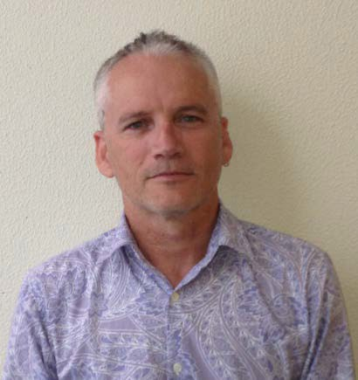
David Manwaring

Background
The Human Rights Legal Service (HRLS) was established in 2008 and implements a framework promoting the four key principles of human rights, namely freedom, respect, equality and dignity. The service also endorses the rights as set out in the Convention on the Rights of Persons with Disabilities (CRPD).
The function of the HRLS is to promote and protect the fundamental human rights of people with disability in Queensland, in particular;

Human Rights Lawyer • The right to life, liberty and security
  - Freedom from torture or cruel, inhuman treatment or punishment; and
  - The right to equality before the law and equal protection of the law
The HRLS lawyer actualises this function by providing specialist legal advice, representation or referral when these rights are threatened or disregarded.
The work of the HRLS falls predominantly within the following areas;
- Restrictive practices including the use of seclusion, containment and chemical, mechanical and/or physical restraint;
- Guardianship and Administration;
- Forensic Orders and Forensic Orders – Disability;
- Health care and life sustaining measures; and
- Abuse/neglect and serious injury of people with disabilities.

Staffing and funding
Staff movements during 2012/2013
David Manwaring moved to working full time in the HRLS lawyer position on 01 July 2013, previously he had been working 9 days per fortnight.

Funding for HRLS
The HRLS has recurrent funding through the Community Legal Service Program (CLSP). Under this program both QAI & HRLS are subject to stringent reporting guidelines. These reports are provided to Legal Aid Queensland (LAQ) who manages the program in Queensland. Funding is from both federal and state sources, namely:
- Commonwealth - Attorney-General's Department
- Queensland - Department of Justice and Attorney-General (DJAG) &

- Legal Practitioners Interest on Trust Account Fund.
Under the new LPITAF funding regime (commencing 2014) there will be no recurrent funding so QAI/HRLS will apply for a further 3 year funding when the application process starts in October 2013.

HRLS Operation in 2012-2013
In 2012-2013, the fifth year of operation of the HRLS used same operational strategy as in previous years, this being to provide legal advice and casework on a range of matters as well as to provide representation in guardianship, restrictive practices, Forensic Orders and Forensic Order – Disability matters.

Casework
Casework is defined as an activity where the HRLS lawyer provides ongoing assistance and/or acts on behalf of a client in respect of a matter. A matter consists of a single problem or a group of related problems, or a group of problems which may be unrelated, but are dealt with together. Casework can extend out over several months with hours of legal and non-legal work invested into the matter. Representation at a guardianship or MHRT hearing is an example of a matter.
Throughout 2012-2013 the HRLS opened 17 cases and closed 12 cases, the current number of open cases is 26 (though some are in the process of being closed).

Representation (casework)
HRLS provided representation at 9 Mental Health Review Tribunal (MHRT) hearings re forensic orders and forensic orders - disability. HRLS also provided legal representation at 5 Queensland Civil and Administrative Tribunal (QCAT) hearings in relation to guardianship, administration and restrictive practice matters. QCAT appointed David Manwaring as separate representative in 1 matter.

HRLS casework examples
Example 1
HRLS represented a client before QCAT in regards to a seclusion and containment order. The order sought was for duration of 12 months for the use of seclusion at 5 hrs for each period of seclusion and containment for 24/7. However there was no community access plan provided or assurances that the Positive Behaviour Support Plan would have an impact on improving the person’s quality of life at the QCAT hearing. In this instance it was Communities who were keen to see approval at this high level, the service provider appeared more reluctant. We were successful in keeping the order down to 6 months duration with a guarantee that the community access plan would be developed and forwarded to relevant stakeholders in that same week.

Systemic issues identified:
- The push for a longer order to minimise QCAT scrutiny- potential for abuse.
- The need to ensure that orders are reviewed in an open forum such as QCAT as often as is possible.
- Communities intent in seeking these orders – is it a funding issue?
- Are occupational health issues in some instances trumping human rights?
- QCAT approving orders without an actual Community Access Plan in place.
Example 2
HRLS represented a client subject to an interim Guardianship & Administration (G&A) order appointing the Office of Adult Guardian (OAG) and Public Trustee. Also on foot was an application for permanent appointment of these bodies. The adult initially sought advice from QAI but the OAG informed the adult that neither they nor their family were allowed to seek legal advice. QAI approached the OAG seeking consent to represent the adult at an upcoming hearing, we were subsequently requested to put this in writing, which we did. However no response was received from the OAG. Subsequently, QAI applied to become the adult’s separate representative at the hearing. This application was successful, thereby negating the need for the OAG consent. QAI approached OAG in the separate representative role for information, again no response was received.
Systemic issues identified:
- Legislative right to legal representation if impaired capacity (s43 QCAT Act). However conflict arises with this provision and the OAG consenting to legal representation.
- This provision needs to be strengthened/rewritten to ensure that the OAG is unable to erode these rights by not consenting to representation if the person is under a guardianship and administration order.
- Due diligence issues within OAG.
- Identifies the need for ongoing meetings with OAG.

Telephone advices (non-casework)
The Telephone Legal Advice Service (TLAS) recommenced operation on 02 May 2013. The response has been great with average of 4 advices per week. TLAS is operated by volunteer lawyers under supervision of the HRLS lawyer every Thursday. Previously this service was provided solely by the HRLS lawyer.
Telephone advice is not simply a dialogue delivering generic advice on the law, all advice provided by the HRLS/TLAS is specific to the person’s unique situation.
Advice is defined as when the lawyer explains the law in relation to the client’s circumstances and helps them to select between options about their problem. Advice extends to assisting with the drafting of simple letters or documents, making phone calls on the client’s behalf and referral to other agencies.
During 2012-2013 the HRLS/TLAS provided legal advices to 90 clients. Areas of law covered were predominantly guardianship and administration, complaints about government processes/procedures (funding & accommodation), disability discrimination, restrictive practices and forensic orders. Other areas included tenancy law, wills, power of attorneys and family law.
The statistics fail to show that many hours can be devoted to one advice, as time is required to adequately research the issue, provide the actual advice and write up file notes. The average length of time provided on an advice is between 3-4 hours. The statistics also fail to reflect that several of these clients have ongoing support provided by the service which is non-legal in nature. This support includes assistance with housing forms, explanation of Public Trustee statements and just being there to listen. Finally the lower number of advices can in some part be attributed to an increase in MHRT/QCAT representation.

Extra curricula activities
In addition to casework, the HRLS advocated more broadly for clients’ rights particularly those espoused in the CRPD. This included liaising with delegates of the Adult Guardian, QCAT & MHRT, Department of Communities and non-government organisations.
The HRLS lawyer also:
- Attended the launch of Prisoners Legal Service’s Safe Way Home Project;
- Provided a presentation to District Forensic Liaison Officers and Community Forensic Mental Health, here in Brisbane;
- Met with Forensic Disability Service A/Centre Director and Senior Manager;
- Promoted QAI to Centrelink and varying Health Services;
- Attended QAI’s Supported Decision Making Forum – 28.06.2013;
- Met with Allens Law firm in regards to Capacity Handbook – 17.07.2013;
- Attend the National Association of Community Legal Centre’s Conference (Cairns) – 22.07.2013 – 26.07.2013;

- Met with Rights in Action (Cairns),mental health staff at Cairns Base Hospital and Community Mental Health Service – 23.07.2013;
- Met with Public Advocate re supported decision making project – 05.08.2013;
- Actively participated in QAI’s Restrictive Practice Forum held 30.08.2013;
- Completed rewrite/editing of Chapter 18 of Caxton Legal Centre publication The Queensland Law Handbook.
- Assisted in QAI’s submission on the ‘Review of the Regulation of Restrictive Practices in the Disability Services Act 2006 and the Guardianship and Administration Act 2000’.
- Assisted in QAI’s submission to Jodie Cook, Public Advocate on ‘People with Disabilities in Long-Stay Health Facilities’.
- Continues to be a member of QAILS Human Rights Social Justice sub-committee.

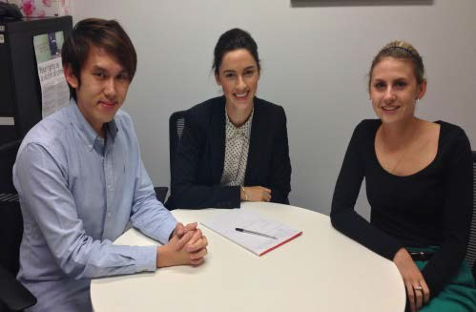
Disability Law Clinic (University of Queensland)
The Disability Law Clinic (DLC) will commenced on 30 July 2013 and will run for 12 weeks. DLC is in partnership with University of Queensland Pro Bono Centre as part of their Clinical Legal Education Program. Our inaugural students will be Daren Tan, Emily Anderson-Jones and Linley Ezzy (pictured left). These students will be supervised by the HRLS lawyer.

Pro bono assistance
HRLS would like to thank the involvement of the following Counsel:
Karen Williams - who continues to accept on a pro bono basis to be briefed in relation to representation at QCAT hearings. Ms Williams also provides significant and ongoing support and advice to HRLS in the carriage of several complex matters.
Brian Cronin - continues to accept on a pro bono basis to be briefed in relation to representation at MHRT forensic order reviews.
Ken Fleming QC- continues to provide on a pro bono basis assistance in relation to a matter concerning unlawful detention. Mr Fleming has also generously offered on a pro-bono basis to assist with upcoming litigation of this matter.
Michael Smith – has provided pro bono assistance and advice in relation to a personal injury proceeding under the Personal Injuries and Proceedings Act (PIPA).
HRLS/TLAS also thanks Sparke Helmore & the Public Advocate in providing volunteers for TLAS. These lawyers are Dianne Hollyoak, Dominique Mayo, Matthew Hawker, Andrew Ross, Benjamin Di Marco and Elise Nolan. Julie Bartlett & Daniel Graham also generously give their time to volunteering with TLAS.
Finally the HRLS thanks Tammy Parsons and Israel Machuca volunteer lawyers for their contribution to our work.

Mental Health Legal Service

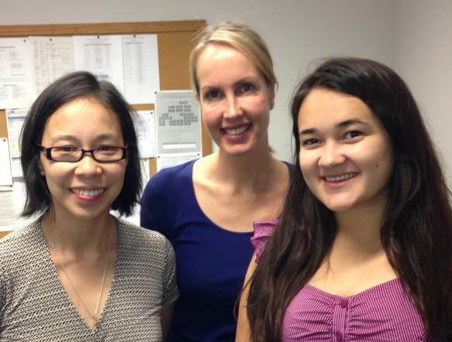Background & 2012-13 highlights

Rebekah Leong (Principal Solicitor),
Natalia Nash (Paralegal) and
Julie Hearnden (Mental Health Lawyer).
The Mental Health Review Tribunal (MHRT) reviews the validity of orders authorising involuntary mental health treatment and detention. It serves to protect vulnerable people with mental illness from arbitrary state action.
In 2011-12, the MHRT dealt with almost 11,000 matters involving over 5,600 individuals. According to the MHRT 2011-12 annual report, individuals were represented in only 2.27% of matters. In contrast, in New South Wales in 2011-12, patient representation was provided in 98% of forensic hearings and 63% of civil hearings.
QAI’s Mental Health Legal Service (MHLS) was established in January 2010 to meet this gap in legal services, and has provided assistance to over 677 clients. While the core work of the service involves representation before the MHRT, the MHLS also provides advice and assistance in related matters such as seclusion, complaints about treatment, service provision, and guardianship and administration. We also strive to ensure that individuals receive adequate support, advocacy and information in relation to matters outside the scope of the Service.
The MHLS aims to empower individuals receiving involuntary treatment to meaningfully participate in treatment decisions made about them. Many clients are isolated, have multiple disabilities, and are detained in facilities which they find frustrating and degrading. It is imperative that such vulnerable people are supported in a legal process which is set up to determine the individual’s liberty, freedom of choice and bodily integrity.
Feedback for the MHLS:
“The service was complete – advice, support and representation at the MHRT. Good advice, support and representation was provided.”
“Fantastic program for advocacy in mental health. Less complex and easy to follow legal advice.”

In 2012-13 the Service has continued to prosper and has developed a reputation for providing high quality expert legal assistance in mental health law in Queensland. The Service maximises its limited resources through the use of student volunteers, pro bono law panels, supporting other advocacy organisations, publication of information and the provision of sector and community education.
While the MHLS was successful in obtaining further funding for the 2013-14 financial year from the Legal Practitioner Interest on Trust Accounts Fund (LPITAF), secure, adequate funding for the MHLS continues to be an ongoing problem. Currently there is no guaranteed funding past 30 June 2014.

Legal advice & casework
The MHLS assisted 158 clients in 2012-13.
Of the 178 advices provided, 50% related to Involuntary Treatment Orders (ITOs), and 22% related to forensic orders. Most clients receive detailed written advice, and often comprise of submissions that the patient can use to represent themselves at an MHRT hearing.
The MHLS opened 146 cases. MHLS staff made 94 appearances before the MHRT and 4 appearances before the Mental Health Court. We instructed barristers in 36 confidentiality order hearings, which often included the substantive ITO or forensic order review hearing, whose fees were covered by the MHRT. Under a new scheme, 20 ITO matters were represented by lawyers from DLA Piper Australia on a pro bono basis. We also thank the pro bono assistance of Karen Williams and Nicholas Tucker.
In 2012-13 financial year most matters came from the following Mental Health Services: Royal Brisbane and Women’s Hospital (15%), Townsville Hospital (14%) and The Prince Charles Hospital (11%).

Type of matters Appearances

Involuntary Treatment Orders (ITOs) | 59
Forensic Orders | 51
Electroconvulsive Therapy (ECT) Applications | 2
Other Matters (Mental Health Court / Refusal of visitor) | 6
TOTAL APPEARANCES | 155

In addition to Tribunal work, the MHLS also advocated more broadly for clients’ rights to self- determination, dignity and liberty. This included discussion with the client’s treating team unsuitable or unsatisfactory medication regimes, and inappropriate case management or managers, with a view to releasing the client from involuntary treatment. The MHLS has also advocated for individuals to be discharged from hospital settings where individuals have been detained at hospital for lengthy periods of time.
In some cases the MHLS have had meetings and discussions with treating teams about alternative treatment and support options available for individuals.
The Service also advocated for the decreased use and elimination of seclusion for vulnerable individuals, an issue which is not reviewable by the MHRT.

The MHLS has also assisted clients with access to legal advice in relation to matters that fall outside the scope the Service, for example, applying to Legal Aid Queensland for representation on criminal charges. On several occasions the Service has also assisted clients to complete Information Access Application forms where they can obtain their medical files; in most cases a client will not be granted full access to their files.

Case Studies
Case Study 1: Refusal of visitor: We represented a client who had been refused the right to visit their partner in hospital. The MHRT confirmed the hospital’s decision to refuse visitation. This case highlighted problems with the current provisions regarding exclusion of visitors under the Mental Health Act 2000 (Qld). QAI have taken up this issue during the recent review of the legislation.
Case Study 2: Unfair delay of Section 238: Report We have been assisting a client on an involuntary treatment order who is currently held on remand due to an approximate 4 year delay in obtaining a psychiatric report. Under the Mental Health Act 2000 (Qld), such reports are required to be completed within 21 days. Due to our advocacy, the report has finally been provided and we await a determination in relation to the outstanding charges.
Case Study 3: Mental Health Court Appeal: We represented a man who was placed on a forensic order in 2001 which required him to remain in Queensland for mental health treatment. In 2008, the client absconded to Victoria where he has significant family support. By 2011, he was living in the community and was engaged with Victorian Mental Health Services. Accordingly, the MHRT revoked his forensic order but this was later reinstated on appeal with a view to have him returned to Queensland. In 2012, QAI was approached by this client and his family for assistance. Based on expert evidence that there was no clinical benefit in removing the client from his support network in Victoria we were successful in obtaining the MHRT’s approval for him to live interstate. On appeal of this decision, at which QAI represented the client with Counsel funded by Legal Aid Queensland, the Mental Health Court revoked his forensic order. With QAI’s help, our client is now able to continue his recovery and progress his life with the support of family and mental health services. (http://archive.sclqld.org.au/qjudgment/2013/QMHC13-002.pdf )
Case Study 4: Refusal of electroconvulsive therapy treatment (ECT) application: We represented a client before the MHRT at an ECT application hearing. We were successful in arguing that ECT was not the most clinically appropriate treatment for our client and the MHRT did not approve the use of ECT for our client.
Case Study 5: Discharge into the community: We assisted a client who had been an inpatient for over 6 months on an involuntary treatment order to be discharged from hospital. We provided representation and advocacy support to ensure that the individual would be reintegrated back into the community successfully.

MHRT Referrals
From time to time, the MHRT refers important matters to QAI for legal representation.
QAI coordinates and instructs a panel of barristers who have agreed to take on these types of matters and whose fees are paid by the MHRT.
In 2012-13 the MHRT referred 36 matters to QAI. We would like to thank the involvement of the following counsel: David Cormack, Nannette Noble, Nicholas Tucker and Karen Williams.

Staffing
During the 2012-13 financial year the MHLS experienced several staff changes which impacted upon our capacity to deliver services to clients. From July 2012 – December 2013, the MHLS was staffed by 1.7 solicitors. From January 2013, the MHLS dropped back to 1.6 solicitors. Since 5 August 2013, the MHLS operates with one full-time solicitor (Julie Hearnden) and one part-time paralegal (Natalia Nash), supervised and supported by the principal solicitor (Rebekah Leong).

Volunteer Program
Since December 2010, QAI has run a student volunteer program, open to senior law students who are willing to volunteer one full day per week for 12 consecutive weeks. This volunteer program has proved to be highly successful and competitive with the number of applicants increasing during each volunteer intake.
QAI thanks the contribution of the following volunteers during 2012-13:

Semester 1, 2013 | University Break Period | Semester 2, 2013
Alainna Simpson Michelle Vu Carl Tessmann Bonita Wong Kaitlyn Rafter Rickey Lingwoodock | Lindsay Kiemann Xaiver Keary Juliet Walker | Tammy McConochie Ustina Boules  Peter King Cameron Jang Keith Sun Naomi Dickson

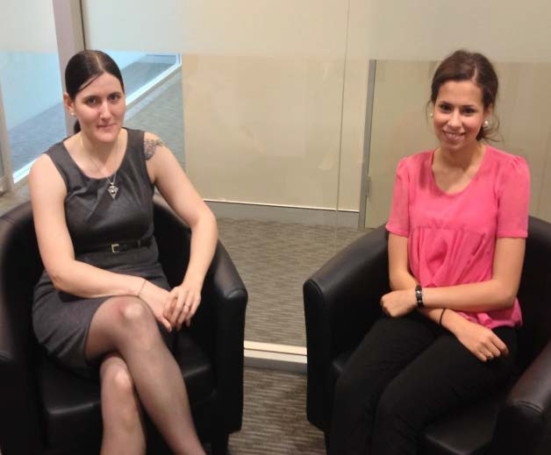


Pro Bono Referrals
Left: Volunteers Cameron Jang and Peter King. Above: Volunteers Tammy McConochie and Ustina Boules.

On 8 August 20112 QAI and the law firm DLA Piper Australia entered into an agreement under which the MHLS could refer particular matters to DLA Piper Australia for pro bono legal representation before the MHRT. In 2012-13 QAI referred 20 matters to DLA Piper Australia. We thank DLA Piper Australia for their ongoing invaluable support and assistance.

This referral scheme has proven to be highly successful and as a result we are looking to expand the scheme with other law firms in 2013-14.

Sector and Community Education

Although direct service delivery is the primary focus of the Service, we are also committed to expanding the knowledge and expertise of the legal and community sector. We continue to provide training and presentations to various mental health services, law firms and organisations about the services we offer and information about mental health law.

In particular we note:
  - Collaboration with the UQ/Caxton Legal Centre’s Manning St Project to produce a research report on delays in the production of psychiatric reports under the Mental Health Act 2000 (Qld)
  - QAI’s submission to the Queensland Mental Health Commission Bill 2012
  - QAI’s submission to the Mental Health Act Review 2013
  - Commencement of a capacity handbook to assist the legal profession in supporting client’s with impaired capacity, with the pro bono support of law firm Allens.

Justice Support Program

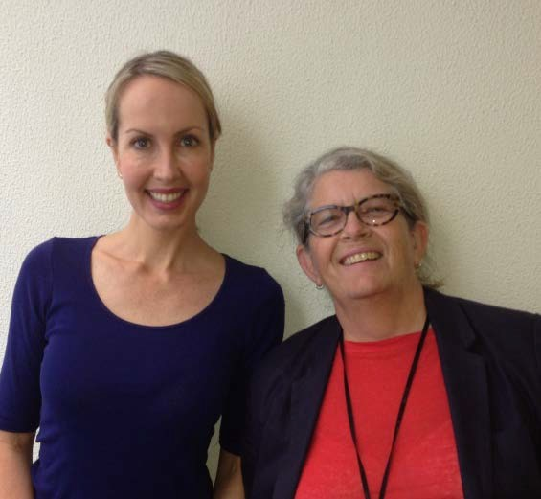The Justice Support Program (JSP) has been operating for three years now, thanks to the funding and support provided by the Department of Justice and Attorney- General. JSP funding is made possible by the Legal Practitioner Interest on Trust Accounts Fund (LPITAF) and we were fortunate to have our funding continued for the 2013-14 financial year. Funding was not increased and so JSP staff continues at two part time Advocates, Liz Francis and Natalia Nash. Natalia is also working part time in the Mental Health Legal Service.

Natalia Nash and Elizabeth Francis Individual Advocates

Referrals
Referrals to JSP continue to come from lawyers, at Legal Aid and Community Legal Centres, the Duty Lawyer service and the JSP brochures distributed throughout the court registries and police stations in the greater Brisbane area. The majority of our clients are located in the greater Brisbane area, ranging from Caboolture to Fernvale to Surfers Paradise however if it is possible to assist a client or carer via phone calls and emails and we frequently do so.

Casework and Advice
JSP actively assisted and advocated for 33 people with disability and provided information, advice or minor assistance to a further 48 people with disability (or their carers) in the 2012-13 financial year. Since JSP commenced in September 2009 we have assisted over 250 people with disability. Of all these clients we have only heard of one who has re-offended, and that was while his first charge was being prosecuted and was a continuation of the same problem with the complainant. Since he was convinced by his lawyer that, contrary to what the complainant had been telling him, he would not be sent to jail for the first charge, his behavioural problems have ceased. As mentioned in the 2012-13 report, it was inevitable that a client would reoffend but 99.6% effectiveness is still a highly commendable success rate and as before, a tribute to our client’s merit.

Scope of work
JSP clients generally have an intellectual impairment or mental health condition and their charges range from minor wilful damage, public nuisance to serious sexual and physical assault. With all clients we give first priority to ensuring they get fair treatment in the criminal justice system, but the real work begins when we assist them to access the available community or family supports which will hopefully prevent any reoccurrence of their offending behaviour.
When assisting our clients within the criminal justice system we advocate with the police (in the field, at the station, at the watch-house and at court), with Legal Aid (both the legal practice and

the grants section), with the Duty Lawyer Service (prior to a client’s court appearance and during), with Community Legal Centres and private law firms and with Correctional Centres.
With the police we provide support to clients if they decide to participate in an interview, we negotiate with police while they are actively investigating a complaint, we advise the watch- house staff of a client’s particular disability, needs and circumstances so that their treatment is appropriate for their condition.
At one of the police interviews we attended the officer was kind enough to explain that one function of the support person is to intervene if the officer becomes aggressive or intimidating, which seemed a bit silly because that’s hardly likely to happen in front of an independent witness. The same officer went on to explain that after a suspect is charged he has to stay in the watch-house overnight and go to court in the morning to see if the police will allow bail. After being queried the officer acknowledged that he could simply issue a notice to appear or the watch-house can grant bail and the court makes the final decision about bail.
The quality of the Duty Lawyer Service is highly variable. This appraisal is not based on the quality or accuracy of their legal service, but on their ability to recognise the client’s impairment and willingness to adjust their service accordingly.
A good duty lawyer carefully explained any legal terms they used, and they were constantly assessing the client’s understanding and level of impairment. They tried not to confuse or agitate the client, they also tried to get the matter dealt with as quickly as possible (it is usually adjourned to obtain a report or apply for Legal Aid). Other duty lawyers just tried to get the client in and out of the room as quickly as possible, barking out questions and getting impatient if there isn’t a yes or no answer, hardly even looking at him or her. JSP does not normally participate in duty lawyer meetings, we just observe and take note of any follow-up that is necessary and provide any useful information or documentation we have on file. However, sometimes we have to intervene to explain about the client’s disability. If this doesn’t have the desired effect we just get the client through the day as quickly as possible and do whatever we can to arrange for advice and hopefully representation from a different lawyer.
We have developed a strong working relationship with the Dual Disability team attached to the Queensland Mental Health Service. The team has been particularly helpful with three JSP clients who are adults living with their families without any form of support from the community or Disability Services. The clients had developed minor behavioural problems which (from my unprofessional observation) remind me of an adolescent struggling to find his place and assert his independence, both in the community and within the family dynamics. The problem is that these clients are between 35 to 45 years old. The common factor is that their carers (parent or sibling) are getting older, more tired and less mobile and are no longer able to control their child or sibling (or perhaps have realised that they need to relinquish their control). Unfortunately the transition has been unplanned, without guidance and with one common result - an adverse reaction by the community to their sometimes confronting behaviours.
Natalia has had a hectic introduction to JSP, her first client has a significant intellectual

impairment, is suspected of a very serious offence, has been thrown him out of his home and multiple government departments are involved. Natalia has juggled phone calls, emails and appointments backwards and forwards between family, support services, police, multiple lawyers and multiple government departments.

Since the last staff report, the Service has:
  - Attended a meeting with the Endeavour Foundation to talk about the JSP
  - Attended a meeting with Caxton Legal Centre to talk about the JSP
Participated in a presentation by QAI MHLS & HRLS to the District Forensic Liaison Officers, Queensland Mental Health.
In addition to this we participate in the QAILS Balanced Justice Project – the development of resources that promote community understanding around evidence-based, effective and human rights compliant criminal justice policies; and distribution and promotion of up-to-date and accurate information about topics such as juvenile offenders, crime statistics, mandatory sentencing, disability and crime, policing policies and procedures, etc..
We continue to distribute the JSP brochures to the various courts and services available to people with disability and are pleased to be receiving more and more referrals from a broad range of these services.

Continuing Professional Development
Since the last staff report, the Service has attended the following:
  - Book launch of ‘Disability and the Queensland Criminal Justice System’
  - Nundah Community Enterprise Co-operative (NCEC) Employment Forum
  - WWILD Paperbag lunch - Self-advocacy and Intellectual Disability
  - Centre of Excellence seminar on Routine Outcome Measurement in Disability Services
  - Centre of Excellence seminar on Supporting Offenders with a Disability in the Community
  - WWILD Paperbag lunch presentations:
  - Dan Toombs on Disability and the Queensland Criminal Justice System
  - Di Pendergast on Disability and the Queensland Criminal Justice System, the Department of Child Safety, QCAT and the Family Court.
  - Youth Justice Forum about masculinity issues for men with intellectual impairment
  - AHRC Forum on people with disability in the criminal justice system
  - Dr Luke Hatzipetrou workshop about Dual Disability
  - QAI Supported Decision Making forum
  - Australian Domestic & Family Violence Clearinghouse webinar about the impact of domestic violence on children.

- - - - -

QUEENSLAND ADVOCACY INCORPORATED

FINANCIAL REPORT

FOR THE YEAR ENDED 30 JUNE 2013

e<,a,,z-<::l4_
CHARTERED CCOUNTANTS
LIABILITY LIMITED BY A SCHEME APPROVED UNDER PROFESSIONAL STANDARDS LEGISLATION

ASSETS AND LIABILITIES STATEMENT AS AT 30 JUNE 2013  2013 |  | 2012
CURRENT ASSETS
Cash on Hand 300.00 |  | 300.00
Cash at Bank (Note 2) 272,589.61 |  | 235,193.29
Debtors & Prepayments 24,036.16 |  | 26,391.77
296,925.77 |  | 261,885.06
FIXED ASSETS (Note 3) 33,456.00 |  | 28,050.00
INVESTMENT 47,972.79 |  | 39,289.18
378,354.56 |  | 329,224.24
CURRENT LIABILITIES
Creditors & Accruals 20,846.57 |  | 13,862.13
Provisions for Employee Entitlements 67,100.30 |  | 40,774.28
Grants Received & Unexpended 38,936.63 |  | 59,662.31
126,883.50 |  | 114,298.72
NET ASSETS $251,471.06 |  | $214,925.52
MEMBERS FUNDS
Balance 1 July 2013 214,925.52 |  | 183,736.63
Net Surplus/(Deficit) for Year - Dept Families & Community Services 11,018.99 |  | 1,270.00

. Net Surplus/(Deficit) for Year - Justice & Attorney-General - JS Net Surplus/(Deficit) for Year - Justice & Attorney-General - MHS Net Surplus/(Deficit) for Year - Justice & Attorney-General - HRLS Net Surplus/(Deficit) for Year - General

TOTAL MEMBERS FUNDS
3,406.00 10,784.00
- -
- -
22,120.55 19,134.89

--
$251,471.06 $214,925.52

DEPARTMENT OF FAMILIES & COMMUNITY SERVICES

INCOME | 2013 |  | 2012
Department Family & Community Services | 414,226.00 |  | 396,716.00
Unexpended Grant from previous year | 6,412.06 |  | 19,441.37
Less Unexpended  Less Grant Funds Returned | (6,412.00) |  | (6,412.06)
 | 414,226.06 |  | 409,745.31

LESS EXPENDITURE
Total Expenditure (Schedule Attached) | 403,207.07 | 408,475.31
NET SURPLUS[(DEFICm FOR THE YEAR | $11,018.99 | $1,270.00

EXPENDITURE | 2013 | 2012
Administration Expenses | - | 7,502.15
Audit & Accountancy | 6,005.11 | 4,830.00
Bank Charges | 661.72 | 623.39
Bookkeeping | 34,924.48 | 49,622.52
Computer Supplies & Support | 8,916.33 | 7,823.56
Consultancy | 4,966.22 | 7,560.00
Depreciation | 6,395.00 | 7,116.00
Electricity | 2,879.77 | 3,670.00
Insurance | 3,321.20 | 4,205.60
Legal Expenses | 1,543.33
Management Committee Expenses | 8,818.67 | 10,726.46
Minor Equipment | 3,081.46 | 6,766.32
Occupancy Costs | 44,944.28 | 44,086.45
Postage, Printing & Stationery | 14,318.65 | 4,420.95
Repairs & Maintenance | 2,611.44 | 1,259.00
Staff Amenities | - | 1,621.84
Staff Training & Supervision | 4,287.53 | 4,965.39
Subscriptions/Memberships | 2,151.03 | 1,465.05
Sundry Expenses | 304.54 | 471.86
Superannuation | 19,015.45 | 18,610.91
Telephone | 3,429.11 | 3,654.81
Travel Expenses | 2,684.31 | 9,369.09
Wages & Salaries | 225,822.32 | 205,181.96
Website Maintenance | 290.52 | 309.87
Workers' Compensation | 1,834.60 | 2,612.13
TOTAL EXPENDITURE | $403,207.07 | $408,475.31

JUSTICE AND ATTORNEY-GENERAL

2013 2012

INCOME

Grant Received - Dept of Justice and Attorney-General Unexpended Grant from previous year
Less Unexpended

135,957.00
22,114.19
(22,348.71)

134,212.00
22,297.31
(22,114.19)

135,722.48 134,395.12

EXPENDITURE
Administration - 4,490.85
Audit 1,078.97
Bookkeeping 15,962.82 13,501.86
Computer Supplies & Support 3,142.78 1,635.84
Depreciation 2,743.00
Electricity 1,130.90 226.60
Insurance 1,281.90 886.40
Minor Equipment 592.50
Occupancy Costs 16,587.21 12,803.48
Office Overheads 1,063.31 1,033.56
Repairs & Maintenance - 433.18
Staff Amenities 344.15 434.75
Staff Training & Supervision 134.07 39.45
Subscriptions/Memberships 72.78 73.92
Superannuation 6,567.15 6,974.39
Telephone 1,127.01 1,341.88
Travel Expenses 9.09 256.31
Wages & Salaries 79,867.55 79,109.76
Work Cover 611.29 241.62
Workshops and Meetings - 127.27

TOTAL EXPENDITURE | 132,316.48 | 123,611.12
 |  | --
NET SURPLUSl(DEFICIT} FOR THE YEAR | $3,406.00 | $10,784.00

s.
QUEENSLAND ADVOCACY INCORPORATED
INCOME AND EXPENDITURE STATEMENT
FOR THE YEAR ENDED 30 JUNE 2013
LEGAL AID FUNDING
2013 | 2012
INCOME
Grant Received - Dept of Justice and Attorney-General 117,002.00 | 114,860.00
Unexpended Grant from Previous Year 7,130.67  Less Unexpended (16,587.92) | (7,130.67)
107,544.75 | 107,729.33
EXPENDITURE
Administration - | 4,492.00
Audit & Accountancy 1,000.00  Bookkeeping 10,533.92 | 9,362.00
Computer Supplies & Support 2,343.19 | 1,349.18
Electricity 816.84 | 477.62
Insurance 946.38 | 887.80
Occupancy Costs 11,150.31 | 9,384.29
Office Overheads 1,089.53 | 1,006.21
Repairs & Maintenance - | 370.03
Staff Amenities 325.10 | 437.37
Staff Training & Supervision 1,851.48 | 56.55
Subscriptions/Memberships 930.75 | 764.17
Superannuation 5,849.83 | 6,278.12
Telephone 1,461.13 | 1,152.70
Travel Expenses 462.08 | 2,419.60
Wages & Salaries 68,258.66 | 68,569.81
Work Cover 525.55 | 271.24
Workshops and Meetings - | 450.64

TOTAL EXPENDITURE 107,544.75 107,729.33
--
NET SURPLUS£(DEFICIT} FOR THE YEAR $ NIL $ NIL

MENTAL HEALTH LEGAL SERVICE

2013 2012

INCOME

Grant Received - Dept of Justice and Attorney-General Unexpended Grant from previous year
Less Unexpended Administration

161,119.00
9,596.09

170,715.09

159,051.00
15,471.34
(9,596.09)
16,485.00

181,411.25

EXPENDITURE

Audit & Accountancy 1,000.00
Bookkeeping 8,795.70 6,701.26
Computer Supplies & Support 2,329.02 669.24
Electricity 943.07 337.65
Insurance 1,121.94 486.87
Occupancy Costs 9,929.32 10,839.47
Office Overheads 1,555.09 1,219.43
Repairs & Maintenance - 512.18
Staff Amenities 407.40 514.72
Staff Training & Supervision 1,697.84 73.45
Subscriptions/Memberships 1,851.23 2,120.87
Superannuation 10,670.60 11,861.55
Telephone 2,651.37 2,159.70
Travel Expenses 1,627.52 3,225.31
Wages & Salaries 125,294.77 139,932.66
Website Maintenance 115.84 126.16
Workshops and Meetings - 630.73
Work Cover 724.38
TOTAL EXPENDITURE 170,715.09 181,411.25
--
NET SURPLUSL(DEFICIT) FOR THE YEAR $ NIL $ NIL

DEPARTMENT OF FAMILIES & COMMUNITY SERVICES - OA

INCOME | 2013 | 2012
Department Family & Community Services Unexpended Grant from previous year Less Unexpended | -  14,409.30  - | 15,000.00  (14,409.30)
 | 14,409.30 | 590.70
EXPENDITURE
Bookkeeping | 10237.86
Superannuation  Wages & Salaries | 344.43  3,827.01 | 590.70

--
TOTAL EXPENDITURE 14,409.30 590.70
--
NET SURPLUSl(DEFICIT) FOR THE YEAR $ NIL $ NIL

GENERAL
 | 2013 |  | 2012
INCOME
Membership | 1,153.53 |  | 1,165.34
Donations | 2,902.46 |  | 2,592.00
Conference/Forums | 19,345.43 |  | 1,145.42
Other Income | 4,988.36 |  | 805.06
Interest Received | 9,613.16 |  | 13,508.81
Investment Income | 1,044.30 |  | 2,024.58
Consulting Income | 28,187.00 |  | 18,985.55
 | 67,234.24 |  | 40,226.76
EXPENDITURE
Consulting Expenses | 22,492.90 |  | 15,236.10
Donation  Minor Equipment Telephone | 477.92  188.82 |  | 1,115.10
Travel Expenses | 790.74
Wages and Salaries | 8,491.00
Workshops and Meetings | 20,311.62 |  | 459.25
TOTAL EXPENDITURE | 52,753.00 |  | 16,810.45
NET OPERATING SURPLUS[(DEFICIT) FOR THE YEAR | $14,481.24 |  | $23,416.31
Market Value Adjustment to Investment | 7639.31 |  | (4,281.42)
NET SURPLUS[(DEFICm FOR THE YEAR | $22,120.55 |  | $19,134.89

CASH FLOWS FROM OPERATING ACTIVITIES | 2013 |  |  | 2012
Receipts  Investment Income | 18,296.77 |  |  | 11,256.97
Other Income | 54,080.39 |  |  | 18,811.60
Cash flows from Government Grants | 828,304.00 |  |  | 819,839.00
Payments  Wages & Salaries | 527,618.46 |  |  | 516,912.10
Other | 312,438.77 |  |  | 332,406.62
Net cash provided by (used in) operating activities | $60,623.93 |  |  | -  $588.85
CASH FLOWS FROM INVESTING ACTIVITIES  Investment Units Purchased | (8,683.61) |  |  | 2,961.84
Payment for purchase of plant & equip | (14,544.00) |  |  | (12,054.00)
Net cash provided by (used in) investing activities | $(23,227.61) |  |  | $(9,092.16)
CASH FLOWS FROM FINANCIAL ACTIVITIES
Net increase (decrease) in cash held | 37,396.32 |  |  | (8,503.31)
Cash at beginning of the reporting period | 235,493.29 |  |  | 243,996.60
Cash at end of the reporting period | $272,889.61 |  |  | $235,493.29
Reconciliation of Net Surplus/Deficit to Net Cash
Provided by (Used in) Operating Activities
Operating Result | 36,545.54 |  |  | 31,188.89
Plus Depreciation | 9,138.00 |  |  | 7,116.00
- (Increase)/Decrease in Receivables | 2,355.61 |  |  | (5,876.77)
- Increase/(Decrease) in Payables | 6,984.44 |  |  | (10,764.35)
- Increase/(Decrease) in Provisions | 26,326.02 |  |  | (23,527.21)
- Increase/(Decrease) in Grants Unexpended | (20,725.68) |  |  | 2,452.29
Net cash provided by (used in) operating activities | $60,623.93 |  |  | $588.85

The accompanying notes form part of these financial statements.

10.

QUEENSLAND ADVOCACY INCORPORATED
NOTES TO AND FORMING PART OF THE FINANCIAL STATEMENTS FOR THE YEAR ENDED 30 JUNE 2013

  - STATEMENT OF SIGNIFICANT ACCOUNTING POLICIES

This financial report is a special purpose financial report prepared in order to satisfy the financial reporting requirement of the Corporations Act 2001. The committee has determined that the association is not a reporting entity.

The report is also prepared on an accruals basis and is based on historical costs and does not take into account changing money values or, except where specifically stated, current valuations of non-current assets.

The following significant accounting policies, which are consistent with the previous period unless otherwise stated, have been adopted in the preparation of this financial report.

    - Fixed Assets - Depreciation

Depreciation is charged on all Fixed Assets on the prime cost method and is brought to account over the estimated economic lives of all Assets.

    - Employee Entitlements

Liabilities for Wages & Salaries and Annual Leave are recognised and are measured as the amount unpaid at the reporting date at current pay rates in respect of employees' services up to that date. Other employee entitlements payable later than one year have been measured at the present value of the estimated future cash outflows to be made for those entitlements.

Contributions are made by the association to an employee superannuation fund and are charges as expenses when incurred.

    - Comparative Figures

Comparative figures, where necessary, have been reclassified in order to comply with the presentation adopted in the figures reported for the current financial year.

    - Economic Dependence

Queensland Advocacy Incorporated is dependant on government funding to operate. As at the date of the report the committee has no reason to believe the government will not continue
to support the organisation.

11.

QUEENSLAND ADVOCACY INCORPORATED
NOTES TO AND FORMING PART OF THE FINANCIAL STATEMENTS FOR THE YEAR ENDED 30 JUNE 2013

2013 2012

  - CASH AT BANK

--
QAI Cheque Account | 225,324.68 | 192,793.06
QAI Gift Fund | 47,264.93 | 42,400.23
 | $272,589.61 | $235,193.29
3. FIXED ASSETS
Furniture & Equipment - Cost | 90,719.00 | 76,175.00
Less Accumulated Depreciation | 57,263.00 | 48,125.00
 |  | -
 | $33,456.00 | $28,050.00
4. AUDITOR'S REMUNERATION

--

Apart from the remuneration disclosed the auditors received no other benefits.

12.

QUEENSLAND ADVOCACY INCORPORATED STATEMENT BY MEMBERS OF THE COMMITTEE

The committee has determined that the association is not a reporting entity and that this special purpose financial report should be prepared in accordance with the accounting policies outlined in Note 1 to the financial statements.

In the opinion of the committee the financial report as set out on pages 1 to 11:

- Presents a true and fair view of the financial position of Queensland Advocacy Incorporated as at 30 June 2013 and its performance for the year ended of that date.

- At the date of this statement, there are reasonable grounds to believe that Queensland Advocacy Incorporated will be able to pay its debts as and when they fall due.

This statement is made in accordance with a resolution of the Committee and is signed for and on behalf of the Committee by:

President e.(_ A7._(3 u t3.{;J_

Treasurer

Dated this 26th day of September 2013

LEVEL 1 488 LUTWYCHE ROAD
.17/
wevr.M/
. CHARTERED ACCOUNTANTS
LUTWYCHE OLD 4030
POBox198
LUlvVYCHE QLD 4030

TELEPHONE: (07) 3357 8322
FACSIMILE: (07) 3357 9909
EMAIL: admin@haywards.net.au
PARTNERS: GREG DORGE
PETER GESCH PHIL ROBINSON

13,

INDEPENDENT AUDITOR'S REPORT TO THE MEMBERS OF

QUEENSLAND ADVOCACY INCORPORATED

Report on the Financial Report

We have audited the accompanying financial report, being a special purpose financial report, of Queensland Advocacy Incorporated which comprises the assets and liabilities statement as at 30 June 2013, and the income and expenditure statement, a summary of significant accounting policies, other explanatory notes and the statement by members of the committee.

Committee's Responsibility for the Financial Report
The committee of the association is responsible for the preparation and fair presentation of the financial report and has determined that the accounting policies described in Note 1 to the financial statements, which form part of the financial report, are consistent with the financial reporting requirements of the Associations Incorporation Act (Qld) and are appropriate to meet the needs of the members. The committee's responsibilities also include designing, implementing and maintaining internal control relevant to the preparation and fair presentation of the financial report that is free from material misstatement, whether due to fraud or error; selecting and applying appropriate accounting policies; and making accounting estimates that are reasonable in the circumstances.

Auditor's Responsibility

Our responsibilily is to express an opinion on the financial report based on our audit. No opinion is expressed as to whether the accounting policies used, as described in Note 1, are appropriate to meet the needs of the members. We conducted our audit in accordance with Australian Auditing Standards. These Auditing Standards require that we comply with relevant ethical requirements relating to audit engagements and plan and perform the audit to obtain reasonable assurance whether the financial report is free from material misstatement.

An audit involves performing procedures to obtain audit evidence about the amounts and disclosures in the financial report. The procedures selected depend on the auditor's judgment, including the assessment of the risks of material misstatement of the financial report, whether due to fraud or error. In making those risk assessments, the auditor considers internal control relevant to the entity's preparation and fair presentation of the financial report in order to design audit procedures that are appropriate in the circumstances, but not for the purpose of expressing an opinion on the effectiveness of the entity's internal control. An audit also includes evaluating the appropriateness of accounting policies used and the reasonableness of accounting estimates made by the committee, as well as evaluating the overall presentation of the financial report.

LIABIL!TY LIMITED BY A SCHEME APPROVED UNDER PROFESSIONAL STANDARDS LEGISLATION

14.

The financial report has been prepared for distribution to members for the purpose of fulfilling the committee's financial reporting under the Associations Incorporation Act. We disclaim any assumption of responsibility for any reliance on this report or on the financial report to which it relates to any person other than the members, or for any purpose other than that for which it was prepared.

We believe that the audit evidence we have obtained is sufficient and appropriate to provide a basis for our audit opinion.

Independence

In conducting our audit, we have complied with the independence requirements of Australian professional ethical pronouncements.

Auditor's Opinion

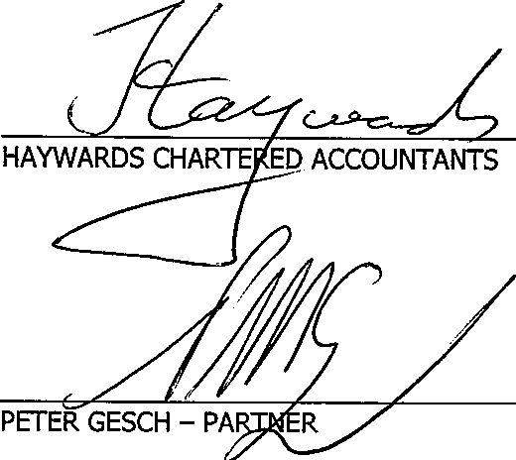
In our opinion, the financial report of Queensland Advocacy Incorporated presents fairly, in all material respects the financial position of Queensland Advocacy Incorporated as of 30 June 2010 and of its financial performance for the year then ended in accordance with the accounting policies described in Note 1 to the financial statements.

26 SEPTEMBER 2013 BRISBANE

26 September 2013

Department of Families, Housing, Community Services and Indigenous Affairs
GPO Box 9820
BRISBANE QLD 4001

QUEENSLAND ADVOCACY INCORPORATED INCOME AND EXPENDITURE STATEMENT FOR THE YEAR ENDED 30 JUNE 2013

INCOME
Grant Received | 414,226.00
Unexpended Grant from previous year | 6,412.06
Less Grant Funds Returned | (6,412.00)  -
 |  | $414,226.06
LESS EXPENSES
Audit & Accountancy | 6,005.11
Bank Charges | 661.72
Bookkeeping | 34,924.48
Capital Expenditure | 11,138.00
Computer Supplies & Support | 8,916.33
Consultancy | 4,966.22
Depreciation | 6,395.00
Electricity | 2,879.77
Insurance | 3,321.20
Legal Expenses | 1,543.33
Management Committee Expenses | 8,818.67
Minor Equipment | 3,081.46
Occupancy Costs | 44,944.28
Postage, Printing & Stationery | 14,318.65
Repairs & Maintenance | 2,611.44
Staff Training & Supervision | 4,287.53
Subscriptions/Memberships | 2,151.03
Sundry Expenses | 304.54
Superannuation | 19,015.45
Telephone | 3,429.11
Travel Expenses | 2,684.31
Wages & Salaries | 225,822.32
Website Maintenance | 290.52
Workers' Compensation | 1,834.60
 |  | 414,345.07
NET LOSS FOR THE YEAR |  | $(119.01)

•

2.

CERTIFICATE OF COMPLIANCE

This is to certify that the grant funds received by this organisation for the above project have been used for the purpose for which they were provided and that conditions included in the letter of advice have been met.

26 September 2013 ;(]3 ff,e, · /2)( C{ff/J-
SID )
ADMINISTRATOR I p

AUDITOR'S REPORT

In our opinion the above statement presents fairly the receipts and payments to which the statement relates for the period ended 30 June 2013.


26 September 2013
HAYWARDS CHA
PETER GESCR/PARTNER

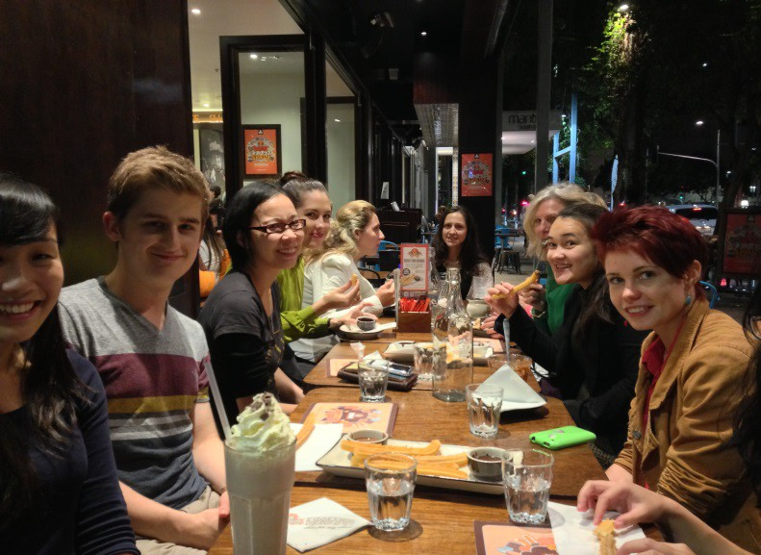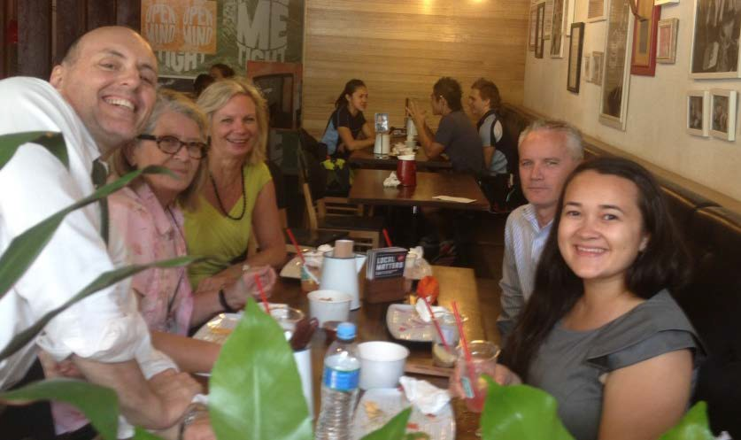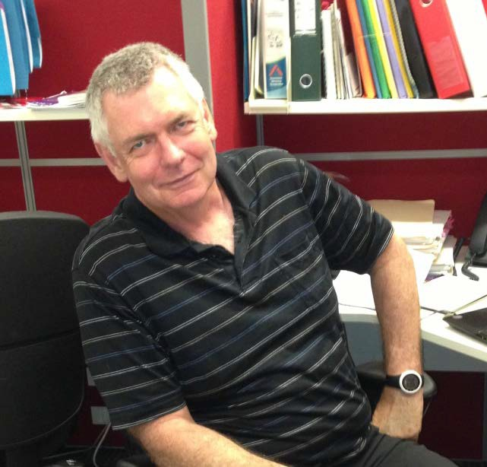
2
6
1

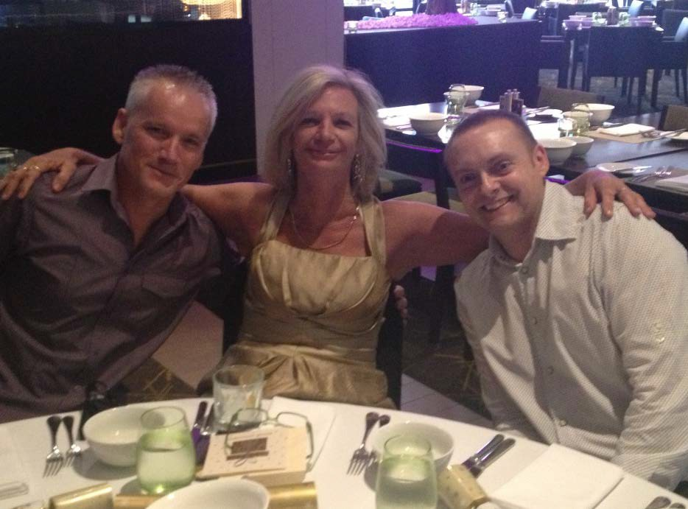
3
4

5

- Volunteer, Nicholas Lauer
- Volunteer Farewell at San Churro
- David Manwaring, Michelle O’Flynn and Ken Wade 4 Karlie Harris and Deborah Bryzak
5 Keith Sun and Naomi Dickson, Law Student Volunteers 6 Staff lunch at Grill’d Southbank

Queensland Advocacy Incorporated
2nd Floor, South Central
43 Peel Street (Cnr Merivale Street) SOUTH BRISBANE QLD 4101
Phone 07 3844 4200
1300 130 582
Fax 07 3844 4220
Email qai@qai.org.au Internet www.qai.org.au

