Open Letter

Immediate Actions Required To Vaccinate and Protect All Australians With Disability Against Coronavirus

12 August 2021

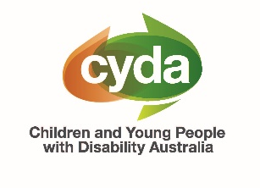
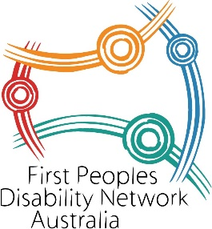
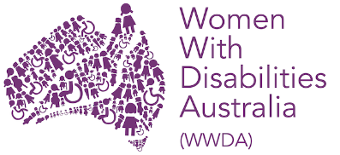


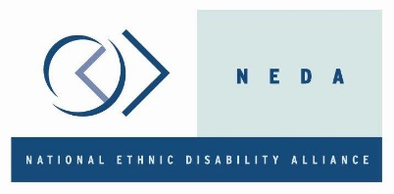


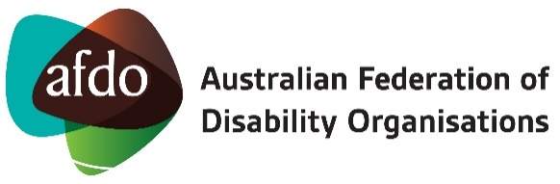
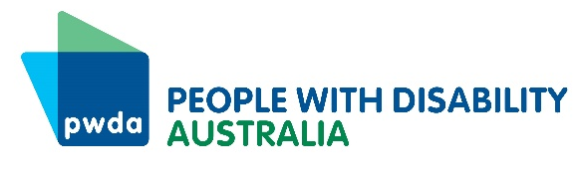

If you are an organisation that represents people with disability, and would like to endorse this open letter, please email your logo to Giancarlo de Vera, Senior Manager of Policy at People with Disability Australia at giancarlod@pwd.org.au
Dear National Cabinet

Immediate Actions Required to Vaccinate And Protect All Australians With Disability Against Coronavirus

We are a diverse alliance of organisations from across Australia, representing the interests of people with disability. Collectively, we have significant, direct and growing knowledge of the impact of coronavirus (COVID-19) on people with disability in Australia.

Australians with disability are one of the groups at greatest risk from contracting coronavirus, and so were identified as needing to be vaccinated in Phase 1a and 1b in Australia’s vaccination rollout. While vaccinations for Phase 1a and 1b began in February 2021, these phases have not been completed, leaving many people with disability at significant risk.

Why Are We Still Waiting?

In June 2021, People with Disability Australia (PWDA), a national cross-disability peak organisation representing people with disability, wrote to the National Cabinet, the Australian Health Protection Principal Committee (AHPPCP), the Minister for the National Disability Insurance Scheme (NDIS) and state and territory disability ministers, calling for the coordination of Australian governments to speed up plans to vaccinate and protect people with disability with a clear 11-point plan.

This 11-point plan is based on best practice standards in COVID-19 vaccination rollouts from the International Disability Alliance. In August 2021, as more than half of Australians remain subject to significant lockdowns due to outbreaks of the highly contagious Delta variant of COVID19 in the community, including in disability group homes, we continue to see a lack of clear, specific and targeted measures from Australian governments, to support and protect people with disability.

Implement Our Plan Now!

As an alliance, we speak with one clear voice and urgently call for transparency around the actions and timeframes Australian governments will take to proactively support and protect people with disability from COVID-19, and urgently call for immediate action from Australian governments. This is urgent.

People with disability must be protected from the impacts of COVID-19 now. The arrangements, communication, and reasonable adjustments people with disability need require collaboration.

The diverse coalition of organisations who have endorsed this open letter now urgently call on the Australian Government to immediately implement the 11-point plan below.

11-Point Plan To Urgently Improve The Rollout Of COVID-19 Vaccines To People With Disability In Australia

- Release a clear public plan and transparent timeframes on how the Australian Government will complete phases 1a and 1b of the vaccines rollout, in consultation with state and territory governments.

- Release a clear public plan and transparent timeframes on how all people with disability, including young people, in all congregate settings not included in Phase 1a will be vaccinated.

- Release a clear plan and timeframes on how people with disability not included in phases 1a and 1b of the vaccine rollout will be vaccinated, and centrally coordinate and implement this plan with state and territory governments.

- Create a dedicated and fully accessible vaccination booking system for all people with disability and their supporters.

- Release a clear public plan and transparent timeframe for all people with disability and their supporters to access the vaccine of their choice, including Pfizer, and centrally coordinate the availability of vaccines with state and territory governments to ensure vaccine choice is realised.

- Vaccinate all young people with disability (12+) in a centrally coordinated effort implemented with state and territory governments.

- Vaccinate all close contacts including carers, support workers and family members (12+) of people with disability in a centrally coordinated effort implemented with state and territory governments.

- Release disaggregated public data on the vaccination numbers for all people with disability now, and continue to publicly report at least weekly on these numbers for each state and territory.

- Provide accessible and up to date information in a variety of formats and languages for people with disability and their supporters about all lockdown rules and changes in one central place, such as the Disability Gateway, and ensure all disability services are aware of current rules.

- Ensure the NDIS Quality and Safeguards Commission take immediate action to enforce public health orders in disability services, and ensure people with disability have what they need to stay safe, including the continuity of supports and access to personal protective equipment (PPE).

- Promote, track and report the use of current Medicare flag-fall arrangements (MBS item 90005) to provide a call-out service to people with disability, so people can be vaccinated in their place of residence.

We look forward to discussing this plan and its implementation as soon as possible with relevant representatives of the government and its respective agencies.

Thank you for your time and consideration.

Kind regards

Sebastian Zagarella  Chief Executive Officer  People with Disability Australia (PWDA) | Damian Griffis  Chief Executive Officer  First Peoples Disability Network (FPDN)
Carolyn Frohmader  Chief Executive Officer  Women with Disabilities Australia (WWDA) | Dwayne Cranfield  Chief Executive Officer  National Ethnic Disability Alliance (NEDA)
Mary Sayers  Chief Executive Officer  Children and Young People with Disability Australia (CYDA) | Catherine McAlpine  Chief Executive Officer  Inclusion Australia
Ross Joyce  Chief Executive Officer  Australian Federation of Disability Organisations (AFDO) | Mary Mallett  Chief Executive Officer  Disability Advocacy Network Australia (DANA)

Endorsements

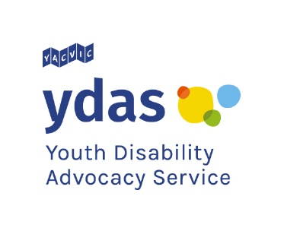
This open letter calling on Australian governments to take immediate action to vaccinate and protect all Australians with disability, has also been endorsed by the following organisations:
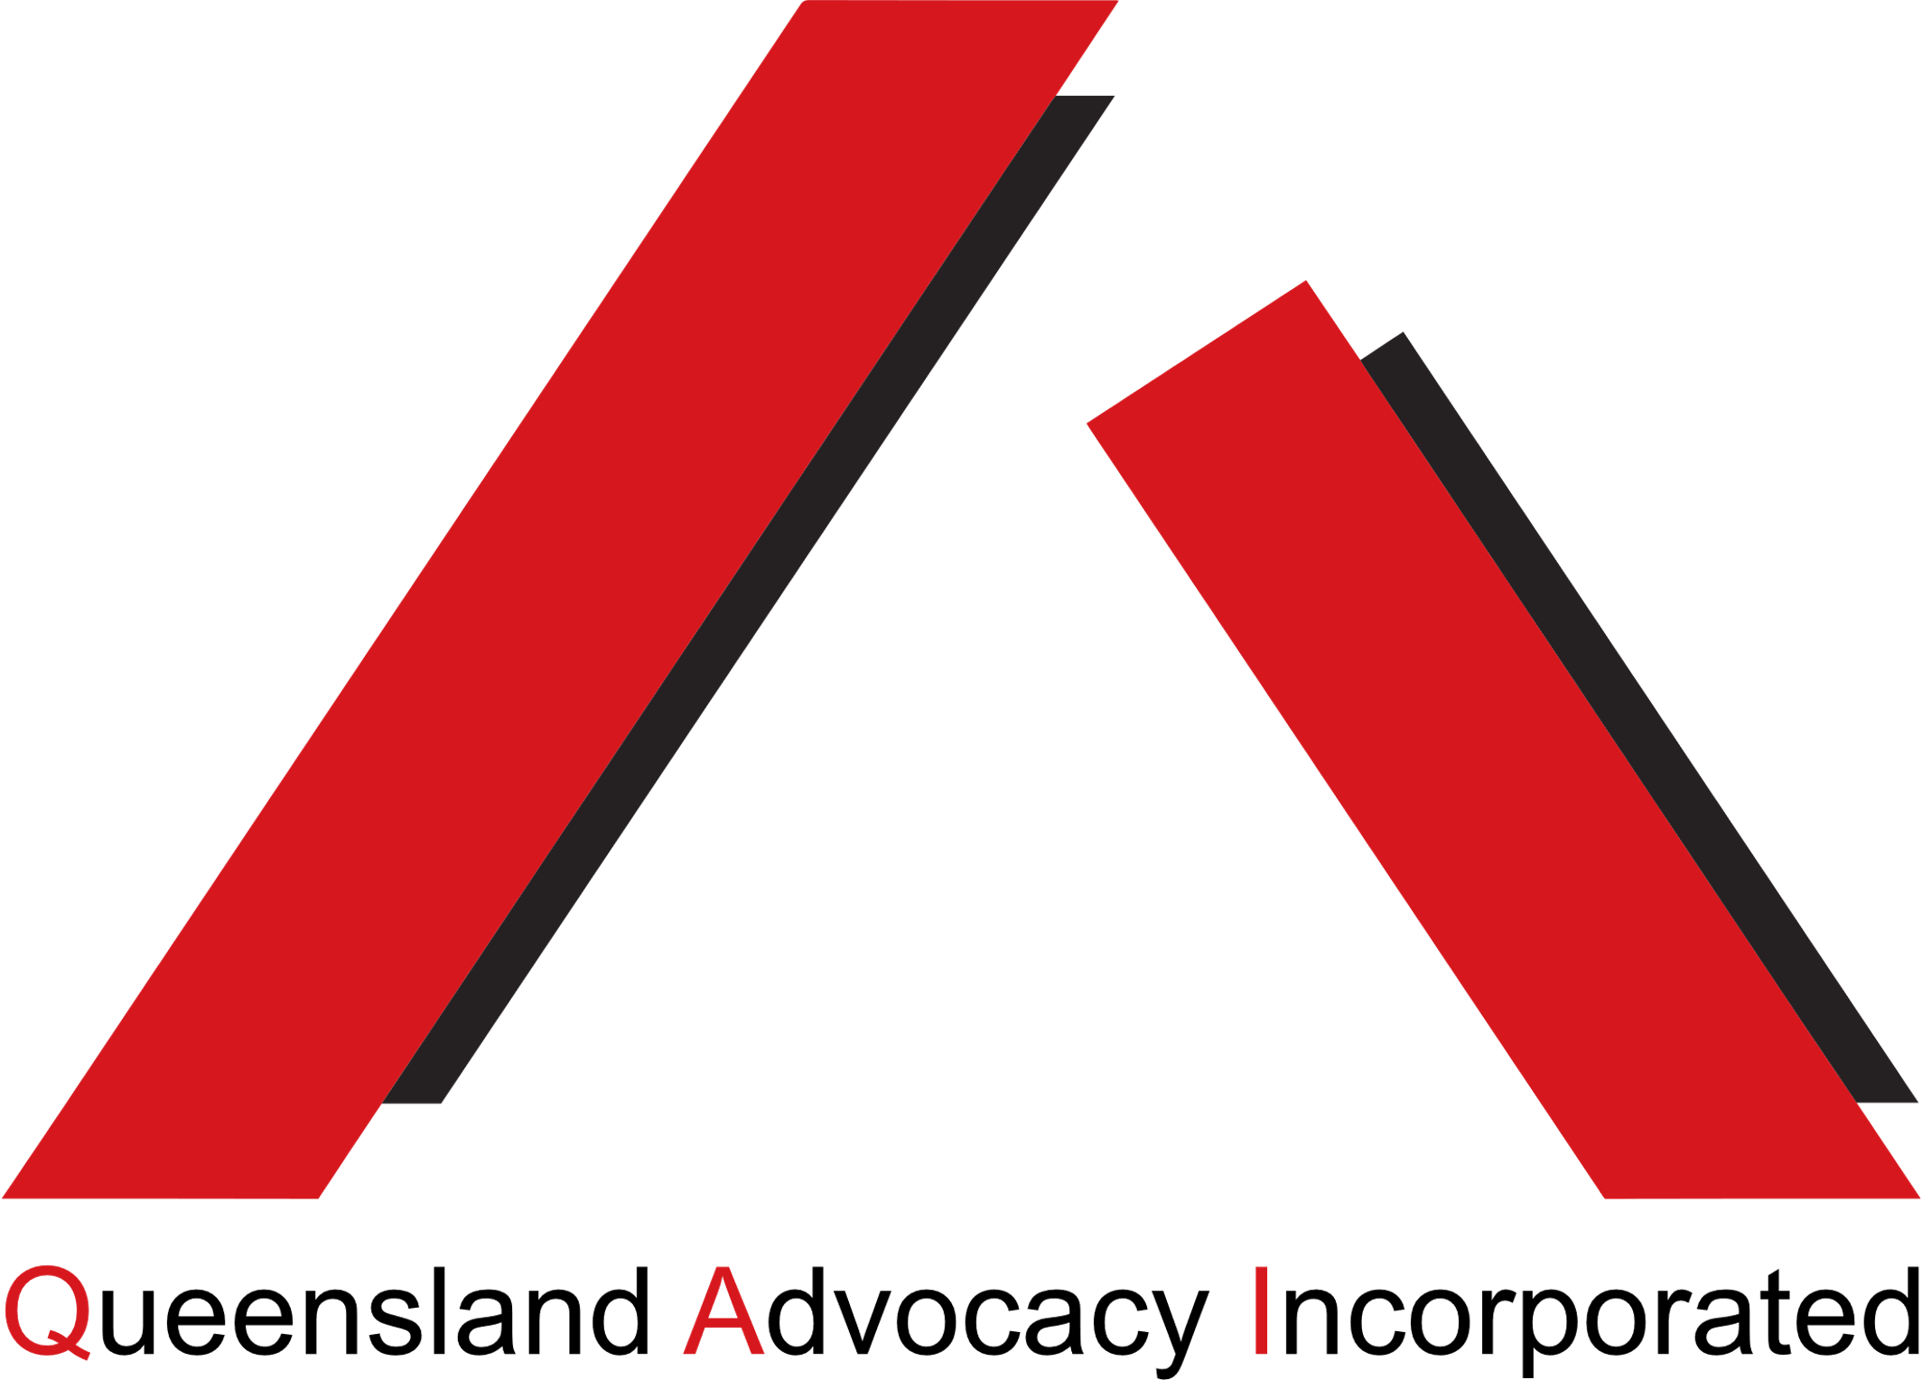

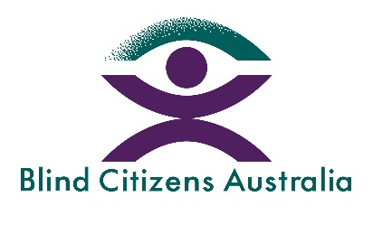




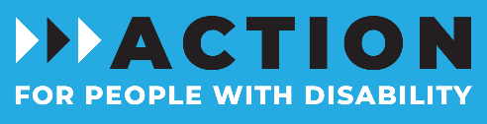
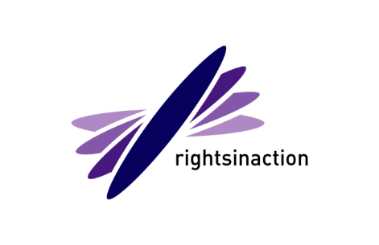
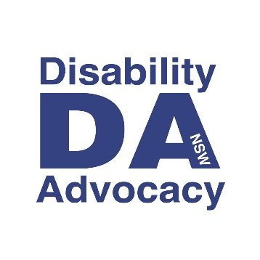
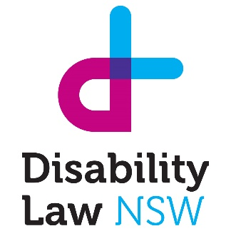
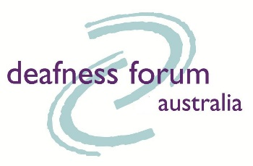





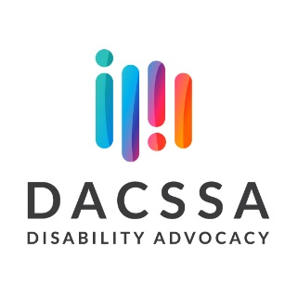
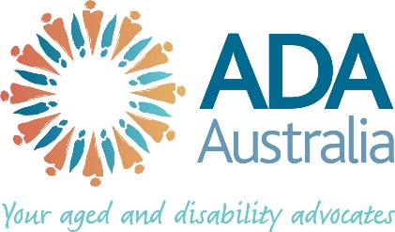
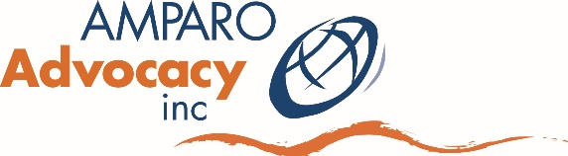


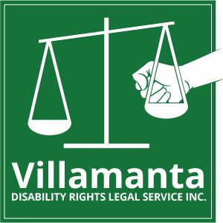

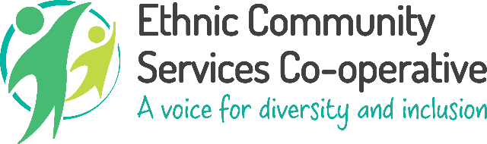


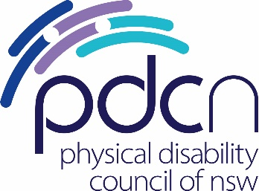
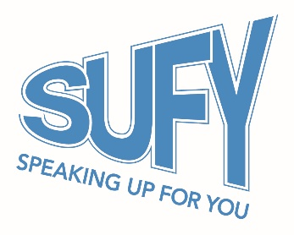
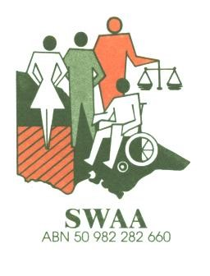





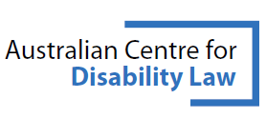

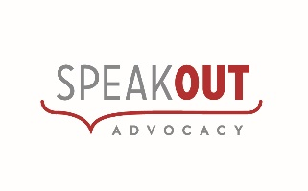


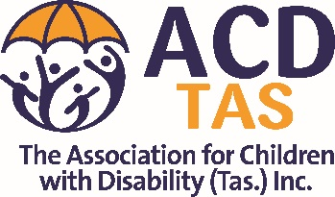
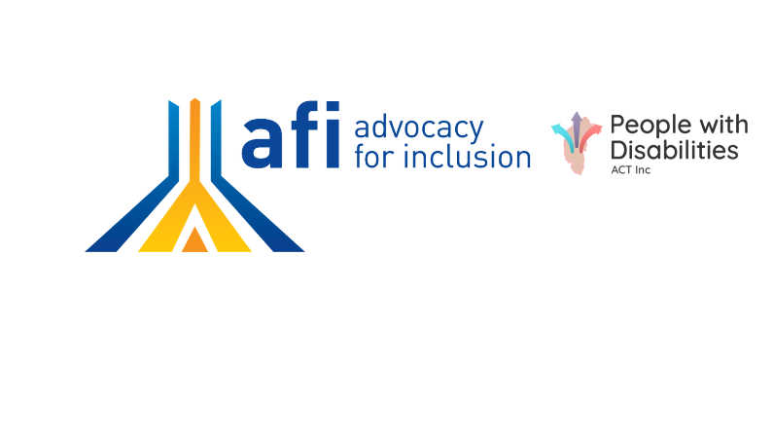
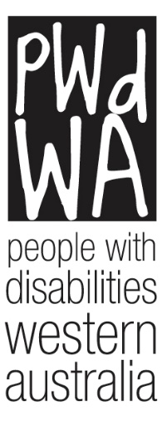


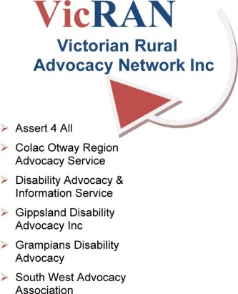



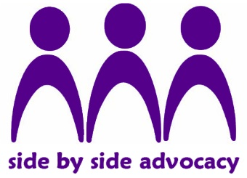
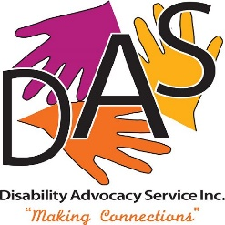

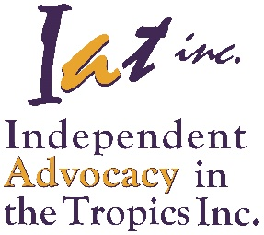
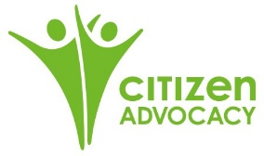






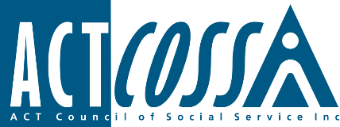

- ACT Council of Social Services  - Action Advocacy  - Action for More Independence and Dignity in Accommodation Inc.  - Advocacy for Inclusion  - Advocacy WA  - Aged and Disability Advocacy Australia  - All Means All  - AMPARO Advocacy Inc  - Association for Children with a Disability  - Australian Centre for Disability Law  - Australian Council of Social Services  - Barwon Disability Resource Council  - Blind Citizens Australia  - Blue Knot Foundation  - Brain Injury Australia  - Brain Injury Matters  - Citizen Advocacy Perth  - Deafness Forum Australia  - Developmental Disability WA  - Disability Advocacy and Complaints Service of SA  - Disability Advocacy NSW  - Disability Advocacy Services  - Disability Justice Australia Inc.  - Disability Law NSW  - Down Syndrome Australia  - Ethnic Community Services Cooperative  - Family Advocacy  - Gippsland Disability Advocacy  - Grampians disAbility Advocacy  - IDEAS | - Imagine More  - Independent Advocacy in the Tropics Inc.  - Leadership Plus  - Melbourne East Disability Advocacy  - Multicultural Disability Advocacy Association of NSW  - Muscular Dystrophy Foundation Australia  - Penrith Disabilities Resource Centre Inc.  - People with Disabilities WA  - Physical Disability Australia  - Physical Disability Council of NSW  - Queensland Advocacy Incorporated  - Queensland Centre for Intellectual and Developmental Disability  - Queensland Council of Social Services  - Rights in Action Inc.  - Side by Side Advocacy  - Southwest Advocacy Association Inc.  - Speak Out Advocacy  - Speaking Up For You  - Spinal Cord Injuries Australia  - Stroke Recovery Association NSW  - VALID  - Victorian Rural Advocacy Network Inc.  - Villamanta Disability Rights Legal Service Inc.  - Women with Disabilities Victoria  - Young People in Nursing Homes National Alliance  - Youth Disability Advocacy Service

Media Enquiries:

Michael Badorrek, PWDA Marketing & Communications Manager
michaelb@pwd.org.au | 0408 682 867

Amanda Ellis, PWDA Senior Policy Officer
media@pwd.org.au | +61 2 9370 3100

ENDS

