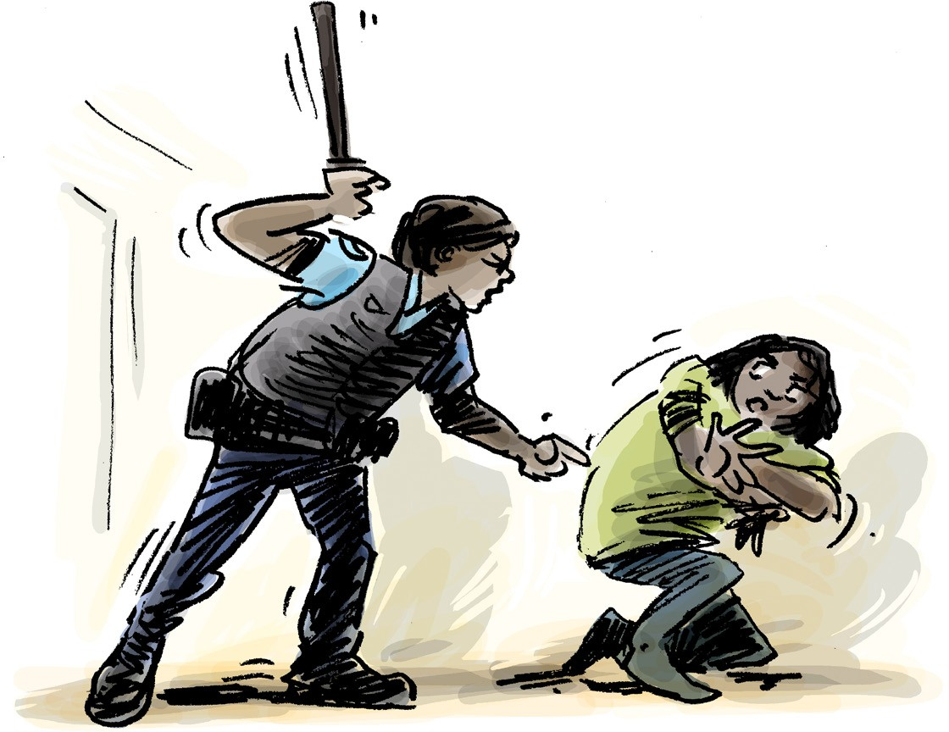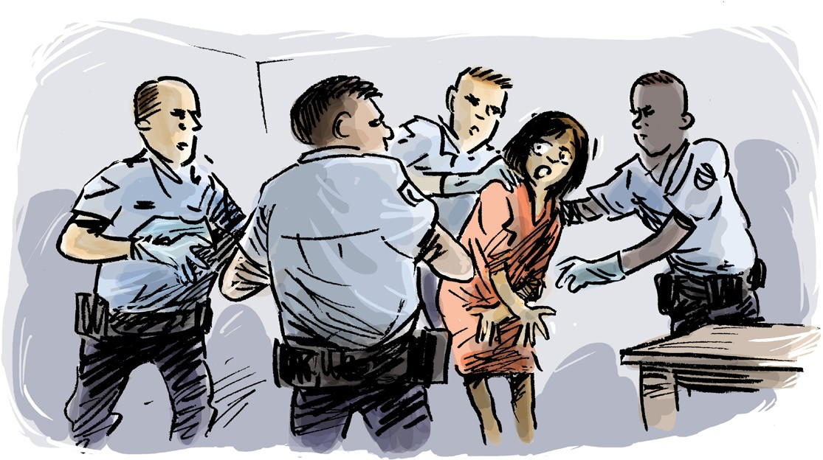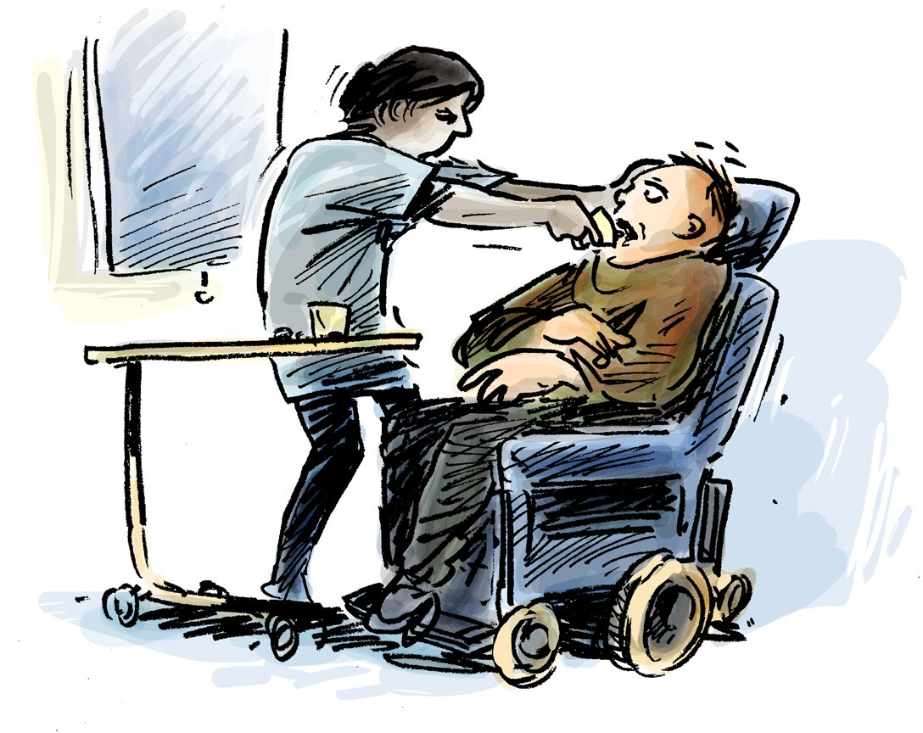

You have the right to feel safe.
You have the right to be treated with respect.

You have
You have the right to good health care.

human rights
Everyone has the right to be safe from torture and cruel treatment
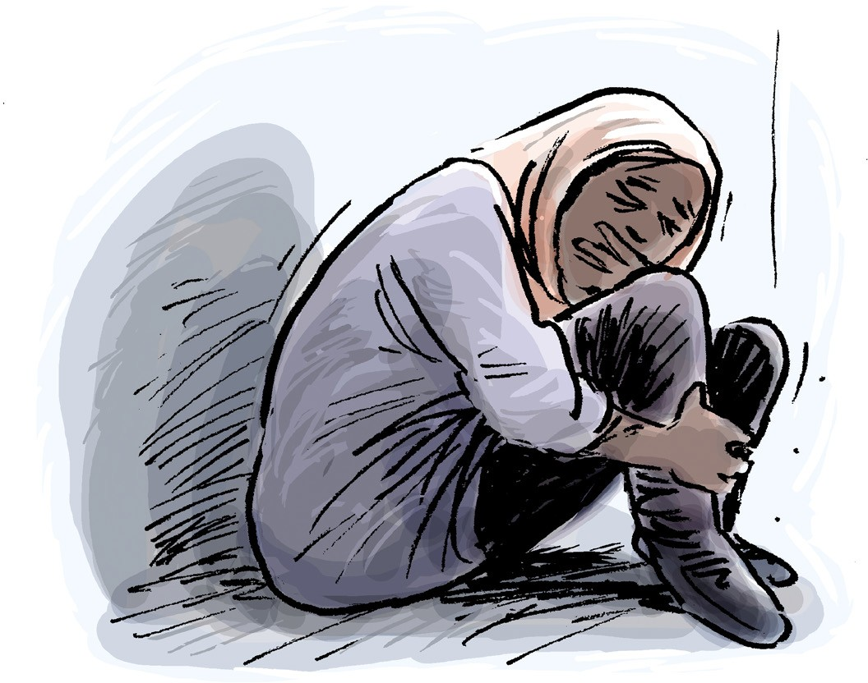
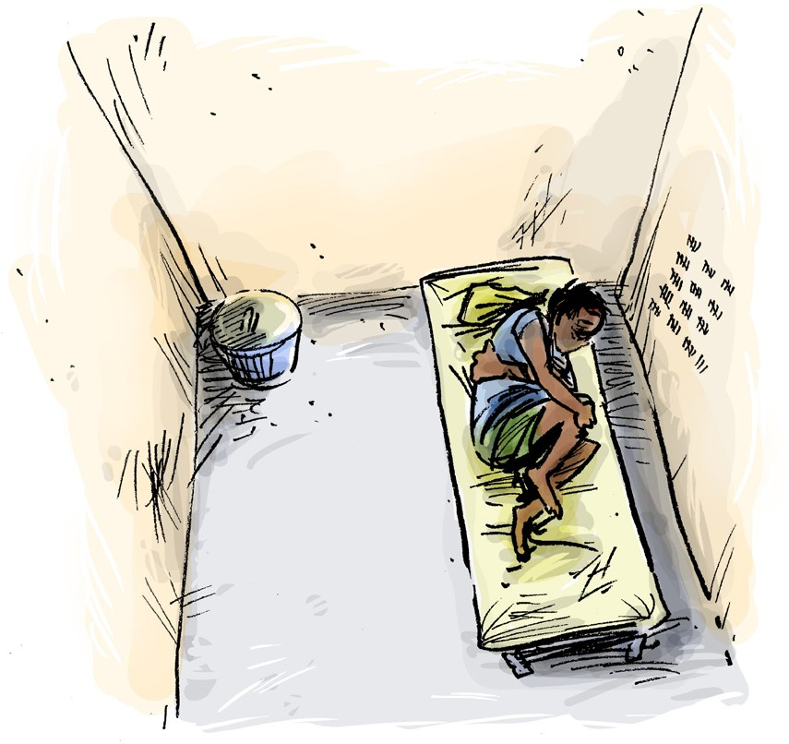
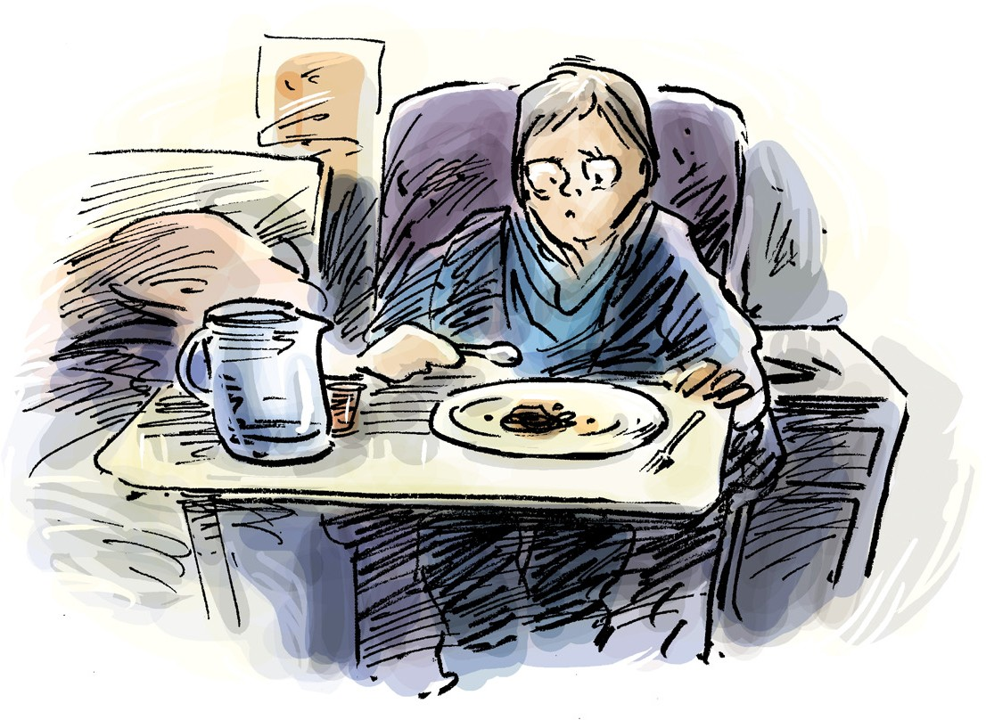

You have the right to get support to understand things and make decisions.
You have the right not to be kept alone for a long time.
You have the right to a clean room with food and fresh air.

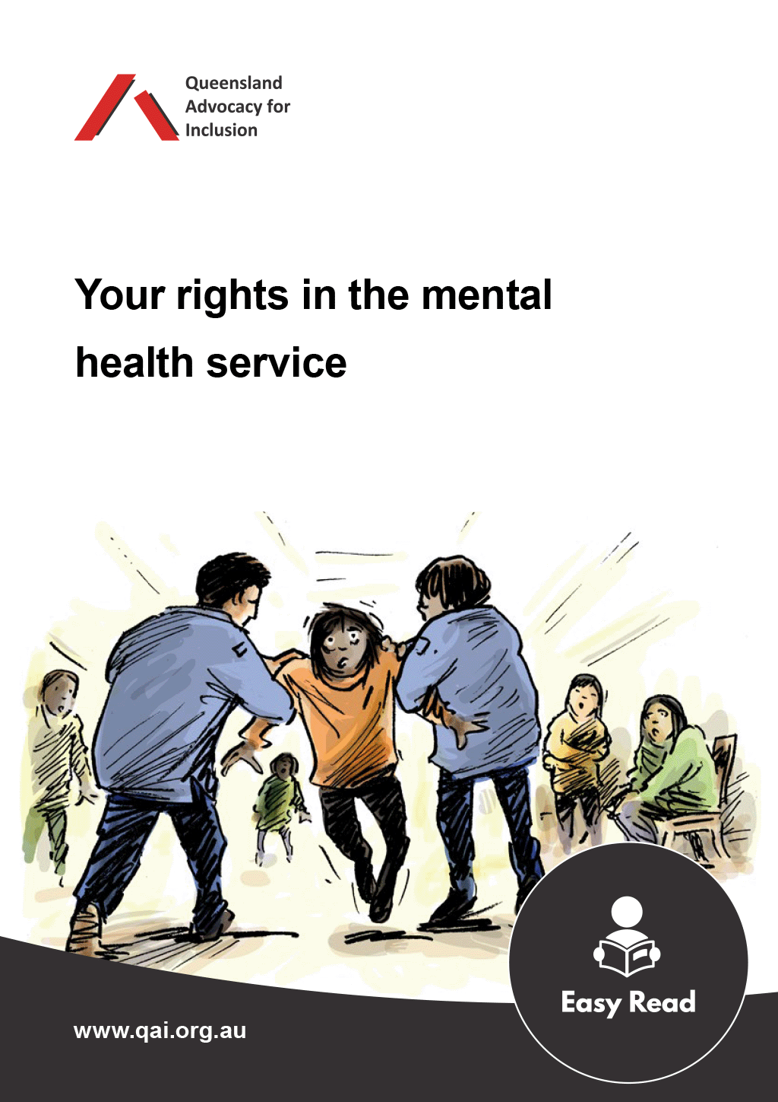
If you think your rights are not being respected, or you think you have experienced torture, cruel, inhuman or degrading treatment or punishment you can get help.

Ask someone you trust for the checklist that comes with this poster. You can find a copy of the checklist with this poster, or it can be downloaded from qai.org.au. This can help you to think about your rights.

If you need help, ask to speak to an advocate or lawyer.


The Convention against Torture and Other Cruel, Inhuman or Degrading Treatment or Punishment is one of the international human rights laws that the Australian Government has agreed to.
By signing this Convention the Australian Government has committed to uphold the rights of people who are detained, or who live in places where their safety and care is the responsibility of Government.

