

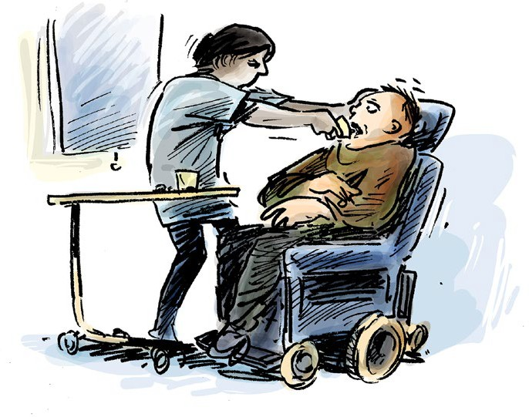

Your rights in the disability

service

www.qai.org.au

Contents

About this info guide 1
What the law says 3
Your right to dignity and respect 6
Your right not to be alone for a long time 9
Your right to good health care 11
Your right to good living and learning areas 14
Your right to be safe 16
Your right to be heard and supported 18
To get more info 20

Council for Intellectual Disability made this document Easy Read. Images ©

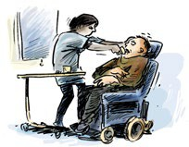

About this info guide

This guide talks about the rights people with disability have where they live.

This could be

- In your disability group home

- In your aged care home.



This info guide helps you know your rights when staff

- Do not respect you

- Do not give you the support you need

- Do not give you things you need

- Search you.

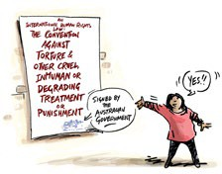

What the law says

There is a human rights law about the things that are not ok to do to someone.

This is an international law.

An international law is a law that countries can choose to say yes or no to.

This law says there are things that are not ok for support or health staff to do.

This law says that torture is never ok.

Torture means that someone does very bad things to you.

Torture is when someone might

- Beat you

- Do sexual things you do not want

- Lock you up by yourself for a long time.

This law says you must not be treated in a way that makes you feel hurt or ashamed.

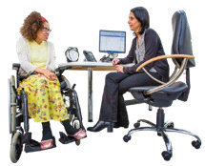This could be things like

- Bullying or scaring you

- Not giving you health care or disability support

- Giving you health care or medication you do not want.

The Australian government said yes to this law.

But there are different laws made by each State or Territory government in Australia.

Some of these laws allow people to be treated in ways that the international law says is not ok.

This info guide talks about the international law and your rights.

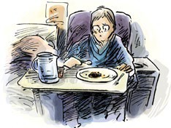

Your right to dignity and respect

This part talks about what support and health staff are allowed to do.

It will help you think about if they treated you with dignity.

Dignity means in a way that does not make you feel bad or ashamed.

Sometimes staff need to search you to see if you are hiding anything.

They must tell you

- Why they need to search you

- How they will do the search.

They must do it quickly.

They should respect your wishes such as

- You do not want a woman in the room

- You do not want a man to search you.

Staff must not use things to hurt or scare you.

They must always give you medical care when you need it.

Staff must always give you things that you need.

This could be things like

- Food and drink

- Sanitary products if you have your period.

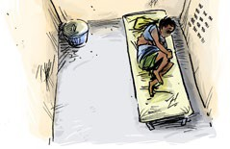

Your right not to be alone for a long time

Sometimes you might need to stay in a room on your own.

This could be because of something like COVID-19.

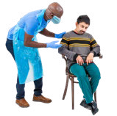Staff must help you understand why you are left alone.

You should not be left alone for a long time.




Staff must give you what you need when you are left alone.

This could be things like

- Food and drink

- Medical needs

- Fresh air.

You have the right to

- Have visits from family and friends

- Get help from an advocate or lawyer.

An advocate is someone who helps you speak up and understand your rights.

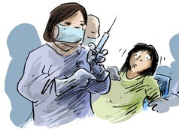

Your right to good health care

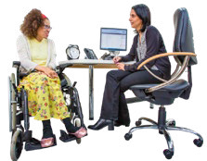You have the right to get good health care.

You have the right to get the medication that you need.

The doctors can only share info about your health with others

- If you say it is ok

- If it is an emergency

- To keep you safe.


You must say it is ok for the doctor to give you medication or treatment.

If it is an emergency the doctor may give you medication or treatment without an ok.

A treatment is something that is meant to make you feel better.

Treatment can be taking medication or talking to someone about how you feel.

The doctor must tell you all about it and why you need it.

You have the right to ask the doctor if you still need the medication or treatment.

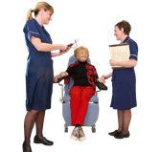You have the right to choose what kind of health care you want to get.

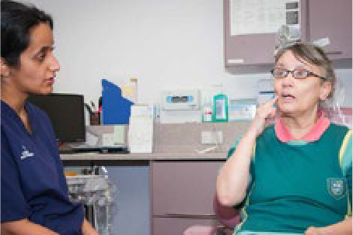

You have the right to good health care even if you say no to medication.

You have the right to get someone to support you to understand medical decisions.

You could get support from

- A support worker

- Advocate

- Lawyer.

You have the right to have health checks to see what your health needs are.



Your right to good living


The places you do things in must be ok for you.

This means you have things like

- A clean room

- A window you can look out

- Air that comes into the room.

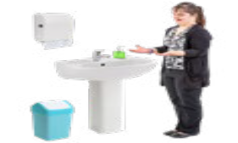You have the right to have a bathroom that

- Is easy for you to move around and use

- You can choose to be alone in.

You must always get good food and drinks.

If you must share your room with other people it should not be crowded.

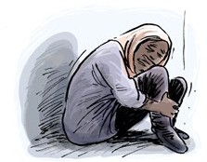

Your right to be safe

You have the right to not be hurt by others.

You should feel safe with

- Staff

- Health workers

- Other people who support you.


You should feel safe in all the rooms at home.


You must get health care straight away if someone hurts you.

Staff must help you.

They need to make sure it will not happen again.

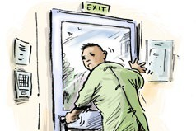

Your right to be heard and supported

You have the right to supports even if staff say you have done the wrong thing.

This means support to

- Do everyday tasks

- To move around

- Understand what is happening

- Be heard and make decisions.

You always have the right to get to see other people who can support you.

This could be

- Family and friends

- Lawyer

- Advocate.



To get more info

If you want help or to get more information about your rights you can speak to advocate or lawyer.

