

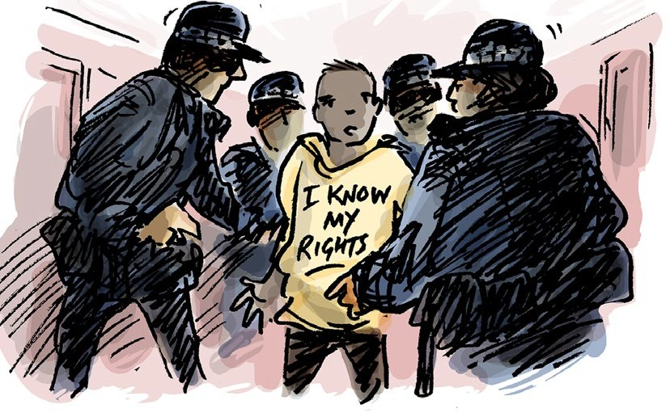

Your rights in the justice service

www.qai.org.au

Contents

About this info guide 1
What the law says 2
Your right to dignity and respect 5
Your right not to be alone for a long time 10
Your right to good health care 14
Your right to live in good living areas 16
Your right to be safe 18
Your right to be heard and supported 20
To get more info 21

Council for Intellectual Disability made this document Easy Read. Images ©

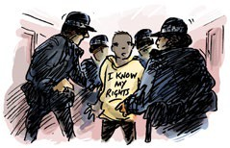

About this info guide

This info guide talks about your rights when you are with the police or in prison.

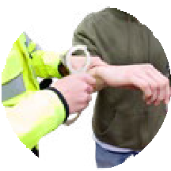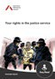This info guide will help you know what is ok and what is not ok when

- The police search you

- You get arrested by the police

- The police ask you questions

- You are in prison.

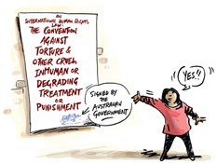

What the law says

There is a human rights law about the things that are not ok to do to someone.

This is an international law.

An international law is a law that countries can choose to say yes or no to.

This law says there are things that are not ok for the police or prison staff to do.

This law says that torture is never ok.

Torture means that someone does very bad things to you.

Torture is when someone might

- Beat you

- Do sexual things you do not want

- Lock you up by yourself for a long time.

This law says you must not be treated in a way that makes you feel hurt or ashamed.

This could be things like

- Bullying or scaring you

- Not giving you health care or disability support

- Giving you health care or medication you do not want.

The Australian government said yes to this law.

But there are different laws made by each State or Territory government in Australia.

Some of these laws allow people to be treated in ways that the international law says is not ok.

This info guide talks about the international law and your rights.

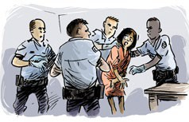
Your right to dignity and respect

This part talks about dignity and respect.

Dignity means in a way that does not make you feel bad or ashamed.

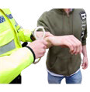We will talk about the different times when you are dealing with police and prison staff.


This part will help you know if they treated you with dignity and respect.


The police must treat you with respect and dignity when they arrest you.

You can ask for someone to help you understand what is happening.

This could be an advocate or a lawyer.

An advocate is someone who helps you speak up.

They must be allowed to support you with all the steps after you were arrested.

The police might use handcuffs or something else to tie your hands together when they

- Arrest you

- Question you

- Search you.

Police are allowed to use handcuffs or ties but only for a short time.

The police might need to search you to see if you have things like weapons or drugs.

When they search you they will touch your body.

They want to see if you hide something under your clothes.

They must tell you

- Why they need to search you

- How they will do the search.

They should respect your wishes such as

- You do not want a woman in the room

- You do not want a man to search you.


Police are allowed to do a strip search.

Strip search means they ask you to take some or all of your clothes off.

There are some rules police must follow when they do a strip search.

Some rules are

- A strip search should be done as quickly as possible

- They must wear gloves to keep everyone safe

- You should not feel like they are making fun of you.

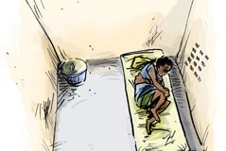

Your right not to be alone for a long time

When you are in prison you have the right not to be alone for a long time.


Officers must not keep you alone because you have a disability.

Solitary confinement is when officers keep you alone in a prison cell for over 22 hours.

+22
hours


They should only do this as a last option.

Solitary confinement should be for the shortest time only.

+15
days

It must not be for more than 15 days in a row.

If they put you in solitary confinement they should tell you

- Why they are doing it

- How long it will be for

- What you need to do to get out.

You should still be allowed to meet with a lawyer or advocate.

Even if you are in solitary confinement your room should be clean.

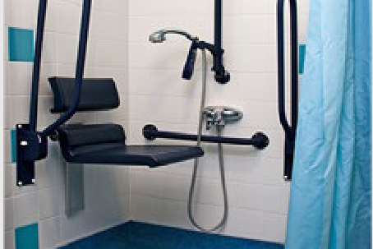
The officers must look after your basic needs. That means that you can always
- Drink water

- Have good food often

- Use a toilet

- Have sanitary products if you have your period

- See a doctor if you are sick or have mental health issues.

You should be allowed to use an accessible bathroom if you need.


You must be allowed fresh air. This could be going outside.

You should get support to move around outside if you need it.

If you have been in solitary confinement think about

- Who did you see?

- Did you see someone every day?

- Could you talk to them for a bit?

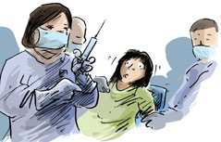

Your right to good health care

When you are in prison you have the right to get good health care.

You can still choose what kind of health care you want to get.


The doctors can only share info about your health with the police or prison staff

- If you say it is ok

- If it is an emergency

- To keep you safe.

You must get the health care and medications you need.



Sometimes a doctor might tell you to take medication or do a treatment.

A treatment is something that is meant to make you feel better.

Treatment can be taking medication or talking to someone about how you feel.

The doctor must tell you

- Why you need it

- How long you need it.

They must get your consent.

Consent means you say yes to the medicaton or treatment.

You can have help to make a decision to give consent or not.

You have the right to ask the doctors if you still need the medicaton or treatment.

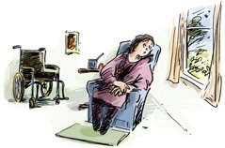

Your right to live in good living areas


When you are in prison the things around you must be ok to live in.

This means you have

- An accessible room and bathroom

- A clean room

- A window

- Air that comes into the room.

You should get time alone in the bathroom or toilet.

You must also always get ok food and drinks.

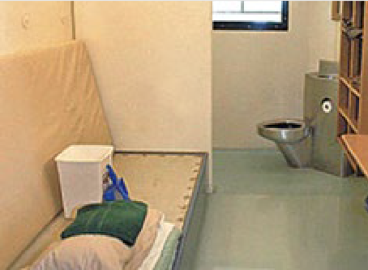If you share a room with other people it should not be crowded.



Your right to be safe

When you are prison you should not get hurt by anyone.

You must get health care straight away if someone hurts you.

Prison staff must help you.

They need to make sure it will not happen again.



You should feel safe in

- Your cell

- The courtyard

- The bathrooms and toilets

- At work

- The common area.

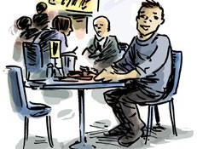

Your right to be heard and supported

When you are in prison you have the right to get the support you need to

- Be heard

- Be supported

- Keep you safe.

This means support to

- Do everyday tasks

- Understand what is happening to you

- Make decisions.


The prison should ask what supports you need when you get to the prison.



To get more info

If you want help or to get more information about your rights you can speak to advocate or lawyer.

