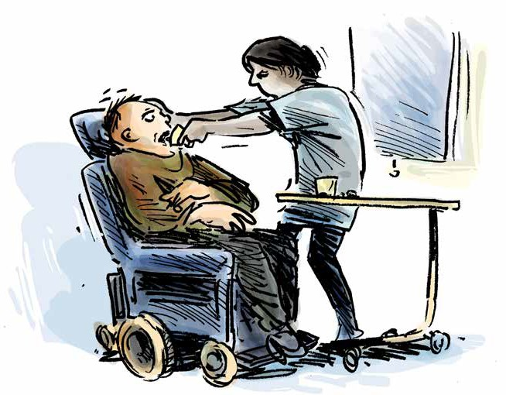Prevention of Torture in Disability Settings

Guide to a disability aware approach

Table of
1
2
3
4
5
6
7
8
9
10

Contents

How to use this booklet

Introduction

Definitions

You have the right to be treated with dignity and respect
You have the right to not be separated from others for long periods of time You have the right to quality, accessible, medical care
You have the right to decent conditions while in this facility You have the right to be safe

You have the right to access support you need to do everyday tasks, understand what is happening to you, and make decisions

Acknowledgements

How to use this booklet

This publication is for general information only. The information provided is not legal advice and should not be treated as such.

These resources are designed to create awareness of rights under the Convention Against Torture. The Convention Against Torture is an international human rights convention that the Australian Government has committed to upholding. Local laws, such as State and Territory laws, are not the same as international human rights conventions. This means that some of the protections under the Convention Against Torture are not found in local laws.

This resource cannot be used to decide whether particular conditions of detention in Australia are lawful. Rather, the resource educates people with disability in detention, their family members, and supporters about international human rights in the Convention Against Torture. If you think you are being treated unlawfully, seek the advice of a lawyer.

Australia is in the process of setting up a framework to implement the Optional Protocol to the Convention Against Torture. This means governments will appoint bodies to monitor places of detention for breaches of the Convention Against Torture.

The monitoring bodies for each State and Territory are listed on the website of the Commonwealth Ombudsman: https://www.ombudsman.gov.au/what-we-do/monitoring-places-of-detention-opcat.

This website also has a complaint form to provide information and make enquiries.

The examples contained in these resources are fictional but draw from cases and the experiences of people with disability in Australia and around the world.

Introduction

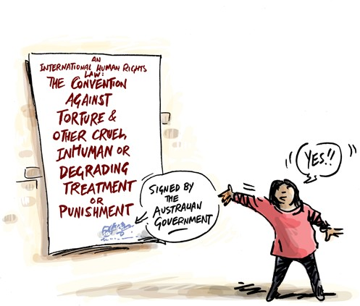
Everyone has the right to be safe from torture and cruel treatment. Everyone has the right to be treated fairly, and with dignity and respect.

If you live in a disability or aged care residence, you have these rights like everyone else.

The Convention against Torture and Other Cruel, Inhuman or Degrading Treatment or Punishment is one of the international human rights laws that the Australian Government has agreed to.

By signing this Convention, the Australian Government has committed to uphold the rights of all people in group homes, disability, or aged care facilities where people are locked in.

This resource can help you learn about your rights under this international law, and to think about whether or not your rights are being respected.
The rights under international law might be different to the rights under the law in your State or Territory.

If you think your rights are not being respected, you can get help. Ask to speak to an advocate or lawyer.


Definitions

What is torture?
Torture is when someone in an official position intentionally inflicts severe pain or suffering, whether physical or mental, on someone else.

Torture can never be justified, and can involve:

- Physical or sexual harm including beating or rape
- Psychological harm including prolonged solitary confinement or indefinite detention

What is cruel, inhuman, or degrading treatment or punishment?
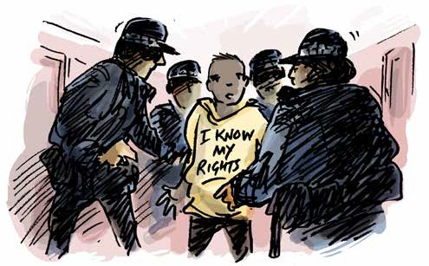
Cruel and inhuman or degrading treatment or punishment causes physical and mental suffering. This may include serious assault or abuse.

This can also include treatment or punishment that is humiliating. This can involve:
- Bullying and intimidation by staff or other residents or students
- Denial of medical and psychological care or disability support
- Involuntary medical and psychological treatment without regular review
- Lack of privacy, overcrowding
- Prolonged isolation
- Inaccessible, poorly equipped, or unhygienic sanitary facilities

The following section tells you what your rights are in international human rights law. Local laws are sometimes different to international law. The questions here will help you to give relevant information to someone who can help. The examples are based on legal cases about torture and cruel and inhumane treatment around the world.


You have the right to be treated with dignity and respect
- This includes being treated with dignity and respect by staff working at the facility
where you live or the school you attend
Examples
Questions

Have you ever been physically restrained?

Have you been searched by staff where you live? Were you made to take off your clothes?
Did someone explain to you why you were being searched?

Who searched you, and who was in the room when you were searched?

Have you had access to a disability advocate to give you advice?
Jake was searched by staff at his group home, following a visit from a relative. A female member of staff was present during the search, despite Jake’s requests that she leave. Jake was made to take off his trousers and asked to squat. He was searched without the staff using appropriate gloves.

The staff would spray Josh with water as punishment. Even though he was all wet, he was locked in a room with a ceiling fan going all day.
Josh was left in the room on his own and vomited. Nobody checked on him or provided him with care or a change of clothes.

Pam did not have access to sanitary products. Every month, she asked the staff at her group home for help, but they would not buy her anything. Pam was forced to use rags and was often embarrassed by marks on her clothes.

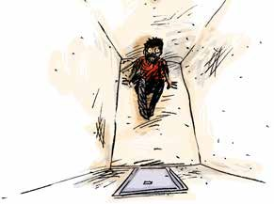
You have the right to not be separated from others for long periods of time
- When someone is held in a separate room for more than 22 hours, this is called solitary confinement
- Solitary confinement must be a last resort and must be for the shortest amount of time possible
- Nobody should be kept in solitary confinement for more than 15 consecutive days, or, repeatedly subject to solitary confinement in consecutive periods
- You have the right to have visitors, and to see family and friends regularly
Examples
Questions

Have you ever been held or locked in a room away from others? How long was it for?

Did someone explain what was happening? Did you have support to help you understand what was happening?

Were you told when it would end, and did it end when you expected it to? Who did you see during this time?
If you were locked in your room, did you see someone every day, and were you able to communicate with them face to face?

If you were in solitary confinement, what were the conditions of your room? Was it clean? Were you able to regularly use an accessible bathroom? Did you have access to things to do? Did you have constant access to water and sanitation?

Were you allowed to meet with a lawyer, or advocate?

Were you able to go outside? If you were, for how long? Did you have the support you need to move around outside?
Imani lived in a residential facility with four other people. One of the residents tested positive to Covid-19. The staff restricted everyone else to their rooms and didn’t allow them to leave.

The facility was also locked, and visitors not allowed to enter. Imani did not see anyone, apart from the staff who brought him his food, for six weeks. He did not attend any regular medical appointments and other
activities. He was not allowed outside.

Imani’s mental health deteriorated very fast, but he was not provided any psychological support.

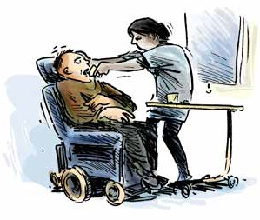
You have the right to quality, accessible, medical care
- You have the right to make decisions about the medical care you receive
- You have the right to privacy and confidentiality around your health care
- If a doctor or psychiatrist has ordered that you need to have a medical treatment, you have the right to have that decision reviewed regularly
- You should have access to all treatments, medication and therapy you need
Examples
Questions

How often do you see a doctor or dentist?

Have you seen your medical records? Who else can see your medical records? Was your consent sought before you received medical or psychiatric treatment?

Has the decision for this treatment been reviewed? How often, and who was involved?

Do you have access to someone (disability support worker, advocate, lawyer) who can help you understand the medical decisions being made?

Do you have access to the medication or treatment you need?

Have you ever been denied a treatment or medical appointment you have requested?

Did you see a medical professional when you needed to?
Staff at an aged care residential facility often gave Huan medication to ‘quieten him down’. They
said he had to have this medication because he kept ‘acting up’ and shouting at staff. Huan was actually in pain due to a fractured wrist, and his behaviour was communicating this pain to staff. Instead of seeking medical help for Huan, he was increasingly sedated. It took 3 weeks for Huan to be seen by a doctor, and this only happened after an advocate was able to visit and raise concern with management.

Gemma lived in a group home. When she moved there, she received no assessment of her medical or dental needs. Gemma had gum disease and did not see a dentist for two years. She developed a serious infection due to lack of care.

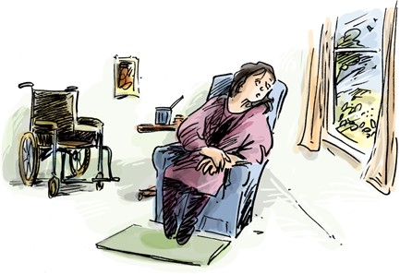
You have the right to decent conditions while in this facility
- This includes having access to accessible facilities
Examples
Questions

Do you have a window in your room that provides natural sunlight?

Can your window be opened for fresh air, or are there other forms of ventilation? Can you use a bathroom that is accessible for you?
Do you have privacy when using the bathroom or toilet? How many people do you share a room with?
What is the quality of your food and drink? Have you ever been denied food or drink?
Pedro uses a wheelchair, but the school he attended did not have accessible bathroom facilities. The staff would not help him, and he was forced to ask other students for help.

He was so embarrassed he would not go to the toilet all day. This happened for over six months and led to Pedro developing medical issues.

You have the right to be safe

- You should be protected from violence, abuse or neglect by staff, other residents where you live and other students where you go to school

Examples
Questions

Do you feel safe?

Are there particular places where you feel less safe, and if so, why?

Are there particular people you feel less safe with, and if so, why?

Have you been verbally bullied by staff, other people you live or go to school with?

Have you ever been physically hurt by staff, other people you live with or go to school with?

Have you ever been locked up somewhere that you could not leave?

If you have been hurt and you needed medical care, was it provided?

Has anything been done about the violence, abuse or neglect you experienced?
Misa, a 9-year-old student with Autism was locked in a very small room with boarded up windows at her segregated school for children with disability. The school locked Misa in the room 20 times over a 12-month period, as a punishment. There was no plan put in place to work with Misa and her family to look at alternative options to using isolation, or to see what support Misa might need. Misa was given no food or drink while in this room, and there was nothing in the room apart from a mattress and pillow.

Janna lived in a group home, with one other female and two males.
The bathroom door did not lock. Over a period of 6 months Janna was repeatedly sexually assaulted by one of the male residents. She told the staff, but the lock was not fixed and the staff did nothing to stop or report the attacks.

Sunny lived in a group home. Over a period of five years, he and the other residents were subjected to violence and abuse by the staff. This included burning with cigarettes, kicking, and punching and spitting in their food and drink. Staff taunted the residents, threatening regularly to withdraw access to their TV and outdoor space. Despite Sunny and the other residents complaining, the staff who were hurting them remained employed.

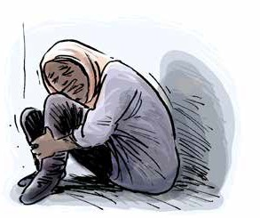You have the right to access support you need to do everyday tasks, understand what is happening to you, and make decisions

- This support should never be denied, withheld or stopped without your permission

Examples
Questions

Do you need any support with everyday activities?

Do you need help understanding what is happening or to make decisions?

Has this support ever been withheld or stopped as a punishment or to make you feel bad?

How long was your support withheld, or stopped?

What happened to you because your support was withheld or stopped? Were you at risk of harm or in danger? Were you unable to move around, go out, or do everyday tasks? Were you isolated from friends, family, your lawyer, or advocate?
Felix has physical and cognitive disability. He lived in a group home with four other residents. They ate dinner together most nights. Felix was repeatedly left at the table for hours after dinner had finished. He required support to move his wheelchair away from the table, but his support worker would not assist. Some of the other residents would mock him and throw food at Felix while he was still at the table. The staff did nothing to prevent this. This treatment continued for over a year and resulted in Felix suffering severe anxiety and distress.

Jesse is an Aboriginal woman with intellectual disability. She lives in an aged care facility over 100km from her family and community. Jesse often didn’t clearly understand the rules and regulations of the facility, as they had never been provided to her in an accessible format or explained clearly. She was punished by staff who thought that she was ignoring the rules. The staff locked Jesse in her room every day for three weeks. They only gave her one meal per day. The staff did not assess Jesse’s support needs or complete a mental health assessment.

Acknowledgements

We acknowledge the following sources in the drafting of the examples used in this resource:

- Christmas Island Medical Officer’s Letter of Concerns – For review by International Health and Medical Services Management and Executive. November 2013
- Council of Europe/European Court of Human Rights Factsheet series (“Detention conditions and treatment of prisoners”, “Detention and Mental Health”, “Prisoners’ health rights” & “Covid-19 health crises”) 2022
- COVID-19 AND OPCAT: Detention of people with disability, and older people. Australian Disability and Aged Care OPCAT Working Group. June 2020
- Response to Australian Human Rights Commission OPCAT in Australia Consultation Paper. Advocacy for Inclusion. July 2017
- Submission to the Senate Inquiry into Violence, abuse, and neglect against people with disability in institutional and residential settings. Australian Cross Disability Alliance (ACDA) August 2015
- Submission to the Special Rapporteur on the Rights of Persons with Disability: Abuse of Students with Disability in Australian Schools. Children and Young People with Disability Australia (CYDA). July 2016
- The Plight of People Living with Disabilities within Australian Immigration Detention: Demonised, Detained, and Disowned. National Ethnic Disability Alliance (NEDA) 2015
- WWDA Response to Restrictive Practices Issues Paper – to the Royal Commission into Violence, Abuse, Neglect and Exploitation of People with Disability. Women With Disabilities Australia. July 2021


For more information or copies of the other resources in this OPCAT monitoring series, please contact us on 1300 130 582 or visit the resource webpage www.qai.org.au/opcat-monitoring-resources/.

Notes

