

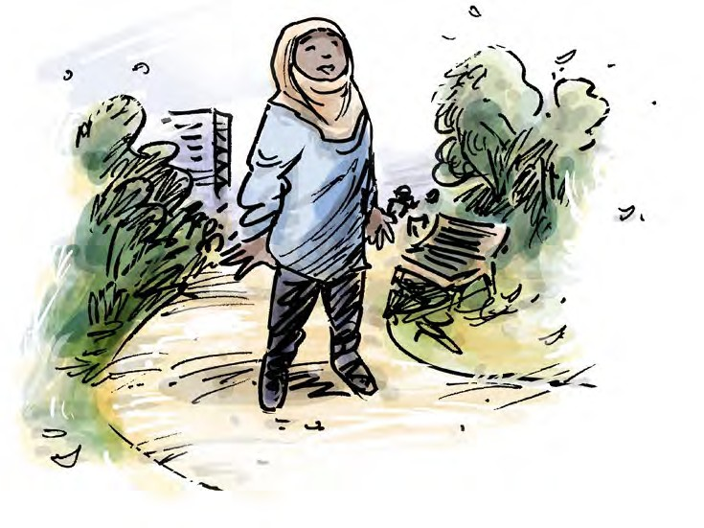


Your rights in

immigration detention

www.qai.org.au

Contents

About this info guide 1
What the law says 3
Your right to dignity and respect 6
Your right not to be alone for a long time 11
Your right to good health care 14
Your right to live in good living areas 16
Your right to be safe 18
Your right to be heard and supported 19
To get more info 22

Council for Intellectual Disability made this document Easy Read. Images ©



About this info guide


This info guide talks about your rights in immigration detention.


Immigration means when you move from your country to live in a new country.


Some people who come to Australia are put in immigration detention.


Immigration detention is a place people go until the government says they

- Can stay in Australia

- Have to go back to the country they
came from. 1


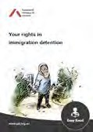

This info guide will help you know what is ok and not ok for immigration officials and detainee service officers to do.





We will talk about when

- The immigration officials or detainee service officers search you

- The immigration officials or detainee service officers ask you questions

- You get support from health people or other staff.

Immigration officials and detainee services officers are the people who look after you in immigration detention.

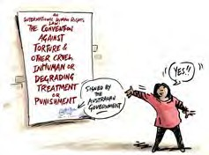

What the law says


There is a human rights law about the things that are not ok to do to someone.


This is an international law.

An international law is a law that countries can choose to say yes or no to.





This law says there are things that are not ok for the immigration officials and detainee service officers to do.




This law says that torture is never ok.

Torture means that someone does very bad things to you.

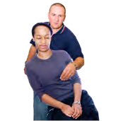
Torture is when someone might

- Beat you

- Do sexual things you do not want

- Lock you up by yourself for a long time.


This law says you must not be treated in a way that makes you feel hurt or ashamed.

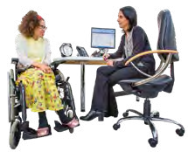
This could be things like

- Bullying or scaring you

- Not giving you health care or disability support

- Giving you health care or medication you do not want.



The Australian government said yes to this law.

But there are different laws made by each State or Territory government in Australia.


Some of these laws allow people to be treated in ways that the international law says is not ok.


This info guide talks about the international law and your rights.


Your right to dignity and respect


This part talks about dignity and respect.


Dignity means being treated in a way that does not make you feel bad or ashamed.



This part talks about what the immigration officials and detainee service officers can and cannot do.




The immigration officials and detainee service officers must tell you

- Why you are in detention

- What will happen next.


You can ask for someone to help you understand what is happening.



This could be an advocate, lawyer, guard or interpreter.

An advocate is someone who helps you speak up.


They must be allowed to support you with all the steps after you go into immigration detention.




The immigration officials or detainee service officers might use handcuffs or something else to tie your hands together when they

- Take you into detention

- Question you

- Search you.


They must ask if their boss says it is ok.


The immigration officials or detainee service officers are allowed to use handcuffs or ties but only for a short time.






The immigration officials or detainee officers might need to search you to see if you have things like weapons or drugs.




When they search you they will touch your body.


They want to see if you hide something under your clothes.




They must tell you

- Why they need to search you

- How they will do the search.

They should respect your wishes such as

- You do not want a woman in the room

- You do not want a man to search you.


Sometimes the immigration officials or detainee service officers will have to do a strip search.

Strip search means they ask you to take some or all of your clothes off.


There are some rules immigration officials and detainee service officers must follow when they do a strip search.





Some rules are

- A strip search should be done as quickly as possible

- They must wear gloves to keep everyone safe

- It is not ok for them to search inside your body

- You should not feel like they are making fun of you.

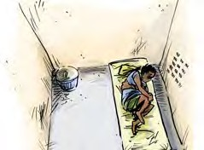

Your right not to be alone for a long time




When you are in an immigration detention centre you have the right not to be alone for a long time.


The immigration detention centre is where you live when you are detained by the Australian Border Force.


You should still be allowed to meet with a lawyer or advocate when you are in an immigration detention centre.






The staff must still look after your basic needs.

That means that you can always

- Drink water

- Use a toilet

- Have sanitary products if you have your period

- See a doctor if you are sick or have mental health issues.

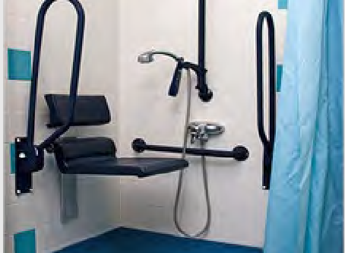
You should be allowed to use an accessible bathroom if you need.


You must be allowed fresh air and recreation. This could be to the courtyard.




You should get support to move around outside if you need it.


If you have been alone for a long time think about

- Who did you see?

- Did you see someone every day?

- Could you talk to them for a bit?

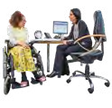



Your right to good health care


When you are in an immigration detention centre you have the right to get good health care.


You get health care from the health provider who is at the centre.

They are called the International Health and Medical Services.


The doctors can only share info about your health with others

- If you say it is ok

- If it is an emergency

- To keep you safe.

You must get the healthcare and medications you need.




Sometimes a doctor might tell you to take medication or do a treatment.



A treatment is something that is meant to make you feel better.

Treatment can be taking medication or talking to someone about how you feel.


The doctor must tell you

- Why you need it

- How long you need it.


They must get your consent.

Consent means you say yes to the medication or treatment.

You can have help to make a decision to give consent or not.

You have the right to ask the doctors if you still need the medication or treatment.






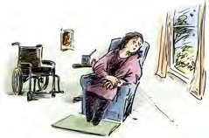

Your right to live in good living areas


When you are in the immigration detention centre the things around you must be ok to live in.

This means you have

- A clean room

- A window

- Air that comes into the room

- Time alone in the bathroom or toilet.



You must also always get good food and drinks.

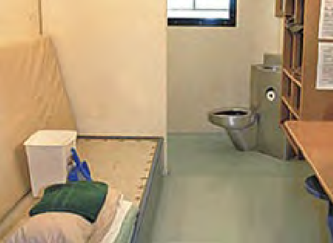

If you share a room with other people it should not be crowded.


Staff should learn about what support you need for your disability or mental health.





Your right to be safe



When you are in the immigration detention centre you should not get hurt by anyone.



Detainee service officers and other people who are detained should not hurt you.


You must get health care straight away if someone hurts you.

Immigration staff must help you.

They need to make sure it will not happen again.



Your right to be heard and supported


When you are detained you still have the right to get the support you need.






This means support to

- Do everyday tasks

- Understand what is happening to you

- Make decisions

- Tell people what you want

- Move around.

19




The staff should ask what supports you need when you get to the immigration detention centre.





Staff must learn if you need support like

- To hear things

- To move around

- To access places like the bathroom

- To understand things.

They should make sure you have things for your basic needs.


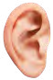
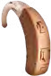

This could be things like

- Hearing aids

- Wheelchair.


The immigration detention centre should make a support plan that you can look at.


The immigration detention centre must make sure things in the support plan get done.

This is also so they do not do things that make your disability or mental health worse.



To get more info


If you want help or to get more information about your rights you can speak to advocate or lawyer.

