12th December 2022

The Hon. Shannon Fentiman MP Attorney-General & Minister for Justice 1 William Street
BRISBANE QLD 4000

Delivered via email: attorney@ministerial.qld.gov.au

Dear Attorney-General,

Civil Society recommendations for an effective implementation of OPCAT in Queensland

On 1st December 2022, The Public Advocate, the Queensland Human Rights Commission and Queensland Advocacy for Inclusion (QAI) co-hosted the Queensland OPCAT Forum at the Queensland Multicultural Centre. This event brought together key stakeholders from government and civil society across Queensland to discuss implementation of the Optional Protocol to the Convention Against Torture (OPCAT).
The forum heard powerful presentations from people with lived experience of detention and included a Civil Society Forum facilitated by QAI, the Aboriginal and Torres Strait Islander Legal Service, Prisoners Legal Service and Sisters Inside. During the Civil Society Forum, six recommendations for an effective implementation of OPCAT in Queensland were presented.
Several other Civil Society organisations have also endorsed these six recommendations. A full list of signatory organisations is included at the end of this letter.
The six recommendations are provided to you here for your attention:

Coverage of OPCAT to all places of detention in Queensland

A NPM needs to ensure all places of detention in Queensland are
monitored. Currently there is only coverage of prisons, watch houses and youth detention. OPCAT must extend beyond traditional sites of detention to include any place where a deprivation of liberty occurs. This includes mental health wards, aged care facilities, and disability specific institutions, such as the Forensic Disability Service and disability group homes.

Create a standalone independent statutory entity

A well-funded oversight body is needed to collate and monitor the recommendations and activities of the Inspectors of various places of

detention. This body should be a separate stand-alone body, such as in the UK. Alternatively, the Queensland Human Rights Commission (QHRC) is already responsible for accepting complaints of torture, cruel, inhumane and degrading treatment under the Human Rights Act (2019) Qld and understands the systemic issues impacting the human rights of people in places of detention, making them an appropriate oversight body for this function.

Formal collaborations with Civil Society Organisations (CSOs)

CSOs can help strengthen the mandate of the NPM by exchanging information on best practice inspection processes and working together by forming formal coalitions on monitoring activities. We call for the formal integration of CSOs into a Queensland NPM as recommended by the Subcommittee on Prevention of Torture. This integration should include funding to participate in OPCAT monitoring and to prepare a shadow report to parliament.

Formal collaborations with people with lived experience of detention in monitoring activities

People who have personal experience in sites of detention provide invaluable insight as to where torture can occur in these settings. People in detention also find it easier to communicate with and express concerns to ‘Experts by
Experience.’ We call for the establishment of transparent legislated and policy pathways for consultation with, and involvement of people with lived experience of detention in monitoring activities, including clear quantitative targets for engagement and a paid position for a prisoner to be a monitoring advocate.

Clear communications to people in detention

To make OPCAT real, people in detention need accessible communication to understand their human rights and to realise them via appropriate complaints mechanisms. Culturally appropriate and disability informed dialogue with people in detention must be a priority of the NPM, which must be culturally and disability inclusive from the outset.

- Improvements to Inspector of Detention Services Act 2022 (Qld)

  - Increase the frequency of visits to places of detention in order to ensure adequate oversight is a legislative rather than political commitment.

  - When reports are made with concerns of torture or ill-treatment of a detainee, that detainees are provided with legal representation and a right of reply to submissions made by the responsible person before the Inspector decides whether further action is required.

  - Expand the role of the Inspector to include:
    - The power to investigate critical incidents;

    - The power to submit proposals and observations on existing and draft legislation, and undertake public advocacy, awareness raising and capacity building;

    - Access to information relating to proceedings of Cabinet or a committee of Cabinet.

  - Publish a framework about how the Inspector will interact with existing oversight agencies, including the Official Visitor Regime and the QHRC.

  - Consult with CSOs about the regulation which determines which areas of the detention facility will be inspected. This will ensure that all places susceptible to abuse receive appropriate oversight.

Yours faithfully,

Aboriginal and Torres Strait Islander Legal Service Aged and Disability Advocacy Australia
Caxton Legal Centre
First Peoples Disability Network (FPDN) Mackay Advocacy
Prisoners Legal Service QCOSS
Queensland Advocacy for Inclusion Sisters Inside
Speaking Up For You
Steven Caruana, Australia OPCAT Network Uniting Church of Australia Queensland Synod


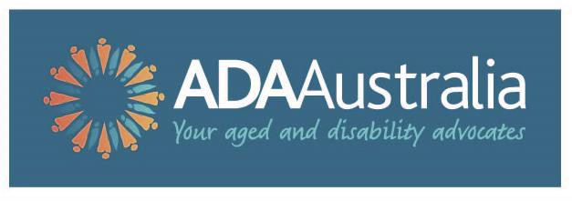

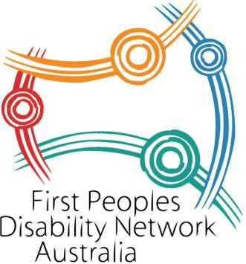
Ca

