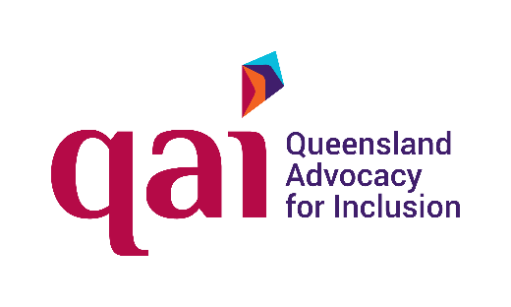



A person makes choices for you.
It is about your money.
How to work with them.

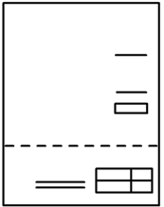



A person makes choices for you.
It is about your money.


They must
- listen to you
- think about what you want
- pay your bills. Like your rent
- make choices about your money.
They do this with you.

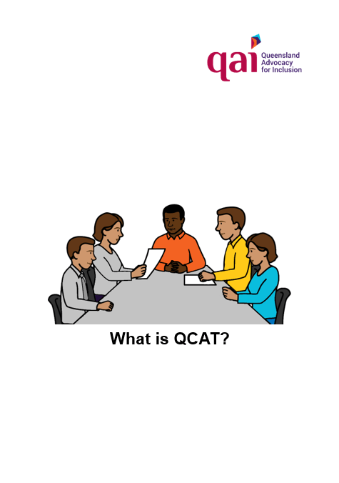
QCAT chose the person.
Read What is QCAT?

You want to talk to this person


You may want to
- ask questions about your money
- say what you need.

But


It may be hard to talk to them. Like
- they use big words
- you call them. They can not talk to you
- you do not like the choices they make.


What can you do?


You can have a person with you.
They know you well. You trust them. Like
- a friend
- a person in your family
- your support worker.


Think about what you want to say.
Do it before the meeting.



Write what you want to say.
Take it to the meeting. Write
        - what you worry about
        - what you want to do with your money
        - problems with your money.
Like you need more money to spend.


Ask a person to help you.
It is a person you trust.

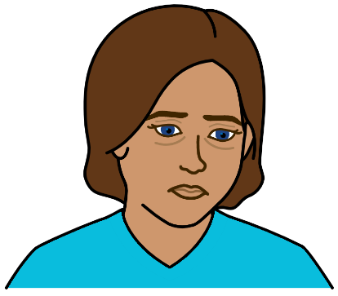
Some problems

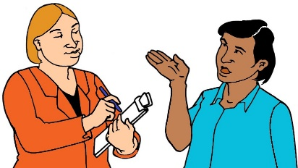
The person may
        - not listen to you
        - say no.


They have to make good choices.
It may not be what you want.
Like you want money to see a movie.
You can not have it.
They need the money for your rent.

They make a plan. It is about your money.
The plan says
- how much money you can use.
- what bills they pay for you.

But

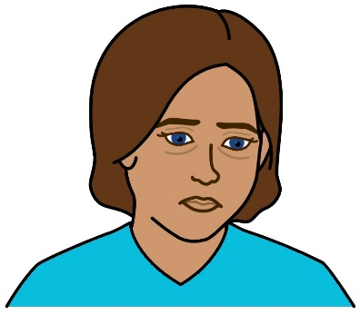
You do not agree.
You may need more money.


QAI can help you



We can tell you the rules.
There are rules for
- who can look after your money
- what they can do
- what they have to tell you.


We can help you
- talk to the person
- talk about problems with your money
- get a different person to help you.



Talk to QAI.



Call 1300 130 582




Email qai@qai.org.au

You want to know more

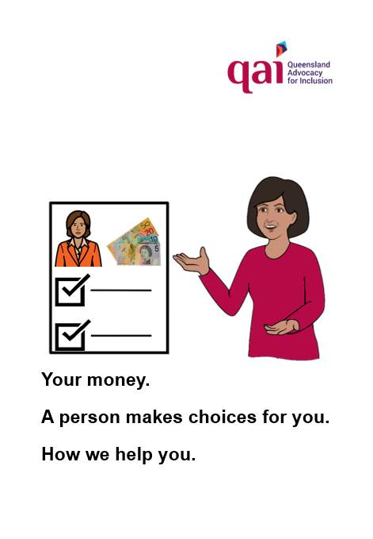
Read
Your money. A person makes choices for you. How we help you.

Images




We can use the images from
- CHANGE changepeople.org
- Inspired Services
- Noun Project
- Picto-selector
- Tobii-Dynavox.

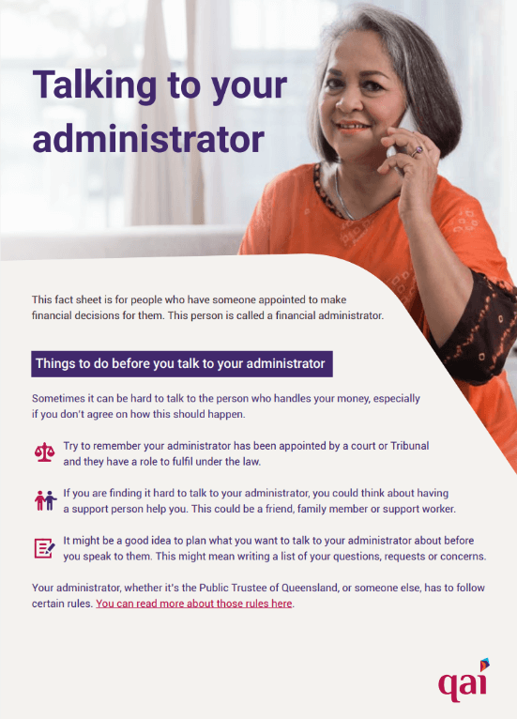
This book is based on
Talking to your administrator. QAI 2024.

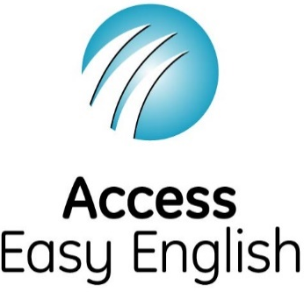
Access Easy English wrote the Easy English.
April 2024.

