
A Right to Learn - Economic cost of suspensions for Queensland students with disability
Queensland Advocacy for Inclusion
Further information on methodology and approach, assumptions and limitations and references

30 April 2024

About Queensland Advocacy for Inclusion
Queensland Advocacy for Inclusion (QAI) is an independent, community-based advocacy organisation and community legal service that provides individual and systems advocacy for people with disability. Our purpose is to advocate for the protection and advancement of the needs, rights, and lives of people with disability in Queensland. QAI’s Management Committee is comprised of a majority of persons with disability, whose wisdom and lived experience guides our work and values.
QAI has been engaged in systems advocacy for over thirty years, advocating for change through campaigns directed at attitudinal, law and policy reform.
QAI also provides individual advocacy services in the areas of human rights, disability discrimination, guardianship and administration, involuntary mental health treatment, criminal justice, NDIS access and appeals, and non-legal advocacy for young people with disability including in relation to education. Our individual advocacy experience informs our understanding and prioritisation of systemic advocacy issues.
Since 1 January 2022, QAI has also been funded by the Queensland Government to establish and co-ordinate the Queensland Independent Disability Advocacy Network (QIDAN). QIDAN members work collaboratively to raise the profile of disability advocacy while also working towards attitudinal, policy and legislative change for people with disability in Queensland.

Contents
1. Key findings 1
2. Purpose 3
3. Glossary of terms 3
4. Modelling approach 4
5. Data availability and use 7
5.1 Data gaps 7
5.2 Cohort size 7
5.3 Short-term impacts 8
5.4 Long-term impacts 10
6. Assumptions and limitations 12
6.1 Key assumptions and limitations around our approach 12
6.2 Assumptions relating to data sources 12
6.3 Assumptions relating to Youth Justice cost estimation approach 14
Appendix A Cohort size 16
Appendix B Short-term impacts 17
Appendix C Long-term impacts 25
Appendix D Non-quantified impacts 28
Appendix E References 31

- Key findings
- Children with disability are disproportionately represented in school suspensions in Queensland and across Australia. Data suggests this affects children across all school years, starting from kindergarten and primary school up to the end of secondary school.
  - 13.9% of Queensland children with NCCD status (16,154 students) had short suspensions compared to 6.9% of the overall child population in 2022.
  - NSW Department of Education statistics suggest that the difference in suspension rates for children with disability relative to other children exists across all school years, and that it is particularly high in the primary school years. In Semester 1, 2021, 2.5% of children with NCCD disability status in years K-2 and 5.0% of children with NCCD status in years 3-6 received short suspensions, compared to 0.5% of all children in years K-2 and 1.3% of all children in years 3-6.
  - NDIS participant outcome statistics suggest that suspensions accumulate for children with disability across their schooling period. Around 26% of surveyed NDIS participants had been ever suspended from school by year 10, with 18% ever suspended by Year 6.
- Suspensions and exclusions have adverse impacts on the mental health and wellbeing of children and young people with disability.
A number of studies drew on interviews and surveys of students who had been suspended to highlight that children and young people reported feeling increased levels of anxiety and depression as a result of social humiliation and isolation due to exclusion and suspension. The Disability Royal Commission’s report into inclusive education highlighted that “students subject to multiple suspensions can be at heightened risk of complete disengagement from education”.
- Suspensions and exclusions can also negatively impact the employment of parents/carers, classroom teaching and wellbeing of teachers, and draw on limited school resources.
Studies highlighted that parents and carers face challenges in maintaining employment while supporting suspended children at home. Children with disability are more likely to come from sole parent households where these financial impacts can be even more acute. Other studies highlighted the adverse impact on the time teachers have available to instruct classrooms, as well as their own health and wellbeing if they are insufficiently supported. Additional school resources are spent on responding to suspensions and subsequent behaviour management strategies.
- Research in Australia and overseas suggests suspensions have a negative association with subsequent youth offending and educational attainment. Assuming these impacts are similar for children with disability, we estimated that for the 16,118 Queensland students with NCCD status expected to be suspended in 2023:
  - An estimated 2,900 will not achieve Year 12 educational levels due to the impact of school disengagement
  - An estimated 310 will have Youth Justice involvement by age 18, including up to 160 with Youth Justice detention orders
- Youth offending and education impacts have immediate and longer term economic costs.
For school aged students, impacts attributed to suspensions and school disengagement are associated with estimated costs of up to $20-24m per year:
  - An estimated $14.1m in lost family income per year
  - An estimated $5.5-10.0m in Youth Justice system costs per year
In the longer run, we estimated an average annual income gap of around $41m per year for students with disability and suspensions not attaining year 12 educational levels. Research indicates that education is strongly associated with subsequent employment and income rates across the adult life course.
Studies suggest the potential for longer term impacts in other life course domains including increased likelihood of adult criminal justice system contact and adverse health and wellbeing impacts from reduced income and employment.
Key sources:
1a. Queensland Department of Education statistics on suspensions, exclusions and cancellations for student categories, provided to QAI
1b. NSW Department of Education (2021). Suspensions and Expulsions Semester 1 2017–2021. Sourced from https://data.cese.nsw.gov.au/data/dataset/c0a90a6f-2509-45c5-ba77-cf5b00350043/resource/7d039678-7527-4744-93a5-e162aa74de11/download/2021_suspension-and-expulsion-factsheet_vr_v2_aa.pdf.
1c. National Disability Insurance Agency (2021). NDIS Participant Outcomes 30 June 2020: Baseline participant outcomes for ages 0-14 report. Sourced from https://data.ndis.gov.au/media/2526/download?attachment.
2. – Key sources outlined in section 3 of this document
3 - Australian Institute of Health and Welfare (2024) People with disability in Australia. Income Table INCM19. Key sources outlined in section 3 of this document
4, 5. – Key sources outlined in section 4 of this document
- Purpose
This document details the approach and findings from for the modelling of economic costs associated with suspensions of Queensland students with disability. Key assumptions, data sources and an overview of qualitative impacts which were also considered are also outlined in this document.
- Glossary of terms
Term | Definition
Disability | Any limitation, restriction or impairment that has lasted, or is likely to last, for at least six months and restricts everyday activities.
Education Adjustment Program (EAP) | A system used by Queensland schools to identify the educational adjustments provided for students with disabilities to meet their learning and access needs.
Nationally Consistent Collection of Data (NCCD) | A national definition of students with verified disability who are receiving schooling adjustments.
Suspension | Any disciplinary action that results in a student having to spend a period away from school. It can either be a short (1-10 day) or long (11-20 day) suspension.
Expulsion/Exclusion | A disciplinary action that involves un-enrolling a student from a school.
Early leaver | An individual who leaves school prior to completing Year 12. This covers both voluntary and forced leaving from school.
Economic costs | Potential costs attributed to individual or government expenditure (i.e. loss of revenue or income).
Social costs | Potential broader costs to society, for example, education levels, public safety, and overall health of a population.
Long-term economic impacts | Potential economic costs that occur during adulthood.
Short-term economic impacts | Potential economic costs that occur during the schooling period.

- Modelling approach
Our modelling approach focused on quantifying:
- The cohort affected by school disengagement (for which suspensions are assumed to be a proxy indicator)
- Short-term impacts of school disengagement – impacts experienced during the schooling period. These estimates are driven by:
  - The amount of schooling days lost by students and subsequent impacts on learning and development, and the employment time given up by parents/carers to look after suspended children and respond to subsequent schooling implications following suspensions and exclusions.
  - The number of students who are more likely to interact with Youth Justice Services, measured by students receiving suspensions and exclusions, and the cost associated with Youth Justice detentions for those students.
We also estimated the opportunity costs to teachers from time spent managing student behaviour rather than classroom instruction, and the number of students with disability and suspensions expected to achieve NAPLAN levels at or below National Minimum Standards. Other short-term impacts not quantified in this analysis include adverse impacts on student and family mental health and wellbeing, teacher stress and wellbeing and school resources required to respond to subsequent implications from suspensions.
- Long-term impacts driven by lower levels of educational attainment which are associated with longer term reductions in employment and income across the adult life course. This can also contribute to increased rates of Government income support and other outcomes such as lower levels of health and a greater likelihood of contact with the adult criminal justice system.
We also estimated the potential impacts on life satisfaction from longer term differences in employment and income, and the number of young people involved with Youth Justice services who potentially proceed to have interactions with the adult Justice custodial system. These are categorised under ‘other impacts’ in our calculations.
We have also highlighted some of the social impacts associated with children with disability experiencing suspensions, their parents/caregivers and teachers, but recognise that there may be many more potential impacts which we have not explored in this study due to the focus on economic impacts or unavailable data. It is important to acknowledge these impacts can be significant to the children and young people affected even if not currently quantifiable or associated with a monetary impact.
Key assumptions in our approach
- The cost estimates in sections 1-4 of this document should be treated as the ‘maximum’ or upper range of economic costs that may be associated with suspensions for children with disability, as they assume that 100% of the short term and longer term life course impacts experienced by students with disability and suspensions can be directly attributed to suspensions and underlying school disengagement.
In practice it is likely that these impacts are partially, but not fully, attributable to school disengagement – other characteristics of these children and young people, their families, schools and community will also likely contribute.
- Impacts associated with suspensions are assumed to be driven by underlying school disengagement and behavioural challenges, with suspensions a proxy indicator for these underlying challenges being experienced by children and young people. A reduction in recorded suspensions that is not accompanied by an improvement in student engagement with their school and learning is not expected to lead to any change in life course impacts.
- We assume that the Queensland cohort is comparable to broader Australia as well as different state jurisdictions. Where available, we use studies and statistics that are taken from the Queensland population but due to limitations in publicly available data, we also reference studies from other state jurisdictions or with national data.
- We assume that the impact of suspensions is the same for students with disability as it is for other students, due to limitations in the data available. This may be different to actual experience, as students with disability have different experiences to those without across a range of different outcomes.

The diagram below summarises the main impacts highlighted in the studies from our research scan, the links assumed between short-term outcomes and long-term impacts, and the elements used to calculate short and long-term impacts that were measured in this analysis. Note that the outcomes outlined here are not exhaustive of all the short term and long term impacts.
It is also important to acknowledge that impacts not quantified in this analysis due to data limitations are still significant to students and their families and will be associated with economic or broader social costs. For instance, the research base highlights differences in the health status of populations with lower levels of educational attainment; economic costs arise to the extent this is directly attributable to lower education attainment and income flowing on from school disengagement.
Figure 1: Overview of quantified and non-quantified impacts associated with suspensions for students with disability
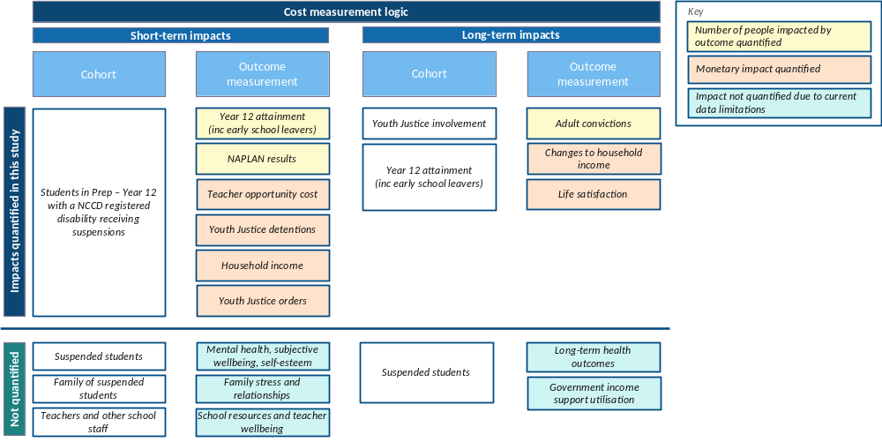

- Data availability and use
The following tables detail data points that are relevant for our economic cost investigation. It outlines the availability of the data, whether an economic cost can be directly derived, as well as considerations on potential social costs. We have broken these data points down into three groups:
- Cohort size
- Short-term impacts, where economic impacts are felt during the schooling period
- Long-term impacts, where economic impacts are felt once the student moves into adulthood
  - Data gaps
Several data gaps in the available research base limited the scope of the assumptions we could make when quantifying impacts. The largest one was quantified estimates around the strength of the relationship between suspensions of Australian children with disabilities and their subsequent young adult and lifetime outcomes. Some of these gaps are due to the lack of available longitudinal data linking Australian students and their school experiences with subsequent adult life course outcomes and service interactions across employment, health, justice, and other sectors. Gaps around published information on short-term impacts (such as the association between suspensions and year 12 attainment controlling for other drivers) could potentially be addressed in the future by statistical analysis of data held by state education departments. Where longitudinal data was available, it covered other Australian states (e.g. the NSW pilot study around Justice system interactions for young people with disability using the National Disability Data Asset) or other countries (e.g. UK, USA).
We note that administrative data relating to life course interactions does exist but is owned by different agencies across Commonwealth and state government jurisdictions and would require linkage to form a suitable research database. The National Disability Data Asset (NDDA) is a developing data linkage project which aims to provide this research base for the Australian population of people with disability, although we note state Education datasets are not currently in the scope of the NDDA linked datasets.
We identified a few longitudinal studies from overseas jurisdictions (UK, USA) that applied statistical techniques to demonstrate an association between suspensions and young adulthood outcomes (ages 18 to 25), even after controlling for other sociodemographic factors. We elected not to apply the quantitative estimates from these studies to this analysis due to uncertainty around the comparability of overseas education, employment, criminal justice and other systems to the Australian context.
  - Cohort size
The target cohort for this analysis are students in Queensland attending Prep Year to Year 12 who have a Nationally Consistent Collection of Data (NCCD) verified disability and are receiving adjustments. This group includes students with intellectual, physical, sensory and social/emotional disability as well as students with difficulties in learning or behaviour due to disability. Of this cohort, we are interested in identifying cohorts of students who may face suspensions or expulsions in a calendar year. Subsequent short-term and long-term outcomes use this cohort alongside other assumptions to estimate economic costs of suspensions on children with disability.
The following table is a summary of our main assumptions on cohort data. Further detailed on these figures can be found in Appendix A.
Description | Data
Number of students in QLD in 2023 | 570,259
Students in QLD with a NCCD verified disability in 2023 | 115,975  (20.3%)
Students in QLD with a NCCD verified disability who received a short suspension in 2023 | 16,118 (13.9%)
Number of school days missed per year for students with a NCCD verified disability receiving suspensions | 107,112

  - Short-term impacts
We identified several short-term economic impacts from suspensions in response to student behaviour, affecting students, parents and carers and schools:
- When children are suspended, parents and carers in a full-time employed position may need to take time off work to supervise their child, resulting in a loss of productivity to industry, which also represents a loss of income to households.
- People with disabilities are known to be overrepresented in both youth justice and prison statistics. In our short-term calculations, we looked at the cost of providing supervised detention services and community-based supervision orders to young people aged up to 18.
- We estimated the number of additional students with disability who are not expected to achieve Year 12 school leaving qualifications due to their suspension history and disengagement with schooling, over and above the expected proportion of students with disability without Year 12 achievement. This impact is the primary driver for longer term economic costs associated with lower employment and income.
The following table identifies our findings on short-term costs. A breakdown of these figures can be found in Appendix B.
Description | Data
Increase in the number of students with NCCD verified disabilities who have had Youth Justice detentions by age 18 associated with their suspension history  (This is estimated based on the increased proportion of NCCD disability students with suspensions who have YJ detention history by age 18, relative to the proportion for other NCCD disability students who have no suspension history) | Between  91 - 163
Total number of detention sentences from students with NCCD verified disabilities and suspensions by age 18 | Between  165 – 296
Annual Youth Justice detention cost for suspended students aged 14-17 | $4.1 - 7.4m
Increase in the number of students with NCCD verified disabilities who have had Youth Justice community-based supervision order(s) by age 18 associated with their suspension history  (This is estimated based on the increased proportion of NCCD disability students with suspensions who have YJ community-based supervision order history by age 18, relative to the proportion for other NCCD disability students who have no suspension history.  Note that this will include some students who also have Youth Justice detention orders.) | Between  166 – 298
Total number of Youth Justice order contact from students with NCCD verified disabilities ever suspended by age 18 | Between  206 – 370
Annual Youth Justice supervision order cost for suspended students aged 14 – 17 | $1.4 – 2.6m
Number of days of employment missed by parents/carers of children with disability | 75,942
Annual cost for parents/carers who have lost days of employment to monitor and pick up their child | $14.1m
Number of children with disabilities receiving suspensions who do not complete Year 12 | 2,917
Number of students in Year 9 – 12 with a disability and short suspensions estimated to achieve NAPLAN proficiency bands at or below the National Minimum Standard in  Year 9 | 2,759

Attribution factor
It is important to note that these results are based on a 100% attribution factor on the following:
- That 100% of parents and carers will take time off work (if they are full-time employed) for the duration of the suspension.
- That the increased proportion of students with suspensions who do not meet the National Minimum Standard of NAPLAN in Year 9 is 100% attributable to suspensions and related school disengagement
- That the increased proportion of students with suspensions who have contact with the Youth Justice system is 100% attributable to suspensions and related school disengagement
We note that this is a strong assumption, and that lower educational achievement and higher frequency interactions with the youth criminal justice system may be a product of a number of factors including education disengagement. As such the estimated impacts noted above should be interpreted as the upper range of potential impacts.
Qualitative impacts
The following short-term impacts have been identified throughout our research scan as broader social impacts and costs from suspending students. Unfortunately the research base had insufficient data to support the quantification of these impacts. It is also not a complete list of all the social costs that may exist in other research. Supplementary to this list is Non-quantified impacts that outlines the impact and examples of reference data sources.
Mental health, subjective wellbeing and educational outcomes
A number of studies drew on interviews and surveys of students who had been suspended to highlight that children and young people reported feeling increased levels of anxiety and depression as a result of social humiliation and isolation due to exclusion and suspension.
For example, the Disability Royal Commission’s report into inclusive education, employment and housing highlighted that “students subject to multiple suspensions can be at heightened risk of complete disengagement from education” and during public hearings they “had heard about students feeling isolated and excluded and being denied opportunities for academic attainment and social development. Feelings of frustration can lead to reduced self-esteem and confidence. This can hinder the acquisition of the skills, competencies and social networks the students require for successful transition to adulthood.”
Other parent / carer employment and income impacts
Pressure on parents/carers’ employment where caregivers have to temporarily or permanently give up employment, leave their child unsupervised, or fund alternative care arrangements (for example, repurposing NDIS funding for respite care during school hours).
Impacts on teachers and school resources used to manage suspensions and associated responses
Reports from a number of government inquiries into the use of disciplinary responses and classroom disruption highlighted the adverse impact that challenging student behaviour can have on the ability of teachers to spend time instructing classrooms, as well as their own health and wellbeing if they are insufficiently supported.
Additional school resources are also required to manage responses to ongoing student suspensions, including reviews and appeals of suspension decisions, working with parents and health professionals to identify alternative arrangements and administrative requirements.
  - Long-term impacts
We identified long-term impacts associated with lower levels of educational attainment that persisted into adulthood. A lower level of educational attainment can contribute to lower income and employability in the long-term post leaving school. This is measured using difference in gross income to capture both the cost to government as a decrease in taxation, and a cost to households in the form of reduced income.
The following table summarises our main assumptions for long-term cost. Further details on these figures can be found in Appendix C.
Description | Data
Average annual income gap for suspended students with disability who do not complete Year 12 (per person) | $14,105
Average annual income gap for all students with disability and suspensions who do not complete Year 12 | $41.1m
Note: The difference in income figure is calculated as a weighted average of the proportion of students with disability assumed to be employed, unemployed or not in the labour force multiplied by average incomes for each labour force status.
Attribution factor
It is important to note that these results are based on attributing 100% of the difference in income and employment profile for people with suspension history and without Year 12 educational attainment to their education levels (and by extension their suspension history).
As with the short-term impact estimates, we note that this is a strong assumption and that other factors may also contribute to these differences, although there are a range of studies across different jurisdictions that identify similar differences by educational attainment. As such the estimated impacts noted above should be interpreted as the upper range of potential impacts.
Qualitative impacts
The following long-term impacts have been identified throughout our research scan as social impacts of suspending children. The research base had insufficient data to support the quantification of these impacts. It is also not a complete list of all the social impacts that may exist in other research. Supplementary to this list is Non-quantified impacts that details the impact and example reference data sources.
Mental health and subjective wellbeing
Numerous studies highlight the association between education attainment, employment and financial wellbeing with lifetime health outcomes (‘socioeconomic determinants of health’). Conversely, early school leaving and non-Y12 educational attainment are associated with poorer reported health outcomes.
The Disability Royal Commission’s analysis of economic costs associated with violence, abuse, neglect and exploitation of people with disability discussed existing differences in life satisfaction experienced by people with disability as a result of lower employment and incomes as well as other drivers. Further impacts from school disengagement may potentially exacerbate these differences.
A UK longitudinal study of young people found that those who had previously been permanently excluded from school were statistically more likely to report poorer health and wellbeing outcomes at ages 25/26 even after controlling for related socioeconomic and demographic factors. Young people who had been temporarily excluded showed smaller differences to students without exclusions. These differences were not considered statistically significant.
Increased income support reliance
Reduced employment and earnings from Y12 education non-attainment is likely to also be associated with increased income support reliance across the adult life course. Income support payments are implicitly reflected in the earnings assumptions used to calculate individual income gaps.
Life satisfaction and subjective wellbeing from unemployment
The Disability Royal Commission’s recent analysis of the economic cost of violence, abuse, neglect and exploitation of people with disability observes that people with disability obtain large negative impacts from unemployment on life satisfaction.
We can extend their estimation approach on the value of subjective wellbeing to people with disability who were suspended and did not attain Year 12 educational levels (relative to people with disability).
This value is estimated to be $2.1m, based on the study where unemployment has a
-0.5 point impact on life satisfaction and a one-point increase is equal to $26,419, affecting a cohort of 2,917 students at an unemployment rate of 5.5%.
- Assumptions and limitations
It is important to note that we have produced the outputs above on a set of clearly defined limitations and assumptions. This will help in drawing conclusions from our work and aide in the interpretation of our outputs.
  - Key assumptions and limitations around our approach
- The cost estimates in sections 1-4 of this document should be treated as the ‘maximum’ or upper range of economic costs that may be associated with suspensions for children with disability, as they assume that 100% of the short term and longer term life course impacts experienced by students with disability and suspensions can be directly attributed to suspensions and underlying school disengagement.
In practice it is likely that these impacts are partially, but not fully, attributable to school disengagement – other characteristics of these children and young people, their families, schools and community will also likely contribute.
- Impacts associated with suspensions are assumed to be driven by underlying school disengagement and behavioural challenges, with suspensions a proxy indicator for these underlying challenges being experienced by children and young people. A reduction in recorded suspensions that is not accompanied by an improvement in student engagement with their school and learning is not expected to lead to any change in life course impacts.
- We assume that the Queensland cohort is comparable to broader Australia as well as different state jurisdictions. Where available, we use studies and statistics that are taken from the Queensland population but due to limitations in publicly available data, we also reference studies from other state jurisdictions or with national data.
- We assume that the impact of suspensions is the same for students with disability as it is for other students, due to limitations in the data available. This may be different to actual experience, as students with disability have different experiences to those without across a range of different outcomes.
  - Assumptions relating to data sources
Due to data limitations and gaps in the available research, we made a number of simplifying assumptions around the applicability of data available when setting economic analysis parameters. We also drew on studies that in some cases partially align completely to the context of this project. For example, many of the studies covered in our research scan measured outcomes for people with disability, or outcomes for people with suspensions and/or expulsions from school, but not the intersection of these two cohorts. Only a few research analyses attempted to control for disability status when assessing the association of suspensions with subsequent impacts.
In several instances we have assumed that the outcome rates experienced by children with disability and suspensions are similar to those of all children with suspensions or of all children with disability. In practice this may not always be the case.
These include:
Data | Ref ID | Assumption
NCCD verified disabilities | 1 | Nationally Consistent Collection of Data on School Students with Disability (NCCD) verified disabilities were chosen over students with EAP verified disabilities. EAP verified disabilities capture a limited set of disability categories and the EAP prevalence rate is at 6%, which is lower than the NCCD rate of 20.3% and the national average disability prevalence rate of approximately 10%.  NCCD is a definition of disability based on the Disability Discrimination Act and used by other state jurisdiction Education agencies. It is noted that the NCCD definition is broader than that used in the ABS Survey of Disability, Ageing and Carers (SDAC), a national source of data on disability prevalence and other observations.
Carer opportunity cost | 2 | Carer full time employment rate (70.9%) was used to estimate the cost of minding children whilst they were suspended. However, this does not account for extended family/kin who could also potentially care for children outside school (e.g. grandparents). Carers may also have flexible working arrangements such as carers leave, work from home or non-fixed hours that would result in a lower productivity loss in the shorter term.
Teacher opportunity cost | 3 | Teacher salary is taken to be the median of 81,628 (first year of work) – 108,359 (the highest base pay before Senior Teacher)
Student performance as reflected in NAPLAN results | 4 | Statistics on students with suspensions/exclusions achieving the South Australia Department of Education’s Standard of Education Achievement (SEA) in NAPLAN tests were used to inform assumptions around the NAPLAN performance of Queensland students with disability and suspensions. SEA is defined as achieving NAPLAN proficiency bands at 1 or more proficiency bands above the National Minimum Standard.  The analysis findings from South Australia excluded withdrawals/absences. The study notes that students with disabilities and those with suspensions are more likely to be absent during an exam.  No data was available on the NAPLAN performance of students with both a history of suspensions and disability.
Student performance and wellbeing influences | 5 | There are many unobserved factors involved in students’ life which can also influence student learning, development and educational achievement alongside school disengagement and suspensions, such as their household’s socioeconomic characteristics, family circumstances and broader school and community factors. It is likely that the short and longer term impacts estimated in this analysis will have been at least partially influenced by these factors.
Students are 18.1% more likely to not complete Year 12 because of suspensions | 6 | This is a 2013 study conducted by the Australian National University to understand the educational penalty for being suspended from school. We assumed this impact is the same for children with disabilities as for other children, as this study did not differentiate findings by disability status. In practice the impact of suspensions may be larger or smaller for children with disability.  The completion rate controls for reported own schooling experience, family welfare history, and family characteristics when the respondent was 14 years of age.  This study uses short term suspensions to count the number of students disassociated from school. This does not account for students who received long-term suspensions or were excluded without a short-term suspension. However, whilst it does occur, it is more common that students receiving long-term suspensions or exclusions have had a history of short-term suspensions. This has a conservative impact on the figures provided.
Data used to inform assumptions around teacher classroom time impacts | 7 | Key assumptions based on this study include: Lower secondary school teachers use 14.5% of their classroom time maintaining order, and lower secondary school teachers spend 27.2 hours teaching per week. These assumptions were drawn from the Australia lower secondary school indicators from the OECD Teacher and Learning International Study (TALIS) 2018 results.  Actual time spent by Queensland teachers on managing classroom behaviour may vary from the national average. As part of the survey data collection methodology, the OECD excluded the collection of information from some specialist schools, such as those for students with special needs. This may mean that 14.5% is not a representative proportion of the time spent maintaining classroom behaviour for all the Queensland teachers our study relates to, and that the actual figure could be higher or lower than 14.5%.
Employment and income statistics for persons with disability | 8 | This study reports on data collected in 2018 and includes disabilities developed in adult life as well as those present during school years. We have assumed the impact of Year 12 education non-attainment is similar for those with disabilities regardless of when disability was acquired.
Data used to inform assumptions around impacts of suspensions on youth justice contact for young people with disability | 9 | The NSW NDDA pilot studies around youth offending for young people with disability were based on a disability cohort that represented 3.5% of the birth cohort population in NSW, using definitions that are likely to be different to the NCCD definition of disability. When used in our calculations, we assumed that a comparable proportion from the NCCD population would experience similar rates of youth justice system contact to the disability cohort in the NSW NDDA study, while the remainder would experience general population rates of contact with the youth justice system.
 | 10 | Likelihood of young people with suspensions having offending contact, relative to other young people without suspensions have been estimated as 1.5–2x. Assumptions are based on Australian studies which found that:  children with school suspensions were associated with a 1.5x likelihood of ‘antisocial behaviour’ and  “children with teacher-identified emotional or behavioural problems at school entry had an incidence rate of police contact that was twice that of children without such problems”.
 | 11 | Assumptions around the ratio of young people with supervision orders relative to those with detention orders by age 18 are based on the ratio of the two populations over the 2022-23 year.  Assumptions around the average number of youth justice supervision orders and detentions by age 18 are based on an AIHW study of accumulated youth justice orders (birth cohort data was available from Tasmania, ACT and NT). The average number of community-based and detention orders may differ for young people in the Queensland youth justice system.
 | 12 | 13% of young people with a Youth Justice offence will go on to have a subsequent Adult Justice custodial sentence.

  - Assumptions relating to Youth Justice cost estimation approach
Key challenges remain when trying to use the existing research to quantify the impact of student behavioural issues and school disengagement on subsequent Justice system interactions, including students with disabilities. In this situation suspensions are assumed to be a proxy indicator of behavioural and school disengagement issues.
These challenges include:
- Wide variation in the disability cohorts analysed by studies, amplified by different attempts to capture disability severity or a focus on specific disability types. For example, Queensland Education reports a 6% and 20% disability prevalence rate when using EAP and NCCD definitions of disability respectively. In comparison:
  - The NSW NDDA Youth Justice pilot study reported 3.5% of its population with a disability indicator (based on interaction with specific disability support services)
  - Queensland Youth Justice census surveys report on the proportion of young people with FASD or suspected disability, and NSW Youth Justice census surveys report on the proportion of young people with suspected cognitive disability – elements which do not fully overlap with the EAP and NCCD definitions.
- Except for the NSW NDDA Justice pilot study, all other studies involve point-in-time analysis. This does not fully support estimates of lifetime involvement with Youth and Adult Justice systems as a considerable proportion of young offenders will cycle through these systems over multiple years.
- Differences in Youth Justice systems and populations across state jurisdictions and over time. These estimates are based on assumptions informed by birth cohort studies from other jurisdictions as well as Queensland indicators and should be treated as indicative only.
- Differences in the definition of Youth Justice involvement analysed by studies (ranging from all offending to Youth Justice custody/detention only).
Other approach limitations and areas for consideration:
- Youth Justice census surveys from NSW and Victoria over recent years have observed that 60 – 94% of people under Youth Justice supervision, or in detention, have had prior school suspensions. These observations suggest that in practice suspensions may possibly have a higher correlation with Youth Justice system involvement.
- The NDDA Justice study highlights that Justice system involvement varies considerably by disability type – for example, young people with psychosocial disabilities are heavily overrepresented in the offending cohort, whereas young people with physical disability only have rates of offending closer to other young people without disability.
- Frequency of suspensions is likely also an important factor. Young people with multiple suspensions are likely to have a higher likelihood of Justice system involvement.
For example – a NSW Youth Justice census study in 2015 observed that 94% of the young people in detention had suspension history and 78% had had repeat suspensions.

- Cohort size
Description | Data | Source
Number of students in QLD in 2023 | 570,259 | Department of Education. (2023). State School Enrolments. https://qed.qld.gov.au/our-publications/reports/statistics/Documents/enrolments-summary.pdf
Proportion of QLD students with a NCCD verified disability in 2022 | 20.3% | Provided in the Queensland student and SDA counts by student categories dataset  Department of Education. (2023). Queensland student and SDA counts by student categories
Number of QLD students with a NCCD verified disability in 2023 | 115,975 | Derived by multiplying the 2022 proportion of students with a NCCD verified disability in 2022 with the 2023 student population
Number of QLD students with a NCCD verified disability who have received a short suspension in 2022 | 16,154 | Provided in the Queensland student and SDA counts by student categories dataset  Department of Education. (2023). Queensland student and SDA counts by student categories
Number of QLD students with a NCCD verified disability who have received a short suspension in 2023 | 16,118 | Derived by multiplying the proportion of students with a NCCD verified disability receiving a short suspension in 2022 with the number of students in QLD with a NCCD verified disability in 2023 (derived above)
Number of QLD students with a NCCD verified disability who have received a long suspension in 2022 | 1,194 | Provided in the Queensland student and SDA counts by student categories dataset  Department of Education. (2023). Queensland student and SDA counts by student categories
Number of QLD students with a NCCD verified disability who have received a long suspension in 2023 | 1,191 | Derived by multiplying the proportion of students with a NCCD verified disability receiving a long suspension with the number of students in QLD with a NCCD verified disability in 2023 (derived above)
Median number of days for a short suspension | 5.5 | Derived by taking the median of the range of days given in a short suspension (1-10 days)
Median number of days for a long suspension | 15.5 | Derived by taking the median of the range of days given in a long suspension (11-20 days)
Average number of days spent in short suspensions for QLD students with a NCCD verified disability in 2023 | 88,646 | Derived by multiplying the median days in a short suspension with the number of short suspensions in 2023
Average number of days spent in long suspensions for QLD students with a NCCD verified disability in 2023 | 18,465 | Derived by multiplying the median days in a long suspension with the number of long suspensions in 2023
Number of school days missed in 2023 | 107,112 | Derived by taking the sum of short and long suspension days in 2023
Number of days of school missed per year per student with a NCCD verified disability given a suspension in 2023 | 6.2 | Derived by dividing the total number of school days missed in 2023 by the number of students receiving short and long suspensions

- Short-term impacts
Description | Data | Source
Youth Justice costs
Proportion of young people in NSW NDDA Justice pilot study having a disability indicator | 3.5% | Boiteux, S. & Poynton, S. (2023). Offending by young people with disability: A NSW linkage study (Crime and Justice Bulletin No. 254). Sydney: NSW Bureau of Crime Statistics and Research. https://www.bocsar.nsw.gov.au/Publications/CJB/2022-Report-Offending-by-young-people-with-disability-CJB254.pdf  Note this includes both remand and sentenced detention.
Probability of young people with disability having Youth Justice detentions by age 18 | 4%
Probability of young people without disability having Youth Justice detentions by age 18 | 0.7%
Probability of ever being suspended by end of Year 10 given disability | 26.1% | National Disability Insurance Agency. (2021). NDIS Participant Outcomes 30 June 2020: Baseline participant outcomes for ages 0-14 report. Sourced from https://data.ndis.gov.au/media/2526/download?attachment
Proportion of students with NCCD verified disabilities who have offending history by age 18 | 7% | Estimate derived with reference to the data points above.  Further detail on the estimation approach for this figure is set out in the following section.
Number of students with NCCD verified disabilities ever suspended with YJ detention orders by age 18 | 91-163
Proportion of suspensions that are received by students in Year 9 – 12 | 47.4% | South Australia Department of Education. (2023). Suspensions, exclusions and expulsions by year level (2013-22). Accessed 24 April 2024. https://data.sa.gov.au/data/dataset/suspensions-exclusions-and-expulsions-by-year-level
Average number of days in detention per young person with detention(s) over the 2022-23 year | 103 days | Australian Institute of Health and Wellbeing. (2023). Youth justice in Australia. https://www.aihw.gov.au/reports/youth-justice/youth-justice-in-australia-2022-23/data
Average number of YJ detentions per young person with NCCD verified disabilities ever suspended who has YJ custodial contact by age 18 | 1.81 | Estimate based on assumed (a) distribution of order counts up to age 18, and (b) assumed detention orders as proportion of all Youth Justice orders.  Australian Institute of Health and Welfare (2022). Young people returning to sentenced youth justice supervision, 2021-22  Australian Institute of Health and Wellbeing. (2023). Youth justice in Australia. https://www.aihw.gov.au/reports/youth-justice/youth-justice-in-australia-2022-23/data
Total days spent in detention orders from students with NCCD verified disabilities ever suspended with Youth Justice custodial contact by age 18 | 16,990 – 30,463 | Calculation derived by multiplying total number of students with detentions by age 18 (91-163), their expected number of detentions by age 18 (1.81), and the average duration of detention (103 days).
Cost per young person subject to detention orders, per day, 2021 – inflated to 2023 levels – Queensland | $2,054 | Productivity Commission (2023). Report on government services. https://www.pc.gov.au/ongoing/report-on-government-services/2023/community-services/youth-justice
Total estimated Youth Justice detention costs up to age 18, for students with NCCD disability suspended in the Youth Justice age range (Years 9-12) | $16.5 – 29.7m | Calculated by multiplying the total days spent in detention for the NCCD disability cohort with suspensions with (a) the cost per young person and (b) the proportion of suspensions received by NCCD disability students in Year 9 – 12 in a given year (47.4%).
Total estimated Youth Justice detention costs in a given year, for students suspended in the Youth Justice age range (Years 9-12) | $4.1 – 7.4m | Calculated by dividing the total estimate for ages up to 18 by the approximate number of age years in the Youth Justice age range (4 age years 14-17 - these are the ages of the majority of young people involved in Youth Justice orders).
Ratio of young people with disability and suspension history who have Youth Justice order contact by age 18 (relative to young people with disability, suspensions and custodial contact by age 18) | 1.82 | Calculated by taking the number of Queensland young people under supervision during the year in 2020-21 by the number of young people aged 10-17 in detention during the year  Australian Institute of Health and Welfare. (2022). Youth justice in Australia 2021-22, Data - Australian Institute of Health and Welfare (aihw.gov.au)
Average number of YJ community-based supervision orders per young person with NCCD verified disabilities ever suspended who has YJ supervision order contact by age 18 | 1.24 | Estimate based on assumed (a) distribution of order counts up to age 18, and (b) assumed community-based supervision orders as proportion of all Youth Justice orders.  Note this will include some young people who also have detention orders.  Australian Institute of Health and Welfare (2022). Young people returning to sentenced youth justice supervision, 2021-22  Australian Institute of Health and Wellbeing. (2023). Youth justice in Australia. https://www.aihw.gov.au/reports/youth-justice/youth-justice-in-australia-2022-23/data
Average supervision period length per year | 227 days | Australian Institute of Health and Wellbeing. (2023). Youth justice in Australia. https://www.aihw.gov.au/reports/youth-justice/youth-justice-in-australia-2022-23/data
Cost per young person subject to community-based supervision, per day, 2021 – inflated to 2023 levels – Queensland | $259 | Productivity Commission. (2023). Report on Government Services. https://www.pc.gov.au/ongoing/report-on-government-services/2023/community-services/youth-justice
Total estimated Youth Justice supervision costs up to age 18, for students with NCCD disability suspended in the Youth Justice age range (Years 9-12) | $5.8 – 10.3m | Calculated by multiplying the total days spent in YJ supervision for the NCCD disability cohort with suspensions with (a) the cost per young person and (b) the proportion of suspensions received by NCCD disability students in Year 9 – 12 in a given year (47.4%).
Total estimated Youth Justice supervision costs in a given year, for students suspended in the Youth Justice age range (Years 9-12) | $1.4 – 2.6m | Calculated by dividing the total estimate for ages up to 18 by the approximate number of age years in the Youth Justice age range (4 age years 14-17 - these are the ages of the majority of young people involved in Youth Justice orders).
Parent / carer opportunity costs
Proportion of parent or carers for disabled students that are employed full-time | 70.9% | Australian Bureau of Statistics. Disability ageing and carers summary findings. https://www.abs.gov.au/statistics/health/disability/disability-ageing-and-carers-australia-summary-findings/latest-release
Number of days of employment missed by parent or carers for disabled students | 75,942 | Derived by multiplying the number of school days missed in 2023 with the proportion of carers of students with disabilities that are full time employed
Median daily earnings for carers of students with disabilities (2018) | $160 | Australian Bureau of Statistics. Disability ageing and carers summary findings. https://www.abs.gov.au/statistics/health/disability/disability-ageing-and-carers-australia-summary-findings/latest-release
Opportunity cost per year for employment days missed | $14.1m | Derived by multiplying the number of days of employment missed with the median earnings for carers of students with disabilities
Teacher opportunity cost
Proportion of lower secondary typical classroom teacher time used on maintaining classroom order | 14.5% | Organisation for Economic Co-operation and Development. (2018). TALIS 2018 Tables. https://www.oecd.org/education/talis/talis2018tables.htm
Proportion of primary school typical classroom teacher time used on maintaining classroom order | 15.4%
Total hours per week spent teaching per teacher in lower secondary school | 27
Average hours spent per week maintaining classroom order (all students) | 3.9 | Derived by multiplying the total hours per week spent teaching with the proportion of time used on maintaining classroom order
Teacher salaried hours per week | 40 | Education NSW. (2024). 2024 Calendar. https://education.nsw.gov.au/schooling/calendars/2024
Teacher salary in 2023 | $94,994 | Queensland Government. (2024). Pay and Benefits. https://teach.qld.gov.au/teach-in-queensland-state-schools/pay-benefits-and-incentives/pay-and-benefits
Behaviour management attributed to students with disability receiving suspensions | 0.8% | Derived by multiplying the proportion of students with a NCCD verified disability with the proportion of students with a NCCD verified disability receiving a short suspension
Total number of hours a single teacher uses per year to address behaviour in classrooms for students with disability receiving suspensions | 1.3 | Derived by multiplying the total number of hours a single teacher uses per year to address behaviour in classrooms by the attribution factor to students with a NCCD verified disability receiving suspensions
Number of FTE teachers (2022) | 98,829 | Australian Bureau of Statistics. (2023). Data on government and non-government students, staff and schools. https://www.abs.gov.au/statistics/people/education/schools/latest-release
School weeks per year | 40 | Education NSW. (2024). 2024 Calendar. https://education.nsw.gov.au/schooling/calendars/2024
Annual opportunity cost for all teachers addressing behaviour management for children with disabilities receiving suspensions | $20.1m | Derived by multiplying (the hourly rate for a teacher) with (the number of hours a teacher spends per year addressing behaviour for students with a NCCD verified disability receiving suspensions) with (the number of FTE teachers)
NAPLAN impacts
Proportion of students with suspensions in Year 3 that met the Standard of Education Achievement (SEA) in Year 3 NAPLAN | 56.3% | Graham et al., (2020). Inquiry into Suspension, Exclusion and Expulsion Processes in South Australian government schools: Final Report. The Centre for Inclusive Education, QUT: Brisbane, QLD.  Counts were derived by multiplying the number of students in QLD with NCCD disability receiving suspensions with the proportion assumed to not achieve Year 9 NAPLAN SEA levels.
Proportion of students with suspensions in Year 9 that met the SEA in Year 9 NAPLAN | 36.6%
Proportion of students scoring "Below Average" on NAPLAN in Year 9 who receive an ATAR less than 50 | 66.1%
Proportion of students scoring "Weak" on NAPLAN in Year 9 who receive an ATAR less than 50 | 89.7%

Further details on calculation approach – Youth Justice costs
Overview
Research from Queensland and other state jurisdictions show that young people with diagnosed or suspected disability, as well as young people with suspension history and school disengagement, are overrepresented in offending and Youth Justice populations. There is also extensive evidence to support the link between Youth Justice and Adult Justice involvement.
However, key challenges remain when trying to use the existing research to quantify the impact of student behavioural issues and school disengagement on subsequent Justice system interactions, including students with disabilities. In this situation suspensions are assumed to be a proxy indicator of behavioural and school disengagement issues.
Calculation approach – Increased number of students with disability who have Youth Justice detentions and Youth Justice supervision orders by age 18 associated with their suspension history
Youth Justice involvement for Queensland students with disability and suspensions up to age 18 has been estimated on the basis outlined below. We have focused on Youth Justice detention and supervision order costs to determine the short term costs associated with students with disability and suspensions who become involved with offending, as these are likely to represent the largest component of offending related economic costs. We acknowledge there are also broader costs associated with youth crime to Courts, Police and the community.
- Estimate the proportion of Queensland students with NCCD disabilities who have offending contact by age 18
The NSW NDDA Youth Justice pilot study was the main data source for these estimates, as the only birth cohort study which identifies Justice system contact rates for young people with disability.
The NDDA study relates to a narrow disability cohort (3.5% of the birth cohort population) and there is no data available to assess the extent to which the Queensland NCCD cohort (a much larger cohort representing 20% of the student population) profile is similar or different, e.g. by disability types or severity. This means it is challenging to extrapolate the NDDA study’s findings to all of the NCCD cohort.
To reflect these population differences we have applied the NDDA study’s disability cohort offending and YJ involvement rates to a comparable subset of the Queensland NCCD student cohort (3.5% out of the 20.3% with NCCD disabilities) and have applied general population offending and YJ involvement rates to all other students in the NCCD cohort.
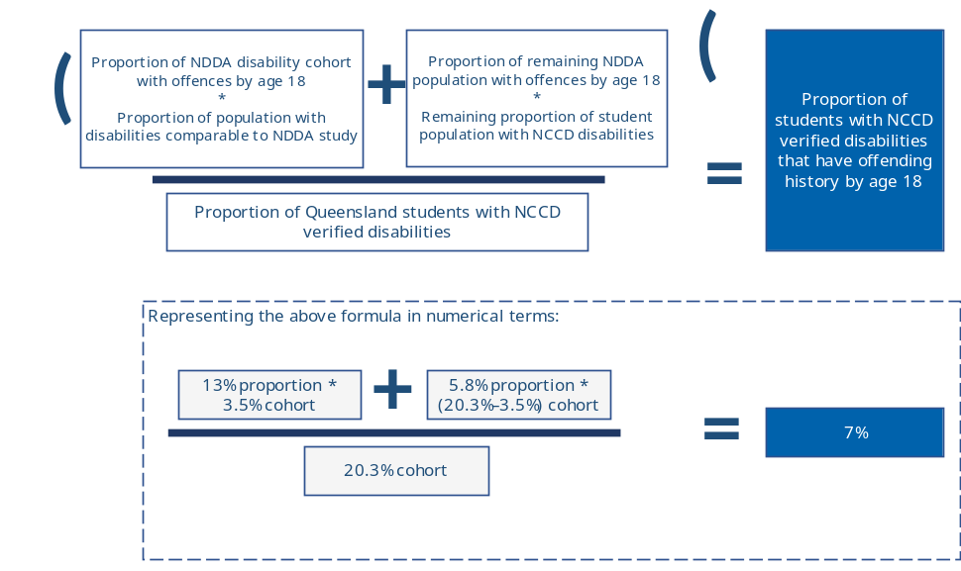
- Estimate the proportion of Queensland students with NCCD disabilities who have Youth Justice detention history by age 18
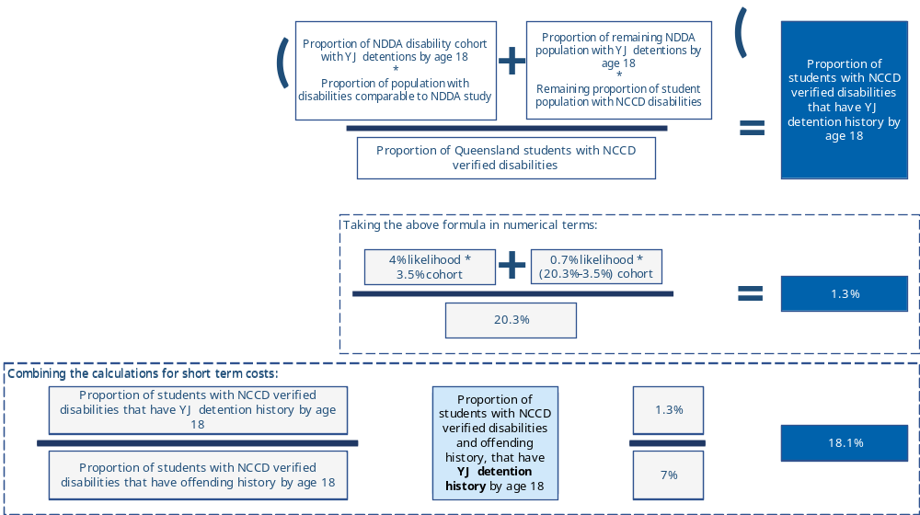

- Estimate the difference in rates of offending involvement between young people with disability who have ever been suspended by age 18, and those who have never been suspended. This is assumed to be 100% attributable to suspension and school disengagement.
Proportion of young people who have ever been suspended by age 18: 26%, from NDIA Baseline participant ages 0-14 outcomes report (2020).
Likelihood of young people with suspensions having offending contact, relative to other young people without suspensions: estimated as 1.5–2x, based on Australian studies which found that (i) children with school suspensions were associated with a 1.5x likelihood of ‘antisocial behaviour’ and (ii) “children with teacher-identified emotional or behavioural problems at school entry had an incidence rate of police contact that was twice that of children without such problems”.
- Estimate the difference in rates of YJ detention involvement between young people with disability who have ever been suspended by age 18, and those who have never been suspended
Based on the proportion of students with NCCD disabilities and offending history (from (b)) multiplied by the proportion assumed to also have YJ detention history (18.1%).
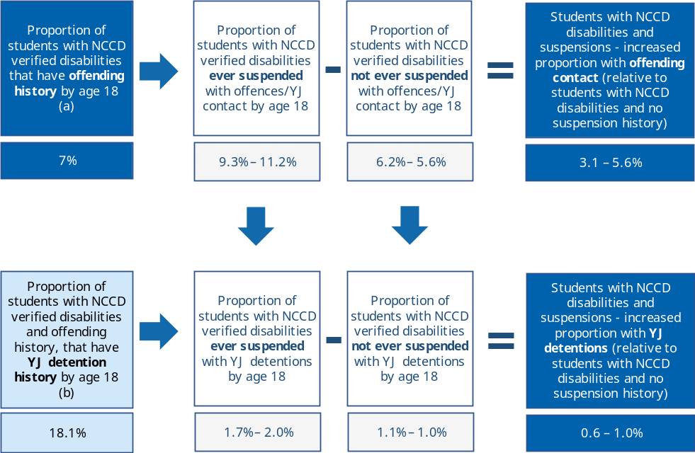
- Estimate the difference in rates of YJ supervision order involvement between young people with disability who have ever been suspended by age 18, and those who have never been suspended
Based on the ratio of Queensland young people under supervision relative to the number of young people in detention over the 2020-21 reporting year, i.e. for every young person in detention at some point over the year there are 1.8 young people under supervision orders over the same period. Note there will be some overlap from young people involved in both supervision and detention orders over a year.
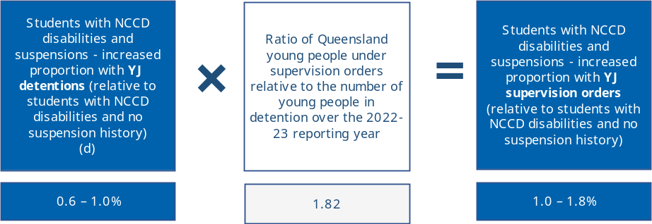

Calculation approach – Estimated costs per year associated with increased number of students with disability who have Youth Justice detentions and Youth Justice supervision orders associated with their suspension history
The cost of Youth Justice detention involvement for Queensland students with disability and suspensions in a given year has been estimated on the basis outlined below.
- Increased number of students with NCCD disabilities suspended in a given year who are estimated to have YJ detention contact by age 18 (over and above the estimated number for students with disabilities but no suspensions) – 91 to 163 (0.6-1.0% as estimated in step (d) above)
- Number of students with NCCD disabilities who are in the Youth Justice age range in the year of their suspension (assumed to be ages 14-17) – 43 to 76
- Estimated total YJ detention costs up to age 18 per young person with NCCD disabilities, suspensions and YJ detention involvement - $382,900 (2023-24 levels)
- Estimated annual YJ detention costs associated with young people with NCCD disabilities who are suspended in a given year - $4.1 - 7.4m (2023-24 levels)
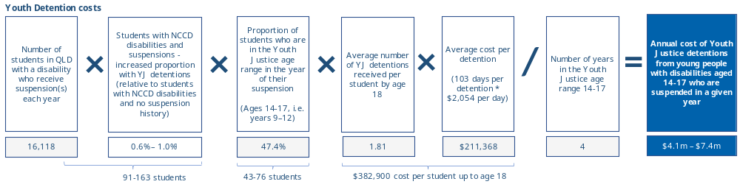
The cost of Youth Justice supervision order involvement for Queensland students with disability and suspensions in a given year has been estimated on the basis outlined below.
- Increased number of students with NCCD disabilities suspended in a given year who are estimated to have YJ supervision order(s) by age 18 (over and above the estimated number for students with disabilities but no suspensions) – 174 to 312 (1.0-1.9% as estimated in step (e) above)
- Number of students with NCCD disabilities who are in the Youth Justice age range in the year of their suspension (assumed to be ages 14-17) – 83 to 148
- Estimated total YJ supervision order costs up to age 18 per young person with NCCD disabilities, suspensions and YJ supervision order involvement - $73,177 (2023-24 levels)
- Estimated annual YJ supervision order costs associated with young people with NCCD disabilities who are suspended in a given year - $1.4 – 2.6m (2023-24 levels)
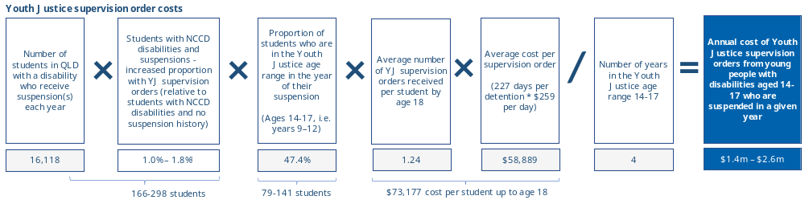

Further details on calculation approach – Other short-term impacts
The figure below outlines the calculation approach used to estimate short term costs to parents and carer, and the opportunity costs associated with teacher time spent addressing student behaviour rather than classroom instruction.
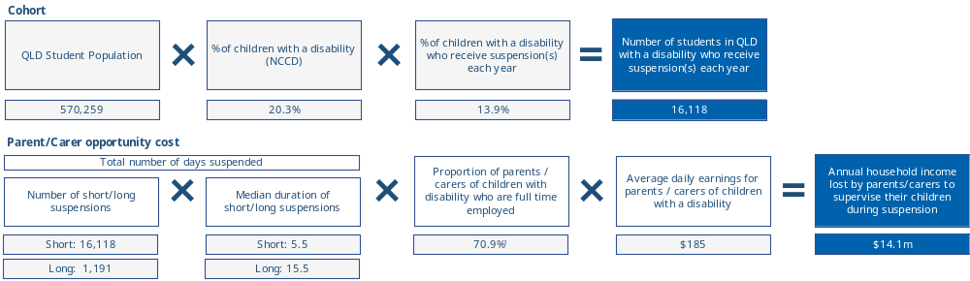
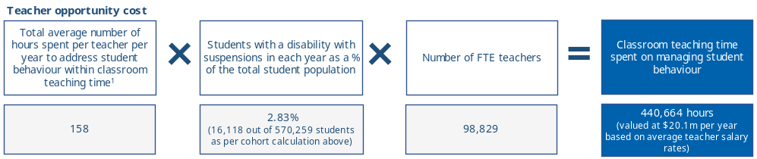

- Long-term impacts
Description | Data | Source
Income gap
% of students who do not complete Year 12 because of suspensions | 18.1% | Cobb-Clark, D. A., Kassenboehmer, S. C., Le, T., McVicar, D., & Zhang, R. (2015). Is there an educational penalty for being suspended from school? Education Economics, 23(4), 376–395. https://doi.org/10.1080/09645292.2014.980398
Employment rate for persons with disability that completed Year 12 | 57.0% | Australian Bureau of Statistics. (2022). Household Income and Wealth, Australia. Key information from the Survey of Income and Housing 2019-20 including distribution of income and wealth by various household characteristics. https://www.abs.gov.au/statistics/economy/finance/household-income-and-wealth-australia/latest-release#introduction  Costs were derived by multiplying the number of Year 12 non-completions with the difference in income, employment rate and attribution factor. These are split into employment rates, unemployment rates and non-participating rates.
Employment rate for persons with disability that did not complete Year 12 | 29.7%
Unemployment rate for persons with disability that completed Year 12 | 5.1%
Unemployment rate for persons with disability that did not complete Year 12 | 5.5%
Non-participation rate for persons with disability that completed Year 12 | 37.7%
Non-participation rate for persons with disability that did not complete Year 12 | 65.5%
Mean income for employed persons with disability that completed Year 12 | $1,086
Mean income for unemployed persons with disability that completed Year 12 | $208
Mean income for not in labour force persons with disability that completed Year 12 | $480
Mean income for employed persons with disability that did not complete Year 12 | $974
Mean income for unemployed persons with disability that did not complete Year 12 | $186
Mean income for not in labour force persons with disability that did not complete Year 12 | $424
Inflation factor for costs | 3% | Reserve Bank of Australia. (2024). Inflation Target. https://www.rba.gov.au/inflation/inflation-target.html
Expected contact with the Adult Justice custodial system
Proportion of juveniles with a Youth Justice offence who had a subsequent Adult Justice custodial sentence | 13% | Chen, S., Matruglio, T., Weatherburn, D., Hua, J. (2005). The transition from juvenile to adult criminal careers (Crime and Justice Bulletin No. 86). Sydney: NSW Bureau of Crime Statistics and Research. https://www.bocsar.nsw.gov.au/Publications/CJB/cjb86.pdf
Life satisfaction
Cost of a one-point increase in life satisfaction per year | $26,419 | Vincent, J., McCarthy, D., Miller, H., Armstrong, K., Lacey, S., Lian, G., Qi, D., Richards, N., Berry, T. (2022). Research Report - The economic cost of violence, abuse, neglect and exploitation of people with disability. Taylor Fry. Commissioned by the Disability Royal Commission.
Life satisfaction impact of unemployment on person with disability | -0.5 points
Annual impact on life satisfaction for persons with disability who do not complete Year 12 | $2.1m | Calculated by multiplying the number of children with disabilities receiving suspensions who do not complete Year 12, the decrease in life satisfaction as a result of unemployment, the cost of a one-point increase in life satisfaction

Further details on calculation approach – Employment and income costs
The figure below outlines the calculation approach used to estimate longer term economic costs of lower employment and income from reduced Year 12 educational attainment.
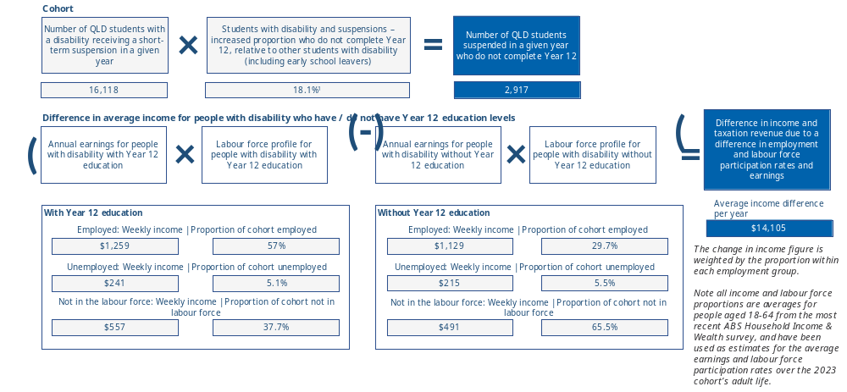

Further details on calculation approach – Other long-term impacts
The figure below outlines the calculation approach used to estimate long term impacts on the costs associated with a decrease in life satisfaction resulting from increased unemployment.
We have also estimated the number of young people with disability and suspensions who may be expected to have contact with the adult Justice custodial system as a result of their youth offending, but have not attempted to estimate the monetary impact due to gaps in the available data exploring the links between school suspensions and adult Justice system involvement. We note there are a number of studies which examine the extent to which Youth Justice system involvement is associated with adult Justice system involvement, and some which highlight the overrepresentation of people with specific disability types in the adult Justice system.
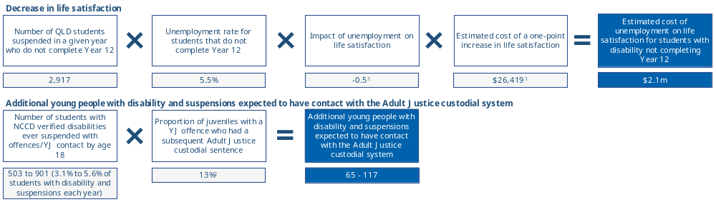

- Non-quantified impacts
Category | Description | Source
Short term impacts
Mental health, subjective wellbeing and educational outcomes | A number of studies drew on interviews and surveys of students who had been suspended to highlight that children and young people reported feeling increased levels of anxiety and depression as a result of social humiliation and isolation due to exclusion and suspension. | Royal Commission into Violence, Abuse, Neglect and Exploitation of People with Disability (2021). Final Report - Volume 7: Inclusive education, employment and housing.  Senate Education and Employment References Committee (2023). The issue of increasing disruption in Australian school classrooms: Interim report. Parliament of Australia.  South Australian Commissioner for Children and Young People (2020). The Blame Game – The perspectives from South Australian children and young people on the causes and impacts of education exclusion and why we need to stop blaming children for system failure.
Other parent / carer employment and income impacts | Pressure on parents/carers’ employment | Royal Commission into Violence, Abuse, Neglect and Exploitation of People with Disability (2021). Final Report - Volume 7: Inclusive education, employment and housing.  South Australian Commissioner for Children and Young People (2020). The Blame Game – The perspectives from South Australian children and young people on the causes and impacts of education exclusion and why we need to stop blaming children for system failure.  Graham. L. “What does exclusionary discipline do and why should it only ever be used as a last resort.” Queensland University of Technology. The Centre for Inclusive Education.
Impacts on teachers and school resources used to manage suspensions and associated responses | Disciplinary responses and classroom disruption having adverse impact on the wellbeing of teachers | Royal Commission into Violence, Abuse, Neglect and Exploitation of People with Disability (2021). Final Report - Volume 7: Inclusive education, employment and housing.  Senate Education and Employment References Committee (2023). The issue of increasing disruption in Australian school classrooms: Interim report. Parliament of Australia.
Long term impacts
Mental health and subjective wellbeing | The association between education attainment, employment and financial wellbeing with lifetime health outcomes | Australian Institute of Health & Welfare (2022). Health across socioeconomic groups. Sourced from https://www.aihw.gov.au/reports/australias-health/health-across-socioeconomic-groups.  Royal Commission into Violence, Abuse, Neglect and Exploitation of People with Disability (2023). Research Report – Economic cost of violence, abuse, neglect and exploitation of people with disability.  Royal Commission into Violence, Abuse, Neglect and Exploitation of People with Disability (2021). Final Report - Volume 7: Inclusive education, employment and housing.  Obsuth, I., Madia, J. E., Murray, A. L., Thompson, I., & Daniels, H. (2023). The impact of school exclusion in childhood on health and well-being outcomes in adulthood: Estimating causal effects using inverse probability of treatment weighting. British Journal of Educational Psychology, 00, 1–14. https://doi.org/10.1111/bjep.12656
Increased income support reliance | Reduced employment and earnings from Year 12 education non-attainment is likely to also be associated with increased income support reliance across the adult life course. Income support payments are implicitly reflected in the earnings assumptions used to calculate individual income gaps.
Life satisfaction and subjective wellbeing from unemployment | The analysis of the economic cost of violence, abuse, neglect and exploitation of people with disability. Extending their estimation approach on the value of subjective wellbeing (life satisfaction) | Royal Commission into Violence, Abuse, Neglect and Exploitation of People with Disability (2023). Research Report – Economic cost of violence, abuse, neglect and exploitation of people with disability.
Other impacts
Social support  Mental health, subjective wellbeing and educational outcomes | First person accounts from students who experienced suspension or exclusion: “It made me question my future. I thought I was going nowhere”, “It was common for young people to say their families were angry, disappointed or let down” and “parents … reported feeling ill-informed and ill-equipped to respond to their child’s concerns” | Royal Commission into Violence, Abuse, Neglect and Exploitation of People with Disability. (2021). Public hearing 7 report - Barriers experienced by students with disability in accessing and obtaining a safe, quality and inclusive school education and consequent life course impacts. Accessed 24 April 2024. https://disability.royalcommission.gov.au/publications/report-public-hearing-7-barriers-experienced-students-disability-accessing-and-obtaining-safe-quality-and-inclusive-school-education-and-consequent-life-course-impacts  South Australian Commissioner for Children and Young People 2020 The Blame Game The perspectives of South Australian children and young people on the causes and impacts of education exclusion and why we need to stop blaming children for system failure.
Income and Finance | Pressure on parents/carers employment where reports are present where caregivers are having to cease or risk employment or leave their child unsupervised. | Graham. L. (2020). “What does exclusionary discipline do and why should it only ever be used as a last resort.” Queensland University of Technology. The Centre for Inclusive Education.
Education | Students who disrupt class and potentially other students in the class impacted are more likely to have decreased academic achievement. | Cortes, K.E., Moussa, W.S., Weinstein, J.M., (2012). Making the grads: The Impacts of Classroom Disruption and Class Size on Academic Achievement
Justice and Safety | Students who disrupt class are more likely to have increased disciplinary issues. | McKee, G., Sims, K. R. E., & Rivkin, S. G. (2014). Disruption, learning, and the heterogeneous benefits of smaller classes. Empirical Economics, 48(3), 1267–1286. https://doi.org/10.1007/s00181-014-0810-1  Mowen TJ, Brent JJ, Boman JH 4th. The Effect of School Discipline on Offending across Time. Justice Q. 2020;37(4):739-760. doi: 10.1080/07418825.2019.1625428. Epub 2019 Jul 12. PMID: 34262239; PMCID: PMC8277153.  Hemphill, S., Broderick, D., & Heerde, J. (2017). Positive associations between school suspension and student problem behaviour: Recent Australian findings. Trends & issues in crime and criminal justice no. 531. Canberra: Australian Institute of Criminology. https://doi.org/10.52922/ti134505
Health | Individuals who experience suspensions are more likely to have health problems into young adulthood. | Rumberger, R. W, & Losen, D. J. (2016). The High Cost Of Harsh Discipline And Its Disparate Impact. UCLA: The Civil Rights Project / Proyecto Derechos Civiles. Retrieved from https://escholarship.org/uc/item/85m2m6sj  Obsuth, I., Madia, J. E., Murray, A. L., Thompson, I., & Daniels, H. (2024). The impact of school exclusion in childhood on health and well-being outcomes in adulthood: Estimating causal effects using inverse probability of treatment weighting. British Journal of Educational Psychology, 94, 460–473. https://doi.org/10.1111/bjep.12656

- References
Australian Bureau of Statistics. (2018). Disability, Ageing and Carers, Australia: Summary of Findings. ABS. Accessed 24 April 2024. https://www.abs.gov.au/statistics/health/disability/disability-ageing-and-carers-australia-summary-findings/latest-release.
Australian Bureau of Statistics. (2019-20). Household Income and Wealth, Australia. ABS. https://www.abs.gov.au/statistics/economy/finance/household-income-and-wealth-australia/latest-release.
Australian Bureau of Statistics. (2020). Disability and the labour force. ABS. https://www.abs.gov.au/articles/disability-and-labour-force.
Australian Bureau of Statistics. (2023). Schools. ABS. https://www.abs.gov.au/statistics/people/education/schools/latest-release.
Australian Institute of Health & Welfare (2022). Health across socioeconomic groups. Sourced from https://www.aihw.gov.au/reports/australias-health/health-across-socioeconomic-groups.
Australian Institute of Health and Welfare (2022) People with disability in Australia 2022, catalogue number DIS 72, AIHW, Australian Government.
Australian Institute of Health and Welfare (2022). Young people returning to sentenced youth justice supervision, 2021-22.
Australian Institute of Health and Welfare (2022). Youth Justice in Australia 2021-22.
Australian Institute of Health and Welfare (2023). Youth Justice in Australia 2022-23.
Australian Institute of Health and Welfare. (2023). The health of people in Australia's prisons 2022.
Black, R. & Education Foundation Australia. (2007). Crossing the bridge: overcoming entrenched disadvantage through student-centred learning. https://catalogue.nla.gov.au/catalog/4202289
Boiteux, S. & Poynton, S. (2023). Offending by young people with disability: A NSW linkage study (Crime and Justice Bulletin No. 254). Sydney: NSW Bureau of Crime Statistics and Research. https://www.bocsar.nsw.gov.au/Publications/CJB/2022-Report-Offending-by-young-people-with-disability-CJB254.pdf
Bruininks, V. L. (1978). Peer Status and Personality Characteristics of Learning Disabled and Nondisabled Students. Journal of Learning Disabilities, 11(8), 484–489. https://doi.org/10.1177/002221947801100804
Chen, S., Matruglio, T., Weatherburn, D., Hua, J. (2005). The transition from juvenile to adult criminal careers (Crime and Justice Bulletin No. 86). Sydney: NSW Bureau of Crime Statistics and Research. https://www.bocsar.nsw.gov.au/Publications/CJB/cjb86.pdf
Cobb-Clark, D. A., Kassenboehmer, S. C., Le, T., McVicar, D., & Zhang, R. (2015). Is there an educational penalty for being suspended from school? Education Economics, 23(4), 376–395. https://doi.org/10.1080/09645292.2014.980398
Commonwealth Department of Education. (2016). Benefits of educational attainment: Income analysis factsheet. Accessed 24 April 2024. https://www.education.gov.au/node/4633
Connolly, H. - Commissioner for Children and Young People SA. (2020). The Blame Game – The perspectives from South Australian children and young people on the causes and impacts of education exclusion and why we need to stop blaming children for system failure.
Cortes, K.E., Moussa, W.S., Weinstein, J.M., (2012). Making the grads: The Impacts of Classroom Disruption and Class Size on Academic Achievement
Dean, K. et al. (2021) Incidence of Early Police Contact Among Children With Emerging Mental Health Problems in Australia. Sourced from 10.1001/jamanetworkopen.2021.12057
Deloitte Access Economics. (2017). Review of education for students with disability in Queensland state schools. Commissioned by Queensland Department of Education & Training. https://education.qld.gov.au/student/Documents/disability-review-report.pdf
Graham, L., McCarthy, T., Killingly, C., Tancredi, H., Poed, S. (2020). Inquiry into Suspension, Exclusion and Expulsion Processes in South Australian government schools: Final Report. The Centre for Inclusive Education, QUT: Brisbane, QLD.
Graham. L. (2020). “What does exclusionary discipline do and why should it only ever be used as a last resort.” Queensland University of Technology. The Centre for Inclusive Education.
Hemphill, S., Broderick, D., & Heerde, J. (2017). Positive associations between school suspension and student problem behaviour: Recent Australian findings. Trends & issues in crime and criminal justice no. 531. Canberra: Australian Institute of Criminology. https://doi.org/10.52922/ti134505
Houng, B., & Justman, M. (2014). NAPLAN Scores as Predictors of Access to Higher Education in Victoria. Melbourne Institute Working Paper No. 22/14. Commissioned by the Victorian Department of Education and Early Childhood Development (DEECD). 10.2139/ssrn.2519864.
Lamb, S. & Huo, S. (2017). Counting the costs of lost opportunity in Australian education. Mitchell Institute report No. 02/2017. Mitchell Institute, Melbourne. https://content.vu.edu.au/sites/default/files/media/counting-the-costs-of-lost-opportunity-in-aus-education-mitchell-institute.pdf
Madia, J.E., Obsuth, I., Thompson, I., Daniels, H. and Murray, A.L. (2022), Long-term labour market and economic consequences of school exclusions in England: Evidence from two counterfactual approaches. Br J Educ Psychol, 92: 801-816. https://doi.org/10.1111/bjep.12487
McKee, G., Sims, K. R. E., & Rivkin, S. G. (2014). Disruption, learning, and the heterogeneous benefits of smaller classes. Empirical Economics, 48(3), 1267–1286. https://doi.org/10.1007/s00181-014-0810-1
Moskos, M., Isherwood, L., Smith, L. (2021). NDDA Education to Employment South Australia (SA) test case: qualitative research into lived experience to support quantitative analysis - High Level Findings Summary. https://www.ndda.gov.au/wp-content/uploads/2022/09/14-Summary-of-NDDA-Pilot-findings-Education-to-Employment.pdf
Mowen TJ, Brent JJ, Boman JH 4th. The Effect of School Discipline on Offending across Time. Justice Q. 2020;37(4):739-760. doi: 10.1080/07418825.2019.1625428. Epub 2019 Jul 12. PMID: 34262239; PMCID: PMC8277153.
National Disability Insurance Agency. (2021). NDIS Participant Outcomes 30 June 2020: Baseline participant outcomes for ages 0-14 report. Sourced from https://data.ndis.gov.au/media/2526/download?attachment.
National Disability Insurance Agency. (2024). Longitudinal participant outcomes data as at 31 December 2023. Sourced from https://data.ndis.gov.au/media/3761/download?attachment
NSW Department of Education. (2023). Suspensions and Expulsions Semester 1 2017–2021 factsheet. Accessed 24 April 2024. https://data.cese.nsw.gov.au/data/dataset/c0a90a6f-2509-45c5-ba77-cf5b00350043/resource/7d039678-7527-4744-93a5-e162aa74de11/download/2021_suspension-and-expulsion-factsheet_semester-1.pdf
Obsuth, I., Madia, J. E., Murray, A. L., Thompson, I., & Daniels, H. (2024). The impact of school exclusion in childhood on health and well-being outcomes in adulthood: Estimating causal effects using inverse probability of treatment weighting. British Journal of Educational Psychology, 94, 460–473. https://doi.org/10.1111/bjep.12656
OECD (2019), TALIS 2018 Results (Volume I): Teachers and School Leaders as Lifelong Learners, TALIS, OECD Publishing, Paris, https://doi.org/10.1787/1d0bc92a-en.
Productivity Commission. (2024). Report on Government Services 2024, Part F, Section 17: Youth Justice services‌. https://www.pc.gov.au/ongoing/report-on-government-services/2024/community-services/youth-justice
Queensland Department of Children, Youth Justice and Multicultural Affairs. (2023). Youth Justice Census Summary: State-wide (2018 to 2022) – under supervision. https://desbt.qld.gov.au/__data/assets/pdf_file/0022/17086/census-summary-statewide.pdf
Queensland Department of Education (2023). State school enrolments 2019-23. Accessed 24 April 2024. https://qed.qld.gov.au/our-publications/reports/statistics/Documents/enrolments-summary.pdf
Queensland Department of Education. (2021-2023). Statistics on suspensions, exclusions and cancellations for student categories. Documents provided to QAI under RTI application disclosure numbers 225041, 215657 and 211882.
Queensland Government Statistician’s Office, Queensland Treasury. (2021). Youth offending: research brief. https://www.qgso.qld.gov.au/issues/10321/youth-offending-april-2021-edn.pdf
Queensland Government. (2024). Teach Queensland - Pay and benefits. Accessed 24 April 2024. https://teach.qld.gov.au/teach-in-queensland-state-schools/pay-benefits-and-incentives/pay-and-benefits
Quin, D. (2019). Levels of problem behaviours and risk and protective factors In suspended and non-suspended students. The Educational and Developmental Psychologist 36: 8–15. doi: 10.1017/edp.2019.4
Ringland, C., Boiteux, S. and Poynton, S. (2023). People with disability and offending in NSW: Results from the National Disability Data Asset pilot (Bureau Brief No. 164). Sydney: NSW Bureau of Crime Statistics and Research. https://www.bocsar.nsw.gov.au/Publications/BB/BB164-Report-People-with-disability-and-offending-in-NSW.pdf
Royal Commission into Violence, Abuse, Neglect and Exploitation of People with Disability. (2021). Final Report - Volume 7, Inclusive education, employment and housing.
Royal Commission into Violence, Abuse, Neglect and Exploitation of People with Disability. (2021). Final Report - Volume 8, Criminal justice and people with disability.
Royal Commission into Violence, Abuse, Neglect and Exploitation of People with Disability. (2021). Public hearing 7 report - Barriers experienced by students with disability in accessing and obtaining a safe, quality and inclusive school education and consequent life course impacts. https://disability.royalcommission.gov.au/publications/report-public-hearing-7-barriers-experienced-students-disability-accessing-and-obtaining-safe-quality-and-inclusive-school-education-and-consequent-life-course-impacts
Rumberger, R. W, & Losen, D. J. (2016). The High Cost Of Harsh Discipline And Its Disparate Impact. UCLA: The Civil Rights Project / Proyecto Derechos Civiles. Retrieved from https://escholarship.org/uc/item/85m2m6sj
Senate Education and Employment References Committee (2023). The issue of increasing disruption in Australian school classrooms: Interim report. Parliament of Australia.
South Australian Commissioner for Children and Young People (2020). The Blame Game – The perspectives from South Australian children and young people on the causes and impacts of education exclusion and why we need to stop blaming children for system failure. "
South Australia Department of Education. (2023). Suspensions, exclusions and expulsions by year level (2013-22). Accessed 24 April 2024. https://data.sa.gov.au/data/dataset/suspensions-exclusions-and-expulsions-by-year-level
Victorian Ombudsman. (2017). Investigation into Victorian government school expulsions. https://assets.ombudsman.vic.gov.au/assets/Reports/Parliamentary-Reports/1-PDF-Report-Files/Investigation-into-Victorian-government-school-expulsions.pdf
Vincent, J., McCarthy, D., Miller, H., Armstrong, K., Lacey, S., Lian, G., Qi, D., Richards, N., Berry, T. (2022). Research Report - The economic cost of violence, abuse, neglect and exploitation of people with disability. Taylor Fry. Commissioned by the Disability Royal Commission. https://disability.royalcommission.gov.au/system/files/2023-09/Research%20Report%20-%20Economic%20cost%20of%20violence%2C%20abuse%2C%20neglect%20and%20exploitation%20of%20people%20with%20disability.pdf
Weatherburn, D., Cush, R., Saunders, P. (2007) Screening juvenile offenders for further assessment and intervention. (Crime and Justice Bulletin No. 109). Sydney: NSW Bureau of Crime Statistics and Research. https://www.bocsar.nsw.gov.au/Publications/CJB/cjb109.pdf

Sourced from https://www.nccd.edu.au/wider-support-materials/which-students-are-included-nccd-under-definitions
Hemphill, S. et al. (2017) Positive associations between school suspension and student problem behaviour: Recent Australian findings. Sourced from https://www.aic.gov.au/sites/default/files/2020-05/tandi531.pdf.
Dean, K. et al. (2021) Incidence of Early Police Contact Among Children With Emerging Mental Health Problems in Australia. Sourced from 10.1001/jamanetworkopen.2021.12057.
Queensland Youth Justice census surveys do not include questions around previous suspension history. They do, however, indicate that a high proportion of people under Youth Justice supervision are “totally disengaged from education, training, or employment” (45-55% of respondents over 2018 to 2022 surveys)

