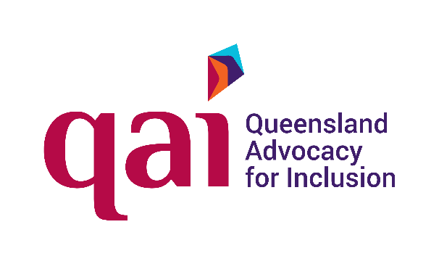


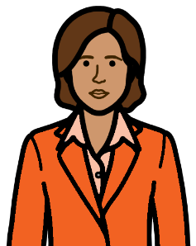

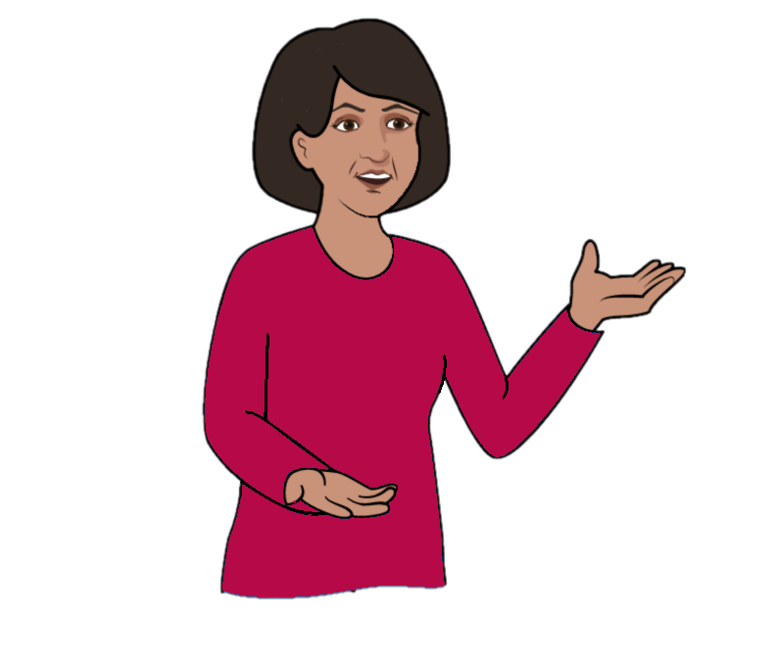

Your money.
A person makes choices for you.
How we help you.



We are QAI. Our long name is
Queensland Advocacy for Inclusion.
Some people call us Queensland Advocacy.


You had a meeting. It was at QCAT.
It was about your money.

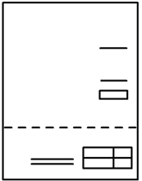


A person makes choices for you now.
It is about your money.
They are your financial administrator.


We can help you know
- about your money
- about your choices
- why that person makes choices for you.


You may want help to
- talk to this person
- find a different person to help you.


You may want help to learn new skills.
You want to make your own choices.
It is about how to spend your money.


What will we do?


We ask about
- you
- your life
- the person who makes choices
about your money.


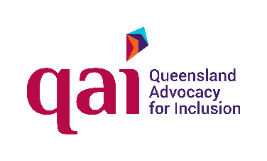

We check. Can we help you?


We can help you. Go to page 6.


It may be we can not help you.

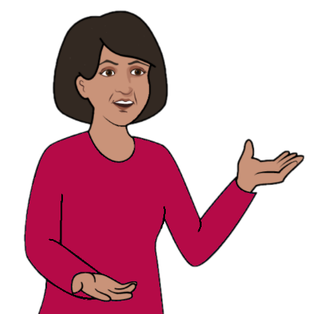
We find other places to help.
We can help you talk to other places.

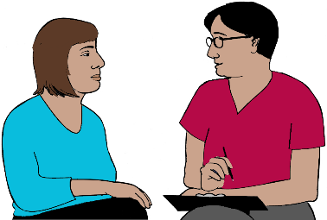
We can help you


We make a time to meet.
We tell you
- the day
- the time.


We remind you. We send a
- text
- email.

We may meet at our office.


We may talk
- on the phone
- on the computer. It is a video call.
You need a quiet place to do this.

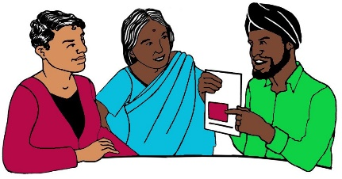
You may need help. Tell us what you need.
You may just speak a little bit of English.
You can have a person to speak your language.


You may be Deaf. You use sign language.
We will have a person to sign.

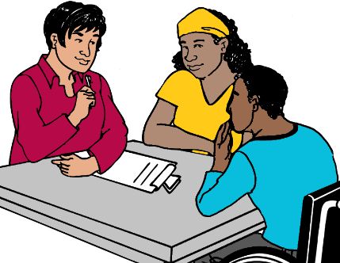
You want to bring a person with you. Like
- your mum
- a friend
- a support worker.
That is OK.

Before the meeting



You may have papers about
- your health
- your money.


It may be
- bills you pay. Like your phone bill
- how much money you have
- a list of your big things. Like your car.

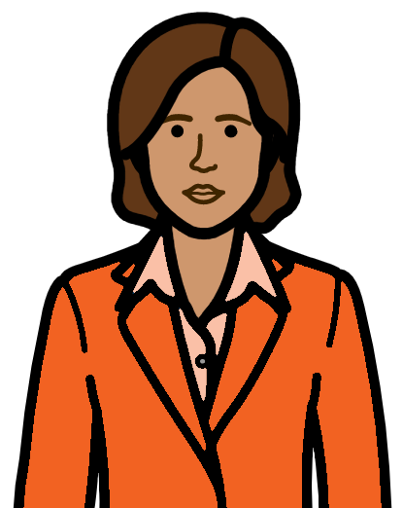
It may be about the person who makes choices.
It may say
- who makes the choices
- what they can do
- why you need this help.


It may be about your health. Like
- doctors you see
- a health problem you have.
It makes it hard to look after your money.


You know a person. You want them to make
choices about your money.
Tell us about that person.

You may not have papers. That is OK.

You have papers.
Give them to us now. It is before we meet.


Bring your papers to our office.
We are in South Central Commercial.
43 Peel Street
South Brisbane.
We are on level 2.
The door is on Merivale Street.

We make a copy of your papers.
We keep the copy.



We read the copy before the meeting.



We give your papers back.

Or


You may copy your papers. Like at the library.
Send us the copies.



Post to PO Box 3384
South Brisbane
Qld 4101.

Or



Email qai@qai.org.au


At the meeting

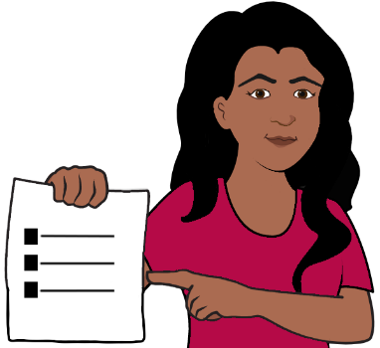
You talk to a lawyer.
They know about the rules. We call them laws. The lawyer
- listens to you
- asks questions
- thinks about what you say.


We tell you the rules.
They are for the person who makes your
money choices.


We tell you things you can do.
We give you ideas.


You choose what you will do.
We do not make you do things.


We may need to talk more. It is after the meeting.
It may be
- to help you know what we said
- papers for you to read.

You want to talk to QAI



Call 1300 130 582

Or

Email qai@qai.org.au


You want to know more.

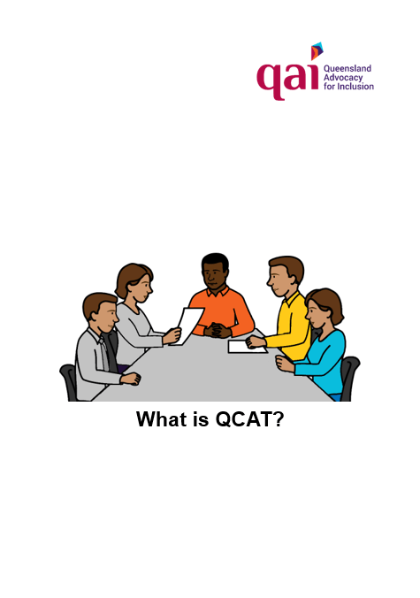

Read What is QCAT

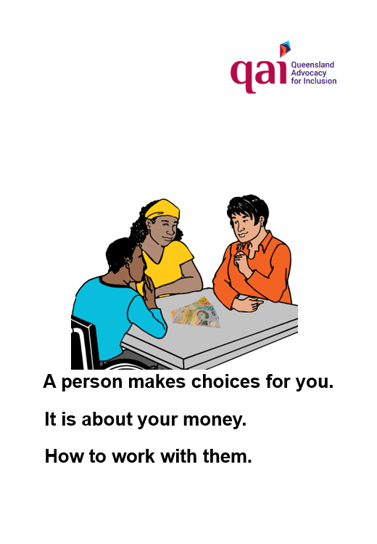
Read
A person makes choices for you.
It is about your money.
How to work with them.

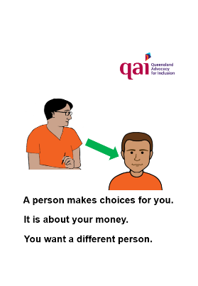
Read
A person makes choices for you.
It is about your money.
You want a different person.

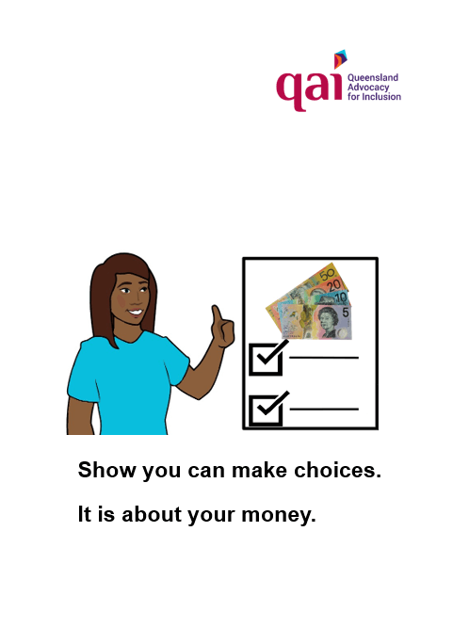
Read
Show you can make choices.
It is about your money.

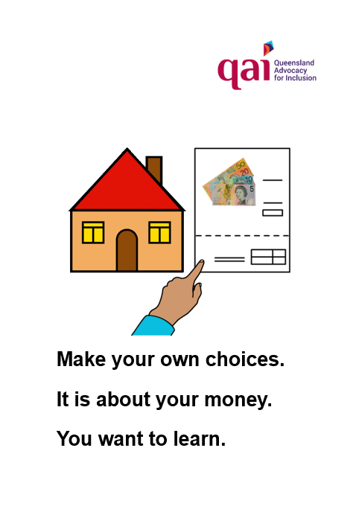
Read
Make your own choices.
It is about your money. You want to learn.

Images




We can use the images from
- CHANGE changepeople.org
- Inspired Services
- Noun Project
- Tobii-Dynavox.

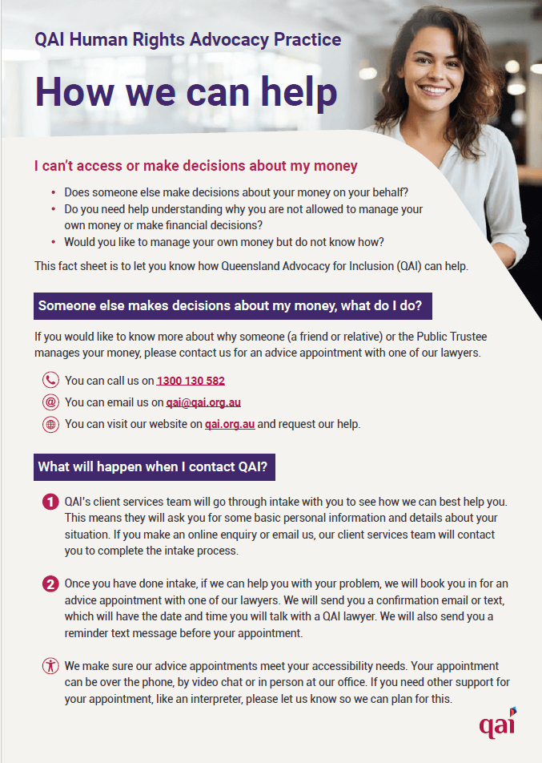
This book is based on
QAI Human Rights Advocacy Practice
How we can help. QAI 2024.

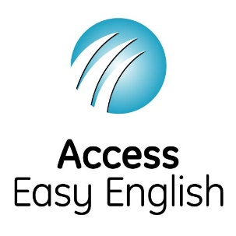
Access Easy English wrote the Easy English.
April 2024.

