

Making Queensland Safer Bill 2024

To Justice, Integrity and Community Safety Committee

2nd December 2024

Background
Queensland Advocacy for Inclusion (QAI) is an independent, community-based advocacy organisation and community legal service that provides individual and systems advocacy for people with disability. Our purpose is to advocate for the protection and advancement of the needs, rights, and lives of people with disability in Queensland.
Our youth advocacy services are delivered through QAI’s Young Peoples Program (YPP). YPP delivers non-legal advocacy to children and young people with disability up to eighteen years of age. Our advocates support children to uphold their rights and interests and to increase control over their lives. YPP works directly with children who are engaged with the criminal justice system and we have a regular presence in all Queensland’s youth detention centres. Our advocates provide support on issues including treatment in detention, transitional supports, education, guardianship, access to health and disability supports, human rights and discrimination related matters.

Introduction
QAI unequivocally rejects the Making Queensland Safer Bill 2024 (the Bill) and strongly recommends the Bill not be passed. This Bill will disproportionately and negatively impact children and young people with disability who are already significantly overrepresented in the criminal justice system. The criminalisation of children with disability occurs due to a multitude of reasons, including a lack of disability awareness among law enforcement agencies which leads to disability-related behaviours being misunderstood as criminogenic. While data shows that at least 44% of children in custody in Queensland have a disability, our experiences and anecdotal evidence suggests that the number is significantly higher than this.
QAI echoes the calls for increased community safety. However, the only way to achieve this is through a system that effectively reduces crime using evidence-based and supportive interventions that uphold the human rights of children. The changes proposed by this Bill do not comply with international human rights standards or reflect evidence-based practice and will cause further harm to children, their families and our communities. As the Queensland Human Rights Commissioner has warned, it will “further traumatize children who are being punished for the collective failure of the systems that are supposed to help them.”
QAI’s submission seeks to highlight the following:
- Detention doesn’t reduce crime
- The threat of detention doesn’t reduce crime; and
- Detaining children is harmful and exacerbates the social determinants of crime.
We provide a case study to illustrate the harmful impacts of detention, particularly for children with disability, before providing some commentary on particular aspects of the Bill and some of the unintended consequences that will occur if it becomes law.

1. Detention doesn’t reduce crime
Decades of research shows that a punitive approach as embodied by this Bill does not reduce youth crime. A punitive approach fails to address the root causes of young people’s behaviour and causes additional harm to children, families and the broader community. Indeed, evidence shows that a punitive approach leads to increased rates of reoffending and fails to increase community safety. For example, the Australian Institute of Health and Welfare found that 80% of children who were released from detention between 2017 to 2018 returned to the criminal justice system within twelve months of their release. Further, the earlier a child is engaged in the criminal justice system, the greater their chance of becoming enmeshed in the system.
In addition to disability, incarcerated children and young people also experience notably high rates of childhood trauma, poor educational experiences, social and financial disadvantage. This intersectional disadvantage means that children can have complex needs that are almost impossible to meet in a detention setting. These children require specialist therapeutic care and conditions that support their health, learning and well-being, yet detention does not provide access to this kind of support or provide these conditions. Detention also disrupts schooling and important connections to family, peers, culture and community; all of which are essential to successful rehabilitation.

2. The threat of detention doesn’t reduce crime
Children and young people are generally diverted away from prisons and receive different sentences to adults for a very simple reason; their executive functioning and decision-making skills are still developing. Evidence about the immature brain development of children has led to a number of international legal instruments recommending the age of criminal responsibility be at least 14. Such evidence has even been used recently to justify new federal laws which ban children under the age of 16 from using social media, yet under this Bill, a child as young as 10 will receive the same criminal punishments as an adult.
Presuming that longer prison sentences will deter children as young as 10 from engaging in offending behaviour is therefore flawed as children do not likely have the maturity to fully comprehend the potential consequences of their actions. This presumption is especially inaccurate for children and young people whose decision-making is further impacted by disability. For example, impulsivity and hyperactivity, both symptoms of attention-deficit/hyperactivity disorder (ADHD), can impair judgment and decision-making and can increase a person’s risk of engaging in risk-taking behaviour. Some disabilities can also affect a person’s ability to self-regulate their emotions. In the absence of appropriate support, this can lead to incidents escalating to the point of law enforcement agencies becoming involved. Threatening detention and punishing children in these circumstances is therefore ineffective and fails to address the underlying causes of the young person’s behaviour.

3. Detaining children is harmful
Among other consequences, detention stigmatises children, impacting their future education, social and employment prospects. Detention also increases children’s exposure to violence, abuse, neglect and exploitation.
QAI has witnessed firsthand the bleak reality of the detention settings where more and more children will be imprisoned if this Bill becomes law. If a parent were to lock up their child for 22 hours a day, restricting their access to sunlight, exercise, education and in some circumstances, basic sanitation and essential medical and disability support, the community would be outraged and would label this as abuse and neglect. However, when this occurs in a State-run facility, this treatment is legitimized in the name of “community safety.”
The detention of children with disability is particularly harmful. Watch houses and youth detention settings are notoriously inflexible environments. The use of strict rules and regimens makes detention completely unsuitable for many children with disability, particularly those with autism spectrum disorder or cognitive disability who require a more individualised and flexible support approach. This can result in children with disability being punished for their inevitable inability to follow certain directions or comply with certain conditions, leading to an escalating trajectory of behaviour that further entrenches them in the system. Adult prisons are even more rigid and inappropriate for many people with disability yet under these new laws, more young people will be transferred to adult prisons during their extended prison sentences.
Accessing disability support for children in detention is also extremely difficult. Many National Disability Insurance Scheme (NDIS) funded supports are not available to children in prison and children are not routinely screened to identify disability or any related support needs, meaning that many go without essential daily supports.

4. Case study
The following case study illustrates the type of harm that occurs within detention settings; these harms will only increase if this Bill becomes law. Practices such as solitary confinement are not uncommon and will likely increase as the youth justice system becomes more overburdened.
Christie* is a 14-year-old Aboriginal girl from a loving family. She has cognitive impairment due to Fetal Alcohol Spectrum Disorder. Christie has difficulty understanding the law, sometimes engages in problem behaviour, and seeks friendships with a group of girls who have regular contact with the police. Christie has expressed that she adopts challenging behaviour as a way of fitting in with her peers.
Christie has been arrested and taken to the watch house and youth detention centre in regional Queensland repeatedly. Christie received an assessment of ‘unsound mind’ and has been deemed unfit for trial, meaning she does not have the capacity to be held criminally responsible for her actions. Despite this, law enforcement continues to detain her in the watch house or youth detention centre when she exhibits problem behaviour, rather than refer her to appropriate health or disability support services.
Christie’s guardian, Sally*, is a qualified health professional, but unfortunately law enforcement has no official plan in place to contact Sally when Christie is arrested. Sally reports inconsistent notifications of Christie's arrests and hospitalisation. This is particularly concerning because Christie is known to engage in self-harming behaviour.
When Christie is detained in a watch house, she has difficulty communicating her needs and experiences acute distress resulting in loud and repetitive vocalisations. She has difficulty understanding the rules of the watch house and has been detained in solitary confinement. During one occasion, law enforcement officers placed Christie into a solitary confinement cell with significant force and closed the door of the cell onto Christie’s arm. Christie suffered an injury to her arm and urinated in her clothing.
When Christie is in a panicked and heightened state in the watch house, she cannot eat or drink and this distress can lead her to urinate herself.
The image below is taken from CCTV footage of the watch house cell that Christie was held in for solitary confinement.

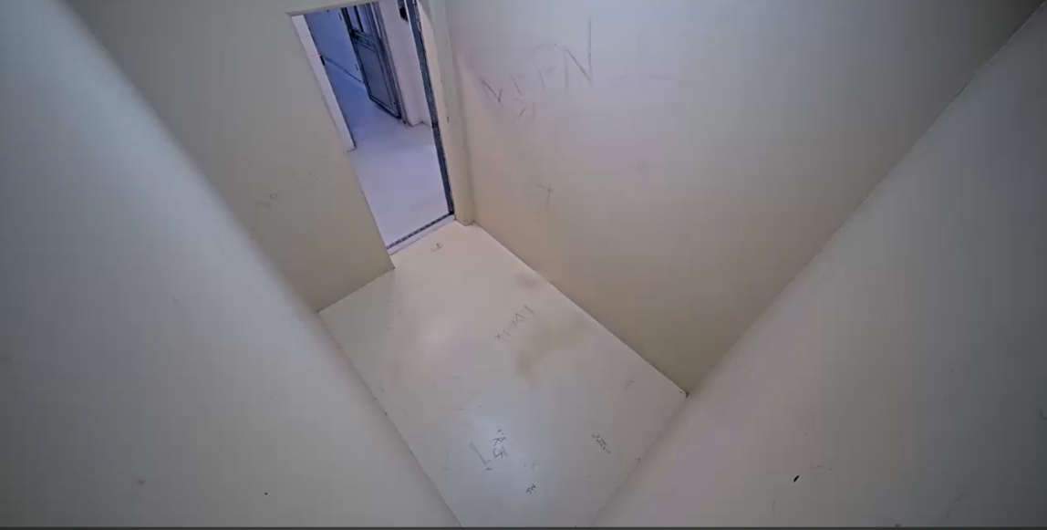
*Names have been changed to protect identities

5. Commentary on the Bill
QAI is deeply concerned that the Bill goes against best practice, ignores the views of experts and breaches several of Australia’s human rights obligations, including Queensland’s own Human Rights Act. The Bill’s Statement of Compatibility acknowledges it “will lead to sentences for children that are more punitive than necessary to achieve community safety” and admits that a key objective is to “demonstrate to the community that youth offending is treated seriously”. In other words, to achieve political gain amidst a moral panic about rising youth crime in Queensland.
QAI is particularly concerned by the long list of offences that the Adult Crime, Adult Time policy will apply to, including non-violent offences such as unlawful possession of a motor vehicle. This appears to go beyond the Adult Crime, Adult Time election proposal that was centred on safety and is a disproportionate response to what would likely be one-off offending, given that most young people charged by police do not go on to commit further offences. It also contradicts best practice in other jurisdictions, such as in Scotland, where detention is only used for violent offences.
Removing judicial sentencing discretion and restorative justice principles is also of great concern. Changing the law so that the impact of the crime on the victim becomes the primary consideration for sentencing is not fair on victims as it will result in the most articulate, engaged and empathy-inducing victims having different or “better” outcomes. We know that ableism, racism, unconscious bias and other societal norms have a large impact on a court’s understanding of a crime and its likely impact on a victim. A rape in a marriage, for example, is unlikely to be thought of as equally harmful as a rape by a stranger. This new primary focus will also mean that the onus to show how bad the impact was will be placed upon victims at a time of significant distress when so many other complex feelings and practical realities are taking place.
Opening the Children’s Court to victims and the media will also potentially impact the level of information some children are willing to disclose about an offence, such as experiences of child abuse or neglect. An open court could also lead to vigilante behaviour that puts children and their families at risk of violence.
Queensland’s youth justice system already incarcerates more children than any other jurisdiction in Australia. Rather than removing detention as a last resort, this principle should be fully restored, having been weakened by amendments in the Queensland Community Safety Act 2024 (Qld) earlier this year. This principle is derived from the United Nations Convention on the Rights of the Child and is an essential safeguard designed to protect the unique rights and needs of children and to foster their development as functioning adults in society.
Punishing children through the various measures contained in this Bill is also incompatible with the government’s stated commitment to “divert youth from crime” and to “allow courts…to get kids the help they need, when they need it.” The two approaches do not align philosophically and send contradictory messages to young people. The Bill will also punish a cohort of children before they have opportunity to access and benefit from the “Gold Standard Early Intervention” programs that are reportedly being introduced by the new Government.
Concerningly, our advocates have already heard from children who are fearful about this Bill, worried they will be incarcerated in an adult prison if these new laws apply retrospectively to cases currently pending before the courts. This is causing an alarming level of psychological distress to children who have already experienced trauma or other adverse childhood events and in some instances, is impacting their willingness to engage in rehabilitative programs.
In addition to harming children, there will be other consequences if this Bill becomes law. Increased penalties for youth crime will lead to an increased demand for legal aid and advocacy services to appeal or contest charges; services which are already under-resourced.
Incarcerating increasing numbers of children will come at a significant financial cost, with little return on investment. It will also see more children being held in overcrowded watchhouses; leaving children vulnerable to abuse from adults in places which serve no rehabilitative or therapeutic purpose and which prevent children from engaging with essential family, community and disability supports.

6. Conclusion
QAI stands with children with disability in strong opposition to this Bill.
Alternatives to detention offer real opportunities for growth and meaningful change and can better provide developmentally appropriate responses to offending behaviour. Tailored therapeutic and educational programs, inclusive transitional support and individualised coordination for appropriate services and restorative justice can all effectively address the underlying causes of criminalised behaviour and should be prioritised instead of the measures introduced by this Bill.
The United Nations Convention on the Rights of the Child states that children in contact with the justice system should be “…treated in a manner consistent with the promotion of the child's sense of dignity and worth…which takes into account the child's age and the desirability of promoting the child's reintegration and the child's assuming a constructive role in society.” Legislative changes relating to youth justice must be aligned with this Convention and must not take us further away from achieving its fundamental objectives.

See for example, Children and Young People with Disability Australia, Submission in response to Criminal justice system issues paper, July 2020, ISS.001.00420, p 3.
The State of Queensland (Department of Youth Justice) A Safer Queensland – Queensland Youth Justice Strategy 2024–2028, p11
Australian Institute of Health and Welfare, Youth Justice in Australia 2019/20, 6.
Australian Institute of Health and Welfare (2022). Australia’s Children: children under youth justice supervision. [online]. https://www.aihw.gov.au/reports/children-youth/australias-children/contents/justice-safety/children-youth-justice-supervision;
Walsh, Tamara, Beilby, Jane, Lim, Phylicia, and Cornwell, Lucy (2023). Safety through support: building safer communities by supporting vulnerable children in Queensland's youth justice system. Brisbane, QLD Australia: The University of Queensland, p8
For example, General Comment no 24 on the Convention on the Rights of the Child
Walsh, Tamara, Beilby, Jane, Lim, Phylicia, and Cornwell, Lucy (2023). Safety through support: building safer communities by supporting vulnerable children in Queensland's youth justice system. Brisbane, QLD Australia: The University of Queensland, p19
Royal Commission into Violence, Abuse, Neglect and Exploitation of People with Disability (2023). Criminal justice and people with disability. [online]. p.81. https://disability.royalcommission.gov.au/system/files/2023-09/Final%20Report%20-%20Volume%208%2C%20Criminal%20justice%20and%20people%20with%20disability.pdf
See for example, https://www.theguardian.com/commentisfree/2024/oct/21/queensland-election-lnp-youth-crime-policy-crisafulli
Statement of Compatibility, Making Queensland Safer Bill 2024, p5
Ibid, p2
The State of Queensland (Queensland Audit Office) Reducing serious youth crime (Report 15: 2023–24) available under CC BY-NC-ND 4.0 International, p8
https://online.lnp.org.au/youthcrime#msdynmkt_trackingcontext=9ac4bd8a-5595-455b-b9d2-be1517d29b38
See for example, Higgins DJ, Mathews B, Pacella R, et al. The prevalence and nature of multi- type child maltreatment in Australia. Med J Aust 2023; 218 (6 Suppl): S19 - S25.

