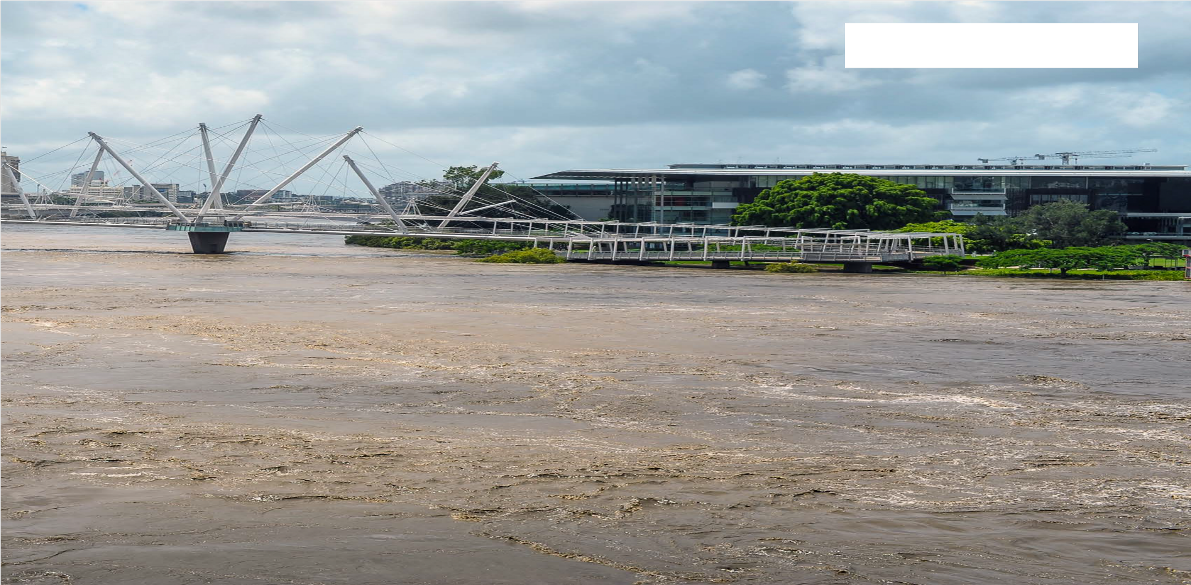



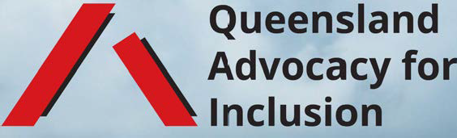
Natural disasters, disability and the law
January 2023

What's in this document?
This document contains legal information about
- discrimination
- human rights
- NDIS service providers
- duty of care
- property and tenancies
- insurance
- government and police powers
- developing an inclusive emergency response plan
- access to evacuation and other services

Who is it for?
This document contains information to help people with disability, their families and carers to understand their rights under law during natural disasters.
It is intended as general information. Please see a lawyer if you need more help.

About discrimination

Queensland has laws to protect against discrimination, including discrimination on the basis of disability. These laws are designed to eliminate discrimination against people with disabilities in areas such as accommodation and access to premises. These laws also ensure that people with disabilities have the same rights to equality before the law.

Queensland also has a Human Rights Act, which creates laws designed to protect your human rights.

When public entities, such as the Queensland government and other public organisations, interact with you, they must consider and protect your human rights because of these laws.

The Human Rights Act requires our government to:
- act and make decisions which are compatible with the rights the Act protects
- fully consider human rights in law, policy and practice.

with a disability

It is unlawful for you to be treated less favourably than other
people because of your disability. That might be unlawful discrimination.
It may also be unlawful to treat you the same as everyone else, if that is going to have an unfair impact on you because of your disability.

That might also be unlawful discrimination.

Forms of discrimination in Queensland
There are different forms of discrimination:
- direct disability discrimination
- indirect disability discrimination
- discrimination as a result of failure to make "reasonable adjustments" or "reasonable alterations"

Direct discrimination occurs when a person treats you differently to others, because of your disability, and that different treatment is less favourable treatment to others without your disability. Direct discrimination can also occur when no reasonable adjustments are made and, because of that, you are treated less favourably.

Indirect discrimination occurs when you are made to comply with the same requirements as everyone else, but this is more difficult for you because of your disability. Indirect discrimination can also occur when reasonable adjustments would allow you to comply with the same requirements as everyone else, but those adjustments are not made.

Discrimination during natural disasters

Discrimination against a person with a disability during natural disasters

Discrimination is unlawful during a natural disaster and at other times.
In the next few pages, there are some examples of situations that might be discrimination against a person with a disability during a natural disaster. These are examples only and the circumstances of each matter would have to be considered to decide whether there might have been unlawful discrimination under Queensland's laws.

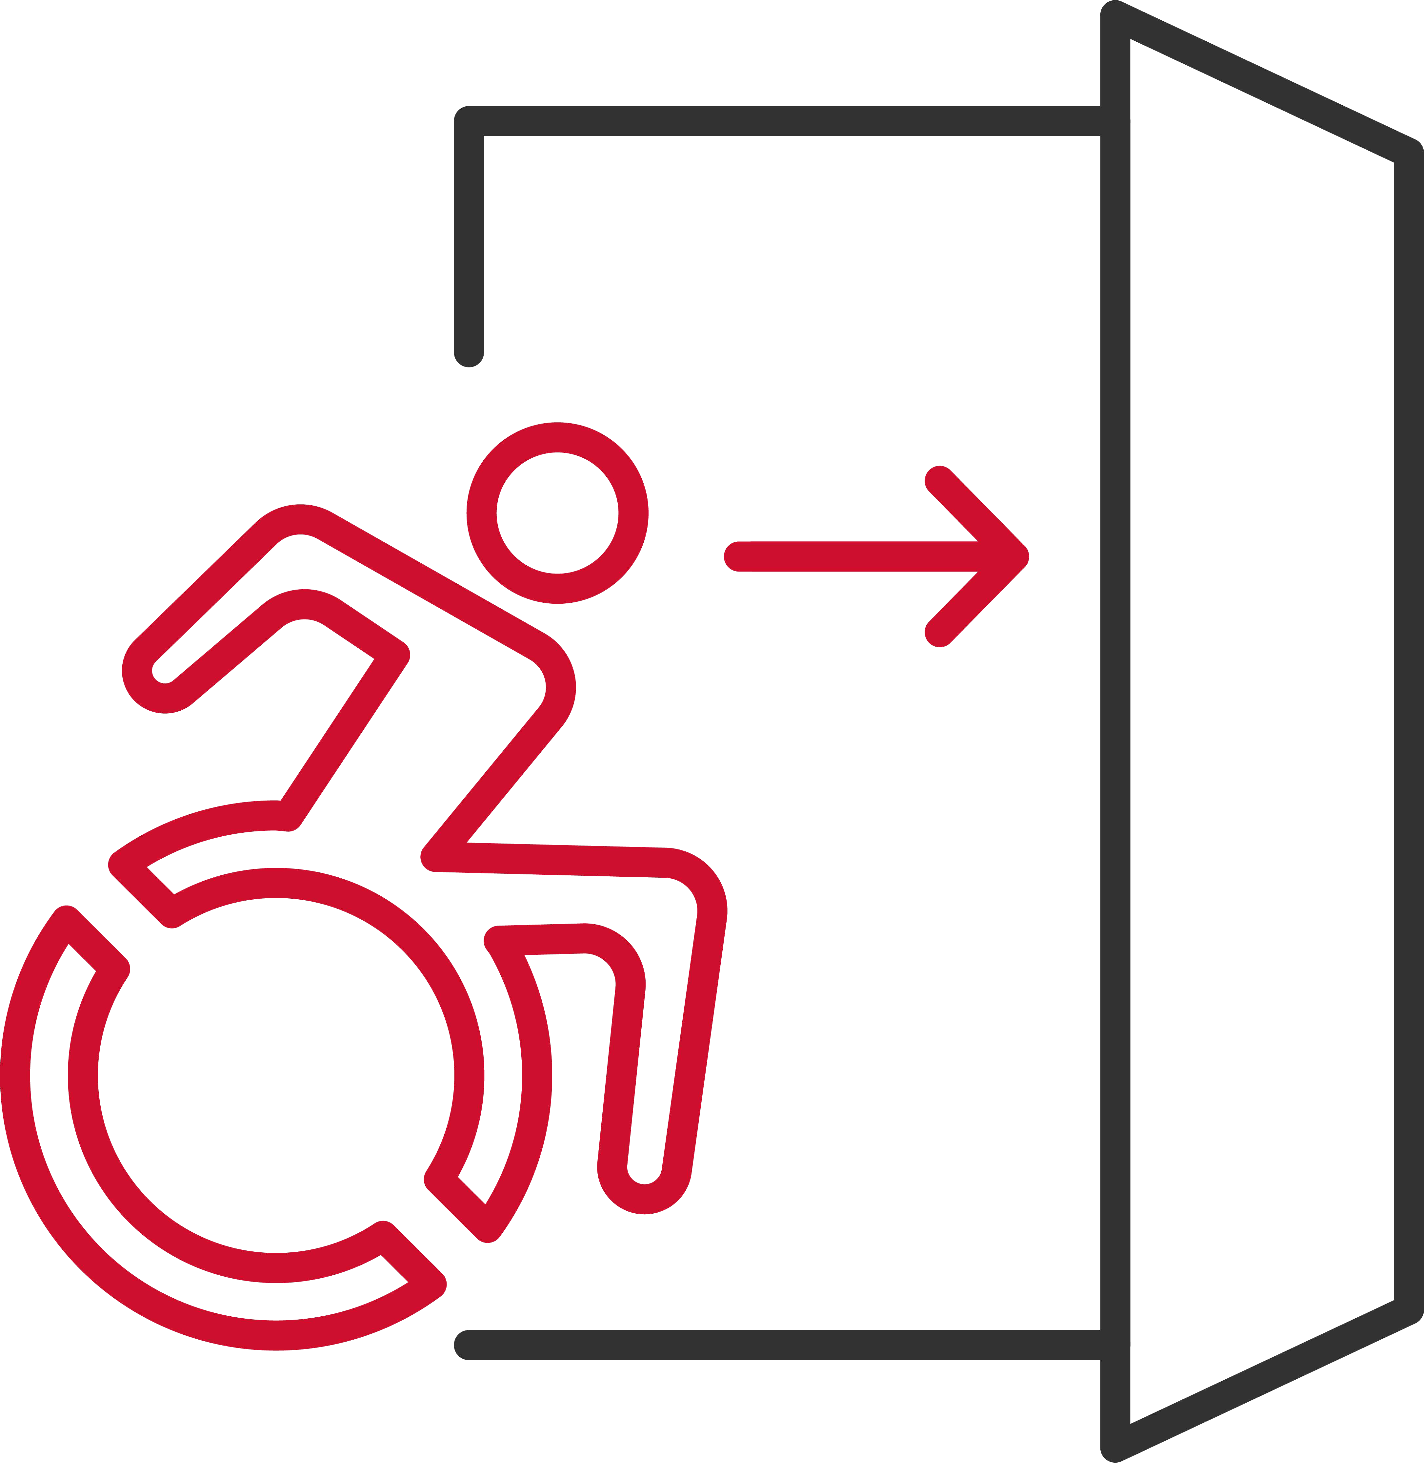

Denying a person with a disability a safe and suitable evacuation plan
You may be being discriminated against if you are a person with a disability and your accommodation has not incorporated reasonable adjustments into its evacuation plan, or has not developed an individual evacuation plan with you, to ensure your safety during an emergency.

Denying a person with a disability accessible evacuation information
You may be being discriminated against if you are a person with a disability and emergency services have issued warnings and provided information to you about evacuation and safety during a natural disaster in a format that is not accessible because of your disability.



Denying a person with a disability safe and suitable accommodation
You may be being discriminated against if you are a person with a disability and the Queensland Government, or your landlord, provides you with accommodation that does not have reasonable adjustments to allow access and safety in that accommodation during and after a natural disaster.

Denying a person with a disability access to services
You may be being discriminated against if you are a person with a disability, and who relies on the use of an assistance animal, and you are denied entry to an evacuation centre because of you attend with your assistance animal.

What to do if you experience discrimination

What to do if you experience discrimination
If you have been discriminated against because of your disability you may be able to make a complaint to the Queensland Human Rights Commission or the Australian Human Rights Commission. You might want to contact a lawyer to explain the process and assist you.

Under the Queensland Human Rights Act, your human rights
include:
- the right to life
- the right to freedom of expression
(the right to seek, receive and communicate information)
- the right to equality and non-discrimination
- the right to freedom of movement
- the right to health services
- the right to property
- the right to privacy

The right to life
You have the right to life. This means that your life, and the lives of other people with disability, have the same value as any other person. This means the government must take appropriate steps to protect your life in a natural disaster.

The right to freedom of expression
Freedom of expression means that you have the right to seek, receive and communicate information. This includes making sure that you can seek, receive and communicate information in a way that is accessible to you. This means that the government and other public organisations should provide information to you in a way that allows you to understand the information. The government and other public organisations should also take steps to make it easy for you to communicate with them.



The right to equality and non-discrimination
You have a right to equality and to not be discriminated against. This is similar to the protections from discrimination that are listed above, which the Human Rights Act also protects when the Queensland Government or other public organisations are interacting with you.

The right to freedom of movement
You have the right to access health services without discrimination. This means that you have a right to access public physical and mental health services during a natural disaster.

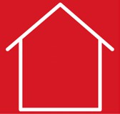

The right to health services
You have the right to access health services without discrimination. This means that you have a right to access public physical and mental health services during a natural disaster.

The right to property
You have the right to own property and to not be deprived of your property without good reason.



The right to privacy
You have the right not to have your privacy, family, home or communication unlawfully or arbitrarily interfered with.

If you think the Queensland Government or another public organisation has treated you in a way that interferes with your human rights, you can complain to the Queensland Human Rights Commission. Before making a human rights complaint to the Queensland Human Rights Commission, you will need to complain to the particular organisation and give the organisation an opportunity to resolve your complaint directly. You will need to give the organisation 45 business days (or about 9 weeks) to respond. If you wish to make a human rights complaint, you might want to contact a lawyer to explain the process and assist you.

NDIS service providers

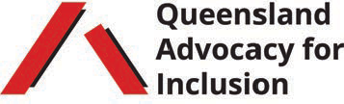

NDIS service provisions
NDIS Practice Standards exist to enable NDIS participants to be aware of the quality of service they should expect from NDIS providers. One of these standards recognises the important role of emergency and disaster management in the maintaining NDIS supports for participants during and after emergencies and disasters.

This means NDIS providers need to make sure that:
- in an emergency, you can still access your supports that are critical to your safety, health and wellbeing
- you have been involved in developing an emergency
and disaster management plan that includes your support network
- your support workers are trained to implement the plan
when needed to ensure NDIS supports can continue during an emergency or disaster
- these plans are tested and changed according to the
type of emergency or natural disaster, with any changes communicated clearly to you and your support network

Duty of care

A person owes you a duty of care if they provide you with goods or services, or you rely on them for help because of special skills they have. This duty can be breached when the person you rely on does something, or does not do something, and because of this you suffer some injury, loss or damage.

The most common examples of people who owe a duty of care to people with disability are health professionals or support workers who care for people with disability. Public authorities may also owe members of the public a duty, including during an emergency or natural disaster. Lots of other people also owe you a duty of care, including landlords, drivers and people who run businesses that you access.

A person who owes you a duty of care must exercise reasonable care in the course of their interactions with you. The standard of care is what would be expected of a person with similar qualifications and experience.

For example, your doctor owes you a duty of care in the advice and treatment they provide to you.

care?

Yes, a landlord owes a duty of care to tenants, as well as to other members of the household and visitors. This means a landlord must inspect the property before each lease begins, respond reasonably to any problems brought to their notice, and make sure any necessary repairs are made.

It is called negligence when someone who owes you a duty of care does not take reasonable care in the course of their interactions with you and this causes you to suffer some injury, loss or damage.
To succeed in a case for negligence, you will need to prove:
- there was a duty of care owed to you by another person or organisation
- they did something or failed to do something, and it was not reasonable for them to do or not do that thing
- you suffered harm as a result

You may be entitled to monetary compensation where negligence is established.

Some general examples of what your support workers and organisations are required to do to fulfill the duty of care owed to you, are:
- deliver care to you that is safe and does not put you at risk of harm
- ensure that you have sufficient support, and notify the NDIS Quality and Safeguards Commission if it is not possible for you to receive the supports you are entitled to under the NDIS
- organisations must have processes in place to ensure the support workers they send to care for you do not put you at risk of harm.

If you think you have been harmed because of someone's negligence, you may wish to find a lawyer and ask for their advice. There are strict time limitations on making a negligence claim, so you should try to speak to a lawyer as soon as you become aware of the loss or damage caused by someone else.
If you are presently in danger, you should call:
- Police, Fire, or Ambulance on 000
- National Disability Abuse & Neglect hotline on 1800 737 732

Property and tenancies

Your landlord must not discriminate against you by changing the terms of how you are supplied accommodation, by denying or limiting access to any benefit connected to your accommodation, by evicting you from your accommodation, or by treating you unfavourably in any other way connected with your accommodation.

A person must not refuse to allow you access to, or use of, a property or any facilities that are open to the public because of your disability. They also cannot make you leave the property or stop using the facilities because of your disability.

It is not unlawful for a person to deny a person with a disability special services or facilities in their accommodation, if supplying those would impose an unjustifiable hardship.

You should see a lawyer immediately if you believe you have been discriminated against.

A landlord must not discriminate against you by refusing to allow you to alter your accommodation to meet your needs if you pay for the alteration, the alteration is only on your property (and no one else's) and you can put the accommodation back to its original condition.

It is discrimination if someone:
- refuses to rent accommodation to you because you have a disability and rely on a guide, hearing, or assistance dog

- requires you to keep your guide, hearing, or assistance dog elsewhere

- requires you to pay an extra charge because your guide, hearing, or assistance dog lives at the accommodation

However, this does not change the fact that you are still responsible for any damage caused by your dog.

If you are renting and your accommodation becomes completely or partially unfit to live in, due to a natural disaster, you can notify the landlord that you are leaving the property for this reason. You must tell the landlord you intend to leave within one month of the property becoming unfit to live in. This includes situations where you are a resident in a larger accommodation and your room or the common areas have become completely or partially unfit to live in.

You should speak with a lawyer as soon as you can if you experience property issues.

Insurance

Which types of damage can you claim with your insurance provider during or following a natural disaster?

You may be able to claim certain types of damage with your insurance provider during or following a natural disaster, depending on the types of damage that your policy covers.

This may include:
- damage to property
- damage to mobility equipment (including wheelchairs)
- costs associated with any medical treatment
- vet bills for an assistance animal

Can insurance providers legally discriminate against you?

In some exceptional circumstances, an insurer is allowed to discriminate against a person with disability. Generally, it is lawful for an insurance provider to discriminate against a person with disability if the reason is based on data or other relevant factors and is considered reasonable.

This discrimination may look like:
- refusing to offer an insurance policy
- changing the terms and conditions of an insurance policy

You should speak to a lawyer as soon as possible if you believe you have been discriminated against. You may be able to make a complaint to the Queensland Human Rights Commission or the Australian Human Rights Commission.

Criminal law, Government and the Police

Does the Queensland Government have powers to order the evacuation and/or movement of people during a natural disaster?

Yes. There are laws that allow certain individuals (such as the Minister and the Premier) to declare a "disaster situation". This means they can use special powers to prevent or minimise loss of human, illness or injury, property loss or damage, or damage to the environment.

These special powers can be used to control the movement of people outside their homes, such as making people or animals evacuate a certain area, as well as disconnecting the supply of electricity and water. Sometimes, these powers can also be given to police, fire, or ambulance officers.


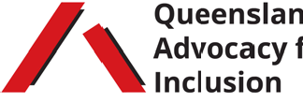

The Queensland State Emergency Service (SES) is a non-for-profit organisation comprised of more than 5,000 active members. The primary purpose of SES members is to "assist the most vulnerable members of the community". The SES performs a number of functions to respond to disasters and emergencies on both a state and national level.

The SES provides:
- assistance for non-life threatening emergency situations during floods, storms and other similar events
- support for agencies, including Queensland Police Service and Queensland Fire and Rescue Service, during times of emergency and disaster

The following services may be able to provide you with evacuation information and help during a natural disaster:

Get Ready Queensland
Information about preparing for a natural disaster with disability. Go to link GetReady.qld.gov.au

Flood Check Queensland
An interactive map which gives you access to flood information and data. Go to link FloodCheck.information.qld.gov.au

Queensland Government's Disaster recovery support Information about financial help and support services to help you recover if you're affected by a disaster. Go to link qld.gov.au/community/disasters-emergencies/disasters

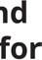
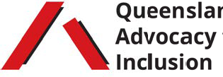
NDIS National Contact Centre
If there is flooding and you had to evacuate, call 1800 800 110 and press 5 if you need temporary access to services, assistive technologies, or supplies.

If you need to evacuate, call SES on 32 500
or Triple Zero on 000 immediately.

